Government Engineering College
Thrissur

CS331 – System Software LabDocumentation
Exp12 – 2 Pass Macro Assembler

Date of Submission:23 November 2020

Submitted By,
Rejath T M
Roll No 50
TCR18CS050
GECT CSE S5

Experiment 12:
To implement a 2 Pass Macro Assembler
Compilation of Code Prerequisite

- The code is provided in the program.c file along with its documentation. You just need to run it on any compiler.
- Compile like gcc program.c
.\a.exe

- The program 2 parts Pass1 and Pass2.
- In the Pass 1 it scans the program and certain output files are generated. In pass 2 it takes outputs from pass 1 are taken as inputs and generate output.
- In Pass1 program takes minp2.txt as input and generate dtab2.txt and ntab.txt as output.
- In Pass2 input and output files from Pass1 as inputs and generates atab2.txt and op2.txt as output.
- Output will be displayed in the terminal also.
at
Output Screenshots

Output of Pass 1

dtab.txt

ntab2.txt

Output of Pass 2
atab2.txt

op2.txt

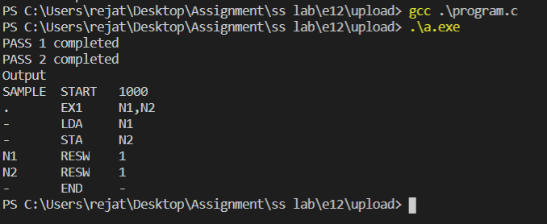
Terminal

