# Project Description

Creating an interactive map of campus that tracks users using NFC tags.

## Purpose and Expected Benefits

We are undertaking this project to improve the overall accessibility of Edinburgh Napier University’s campuses without making changes to the University’s physical infrastructure. The web app will allow a user to get from A to B on campus, whilst being tracked round the campus, and offering them step-free and less busy routes to classes. The project is a proof of concept.

## Expected Cost and Duration

The overall cost of the project should be negligible. We should be provided appropriate resources by the University. If we are not, this is not a massive problem as the project is a proof of concept, so does not need to be implemented.

The project shall take place from 23rd January 2023 till 28th April 2023.

Edinburgh Napier University may not allow us to test the web app on the University premises, this however is not a major constraint if it does occur as the project is a proof of concept.

The main constraint on the project will be time. In order to meet the requirements and quality expectations of the project, we have produced a deliverables map, in the form of a Gantt chart which can be found as an appendix to this document.

## Requirements and Quality Expectations

The project will create a web application that could be at a future point integrated into MyAccount, which would allow students, particularly those with additional needs to find their way around the University’s three campuses.

This will be achieved by using NFC tags where a user will enter a room they want to go to, and then tap their nearest tag and then the app will calculate a route based off of their settings.

The project will integrate security into every part of the application.

The project must have the ability to track users around campus.

The project must have the ability to set up journeys on the app.

In terms of deliverables, the project will result in an application with an accessible user interface, which presents a Google Maps style application for Edinburgh Napier University campuses. The project will also include a back-end that includes a database of location information and access scripts. Additionally, an administrative interface for maintaining location data and documentation will also be produced.

## Stakeholder List

The stakeholders for this project are:

* George Brightman – Project Manager (front-end sub-team lead, also acting as the client)
* Ailish Vandome – Project Team Member (front-end sub-team, implementation lead)
* Aimee Bell – Project Team Member (front-end sub-team, design lead)
* Lewis Dickson – Project Team Member (back-end sub-team, databases lead)
* Aink Acrie Soe Thein – Project Team Member (back-end sub-team, development lead)
* Ross Adamson – Project Team Member (back-end sub-team lead, testing and IoT lead)
* Dr Baraq Ghaleb – Academic Sponsor
* Dr Brian Davison – Module Leader
* Jonathon Staal – Inclusion Services Manager, Edinburgh Napier University – has an interest in an interactive map of campus being integrated into MyAccount

**Appendix 1 – Deliverables Map:**

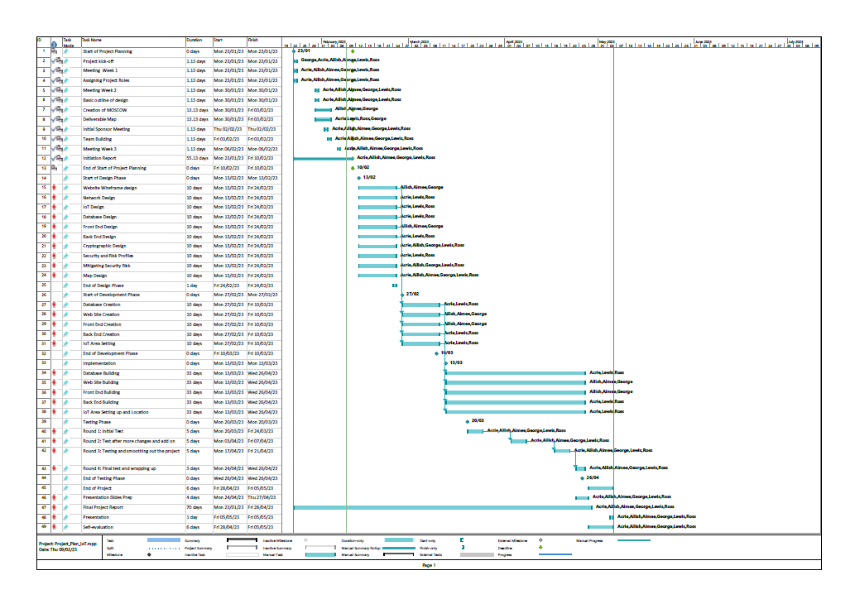

**Appendix 2 – MoSCow Prioritisation:**

*Must have features:*

* Identification and authentication of tag ID.
* A map for the user to interact with.
* A graphing of the campus floorplan in the form of a node and edge graph.
* A fully functional and well-designed web application.
* Room-to-room and location-to-room directions and mapping.
* A time to live for user tracking data in the database, so that the database knows when to remove the tracking data from the system.
* Well-designed and efficient databases that are in full working condition.
* A secure database and web application using industry-level security techniques to prevent against vulnerabilities such as: SQL injection, clickjacking, directory traversal, unencrypted communication, DoS attacks, DDoS attacks and RegEx injection.
* The project will confirm to the client’s vision and to standard working practices.
* All product images, titles and descriptions must have the suitable copyright protections
* The application must be maintainable and offer long-life useability for any parties that may want to inherit the project.

*Should have features:*

* Built-in accessibility features, for example, the ability for users to increase the font size.
* The listing of real life on-campus features on the application, for example, lifts, toilets, and reception.
* An accessible user interface, that conforms to the Web Content Accessibility Guidelines.

*Could have features:*

* A list of most popular rooms or locations on campus. These would most likely not be programmed in, but would instead be places such as reception, iPoints, the JKCC, key lecture theatres and social areas. It could easily be implemented to be a true reflection of the most visited locations on campus.
* The ability to select a campus. If this feature isn’t implemented, the campus will be automatically selected based off the NFC tag that the user taps to begin their journey.
* The categorisation of rooms, for example, into groups such as lecture theatres, classrooms and staff offices.
* The ability to search for a room. Without this feature, the user will just have to enter a room number.
* The ability to retrace a previous journey. Journey data will be stored locally.
* A set of instructions on how to use the application that are available at any time. First-time users will have access to a one-time set of instructions.

*Won’t have features:*

* The application will not have a log-in page or the ability to have an account for the application.
* The application will not have maps for specific schools.
* The application will not have a help feature.

**Appendix 3 – Peer Review Feedback:**

Reviewer – Jake Davidson, Team 43

Reviewee – George Brightman, Team 34

Date of review: 09/02/2023

1. Project Description

*Review comments and recommendations:*

No recommendations needed this project description clearly states what the project is set out to do and what the benefits are which is to make it easier for students to get around campus.

*Response and actions taken:*

As a team, we are happy with this feedback and we feel that no action needs to be taken.

2. Deliverables Map

*Reviewer’s comments and recommendations:*

The deliverables map in the appendix clearly shows to the client the tasks that will be carried out, who is responsible for doing them, when they will be finished, when they are going to be tested.

No recommendations needed.

*Response and actions taken:*

As a team, we are happy with this feedback and we feel that no action needs to be taken.

3. Follow-up Register

*Reviewer’s comments and recommendations:*

The follow-up register shows the client what risks could occur for the team doing the project and how the team will work to avoid or mitigate these.

As these are laid out and in detail of how they are handled I have no recommendations.

*Response and actions taken:*

As a team, we are happy with this feedback and we feel that no action needs to be taken.

4. Quality of document:

*Reviewer’s comments and recommendations:*

The quality of the document is high and explains in clear detail of why the project is being undertaken, how long the project will last for, costs of the project, what the quality standards and the role of each individual team member.

It also clearly states using MoSCoW to the client what will definitely be delivered at the end of the project, what could be delivered if there is time to do them and what is completely out the scope of the project and will not be included no matter what.

No recommendations needed.

*Response and actions taken:*

As a team, we are happy with this feedback and we feel that no action needs to be taken.