1. **First you will do is to back up the original job_bid_attachment table.**
2. **Click ‘job_bid_attachments’**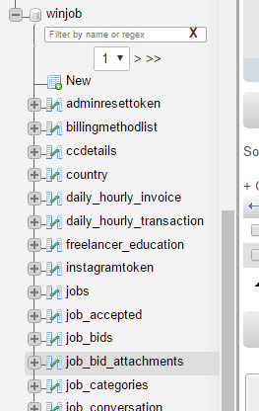
3. **Click ‘Export’**

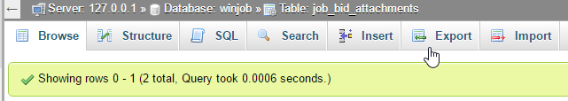

1. **Click ‘GO’**

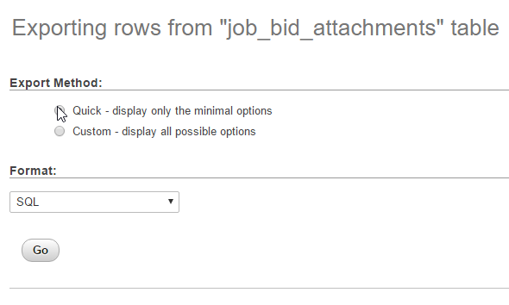

1. **You should be able to get a job_bid_attachment table.sql downloaded file. Once you get that you will need to drop the original table. Click ‘Operations’**

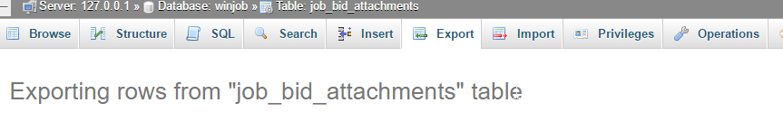

1. **Make sure that the table is job_bid_attachment table. Click “Delete the table (DROP)”**

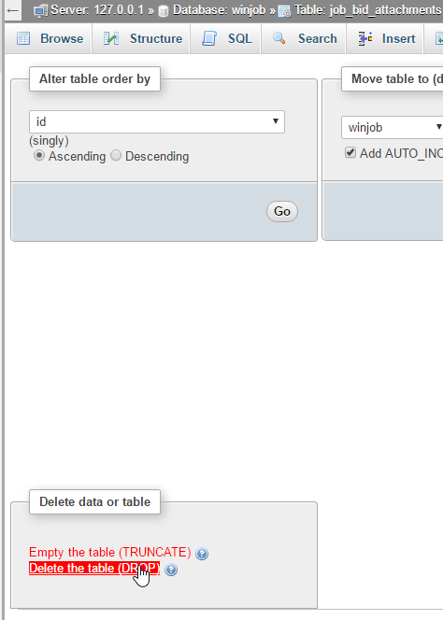

1. **After dropping, click the ‘winjobx’ mine is (winjob) database.**

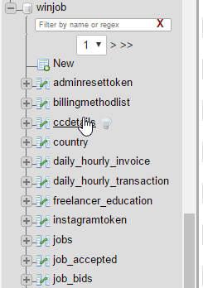

1. **Click ‘SQL’**

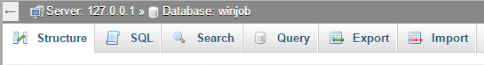

1. **Copy and Paste this.**

|  |
| --- |
| DROP TABLE IF EXISTS `job_bid_attachments`;  CREATE TABLE IF NOT EXISTS `job_bid_attachments` (  `id` int(11) NOT NULL AUTO_INCREMENT,  `job_bid_id` int(11) NOT NULL,  `path` mediumtext,  `tid` int(11) NOT NULL,  PRIMARY KEY (`id`)  ) ENGINE=MyISAM DEFAULT CHARSET=latin1 AUTO_INCREMENT=3 ;  --  -- Contenu de la table `job_bid_attachments`  --  INSERT INTO `job_bid_attachments` (`id`, `job_bid_id`, `path`) VALUES  (1, 18, '/uploads/1472539190866726.jpg'),  (2, 82, '/uploads/147984392568749.png'); |

1. **Click ‘GO’**

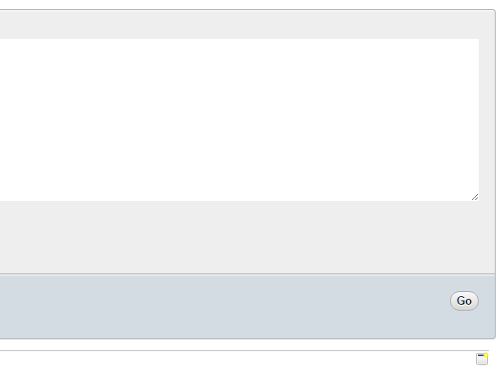

1. **Click your database. ‘Winjobx’ mine is (winjob)**

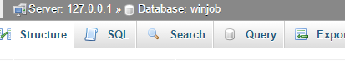

1. **The job_bid_attachment table should now be available.**

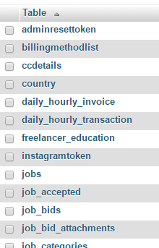

1. **If you click on the job_bid_attachments table. It should look like this now.**

