Richard Carmona HTML Spring 2018 Assignment #2

**Part 1: Answer the 7 questions** below, covering the "Links" video, by selecting the correct answer and **bolding and changing its text highlight color to yellow just like this text!** …

1. What HTML tag is used in the video to create links?…

a) <nav> b) <link> c) <a> d) <www> e) <http>

2. In the video, the links that go to Google and Dog Pile are surrounded by what tag?

a) <ul> b) <li> c) <dd> d) <dt> e) <nav>

3. Links that are supposed to launch an email when clicked are created in HTML by placing what characters at the start of the link's “href” value?

a) email- b) email-to- c) mail: d) mailto: e) send:

4. How many actual working links are there in the “links.htm” page when shown in the video around the 7th minute?

a) 0 b) 1 c) 2 d) 5 e) 10

5. How many actual working links are there in the “links.htm” page at the very end of the video?

a) 0 b) 5 c) 9 d) 12 e) 15

6. Which one of the following links would actually work to get to the web site ebay?

a) <a href=ebay.com>ebay</a>

b) <a href=”#ebay.com”>ebay</a>

c) <a href=”www.ebay.com”>ebay</a>

d) <a href=”http://www.ebay.com”>ebay</a>

e) <a href=”mailto:www.ebay.com”>ebay</a>

7. How many email links (links that will initiate an email when clicked) are there within the completed “links.htm” page (at the end of the video)?

a) 0 b) 1 c) 2 d) 3 e) 5

**Part 2: Your Favorite Links Web Page Screenshot**

[Paste your part 2 screenshot here. Use 2 screenshots if necessary to show the whole favorite links page. Then move to the next page below to paste your HTML code.]

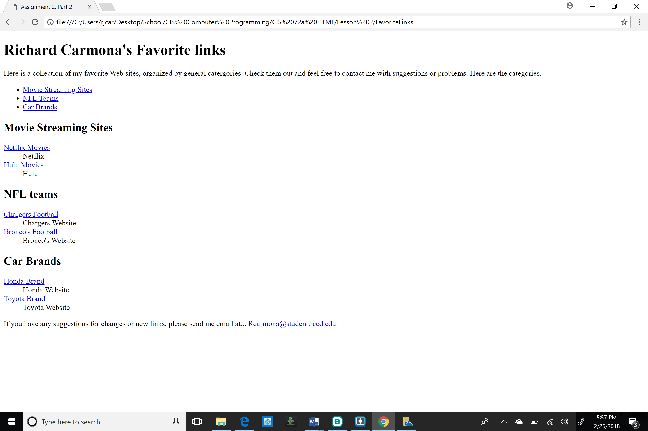

**Part 2: Your Favorite Links Web Page Code**

[Paste your Links page Code below – Be sure to paste ALL of the HTML code for the page. Use “Courier New” or another monospace font to make your code more readable. Bold the code too if that helps make it more readable. Then move on to the next page below for part 3.]

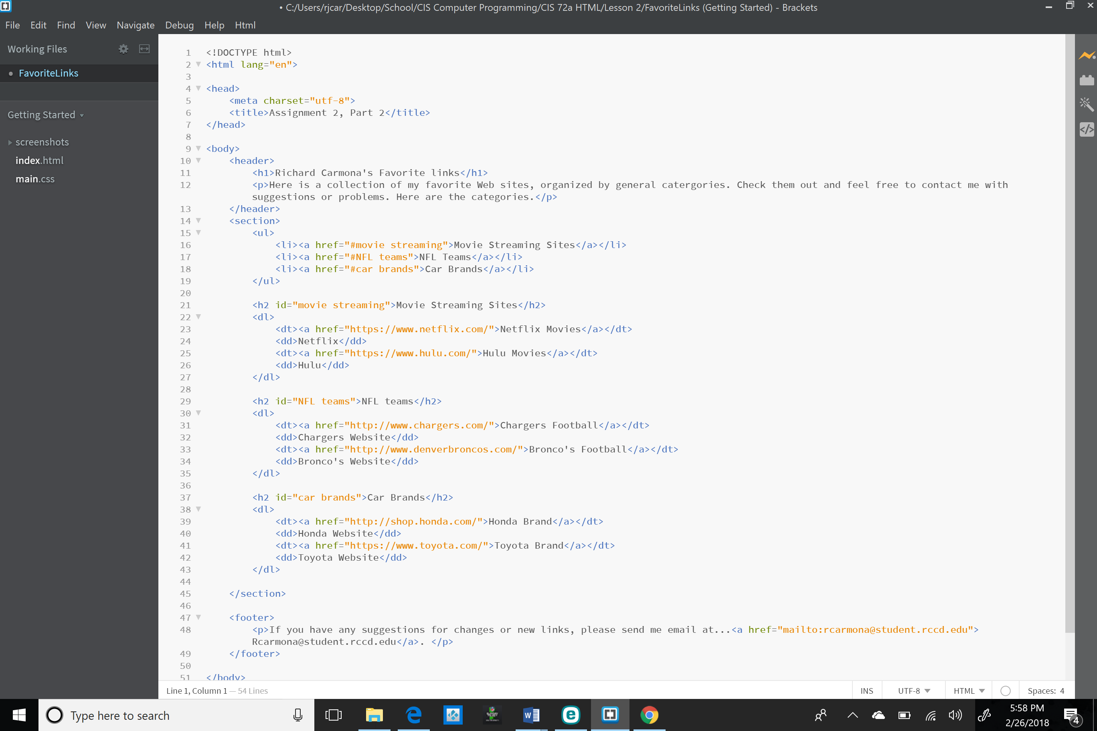

**Part 3: Your Rock Climbing Web Page Screenshot**

[Paste your part 3 screenshot here. Use 2 screenshots if necessary to show the whole rock climbing page. Then move to the next page below to paste your HTML code.]

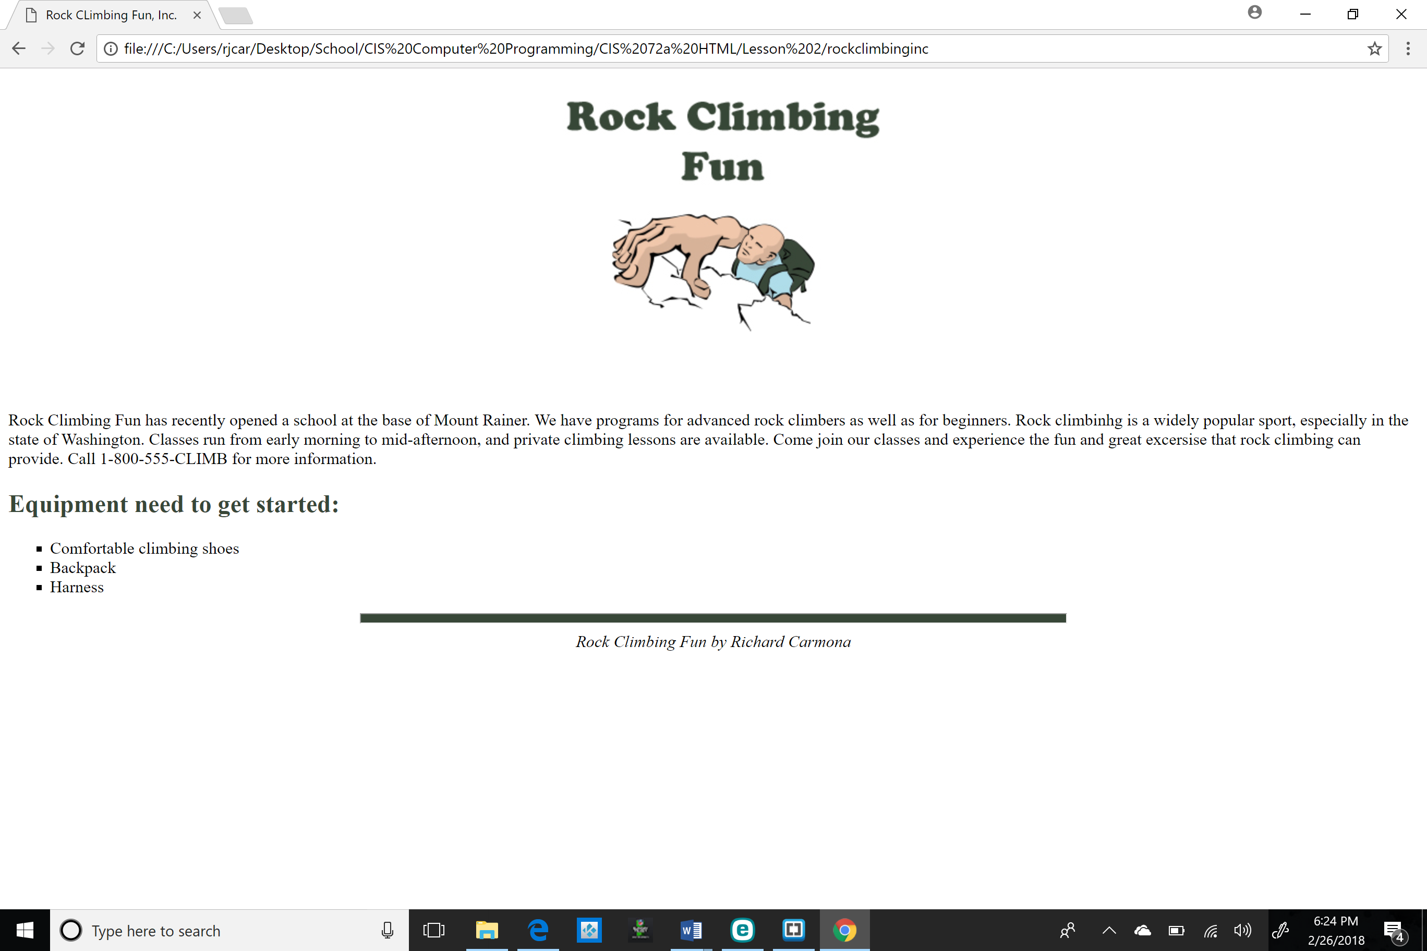

**Part 3: Your Rock Climbing Web Page Code**

[Paste your rock climbing page Code below – Be sure to paste ALL of the HTML code for the page. Use “Courier New” or another monospace font to make your code more readable. Bold the code too if that helps make it more readable. ]

