Richard Carmona HTML Spring 2018 Assignment #5

**Part 1 Screenshot: Your “Feedback Form Page” in the browser (after the HTML 5 Forms YouTube Video)**

[Paste your part 1 Feedback form page screenshot here. Use 2 screenshots if necessary to show the whole page.]

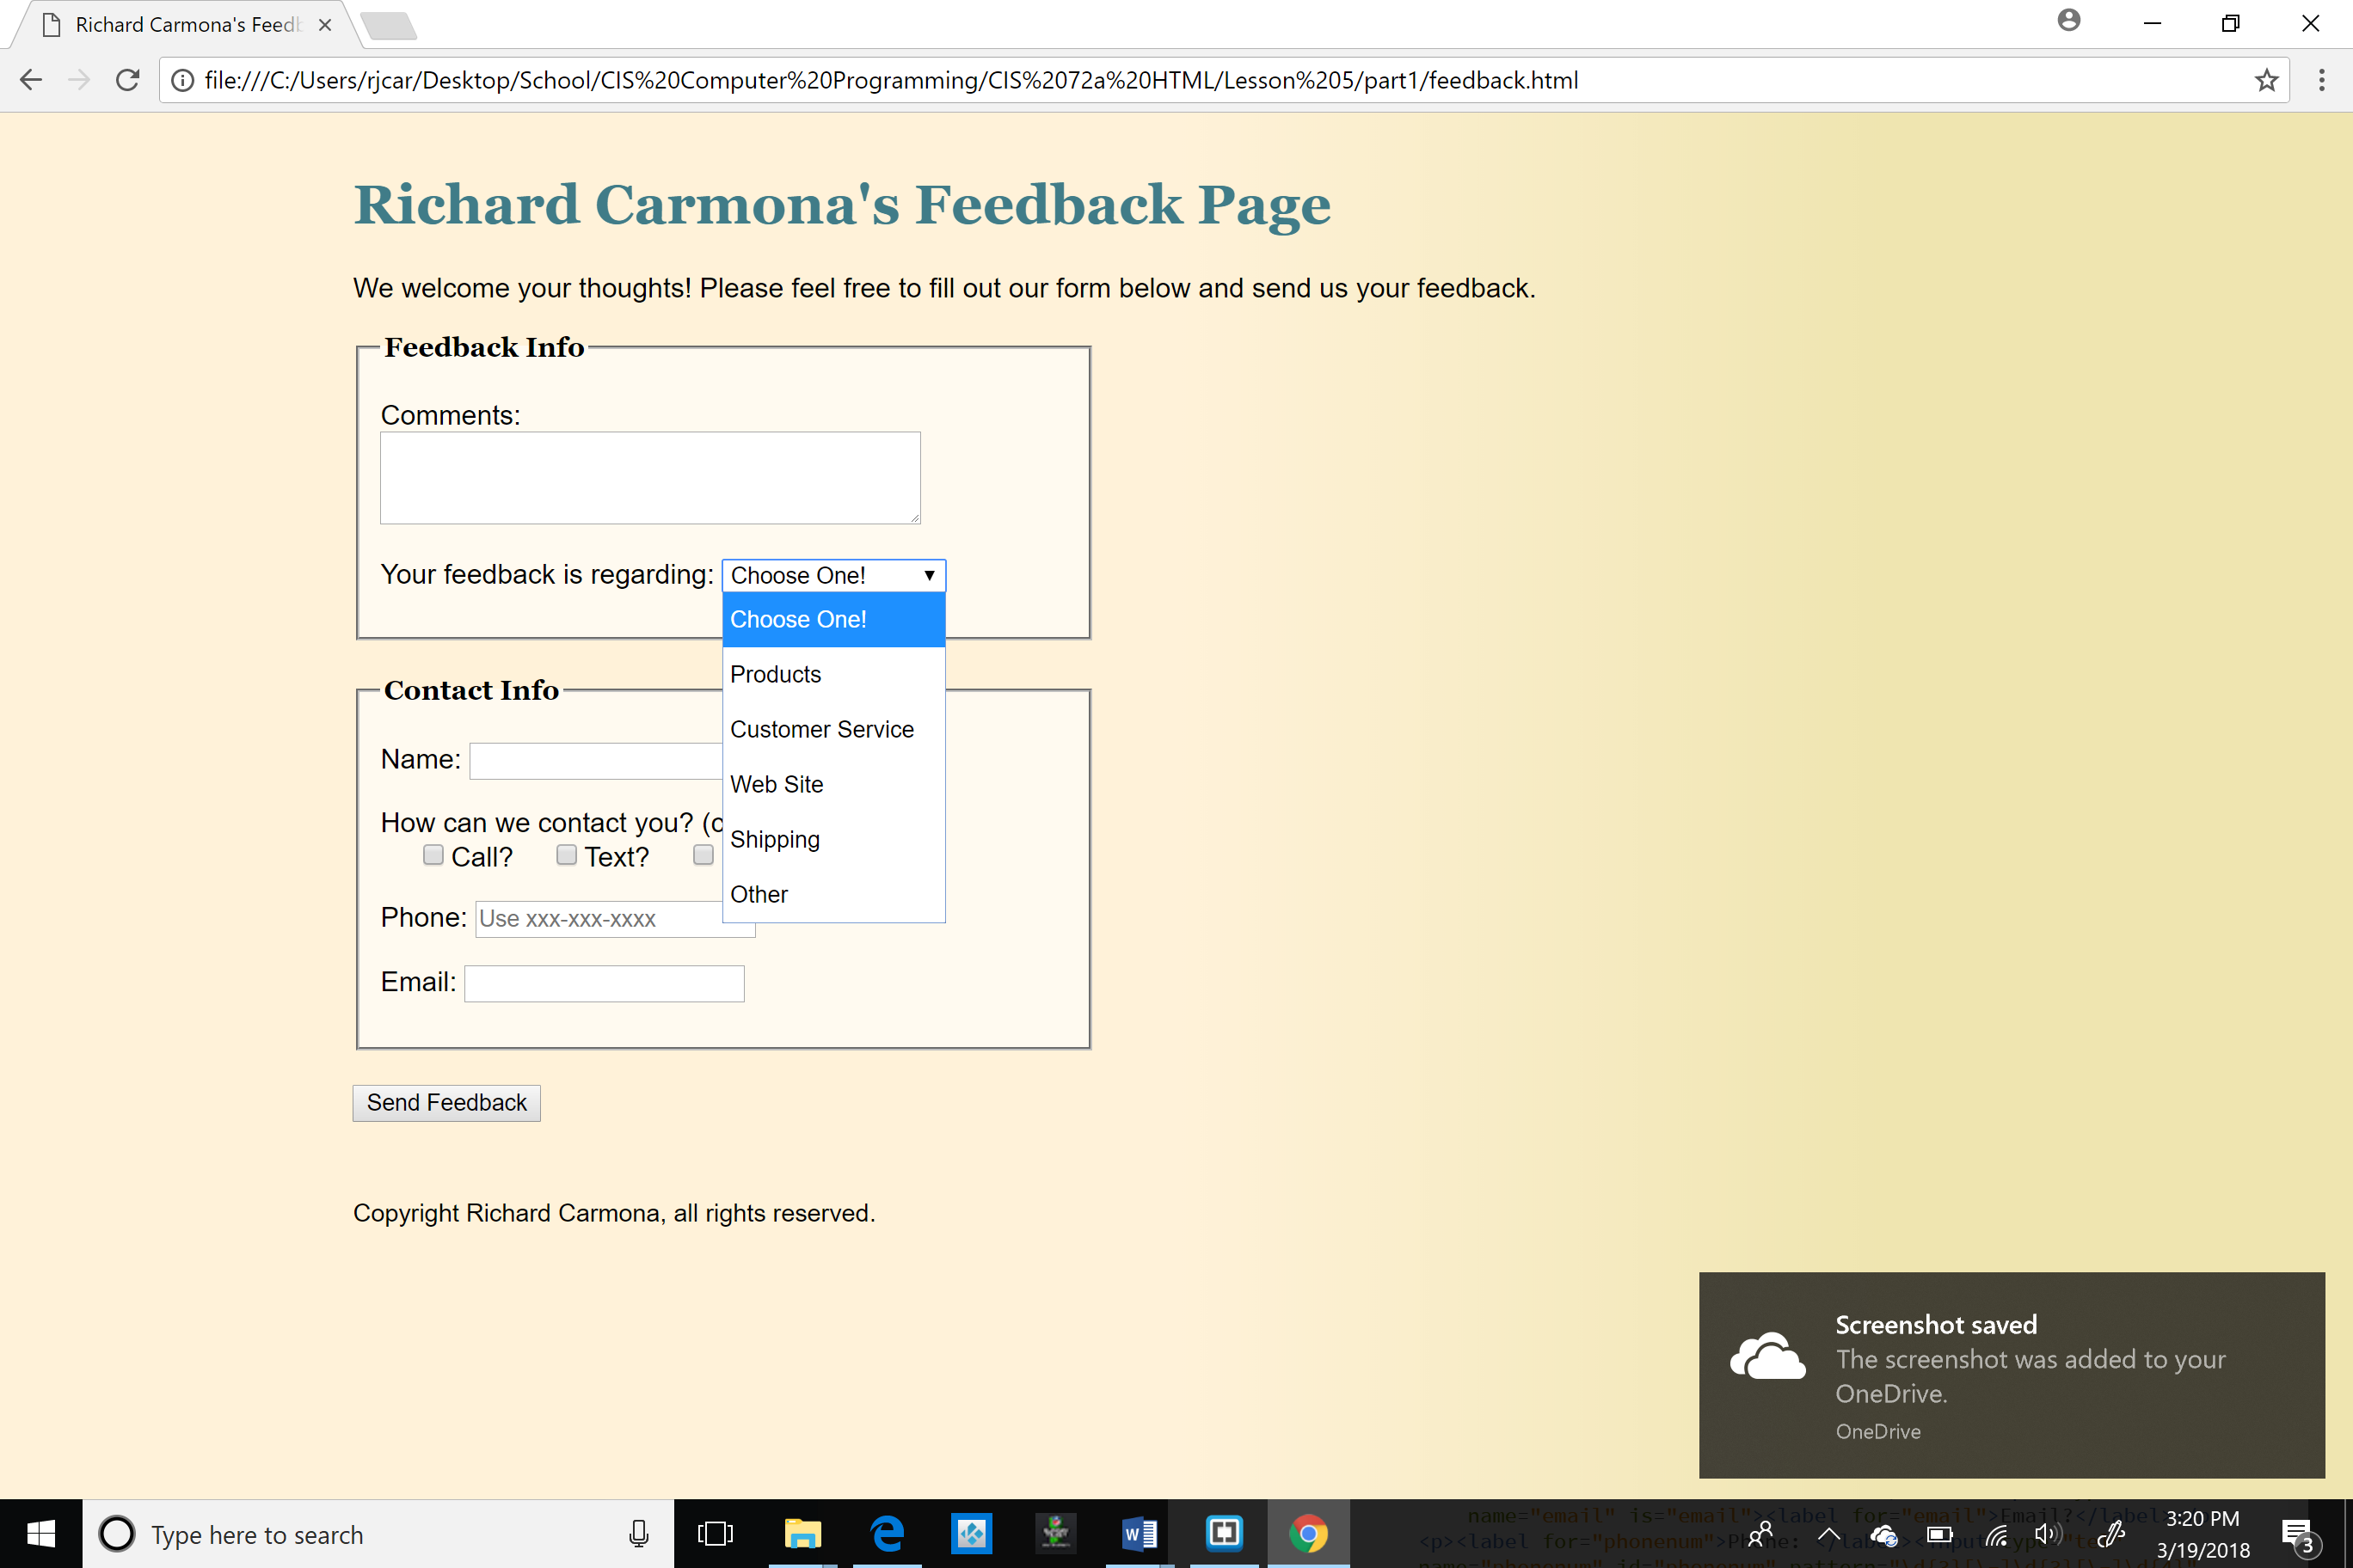

**Part 1 HTML Code: Your “feedback.html” HTML 5 Forms Feedback form page HTML Code**

[Paste your “feedback.html” HTML Code below – Be sure to paste ALL of the HTML code for the file. Use “Courier New” or another monospace font to make your code more readable. Bold the code too if that helps make it more readable. ]

<!DOCTYPE html>

<html lang="">

<head>

<meta charset="utf-8">

<title>Richard Carmona's Feedback Page</title>

<link rel="stylesheet" href="site.css">

<link rel="stylesheet" href="form.css">

</head>

<body>

<header>

<h1>Richard Carmona's Feedback Page</h1>

</header>

<p>We welcome your thoughts! Please feel free to fill out our form below and send us your feedback. </p>

<form action="response.html" method="get">

<fieldset id="feedbackinfo">

<legend>Feedback Info</legend>

<p><label for="comments">Comments: </label><textarea rows="3" cols="40" name="comments" id="comments" required="required"></textarea></p>

<p><label for="re">Your feedback is regarding: </label>

<select name="re" id="re">

<option value="none">Choose One!</option>

<option value="products">Products</option>

<option value="cust-serv">Customer Service</option>

<option value="site">Web Site</option>

<option value="shipping">Shipping</option>

<option value="other">Other</option>

</select>

</p>

</fieldset>

<fieldset id="contactinfo">

<legend>Contact Info</legend>

<p><label for="name">Name: </label><input type="text" name="name" id="name"></p>

<p>How can we contact you? (check all the apply)<br>

<input type="checkbox" name="call" id="call"><label for="call">Call?</label><input type="checkbox" name="text" is="text"><label for="text">Text?</label><input type="checkbox" name="email" is="email"><label for="email">Email?</label></p>

<p><label for="phonenum">Phone: </label><input type="tel" name="phonenum" id="phonenum" pattern="\d{3}[\-]\d{3}[\-]\d{4}" placeholder="Use xxx-xxx-xxxx"></p>

<p><label for="emailaddy">Email: </label><input type="email" name="emailaddy" id="emailaddy"></p>

</fieldset>

<p><input type="submit" value="Send Feedback"></p>

</form>

<footer>

<p>Copyright Richard Carmona, all rights reserved.</p>

</footer>

</body>

</html>

**Part 2 Screenshot: Your “Blue Wav Music” form page displaying in the browser.**

[Paste your part 2 “Blue Wav Music” form page screenshot here. Use 2 screenshots if necessary to show the entire page.]

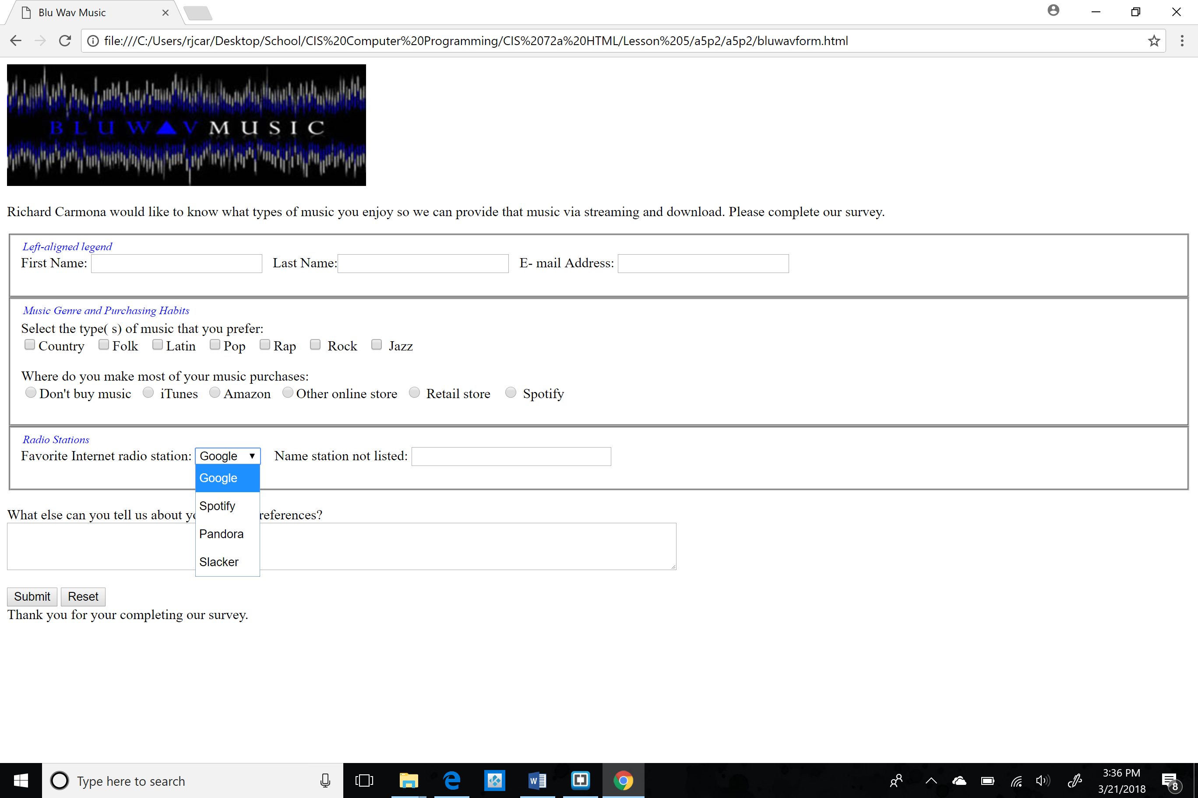

**Part 2 HTML Code: Your “Blue Wav Music” form page HTML Code:**

[Paste your “Blue Wav Music” page (“bluwavform.html”) HTML Code below – Be sure to paste ALL of the HTML code for the page – it is ok if it takes several pages. Use “Courier New” or another monospace font to make your code more readable. Bold the code too if that helps make it more readable. ]

<!DOCTYPE HTML>

<html>

<head>

<meta charset="utf-8" />

<title>Blu Wav Music</title>

<style type="text/css">

<!-- legend {

float: left;

color: #0000fe;

font-style: italic;

font-size: small;

}

-->

</style>

</head>

<body>

<form method="post" action="mailto:bluwav@isp.com">

<header>

<td><img src="bluwavlogo.jpg" width="410" height="139" alt="Blu Wav logo" /></td>

</header>

<p> Richard Carmona would like to know what types of music you enjoy so we can provide that music via streaming and download. Please complete our survey.</p>

<fieldset>

<legend align="left">Left-aligned legend</legend>

<p> First Name: <input name="firstname" type="text" size="25" />&nbsp;&nbsp; Last Name:<input name="lastname" type="text" size="25" />&nbsp;&nbsp; E- mail Address: <input name="email" type="text" size="25" /></p>

</fieldset>

<fieldset>

<legend>Music Genre and Purchasing Habits</legend>

<br/> Select the type( s) of music that you prefer:

<br/><input name="musictype" type="checkbox" value="country" />Country &nbsp;

<input name="musictype" type="checkbox" value="folk" />Folk &nbsp;

<input name="musictype" type="checkbox" value="latin" />Latin &nbsp;

<input name="musictype" type="checkbox" value="pop" />Pop &nbsp;

<input name="musictype" type="checkbox" value="rap" />Rap &nbsp;

<input name="musictype" type="checkbox" value="rock" /> Rock &nbsp;

<input name="musictype" type="checkbox" value="jazz" /> Jazz &nbsp;

<p> Where do you make most of your music purchases:

<br/><input name="purchases" type="radio" value="none" />Don't buy music&nbsp;

<input name="purchases" type="radio" value="itunes" /> iTunes&nbsp;

<input name="purchases" type="radio" value="amazon" />Amazon&nbsp;

<input name="purchases" type="radio" value="online" />Other online store&nbsp;

<input name="purchases" type="radio" value="retail" /> Retail store &nbsp;

<input name="purchases" type="radio" value="spotify" /> Spotify &nbsp;

</p>

</fieldset>

<fieldset>

<legend>Radio Stations</legend>

<p>Favorite Internet radio station:

<select name="Station">

<option>Google</option>

<option>Spotify</option>

<option>Pandora</option>

<option>Slacker</option>

</select> &nbsp; &nbsp;Name station not listed:

<input name="additstation" type="text" size="30" maxlength="30" /></p>

</fieldset>

<br/>What else can you tell us about your music preferences?

<br/><textarea name="other" rows="3" cols="100"></textarea>

<p><input type="submit" value="Submit" />

<input type="reset" value="Reset" />

<br/>Thank you for your completing our survey.</p>

</form>

</body>

</html>