Praxis
A GenAI course studio for software engineering education
COMP5241 Software Engineering · Group project · 20 October 2026 · github.com/Rjiang12138/comp5241-project1
Why we built it
Students meet software engineering as a list of definitions. In the same week they meet a coding agent that can produce a working app in an afternoon, and the two things do not connect. Praxis is our attempt to connect them: a studio where an instructor turns a topic or their own lecture deck into a short course that makes students practise the part the agent cannot do for them. Framing a requirement, reviewing a diff, defending a design decision.
What it does
An instructor writes a brief, picks an audience and a time budget, and gets a five-module draft. Each module is assigned an activity format: reading, stakeholder simulation, code lab, design-review role play, quiz. The instructor edits, reorders or deletes anything. A panel on the right records what the generator did, step by step, so the draft can be argued with instead of accepted.
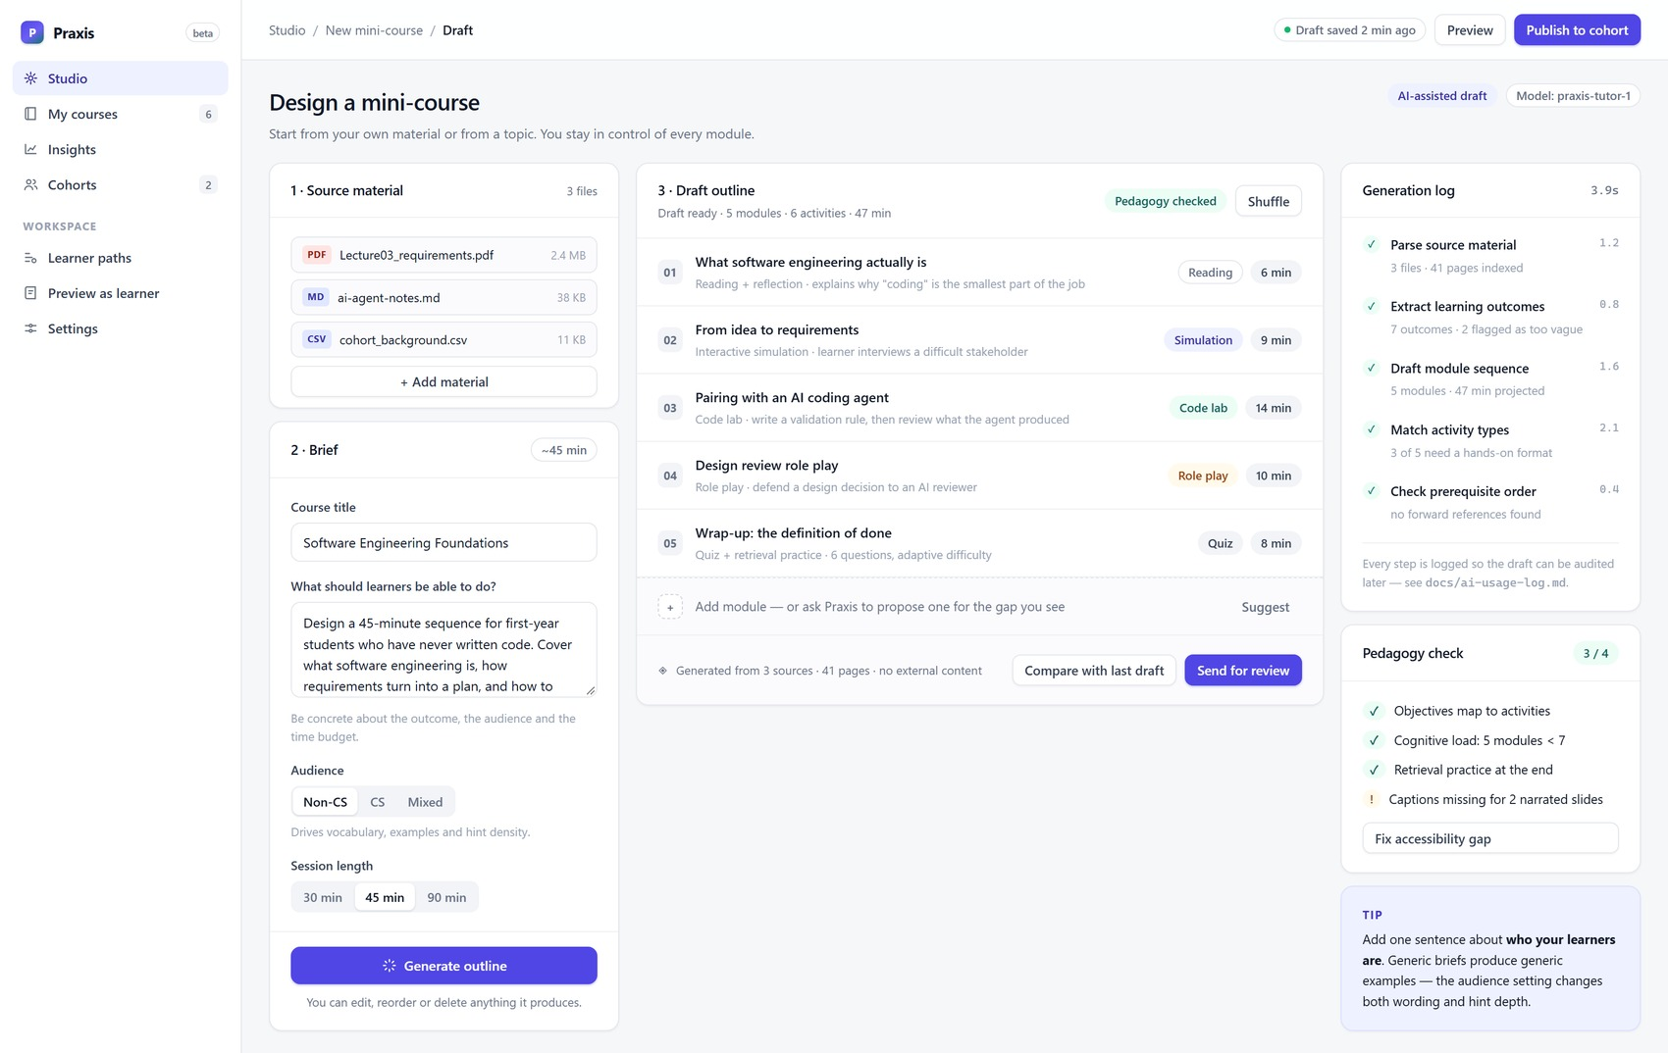
The studio. Brief and audience on the left, an editable draft in the middle, the generator's log and a pedagogy check on the right.
What is different
1. Three registers, one source. The same module is written three ways: an analogy-first version for a business student, a version built on contracts and invariants for a CS graduate, and a formal one. It is a switch inside the lesson, not three separate courses.
2. Paths from a goal. A learner says what they want to be able to do and how many hours a week they have. The platform sequences what already exists, generates what does not, and gives a reason for each step.
3. Generation you can audit. Five logged steps, the sources it read, and a comparison with the previous draft. The log exists because a draft that arrives complete is very hard to argue with.
Where we are
Six screens, clickable, plain HTML, CSS and JavaScript with no build step. It runs from a file on any laptop, which is how we demo it. Students work through a module inside a player; the code lab starts with a failing test, a hint that only appears after one failed attempt, and a tutor that answers from the course material and says which lecture it came from.
Nothing is deployed yet; the backend is weeks 9 to 11. We are not building the mini-game or the AI-narrated slides this time. Both were on the format menu and both cost more to make convincing than they return, so we would rather finish five activity formats properly.
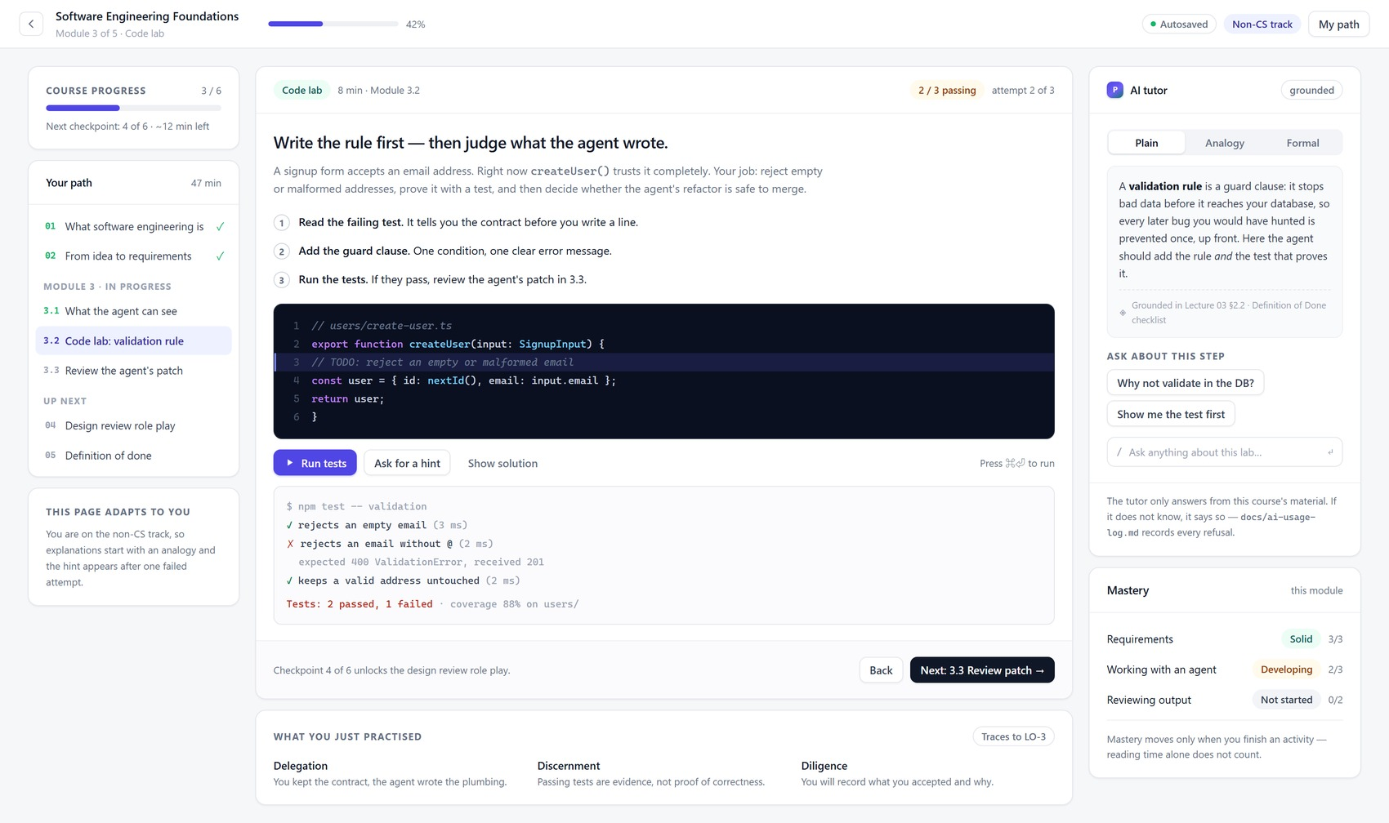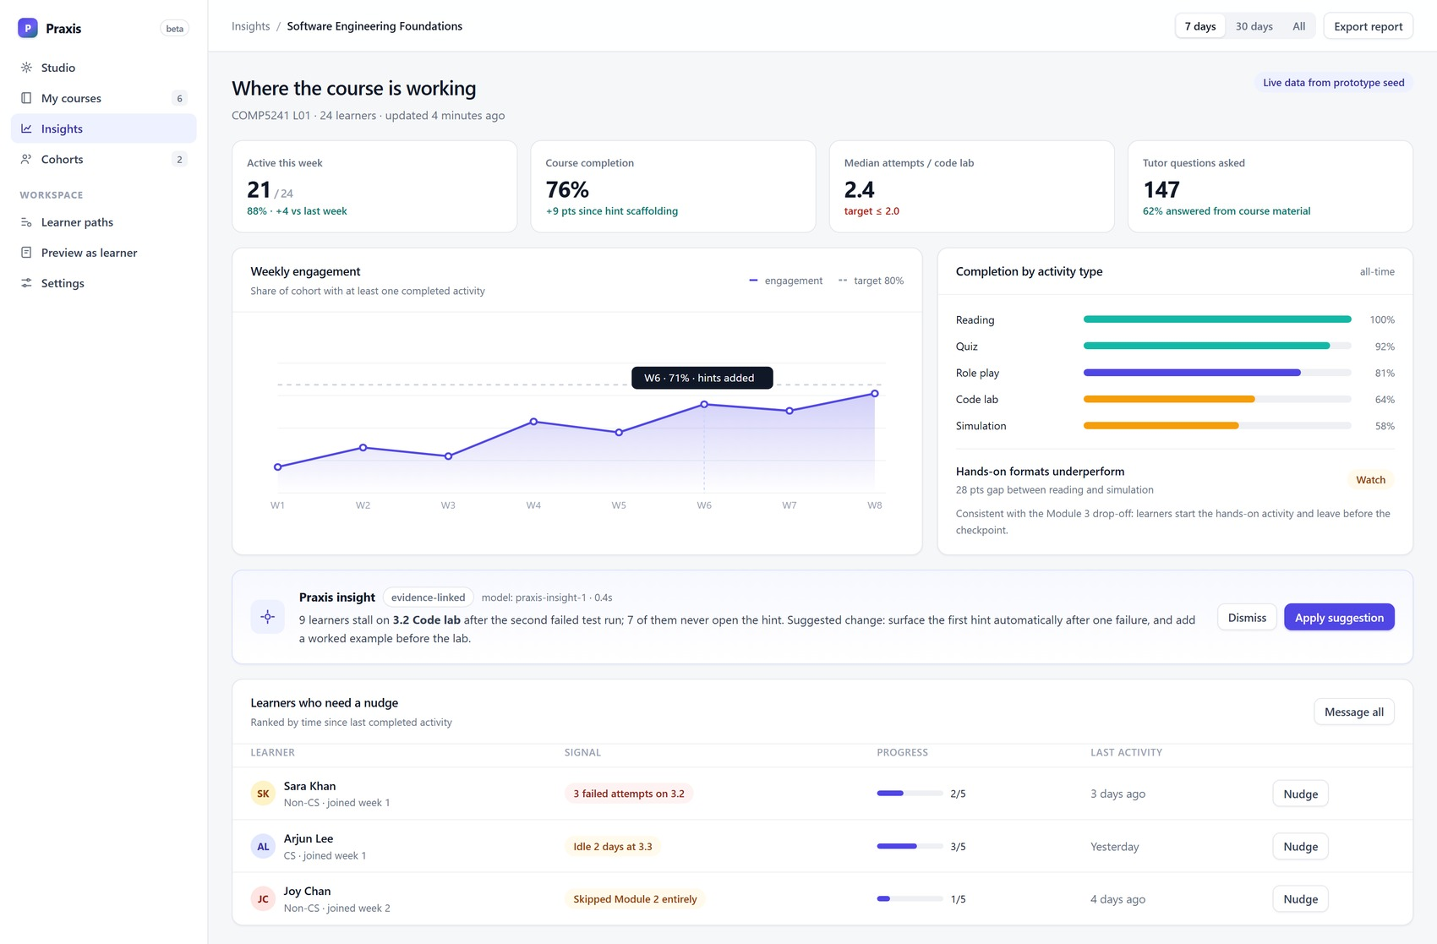
The code lab, left: two of three tests pass on the first attempt, by design. Insights, right: completion by activity type and one recommended change.
What happens next
Week 9: authentication, database schema, deployment and the generation pipeline, so a real course can be produced and saved.
Week 10: the code lab with real execution, the instructor editor, and analytics computed from real event data rather than seeded numbers.
Week 11: features freeze, public deployment, the five-minute demo video, the report, three user manuals and the slides.
All screens are static and seeded with prototype data. Repository: github.com/Rjiang12138/comp5241-project1 · Prototype: prototype/index.html

