Evaluating the Financial and Economic Impact of
USAID SME-Related Assistance
Using Country-Level Economic Measures
Final Business Analytics Project Report
Group 3: Reshon Johnson, Laila Harris, Wayne Harrell
Management Science / Business Analytics Project
April 28, 2026

Table of Contents
Executive Summary
List of Figures
List of Tables
1. Introduction
1.1 General Overview of the Contents
1.2 Motivation
1.3 Goals
1.4 Company Background
2. Problem Definition
2.1 Business Problem
2.2 Decision Problem
2.3 Analytical Problem
2.4 Challenges
3. Literature Review
4. Approach / Methodology
5. Data Collection & Analysis
6. Implementation
7. Results and Analysis
8. Project Evaluation
8.1 Project Outcomes
8.2 Contribution to Company
8.3 Contribution to Student
8.4 Performance of Team
9. Conclusion
References
10. Appendix

List of Figures
Figure 1. USAID SME-Related Disbursements by Sample Country, 2021-2024
Figure 2. Pairwise Correlations with GDP Growth

List of Tables
Table 1. Executive Summary of Findings
Table 2. Scope Transition and Rationale
Table 3. Analytical Challenges and Controls
Table 4. Core Data and Analytical Variables
Table 5. Results Summary
Table 6. Project Evaluation Summary

Executive Summary
This report evaluates whether USAID SME-related assistance is associated with measurable country-level economic outcomes. The initial proposal aimed to identify the most effective individual SME loans; however, the project was refined into a country-year economic impact study because borrower-level outcome records were not consistently available in the public datasets used for the project.
The analysis uses publicly available sources of foreign assistance and economic measures, including ForeignAssistance.gov, USAspending.gov, IATI-related USAID reporting, and World Bank GDP data. The working sample covered fiscal years 2021 through 2024 and included 215 transaction rows, 36 country-year observations, and 27 country-year observations with GDP growth available.
Item | Summary
Business question | Is USAID SME-related assistance associated with improved country-level economic outcomes over time?
Unit of analysis | Country-year observations, with USAID assistance aggregated by country and year.
Main descriptive finding | Funding varied substantially across the sample. Ukraine, Egypt, and Jordan had the largest total disbursements.
Main statistical finding | The regression model did not produce strong evidence that USAID SME-related disbursements alone predict GDP growth.
Practical conclusion | The analysis is most useful as a monitoring and decision-support framework, not as proof of causal impact.
Table 1. Executive Summary of Findings

1. INTRODUCTION

1.1 General Overview of the Contents
This report presents the completed business analytics project conducted by Group 3. It defines the business problem, connects the problem to peer-reviewed literature, describes the methodology, summarizes the data collection and cleaning process, presents the results, and evaluates the project outcomes. The report follows the final-project structure required by the Management Science / Business Analytics project guide.

1.2 Motivation
Small and medium enterprises play a significant role in employment, entrepreneurship, local production, and private-sector development. In developing markets, SMEs frequently face limited access to affordable financing, high collateral requirements, incomplete financial records, and other barriers that restrict growth. Consequently, USAID and similar development agencies require practical methods to evaluate whether SME-related assistance is linked to measurable economic outcomes.

1.3 Goals
- Organize USAID SME-related assistance by country and year.
- Compare assistance levels with selected country-level economic measures.
- Apply descriptive, correlation, and regression analysis to identify patterns.
- Provide a feasible framework for future monitoring and decision support.

1.4 Company Background
The organization examined in this project is the United States Agency for International Development, commonly referred to as USAID. USAID has historically supported international development programs focused on economic growth, private-sector development, enterprise support, and related objectives. This project evaluates USAID-related assistance using public foreign assistance and country-level economic datasets.
Original Proposal Focus | Final Report Focus | Reason for Change
Predict which individual SME loans would succeed. | Evaluate country-year relationships between SME-related USAID assistance and economic indicators. | Borrower-level outcome records were not consistently available.
Use firm-level outcomes such as revenue growth, job creation, and community impact. | Use measurable country-level indicators such as GDP, GDP growth, obligations, disbursements, and execution rate. | Country-year indicators could be merged across sources.
Build a predictive loan approval model. | Build a monitoring and decision-support framework. | The revised scope better matched the available data and course timeline.
Table 2. Scope Transition and Rationale

2. PROBLEM DEFINITION

2.1 Business Problem
The business problem is that USAID distributes resources to SME-related development assistance, but the measurable economic effect of that assistance is not always clear from public data. The final research question is: Is USAID SME-related assistance associated with improved country-level economic outcomes over time?

2.2 Decision Problem
The decision problem is whether USAID and similar agencies can use public assistance and macroeconomic data to support better resource allocation. If consistent relationships appear in the data, decision-makers can identify countries, sectors, or funding patterns that may warrant deeper investment or evaluation. If relationships are weak, the agency may need more targeted project-level performance measures.

2.3 Analytical Problem
The analytical problem is attribution. GDP growth is influenced by domestic policy, inflation, trade, conflict, commodity prices, private investment, and global macroeconomic conditions. Because USAID SME-related funding is small relative to total GDP, the analysis cannot reasonably claim that funding directly causes country-level growth.

2.4 Challenges
Challenge | Effect on Analysis | Project Response
Borrower-level data limitations | Limited ability to predict individual SME loan success. | Shifted to country-year analysis using accessible public data.
Attribution problem | GDP growth cannot be tied solely to USAID assistance. | Used cautious language and treated results as associative.
Small sample size | Only 27 country-year observations had GDP growth available. | Used descriptive analysis and regression as exploratory tools.
Timing of impact | SME assistance may affect outcomes after a delay. | Recommended lagged models for future research.
Table 3. Analytical Challenges and Controls

3. LITERATURE REVIEW
The literature supporting this project is organized around four areas: SME financing constraints, public financial support and SME growth, foreign aid and country-level economic outcomes, and business analytics decision support.

3.1 SME Financing Constraints and Financial Inclusion
Research on SME finance consistently finds that small and medium enterprises encounter greater barriers to external finance compared to larger firms. These barriers include collateral requirements, complex application procedures, inconsistent recordkeeping, limited business experience, and institutional constraints. Thathsarani, Jianguo, and Alariqi (2023) provide useful support by identifying demand-side, supply-side, and institutional factors that influence SME financial inclusion in developing countries. Their findings support the assumption that SME-related assistance should be evaluated within a broader financial inclusion and development framework.
The Albania article is useful as background because it describes SMEs as contributors to employment, value added, and economic activity. However, because it is descriptive and country-specific, it is treated as a supporting source rather than a core source.

3.2 Public Financial Support and SME Growth
Boccaletti, Ferrando, Rossi, and Rossolini (2025) provide the strongest connection between the original project idea and the revised project design. Their study examines the role of market-based finance and public financial support in European SME growth. They find that prior use of public support is associated with access to market-based finance and that access to market-based finance is associated with later firm growth. This supports the idea that public or development-oriented assistance may help SMEs not only through direct funding, but also by reducing financing barriers and signaling firm potential to outside investors.

3.3 Foreign Aid and Country-Level Economic Outcomes
The aid effectiveness literature is important because this project compares USAID SME-related assistance with country-level GDP growth. Igbinovia, Odengha, and Umoru (2024) show that official development assistance may be positively associated with GDP growth in Nigeria, while also emphasizing that exchange-rate volatility and other macroeconomic conditions can affect the relationship. This supports the cautious interpretation used in this report: aid may matter, but the aid-growth relationship is complex and should not be interpreted as simple causation.

3.4 Business Analytics and Decision Support
Business analytics contributes to this project by transforming fragmented public records into an organized framework for monitoring and decision-making. The primary value of the project lies not in constructing a perfect causal model, but in demonstrating how USAID-related funding records can be organized, compared, and tested against public economic indicators to support more focused evaluation questions in the future.

4. APPROACH / METHODOLOGY
The project uses a quantitative country-level business analytics approach. The unit of analysis is the country-year. USAID SME-related assistance is aggregated by country and year and compared with GDP growth and related economic indicators. The method includes descriptive analysis, correlation analysis, and ordinary least squares regression.

4.1 Analytical Design
- Identify SME-related USAID funding records.
- Filter records to relevant sectors and countries.
- Aggregate disbursements and obligations by country and fiscal year.
- Merge GDP and GDP growth data by country and year.
- Calculate execution rate, USAID Spending % GDP, and annual change measures.
- Evaluate patterns using descriptive statistics, correlations, and regression.
Variable / Metric | Role in Analysis | Definition
Disbursements | Independent variable | Funds actually spent or delivered in the fiscal year.
Obligations | Independent variable | Funds legally committed in the fiscal year.
Execution Rate | Calculated metric | Disbursements divided by obligations.
USAID Spending % GDP | Calculated metric | Disbursements divided by country GDP.
GDP Growth % | Dependent variable | Annual percentage change in country-level GDP.
Disbursement Change % | Calculated metric | Year-over-year percentage change in disbursements.
Table 4. Core Data and Analytical Variables

5. DATA COLLECTION & ANALYSIS
Data collection focused on combining USAID SME-related assistance data with country-level economic indicators. The source list included ForeignAssistance.gov, USAspending.gov, IATI-related USAID reporting, World Bank Open Data, ILOSTAT, UN Data, and IMF Data. The working dataset used the variables that were most consistently available across the selected countries and years.

5.1 Dataset Scope
- Analysis years: 2021-2024.
- Transaction rows analyzed: 215.
- Country-year rows analyzed: 36.
- Rows with GDP growth available: 27.
- Sample countries: Bangladesh, Chile, Colombia, Egypt, Georgia, Jordan, Niger, Papua New Guinea, and Ukraine.

5.2 Data Quality and Cleaning
The data was filtered to include sectors directly related to SME activity. The country and year fields were standardized to enable merging USAID assistance data with World Bank GDP indicators. Missing GDP values were left blank rather than estimated. Negative funding values were retained when they appeared to represent de-obligations, corrections, or returned funds rather than data errors.

6. IMPLEMENTATION
Implementation began by narrowing the project scope and aligning available data with a measurable research question. Relevant sectors were selected, funding data was filtered, countries were chosen, GDP measures were merged, and core metrics were calculated. This workflow produced a country-year dataset suitable for descriptive statistics, correlation analysis, and regression modeling.
Implementation Note
The implementation was successful for an exploratory analytics project. The main limitation is not the workflow, but the level of available data. Public country-year data can identify broad patterns, but it cannot fully measure individual SME loan success or project-level outcomes.

7. RESULTS AND ANALYSIS

7.1 Descriptive Results
The descriptive results indicate substantial differences in total disbursements across countries. Ukraine received the largest amount in the sample, followed by Egypt and Jordan. Several countries, including Chile, Colombia, Niger, and Papua New Guinea, had much smaller totals. This variation enhances the utility of cross-country comparisons, but it also makes the sample sensitive to a few high-disbursement observations.
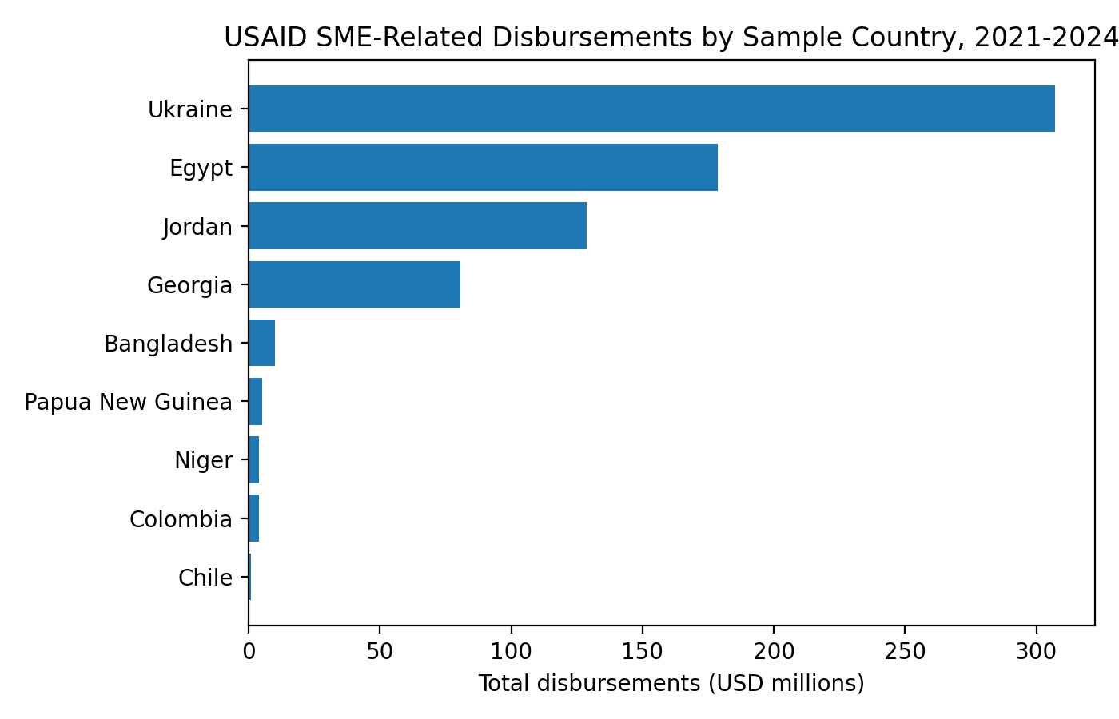
Figure 1. USAID SME-Related Disbursements by Sample Country, 2021-2024

7.2 Correlation Results
The pairwise correlations with GDP Growth % were generally weak. Disbursements exhibited a weak negative correlation with GDP growth (-0.1028), obligations showed almost no correlation (0.0082), execution rate demonstrated a weak positive correlation (0.1368), USAID Spending % GDP had the strongest positive correlation in the group (0.2337), and disbursement change displayed a weak positive correlation (0.1513). These results do not support a strong direct relationship between higher funding levels and higher same-year GDP growth.
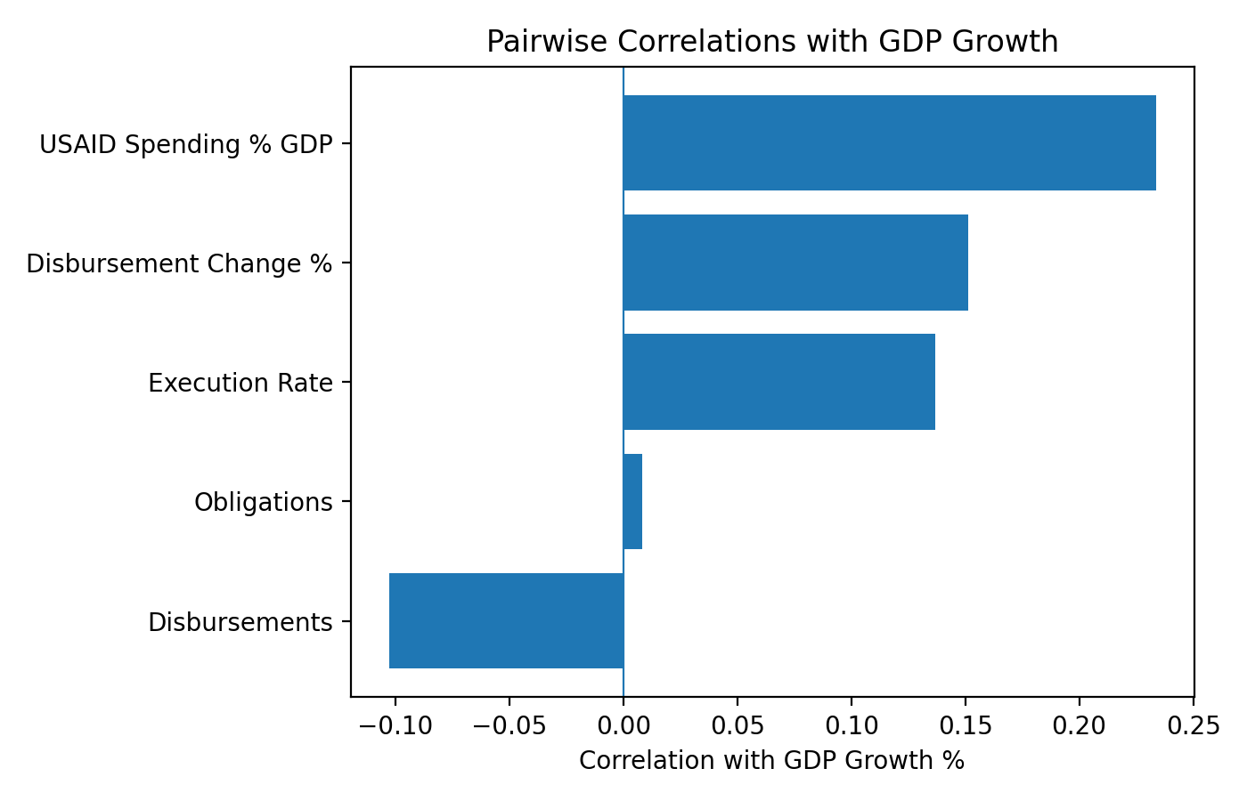
Figure 2. Pairwise Correlations with GDP Growth

7.3 Regression Results
The OLS regression used GDP Growth % as the dependent variable and included log disbursements, log obligations, execution rate, and USAID Spending % GDP as predictors. The model included 27 observations and produced R-squared and adjusted R-squared values of 0.189 and 0.042, respectively. The overall model was not statistically significant at the 0.05 level, with a Prob(F-statistic) of 0.307.
Analysis Area | Result | Interpretation
Country funding totals | Ukraine $307.0M; Egypt $178.7M; Jordan $128.6M | Funding was highly concentrated in a few countries.
Correlation: disbursements and GDP growth | -0.1028 | Weak negative relationship; not evidence of a meaningful direct link.
Correlation: USAID Spending % GDP and GDP growth | 0.2337 | Weak positive relationship and strongest correlation in the set.
Regression model fit | R-squared 0.189; adjusted R-squared 0.042 | Model explained limited variation in GDP growth.
Regression significance | Prob(F-statistic) 0.307 | Overall model was not statistically significant.
Main finding | No strong same-year statistical relationship | Funding may still have value, but GDP growth is too broad and noisy as the only outcome measure.
Table 5. Results Summary

8. PROJECT EVALUATION

8.1 Project Outcomes
The project resulted in a comprehensive analytical workflow, including data collection, cleaning, aggregation, descriptive statistics, correlation analysis, regression modeling, and interpretation. Additionally, a more realistic research design was developed after the original borrower-level approach proved infeasible due to limitations in publicly available data.

8.2 Contribution to Company
The project provides a practical monitoring framework for USAID and similar agencies. It identifies which metrics can be constructed from public data and highlights areas where public data is insufficient for causal evaluation. This framework can assist USAID in determining when country-level monitoring is adequate and when more detailed project-level or borrower-level data is necessary.

8.3 Contribution to Student
The project enhanced skills in problem definition, data cleaning, public data sourcing, variable construction, statistical interpretation, and business communication. It also demonstrated the importance of revising project design when the desired data is unavailable.

8.4 Performance of Team
The team transitioned from the original predictive loan model to a more feasible country-level impact analysis. This adjustment improved the quality of the final project by aligning the research question, data, and methodology.
Evaluation Area | Assessment
Project outcomes | Completed a measurable country-year analysis and produced descriptive, correlation, and regression results.
Contribution to USAID | Created a practical monitoring framework and identified metrics for future evaluation.
Contribution to student | Built experience in analytics, data quality, methodology design, and business writing.
Team performance | Adapted the project scope when data limitations required a more realistic design.
Future improvement | Use lagged models, add control variables, and obtain project-level or borrower-level performance data.
Table 6. Project Evaluation Summary

9. CONCLUSION
This project evaluated whether USAID SME-related assistance is associated with country-level economic outcomes. The analysis identified substantial variation in funding across countries, but found weak correlations and an overall regression model that was not statistically significant. These results do not demonstrate that USAID SME-related assistance lacks value; rather, they indicate that same-year country-level GDP growth is too broad to serve as the sole measure of SME assistance impact.
The most practical value of the project lies in its decision-support framework. The analysis demonstrates how public funding records and economic indicators can be organized, cleaned, merged, and tested. Future evaluations should incorporate lagged effects, additional economic controls, larger samples, and project-level or borrower-level performance data.

References
Ayyagari, M., Beck, T., & Demirgüç-Kunt, A. (2007). Small and medium enterprises across the globe. Small Business Economics, 29, 415-434. https://doi.org/10.1007/s11187-006-9002-5
Beck, T., & Demirgüç-Kunt, A. (2006). Small and medium-size enterprises: Access to finance as a growth constraint. Journal of Banking & Finance, 30(11), 2931-2943.
Beck, T., Demirgüç-Kunt, A., & Levine, R. (2005). SMEs, growth, and poverty: Cross-country evidence. Journal of Economic Growth, 10, 199-229.
Boccaletti, S., Ferrando, A., Rossi, E., & Rossolini, M. (2025). European SMEs' growth: The role of market-based finance and public financial support. Small Business Economics, 64, 691-727. https://doi.org/10.1007/s11187-024-00918-y
Burnside, C., & Dollar, D. (2000). Aid, policies, and growth. American Economic Review, 90(4), 847-868. https://doi.org/10.1257/aer.90.4.847
ForeignAssistance.gov. (n.d.). Foreign assistance data. https://foreignassistance.gov
Hallunovia, A. (2021). The impact of SMEs in the economic growth in Albania. Turkish Online Journal of Qualitative Inquiry, 12(8), 2801-2807.
IATI Registry. (n.d.). USAID publisher data. https://iatiregistry.org/publisher/usaid
Igbinovia, B., Odengha, B., & Umoru, D. (2024). Foreign aid, capital formation and economic growth in Nigeria. Journal of Academic Research in Economics, 16(3), 476-498.
Thathsarani, S., Jianguo, W., & Alariqi, M. (2023). How do demand, supply, and institutional factors influence SME financial inclusion: A developing country perspective. SAGE Open, 13(3), 1-13. https://doi.org/10.1177/21582440231187603
USAspending.gov. (n.d.). Federal award and foreign assistance data. https://www.usaspending.gov
World Bank. (n.d.). GDP (current US$), GDP growth, and country-level development indicators. https://data.worldbank.org

10. APPENDIX

Appendix A. Data Sources
Primary public sources included ForeignAssistance.gov for obligations, disbursements, and project-level foreign assistance data; USAspending.gov for federal award and foreign assistance records; IATI Registry for machine-readable USAID activity-level aid data; and World Bank Open Data for GDP and GDP growth indicators. Supplemental sources considered for future enhancement include ILOSTAT, UN Data, and IMF Data.

Appendix B. Data Dictionary Summary
Key variables included country name, fiscal year, US category, US sector name, transaction type, obligations, disbursements, GDP, continent or region, execution rate, USAID Spending % GDP, and negative transaction flags. These variables supported grouping, merging, calculating metrics, and data quality checks.

Appendix C. Regression Details
OLS regression results: dependent variable = GDP Growth %. Observations = 27. R-squared = 0.189. Adjusted R-squared = 0.042. F-statistic = 1.283. Prob(F-statistic) = 0.307. Predictor p-values were log_disbursements = 0.120, log_obligations = 0.765, Execution Rate = 0.840, and USAID Spending % GDP = 0.054.

Appendix D. Recommended Future Enhancements
- Add lagged variables because SME-related assistance may influence economic outcomes after one or more years.
- Add employment, poverty, business formation, and firm survival measures where available.
- Separate assistance by sector and program type rather than treating all SME-related funding as one category.
- Expand the sample beyond nine countries to improve statistical power.
- Add country-level controls such as inflation, conflict, trade openness, institutional quality, and baseline GDP per capita.
- Seek borrower-level or project-level performance data to return to the original predictive modeling goal.

