Creating Jsonl format with training data:
- Added the input data location that is the sample training data required for creating Jsonl file.
- Added the output location where the Jsonl file will be created after running the code.
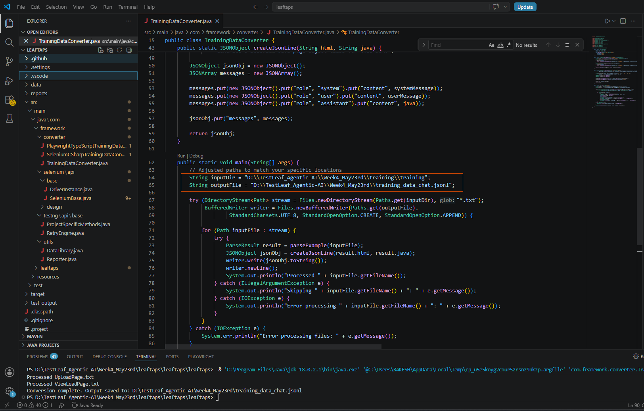

- Model Options by provider is updated in “AI-Extension” :
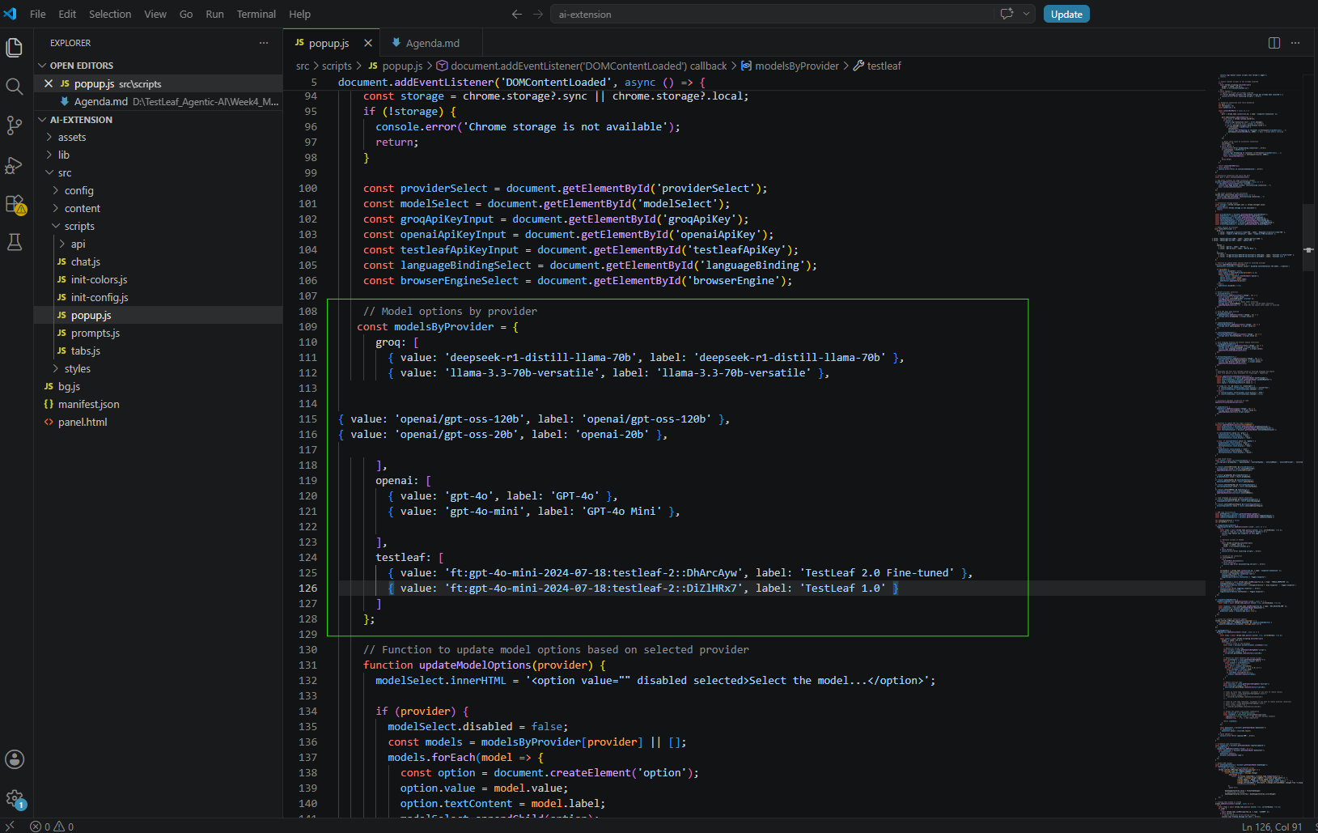
Dataset Uploaded:
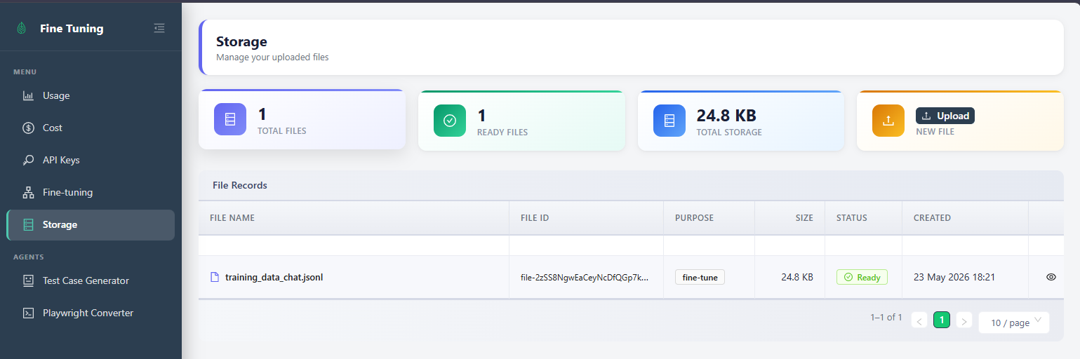
Page class created for https://leaftaps.com/crmsfa
Login: DemoCSR2
Pwd: crmsfa

package com.testleaf.pages;
import org.openqa.selenium.WebElement;
import org.openqa.selenium.support.FindBy;
import org.openqa.selenium.support.PageFactory;

/**
* Page Object representing the Create Lead form.
* Provides methods to interact with the form fields and actions.
*/
public class CreateLeadPage {

/**
* Initializes the CreateLeadPage with the specified driver.
*/
public CreateLeadPage() {
PageFactory.initElements(driver, this);
}

@FindBy(id = "createLeadForm_companyName")
private WebElement companyNameField;

@FindBy(id = "createLeadForm_firstName")
private WebElement firstNameField;

@FindBy(id = "createLeadForm_lastName")
private WebElement lastNameField;

@FindBy(className = "smallSubmit")
private WebElement createLeadButton;

/**
* Enters the company name in the Create Lead form.
*
* @param companyName the company name to enter
* @return the current CreateLeadPage instance
*/
public CreateLeadPage enterCompanyName(String companyName) {
clearAndType(companyNameField, companyName);
reportStep(companyName + " is entered in CompanyName field", "pass");
return this;
}

/**
* Enters the first name in the Create Lead form.
*
* @param firstName the first name to enter
* @return the current CreateLeadPage instance
*/
public CreateLeadPage enterFirstName(String firstName) {
clearAndType(firstNameField, firstName);
reportStep(firstName + " is entered in FirstName field", "pass");
return this;
}

/**
* Enters the last name in the Create Lead form.
*
* @param lastName the last name to enter
* @return the current CreateLeadPage instance
*/
public CreateLeadPage enterLastName(String lastName) {
clearAndType(lastNameField, lastName);
reportStep(lastName + " is entered in LastName field", "pass");
return this;
}

/**
* Clicks the Create Lead button to submit the form.
*
* @return the MyLeadsPage instance after submission
*/
public MyLeadsPage clickCreateLeadButton() {
click(createLeadButton);
reportStep("CreateLead button is clicked", "pass");
return new MyLeadsPage();
}

}

Package class created for Salesforce Login:
package com.testleaf.pages;

import org.openqa.selenium.By;
import org.openqa.selenium.WebElement;
import com.testleaf.selenium.api.design.Locators;
import com.testleaf.selenium.api.design.SeleniumBase;

/**
* Page Object for the Login Page
*/
public class LoginPage extends SeleniumBase {

/**
* Enters the username in the login form.
* @param username The username to enter
* @return The current LoginPage instance
*/
public LoginPage enterUsername(String username) {
clearAndType(locateElement(Locators.ID,"username"), username);
reportStep(username + " username is entered", "pass");
return this;
}

/**
* Enters the password in the login form.
* @param password The password to enter
* @return The current LoginPage instance
*/
public LoginPage enterPassword(String password) {
clearAndType(locateElement(Locators.ID,"password"), password);
reportStep("Password is entered", "pass");
return this;
}

/**
* Clicks the Login button to submit the form.
* @return A new HomePage instance
*/
public HomePage clickLogin() {
click(locateElement(Locators.ID,"Login"));
reportStep("Login button is clicked", "pass");
return new HomePage();
}

/**
* Clicks the Forgot Password link.
* @return The current LoginPage instance
*/
public LoginPage clickForgotPassword() {
click(locateElement(Locators.ID,"forgot_password_link"));
reportStep("Forgot Password link is clicked", "pass");
return this;
}

/**
* Checks if the error message is displayed.
* @return true if the error message is displayed, false otherwise
*/
public boolean verifyErrorMessage() {
WebElement errorMessage = locateElement(Locators.XPATH,"//div[@id='error']");
return errorMessage.isDisplayed();
}

/**
* Gets the error message text.
* @return The error message text
*/
public String getErrorMessageText() {
return getElementText(locateElement(Locators.XPATH,"//div[@id='error']"));
}

}

