Software Requirements Specification
for
Equipment Maintenance System
Version 1.0 approved
Prepared by Rinkal Singh
Niit University
30-August 2018
Table of Contents
Table of Contents ii
Revision History ii
1. Introduction 1
1.1 Purpose 1
1.2 Document Conventions 1
1.3 Intended Audience and Reading Suggestions 1
1.4 Product Scope 1
1.5 References 1
2. Overall Description 2
2.1 Product Perspective 2
2.2 Product Functions 2
2.3 User Classes and Characteristics 2
2.4 Operating Environment 2
2.5 Design and Implementation Constraints 2
2.6 User Documentation 2
2.7 Assumptions and Dependencies 3
3. External Interface Requirements 3
3.1 User Interfaces 3
3.2 Hardware Interfaces 3
3.3 Software Interfaces 3
3.4 Communications Interfaces 3
4. System Features 4
4.1 System Feature 1 4
4.2 System Feature 2 (and so on) 4
5. Other Nonfunctional Requirements 4
5.1 Performance Requirements 4
5.2 Safety Requirements 5
5.3 Security Requirements 5
5.4 Software Quality Attributes 5
5.5 Business Rules 5
6. Other Requirements 5
Appendix A: Glossary 5
Appendix B: Analysis Models 5
Appendix C: To Be Determined List 6

Revision History
Name | Date | Reason For Changes | Version

Introduction

Purpose
This document provides guidelines about how to do a requirements analysis of PPM module and how to validate, analyse and document them. It gives hints about what you could do and warns you about things that you should not do.
PPM module is Pre - preventive Maintenance module which is a week - wide module for 52 weeks. It will generate an order for maintenance after a fixed interval and generate a different serial number. There will also be a check module which will be verified by the four Users.
It is basically 52 week module (Week wide maintenance). It will generate an order (type of check sheet) after fixed interval with different serial number generated. There will be a check module Verified by 4 Users. After final process list will not be editable (it will become a history record).

Document Conventions
This document follows MLA Format. Bold-faced text has been used to emphasize section
and sub-section headings. Highlighting is to point out words in the glossary and italicized text is
used to label and recognize diagrams.

Intended Audience and Reading Suggestions
This document is to be read by the development team, Data Entry Operator, O/M Incharge,
E/M Incharge and TCO Staff. The SRS has been organized approximately in order
of increasing specificity. The developers and project members need to become intimately
familiar with the SRS.

Product Scope
This Product has features that it will help the Users by automatically creating the checklist that can easily validated by the users. For further information refer to this doucument.

References
[1]srs_template-ieee-1.doc
[2] https://stackoverflow.com/questions/4015729/php-session-start
[3] https://www.w3schools.com/php/default.asp
[4] https://teamtreehouse.com/community/how-to-display-alert-box-in-login-screen-in-php-if-a-user-enters-a-wrong-password-i-have-tried-that-in-ajax-is-there.
[5]https://softwareengineering.stackexchange.com/questions/302099/shopping-cart-in-php-sessions-or-database
[6] https://www.tutorialrepublic.com/php-tutorial/php-mysql-update-query.php
[7] https://www.formget.com/update-data-in-database-using-php/ [8] https://www.quora.com/How-do-I-create-a-scheduled-newsletter-in-PHP-MySQL [9] http://www.psychocodes.in/schedule-posting-system-using-php-and-mysql.html [10https://www.sitepoint.com/how-to-create-mysql-events/ [11https://www.c-sharpcorner.com/UploadFile/051e29/insert-value-from-checkbox-in-database-mysql-in-php/
[12] https://www.formget.com/php-checkbox/
[13] https://corpocrat.com/2009/05/24/how-to-store-and-retreive-checkbox-value-in-mysql-with-php/
[14]https://www.daniweb.com/programming/web-development/threads/428652/display-data-from-mysql-database-in-popup-window

Overall Description

Product Perspective
The software product being developed is for Equipment Maintenance which functions as a chronic scheduler for generating checklist and deciding the status of equipment whether it is completed or pending or in progress. It has also the features of attaching the images/documents of the equipments. Please refer to this document for further information.

Product Functions
It contains following key functions:-
2.2.1-Functions
2.2.1.1- Acts as chronic scheduler for maintaining the equipments.
2.2.1.2- Shows the current Status of the equipments.
2.2.1.2- Generates the checklist.
2.2.1.3- Provide user verification Interface.
2.2.1.4- Have features of uploading image/doc.
2.2.2- User Case Diagram

User Classes and Characteristics
In this module there are basically four Users:
2.3.1-Data Operator - a technician will be the first user who will verify the equipments and if it is ok then Sr. Engineer will verify the checklist and the E/M incharge.
2.3.2-Property Manager - Engineers will be the second users which will again verify the equipments already verified by the technicians or first users.
2.3.3-E/M Incharge - They will be the third users who will again verify the equipments which is verified by both a technician or Engineers.
2.3.4-O/M Incharge/ Admin - He can give the Permission and rights to the different users according to the roles assign to them.

Operating Environment
The software operate on windows xp,vista,7,8,8.1,10 ,android os,mac os,ios or linux and ubuntu with browsers like chrome, firefox, edge, safare with internet connectivity.

Design and Implementation Constraints
2.5.1- Previous Record and History: uses Admin login for accessing record, log History
2.5.2- Equipment Maintenance: Admin will have permission of maintaining the equipment like adding, importing, exporting the Equipment record.
2.5.3- Language requirements: Only English is supported.

User Documentation
For user documentation and information, please consult section 3: External Interface Requirements and attached user manual.

Assumptions and Dependencies
It is assumed that the software designed will work correctly with the every operating system with any pc and mobile phone with internet connections.

External Interface Requirements

User Interfaces
PPM module is Pre - preventive Maintenance module which is a week - wide module for 52 weeks. It will generate an order for maintenance after a fixed interval and generate a different serial number. There will also be a check module which will be verified by the four Users.
There will be four users so there will be four different user home screen after login. But the key features will be:-
3.1.1-A login Screen
3.1.2-Home Page Screen(diff. For different users)
3.1.3-Reports Import Export Screen
3.1.4-Checklist verification as well as import -Export Screen
3.1.5-Equipment Add, Delete, Update Screen(Only Admin).
3.1.6-Defectlist Screen
3.1.7- Event Log Screen(Only Admin).
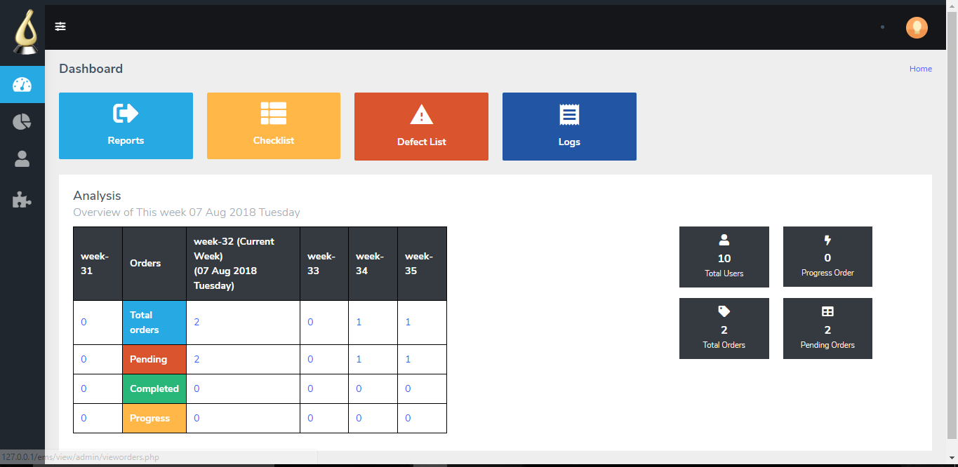

Admin home screen

3.1 Hardware Inderfaces
This software requires an pc with internet connections with any os. It runs smoothly on any phone and on any browser.

Software Interfaces
This software runs on any operating system whether be windows, mac or linux on any browser. It is also supported on smartphones.

Communications Interfaces
User’s can connect their pc or system with software via internet.Once
connected to the internet, user’s can easily login and can update, validate and maintain the equipments.

System Features
Ems based on PPM module has feature to maintain all the equipments inside the niit university. It will generate an order for maintenance after a fixed interval and generate a different serial number. There will also be a check module which will be verified by the four Users.

Chronic scheduler
It basically schedule the equipment according to their frequency and classify them into pending, progress or completed.
4.1.1 Description and Priority
It basically schedule the equipment according to their frequency and classify them into pending, progress or completed.
4.1.2 Stimulus/Response Sequences
It also generate checklist according to their status and type for the verification and validation by all the four users.
4.1.3 Functional Requirements
This features requires Equipment in the database as well as internet connectivity to set its timer for chronic schedule.

Checklist Validation
The generated checklist was validated and verified in a different sequences.
    - Description and Priority
First data operator goes on site and verify the equipment through ok or not ok checklist then it is validated by other three user – Property Manager then E-M Incharge and at last O-M Incharge.
    - Stimulus/Response Sequences
According to the higher priority validation of checklist is carried out and at last when O-M Incharge validate it then that order becomes completed.
    - Functional Requirements
This feature requires Orders should be present so that checklist generation and checklist validation takes place.

  - Manage Users

    - Description
Users can be added, details can be updated like password, email or their roles which can be done by O-M Incharge or Admin.
    - Stimulus/Response Sequences
As a result of management users can be updated.
    - Functional Requirements
Users can be managed only when the person is logged in as Admin or O-M Incharge.

  - Manage Orders

    - Description and Priority
Orders can be updated, removed or can be added by admin or O-M Incharge not by other.
    - Stimulus/Response Sequences
As a result orders are updated.
    - Functional Requirements
Orders can be managed only when user is logged in as admin or O-M Incharge.

  - Manage Equipment

    - Description and Priority
Equipment can be added, updated or removed by the admin or O-M incharge not by others.
    - Stimulus/Response Sequences
As a result Equipment are updated.
    - Functional Requirements
Equipment can be managed only when user is logged in as admin or O-M Incharge.

  - User Reports

    - Description and Priority
Reports of user like how many users are added from this date to till which date. These types
Of details can be viewed by the admin and O-M Incharge.
    - Stimulus/Response Sequences
Reports can be printed or viewed.
    - Functional Requirements
To view user report or print it user should be logged in as Admin or O-M Incharge.

  - Order Reports

    - Description and Priority
Reports of user like how many users are added from this date to till which date. These types
Of details can be viewed by the admin and O-M Incharge.
    - Stimulus/Response Sequences
Reports can be printed or viewed.
    - Functional Requirements
To view user report or print it user should be logged in as Admin or O-M Incharge.

  - Equipment Reports

    - Description and Priority
Reports of user like how many users are added from this date to till which date. These types
Of details can be viewed by the admin and O-M Incharge.
    - Stimulus/Response Sequences
Reports can be printed or viewed.
    - Functional Requirements
To view user report or print it user should be logged in as Admin or O-M Incharge.

  - Defectlist Reports

    - Description and Priority
Reports of user like how many users are added from this date to till which date. These types
Of details can be viewed by the admin and O-M Incharge.
    - Stimulus/Response Sequences
Reports can be printed or viewed.
    - Functional Requirements
To view user report or print it user should be logged in as Admin or O-M Incharge.

  - Event Logs

    - Description and Priority
Reports of user like how many users are added from this date to till which date. These types
Of details can be viewed by the admin and O-M Incharge.
    - Stimulus/Response Sequences
Reports can be printed or viewed.
    - Functional Requirements
To view user report or print it user should be logged in as Admin or O-M Incharge.

  - Defectlist

    - Description and Priority
Reports of user like how many users are added from this date to till which date. These types
Of details can be viewed by the admin and O-M Incharge.
    - Stimulus/Response Sequences
Reports can be printed or viewed.
    - Functional Requirements
To view user report or print it user should be logged in as Admin or O-M Incharge.

  - Import

    - Description and Priority
Reports of user like how many users are added from this date to till which date. These types
Of details can be viewed by the admin and O-M Incharge.
    - Stimulus/Response Sequences
Reports can be printed or viewed.
    - Functional Requirements
To view user report or print it user should be logged in as Admin or O-M Incharge.

  - Export

    - Description and Priority
Reports of user like how many users are added from this date to till which date. These types
Of details can be viewed by the admin and O-M Incharge.
    - Stimulus/Response Sequences
Reports can be printed or viewed.
    - Functional Requirements
To view user report or print it user should be logged in as Admin or O-M Incharge.

  - Search

    - Description and Priority
Reports of user like how many users are added from this date to till which date. These types
Of details can be viewed by the admin and O-M Incharge.
    - Stimulus/Response Sequences
Reports can be printed or viewed.
    - Functional Requirements
To view user report or print it user should be logged in as Admin or O-M Incharge.

  - Manage Checklist Questions

    - Description and Priority
Reports of user like how many users are added from this date to till which date. These types
Of details can be viewed by the admin and O-M Incharge.
    - Stimulus/Response Sequences
Reports can be printed or viewed.
    - Functional Requirements
To view user report or print it user should be logged in as Admin or O-M Incharge.

Other Nonfunctional Requirements

Performance Requirements

The system supports concurrent users. This statement provides a general sense of reliability when the system is under load. It is important that a substantial number of users be able to access the system at the same time, since this is an employee portal. The times when the system will be under the most stress are likely during simultaneous checklist validation. Therefore, it must be able to handle the concurrent users.

5.2 Safety Requirements

All data will be saved in the database: user accounts and profiles, password, orders etc. (except files which are stored on the disk.) The database allows concurrent access and will be kept consistent at all times, requiring a good database design.

Security Requirements

Passwords will be saved encrypted in the database in order to ensure the user's privacy.

The user's IP will be logged.

The system will be protected against vulnerabilities such as SQL injection attacks.

Software Quality Attributes
      - Reliability The reliability of the overall program depends on the reliability of the separate components.
    - Availability The system should be available at all times, meaning the user can access it using a web browser, only restricted by the down time of the server on which the system runs. In case of a of a hardware failure or database corruption, a replacement page will be shown. Also in case of a hardware failure or database corruption, backups of the database should be retrieved with the MySQL server and saved by the administrator.
    - Maintainability MySQL is used for maintaining the database and the Apache server takes care of the site. In case of a failure, a re-initialization of the program is recommended.
    - Portability The application is Linux-based and should be compatible with other systems. Apache, PHP and MySQL programs are practically independent of the OS-system which they communicate with. The end-user part is fully portable and any system using any web browser should be able to use the features of the application.

Business Rules
<List any operating principles about the product, such as which individuals or roles can perform which functions under specific circumstances. These are not functional requirements in themselves, but they may imply certain functional requirements to enforce the rules.>

Other Requirements
6.1 Logical database requirements
All data will be saved in the database: user accounts and profiles, discussion data, messages etc. (except files which are stored on the disk.) The database allows concurrent access and will be kept consistent at all times, requiring a good database design.
6.2 Design Constraints
6.2.1 The communication between the portal software and the database will be in SQL.
6.2.2The portal layout will be produced with HTML/CSS.
6.2.3. The product will be written in PHP.
6.2.4. The output must be compatible with W3C XHTML 1.0
6.2.5. The source code must follow the coding conventions of PHP.
6.2.6. System administrators must have access to comprehensive documentation.
can be tracked to closure.>

