**Web Servers**

**1.Httpd**

First,Launch an ec2 Instance

Here, we need to run httpd service on 444 port

So, While Launching EC2 Instance we need to add 444 in Security Group of Virtual Server

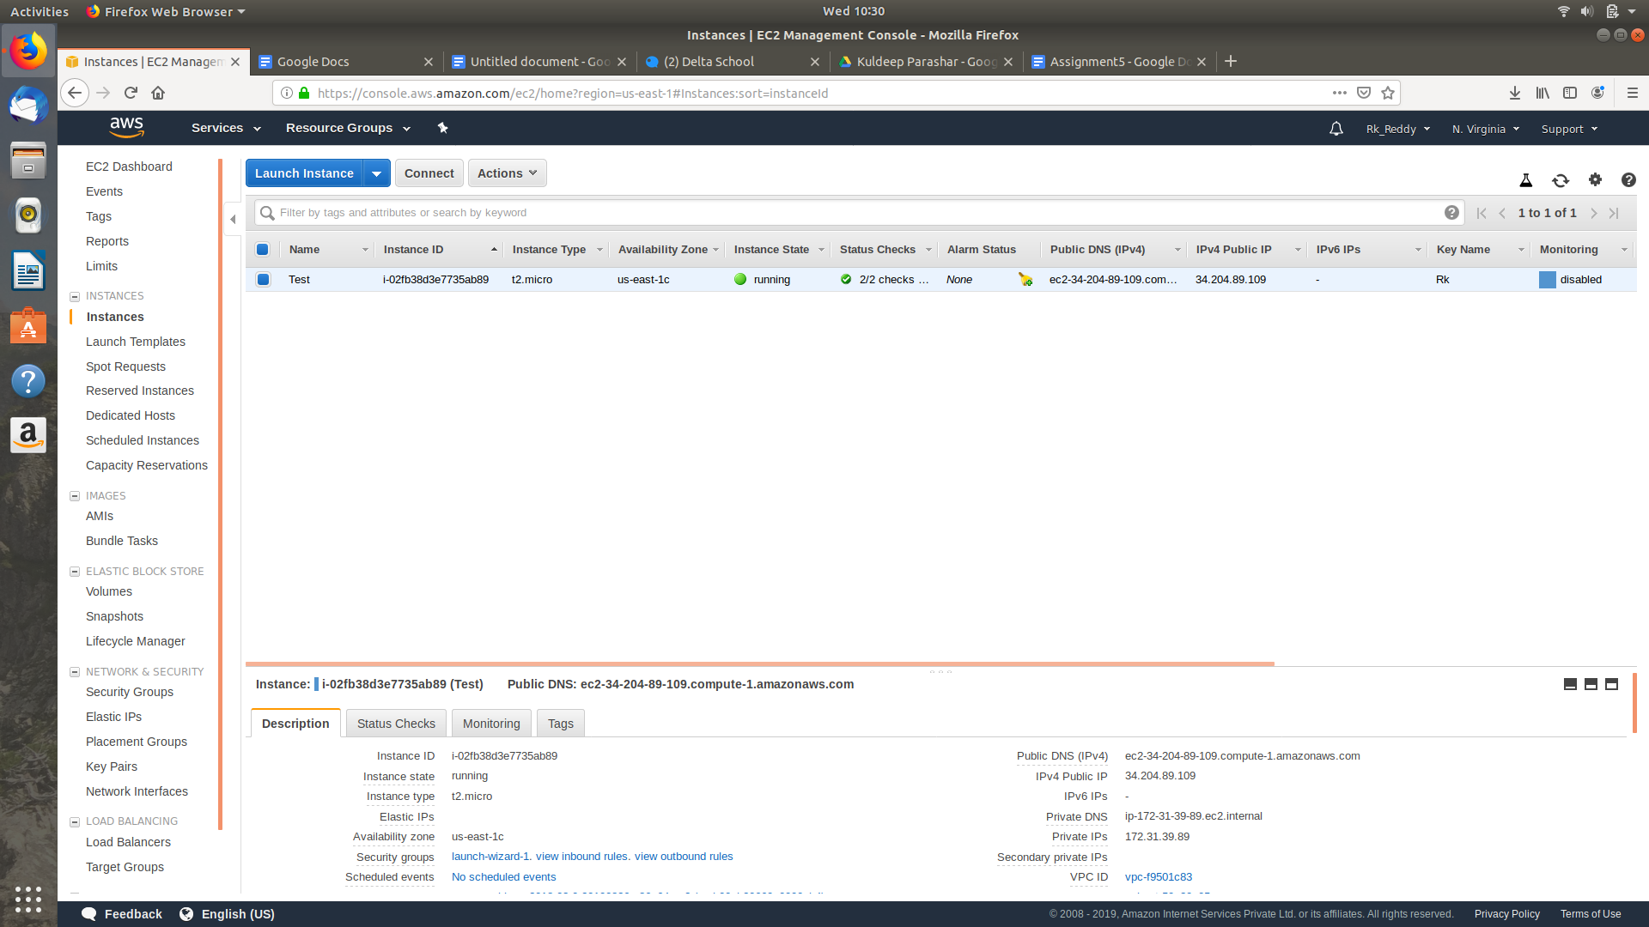



In httpd.conf file add Listen 444

Conf File

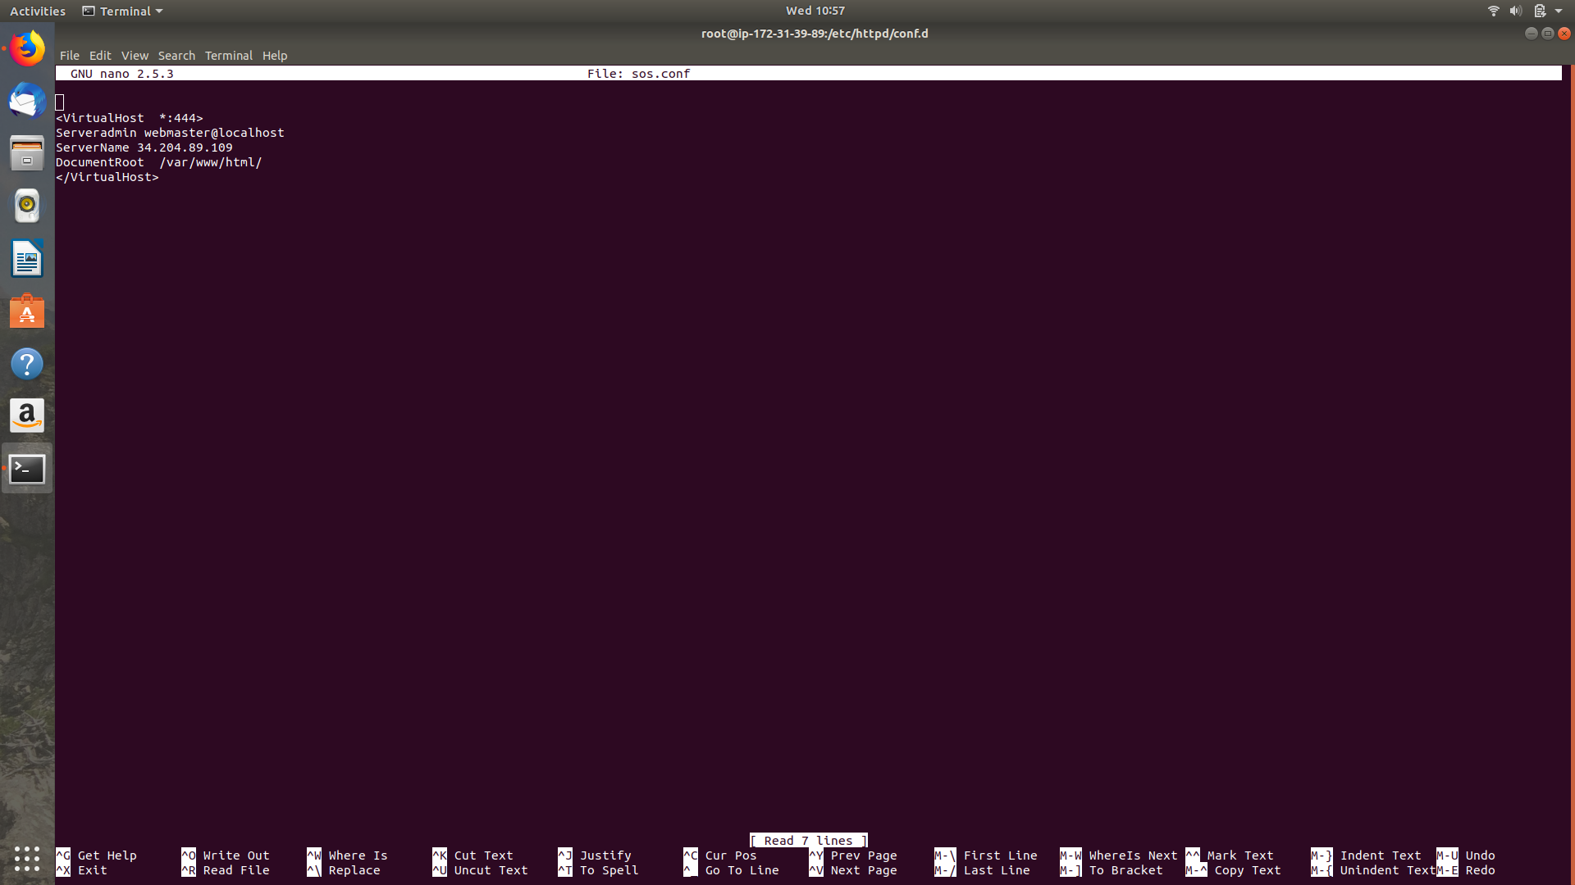

Conf File

<VirtualHost *:444>

ServerAdmin 34.204.89.109

DocumentRoot /var/www/html

</virtualHost>

Save it

$httpd -t

$service httpd reload

$service httpd restart

Output :



**Nginx Load Balancer**

Simultaneously Launch 3 instances

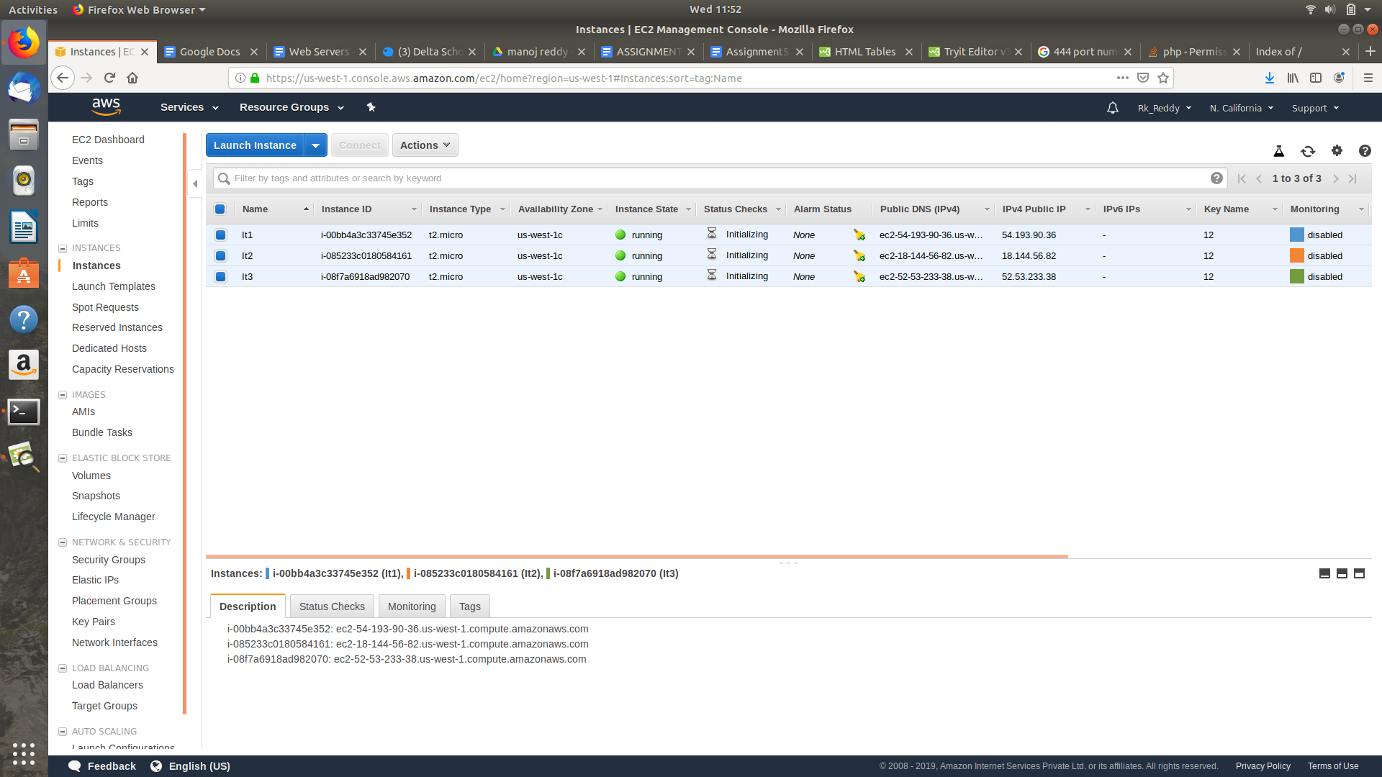

Type sudo su in all instances to get redirected into the root mode

>Install Nginx in all three Instances

>In first instance

$cd /var/www/html

$nano index.html

$cd /etc/nginx/conf.d

$cd /usr/share/nginx/html

$echo "rk" > index.html

$service nginx restart

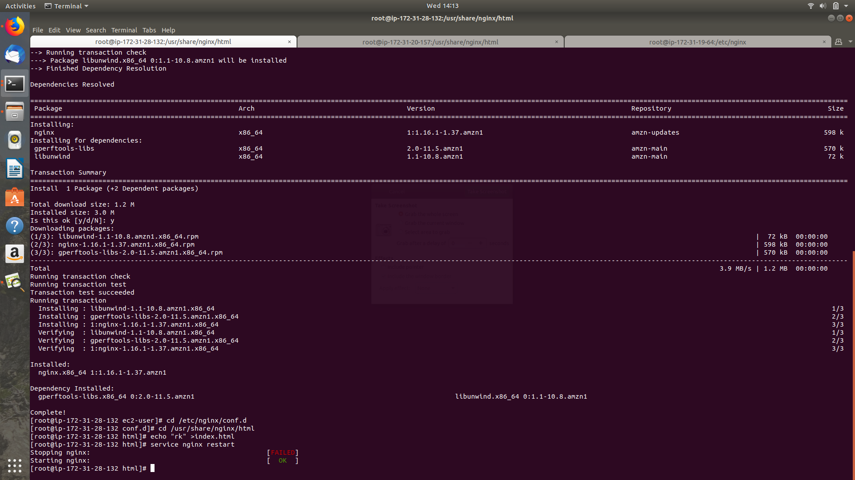

>In second instance

--->In second instance

$cd /var/www/html

$nano index.html

$cd /etc/nginx/conf.d

$cd /usr/share/nginx/html

$echo "filmygeeks" > index.html

$service nginx restart

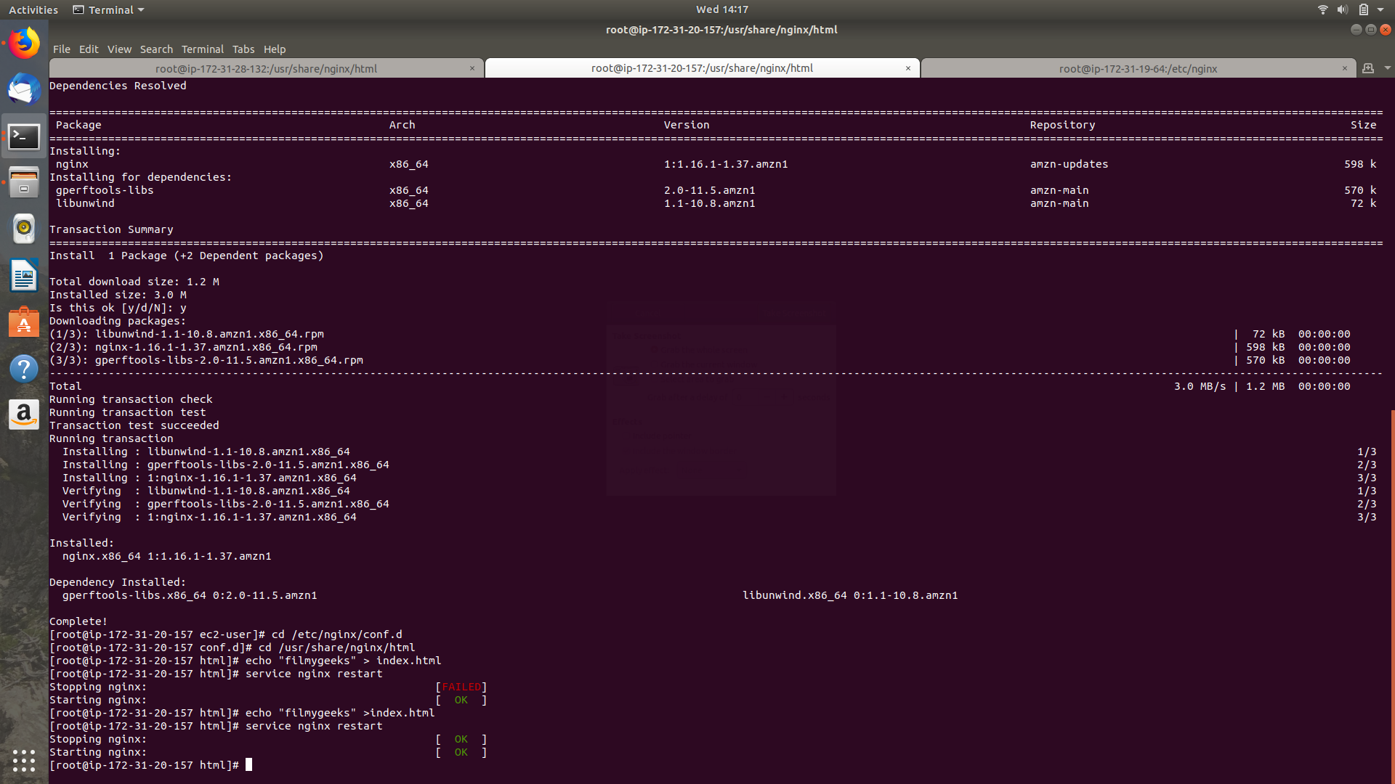

>In Third Instance

$cd /etc/nginx/conf.d

$nano rk.conf

upstream rk

{

server 54.193.90.36;

server 18.144.56.82;

}

server

{

listen 80;

location /

{

proxy_pass http://rk;

}

}

Save It

$cd ..

$nano nginx.conf

$service nginx restart

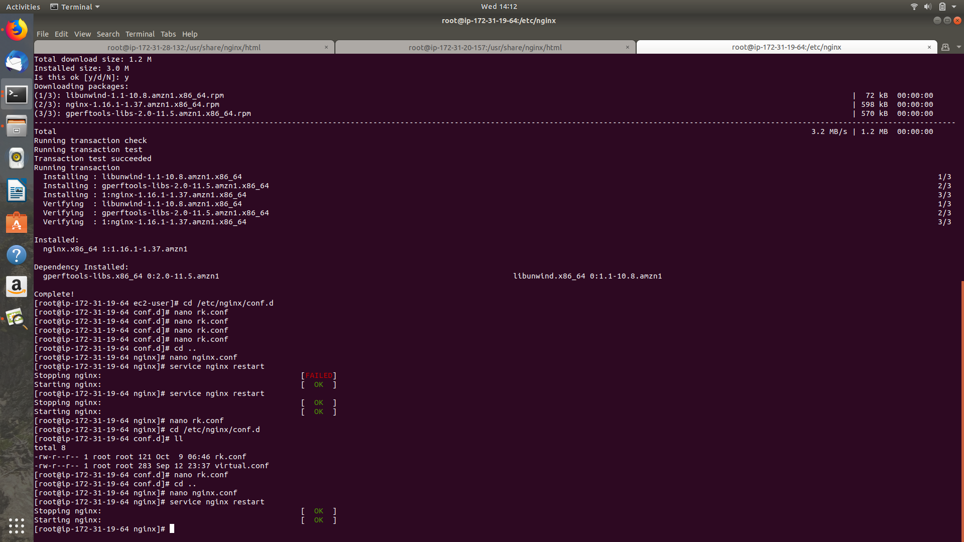

**Conf file**

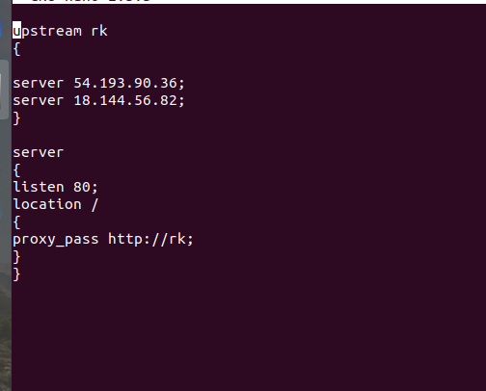

Here,Below is the output

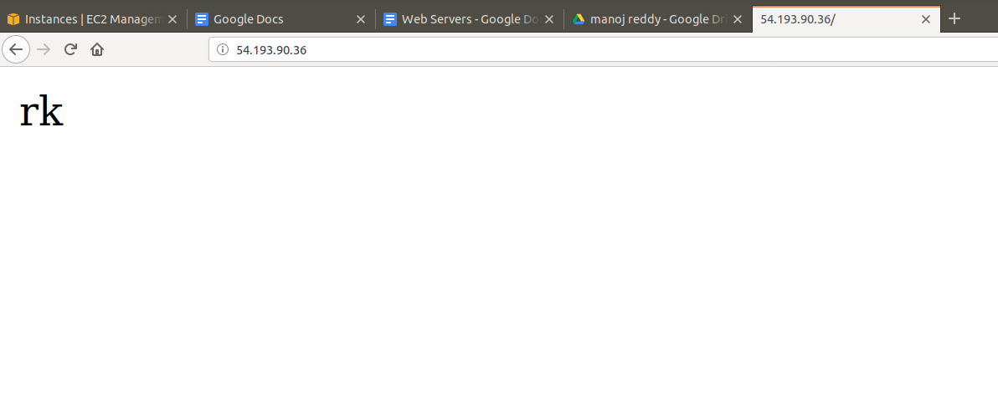



Ngnix uses round-robin algorithm by default

and

Other methods are :

Least_conn

Ip_hash

Weight

Max_Fails

Fail_Timeout

Down

**Haproxy**

[HAProxy](http://www.knowarth.com/haproxy-load-balancer-configuration/) is an open source, free, very fast and reliable solution offering high availability, load balancing and proxying for TCP and HTTP-based applications. It is particularly suited for web sites crawling under very high loads while needing persistence or Layer7 processing. It distributes a workload across a set of servers to maximize performance and optimize resource usage.

For Performing Load balancing Using Haproxy we Need to launch three EC2 Instances. ->Install httpd in Two servers and install haproxy in oneserver(Loadbalancer)



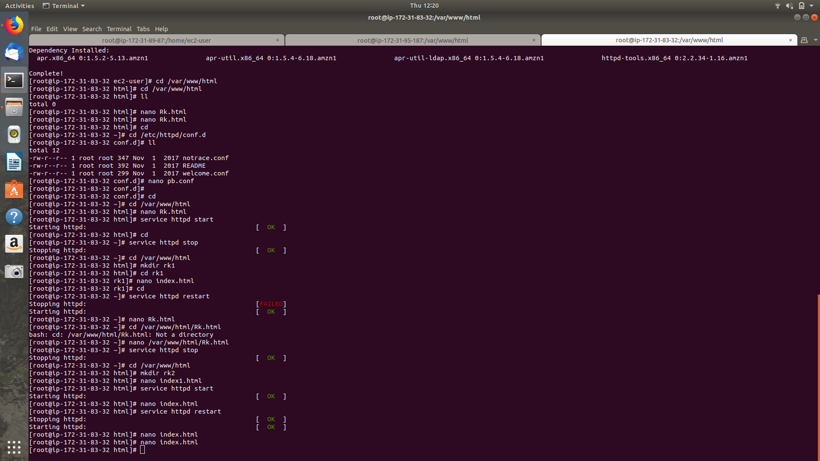

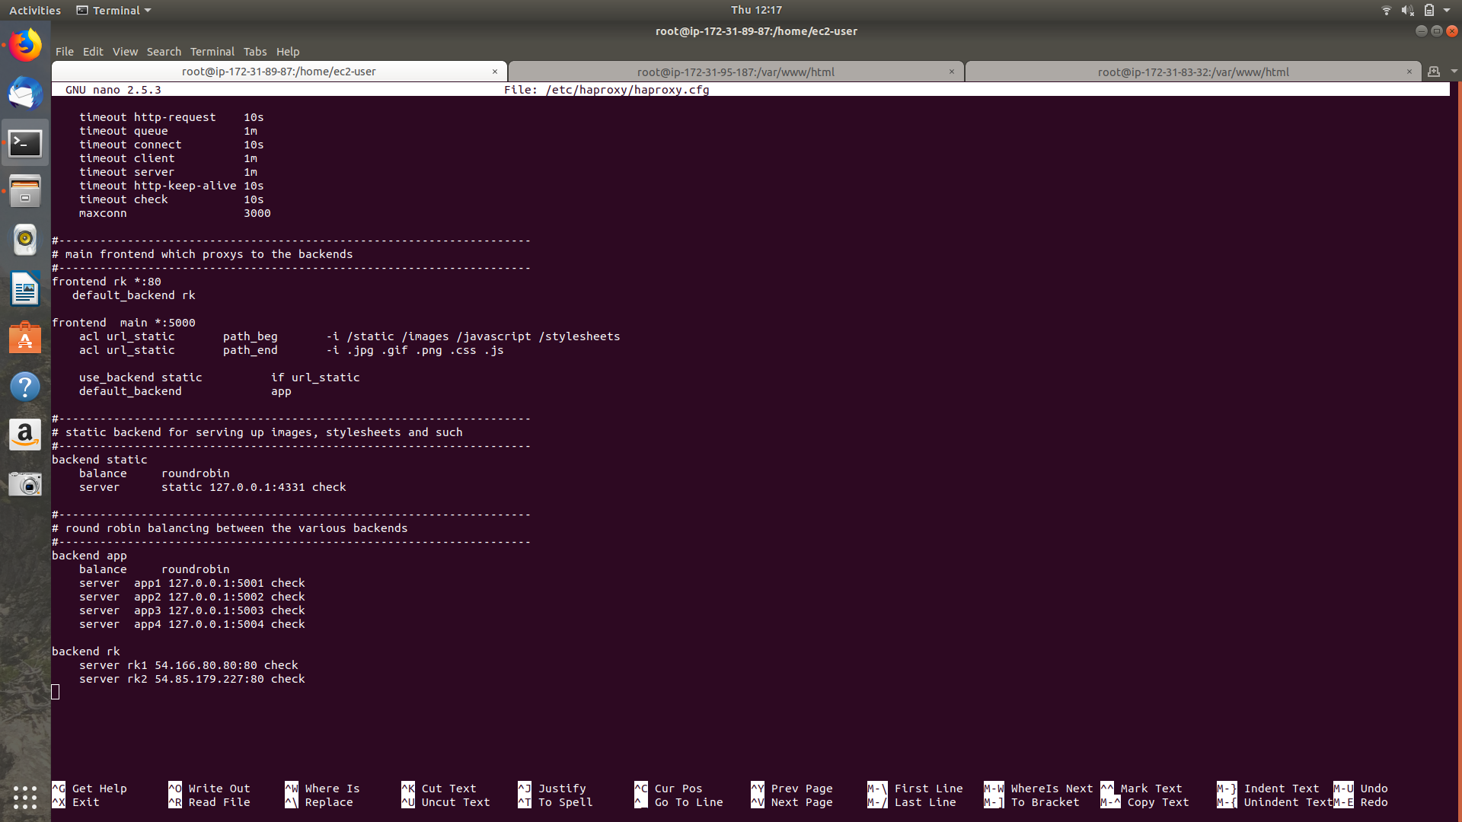

When you configure load balancing using HAProxy, there are two types of nodes which need to be defined: frontend and backend. The frontend is the node by which HAProxy listens for connections. Backend nodes are those by which HAProxy can forward requests. A third node type, the stats node, can be used to monitor the load balancer and the other two nodes.

Add these text in $nano /etc/haproxy/haproxy.conf

frontend rk *:80

Default_backend ec2

In the backend

backend ec21 54.85.179.227:80 check

backend ec22 54.166.80.80:80 check

Here, Below is the output



