**SSL**(Secure Socket Layer)Certificate Assigning To Domain.

>Register a domain in freenom.com. Here, I registered **Cinephilia.tk** domain.

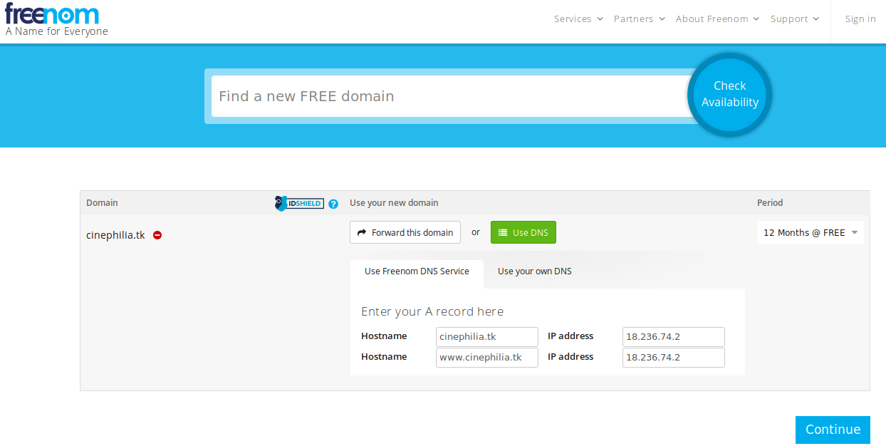

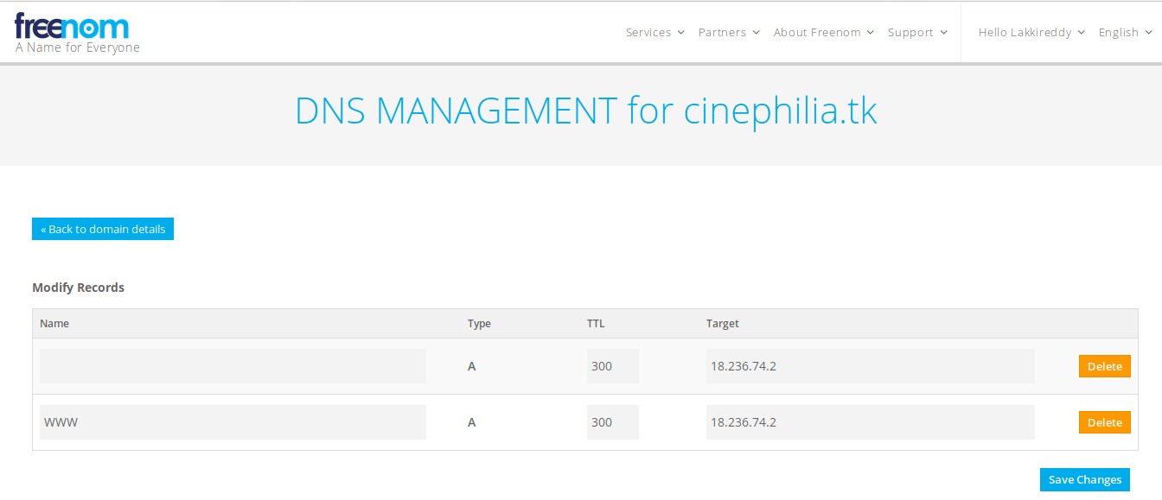

>Launch an Ec2 Instance in AWS.

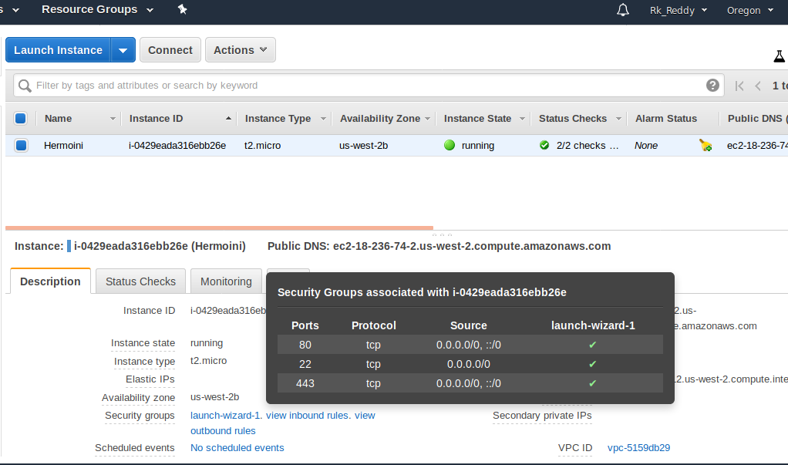

Launch Instance in Terminal Window

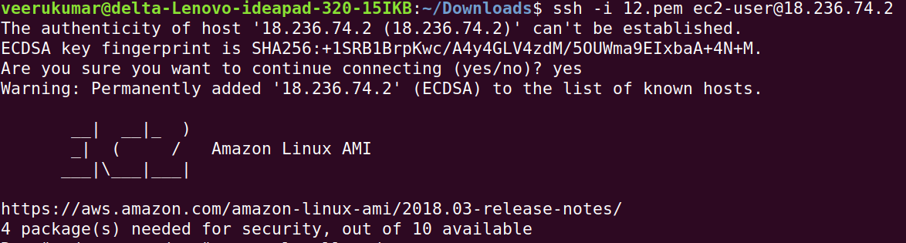

>Install git and httpd in the server

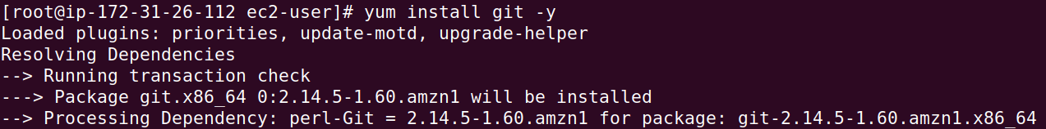

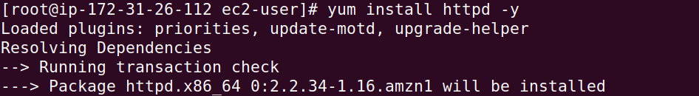

sudo git clone https://github.com/letsencrypt/letsencrypt /opt/letsencrypt

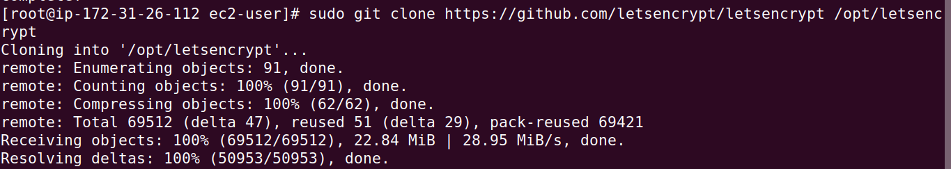

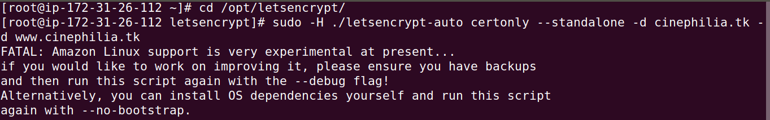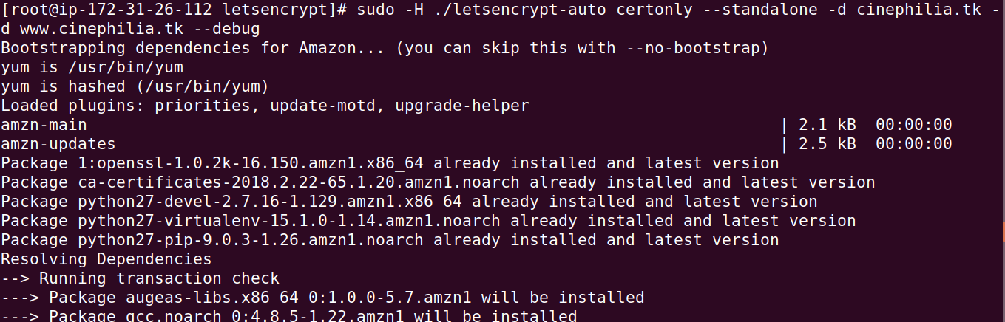

sudo -H ./letsencrypt-auto certonly --standalone -d cinephilia.tk -d [www.cinephilia.tk](http://www.cinephilia.tk) --debug

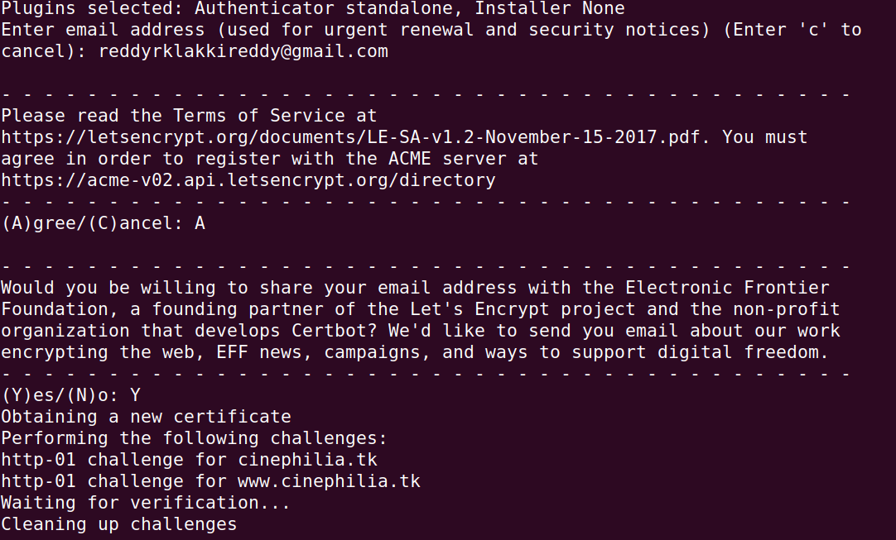

Agree to the Terms of Service and specify if you would like to share your email address with EFF.

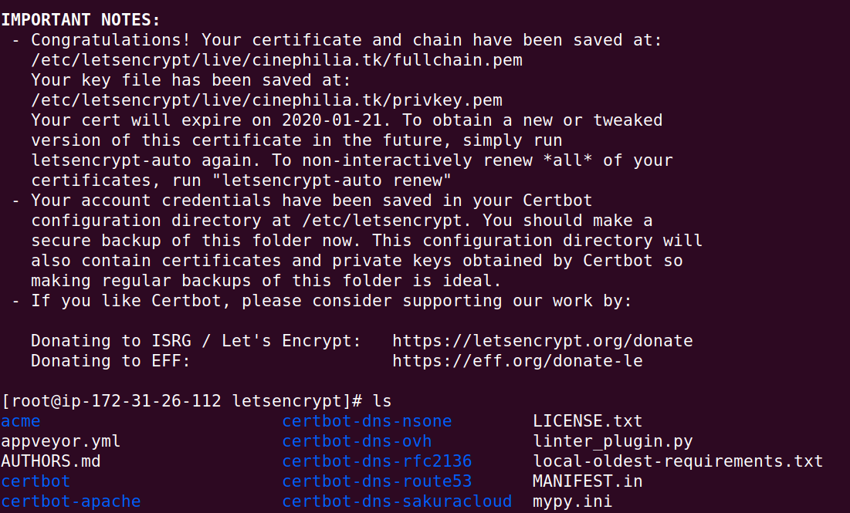



**Cinema.html**

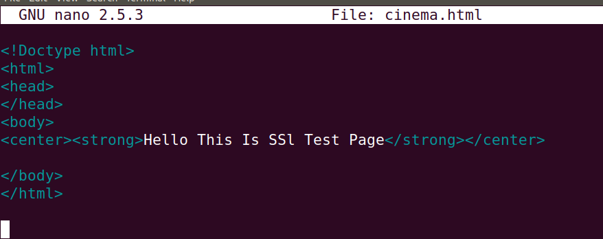

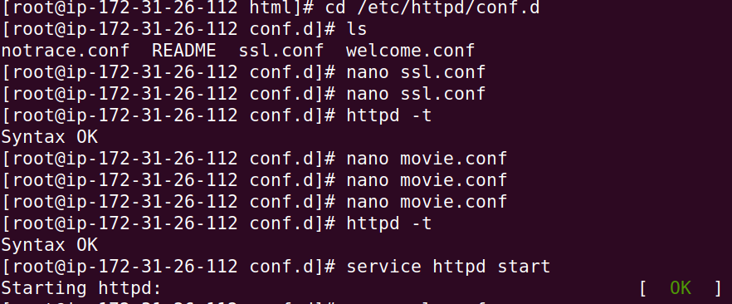

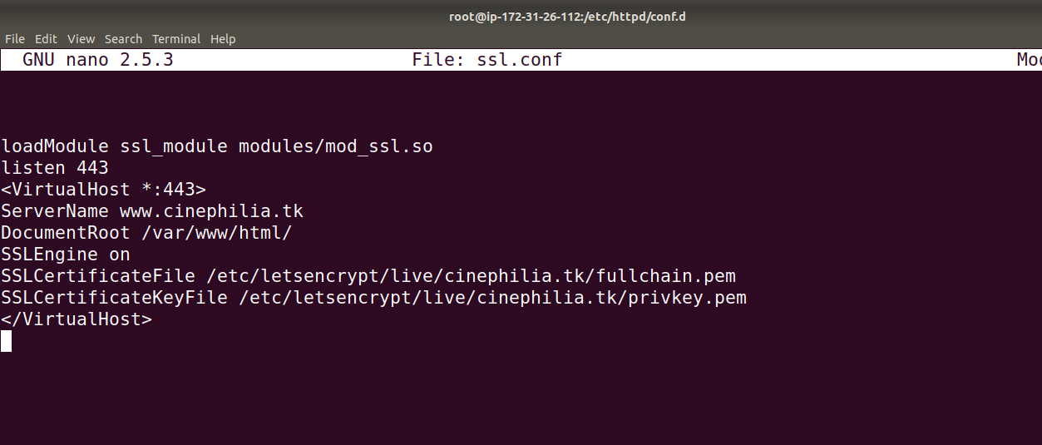

Add servername and ssl certificate files in **ssl.conf**

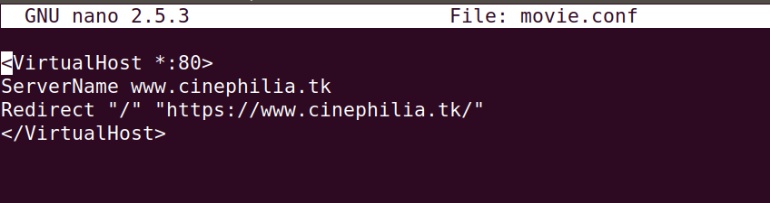

>service httpd restart

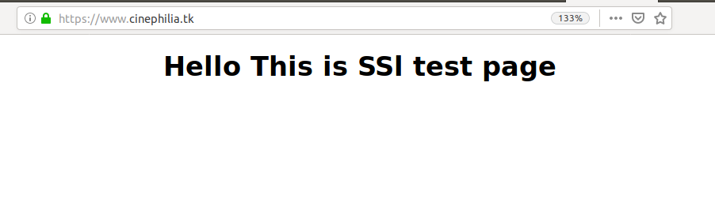

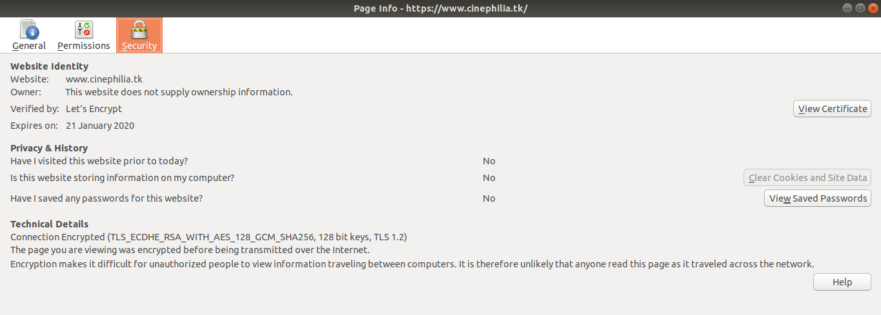

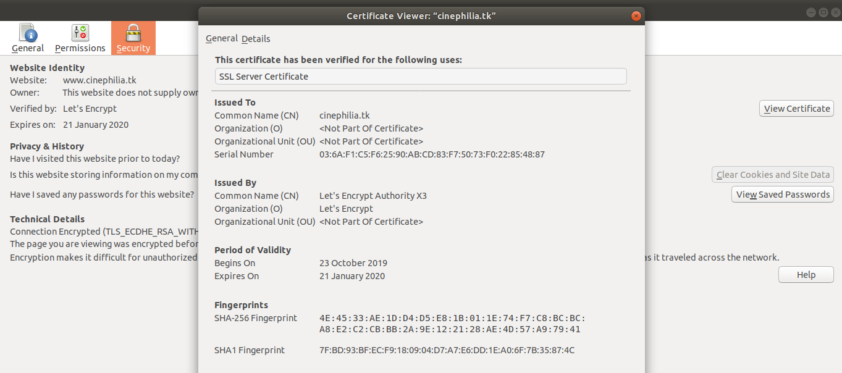

Cloning the private repository directly without Login Credentials

Create one Private Repository in GitHub. Here, I created **PrivateProject** repository.

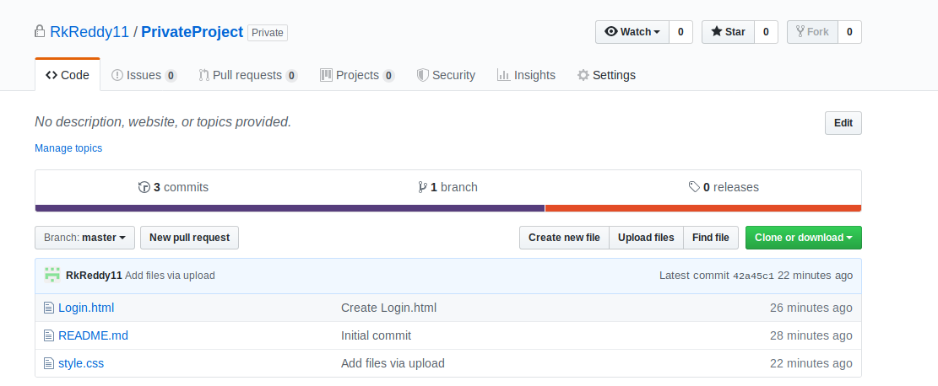

Launch an EC2 Server in your Machine and Install git in it. In my server git is already installed.

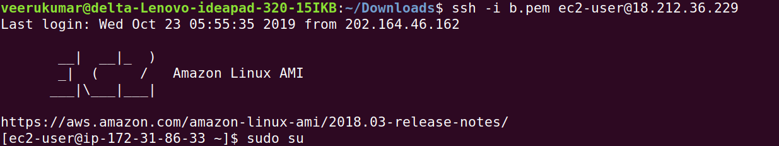

Generate Private and public key using **ssh-keygen** command

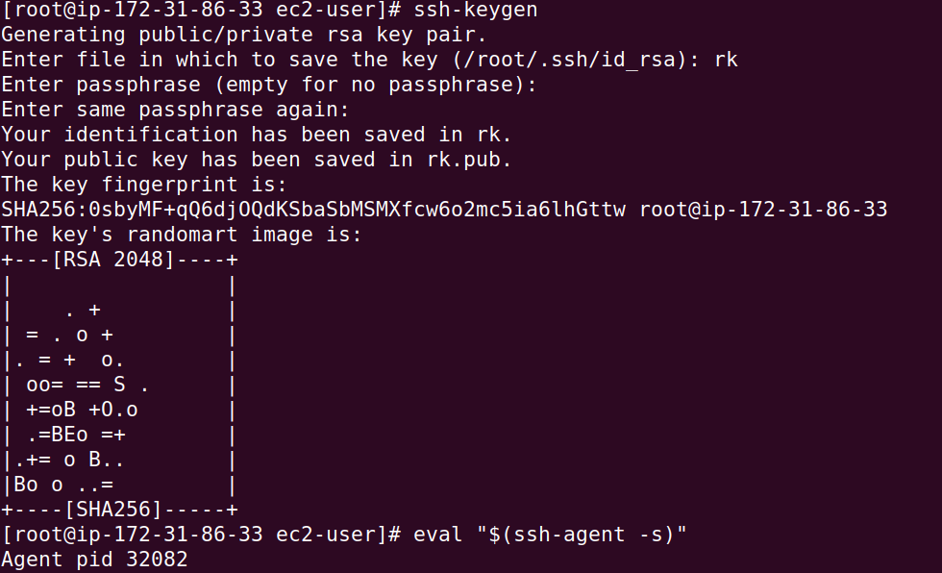





Add the **public key** under deploy keys in github.

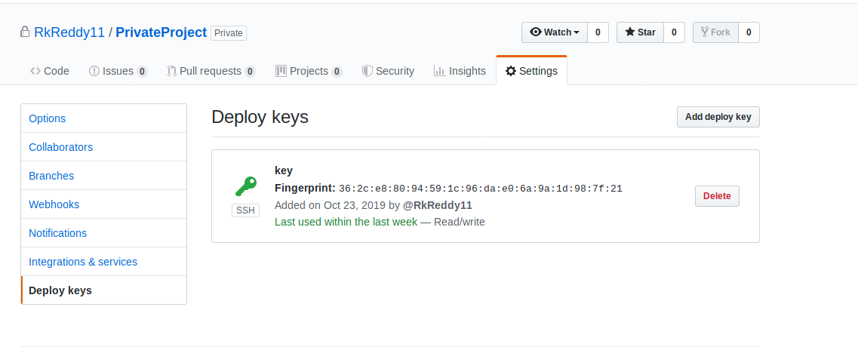

Make Authentication using **ssh -T git@github.com**

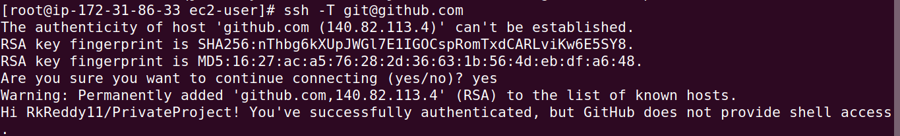

Clone Your Private Repository using git clone [git@github.com](mailto:git@github.com):git@github.com:RkReddy11/PrivateProject.git

