**Nagios**

**Introduction:**

Nagios is an open source software that can be used for network and infrastructure monitoring. Nagios will monitor servers, switches, applications and services. It alerts the System Administrator when something went wrong and also alerts back when the issues have been rectified.

**Features:**

* Monitor your entire IT infrastructure;
* Identify problems before they occur;
* Know immediately when problems arise;
* Share availability data with stakeholders.hypothetical question;
* Detect security breaches;
* Plan and budget for IT upgrades;
* Reduce downtime and business losses.

## **Prerequisites**

Before installing Nagios, make sure that you've properly installed and configured LAMP stack in your server. To install and configure LAMP server to run below commands as a root user.

>Create a new ***nagcmd*** group for allowing external commands to be submitted through the web interface. Add both the nagios user and the apache user to the group.

>By typing this command you will get the latest version of Nagios

**wget**

[**http://prdownloads.sourceforge.net/sourceforge/nagios/nagios-4.0.8.tar.gz**](http://prdownloads.sourceforge.net/sourceforge/nagios/nagios-4.0.8.tar.gz)

> After that Install Nagios plugins using this command

**wget** [**http://nagios-plugins.org/download/nagios-plugins-2.0.3.tar.gz**](http://nagios-plugins.org/download/nagios-plugins-2.0.3.tar.gz)

>Go to the folder where you’ve downloaded nagios, and extract it using command:

**tar xzf nagios-4.0.8.tar.gz**

>Change to the nagios directory, and run the following commands one by one from the Terminal to compile and install nagios.

**cd nagios-4.0.8**

**./configure --with-command-group=nagcmd**

**make all**

**make install**

**make install-init**

**make install-config**

**make install-commandmode**

> Enter the following commands to compile and install nagios web interface.

**make install-webconf**

Create a ***nagiosadmin*** account for logging into the Nagios web interface. Remember the password you assign to this account. You’ll need it while logging in to nagios web interface..

**htpasswd -c /usr/local/nagios/etc/htpasswd.users nagiosadmin**

Restart Apache to make the new settings take effect.

**Service httpd restart**

##### **Install Nagios plugins:**

Go to the directory where you downloaded the nagios plugins, and extract it.

**tar xzf nagios-plugins-2.0.3.tar.gz**

**Change to the nagios plugins directory:**

**cd nagios-plugins-2.0.3**

**Run the following commands one by one to compile and install it.**

**./configure --with-nagios-user=nagios --with-nagios-group=nagios**

**make**

**make install**

## **Configure Nagios**

Nagios sample configuration files have now been installed in the */usr/local/nagios/etc* directory. These sample files should work fine for getting started with Nagios. However, you’ll need to put your actual email ID to receive alerts.

To do that, Edit the */usr/local/nagios/etc/objects/contacts.cfg* config file with your favorite editor and change the email address associated with the *nagiosadmin* contact definition to the address you’d like to use for receiving alerts.

**vi /usr/local/nagios/etc/objects/contacts.cfg**

**[...]**

**define contact{**

**contact_name nagiosadmin ; Short name of user**

**use generic-contact ; Inherit default values from generic-contact template (defined above)**

**alias Nagios Admin ; Full name of user**

**email rkreddii01@gmail.com ; <<***** CHANGE THIS TO YOUR EMAIL ADDRESS \*\*\*\*\*\***

**}**

**[...]**

Save and close the file.

Then, Edit file **/etc/httpd/conf.d/nagios.conf**

And edit the following lines if you want to access nagios administrative console from a particular IP series. Here, I want to allow nagios administrative access from 54.241.190.78 only.

**[...]**

**## Comment the following lines ##**

**# Order allow,deny**

**# Allow from all**

**## Uncomment and Change lines as shown below ##**

**Order deny,allow**

**Deny from all**

**Allow from 127.0.0.1 54.241.190.78**

**[...]**

Restart httpd service:

**Service httpd restart**

Now, check for any configuration errors using command:

**/usr/local/nagios/bin/nagios -v /usr/local/nagios/etc/nagios.cfg**

If there are no errors, start nagios service and make it to start automatically on every boot.

**Service nagios start**

**chkconfig --add nagios**

**chkconfig nagios on**

## **Access Nagios Web Interface**

Open nagios administrator console with URL **http://nagios-server-ip/nagios** and enter the username as nagiosadmin and its password which we created in the earlier steps.

Click on the “Hosts” section in the left pane of the console. You will see there the no of hosts to be monitored by Nagios server. We haven’t added any hosts yet. So it simply monitors the localhost itself only.

## **Add Monitoring targets to Nagios server**

Now, let us add some clients to monitor by Nagios server. To do that we have to install **nrpe** and **nagios-plugins** in our monitoring targets.

Add EPEL repository in your CentOS clients to install nrpe package.

To install EPEL on CentOS 7, run the following command:

**yum install epel-release**

Install “nrpe” and “nagios-plugins” packages in client system:

**yum install nrpe nagios-plugins-all openssl**

## **Configure Monitoring targets**

**Edit /etc/nagios/nrpe.cfg file,**

**sudo vi /etc/nagios/nrpe.cfg**

**Add your Nagios server ip address:**

**[...]**

**## Find the following line and add the Nagios server IP ##**

**allowed_hosts=127.0.0.1 54.241.190.78**

**[...]**

**Start nrpe service on CentOS clients:**

**CentOS 6.x:**

**service nrpe start**

**chkconfig nrpe on**

Now, go back to your Nagios server, and add the clients in the configuration file.

To do that, Edit **“/usr/local/nagios/etc/nagios.cfg” file,**

**vi /usr/local/nagios/etc/nagios.cfg**

and uncomment the following lines.

## Find and uncomment the following line ##

**cfg_dir=/usr/local/nagios/etc/servers**

Create a directory called “servers” under “/usr/local/nagios/etc/”.

**mkdir /usr/local/nagios/etc/servers**

**Create config file to the client to be monitored:**

**vi /usr/local/nagios/etc/servers/yv.cfg**

**Add the following lines:**

**define host{**

**use linux-server**

**host_name client**

**alias client**

**address 13.52.180.9**

**max_check_attempts 5**

**check_period 24x7**

**notification_interval 30**

**notification_period 24x7**

**}**

**Here, 13.52.180.9 is my nagios client IP address. Finally restart nagios service.**

**Service nagios restart**

Wait for few seconds, and refresh nagios admin console in the browser and navigate to “Hosts” section in the left pane. You will see the newly added client will be visible there. Click on the host to see if there is anything wrong or any alerts it has.

## **Define services**

We have just defined the monitoring host. Now, let us add some services of the monitoring host. For example, to monitor the **ssh** service, add the following lines shown in bold in the **“/usr/local/nagios/etc/servers/clients.cfg”** file.

vi /usr/local/nagios/etc/servers/clients.cfg

Add the following lines shown in bold:

define host{

use linux-server

host_name client

alias client

address **13.52.180.9**

max_check_attempts 5

check_period 24x7

notification_interval 30

notification_period 24x7

}

**define service {**

**use generic-service**

**host_name client**

**service_description SSH**

**check_command check_ssh**

**notifications_enabled 0**

**}**

**define service {**

**use generic-service**

**host_name client**

**service_description HTTP**

**check_command check_http**

**notifications_enabled 0**

**}**

Save and close the file. Restart Nagios.

**Service nagios restart**

Wait for few seconds, and check for the added services (i.e ssh) in the nagios web interface. Navigate to **Services** section on the left side bar, you’ll see the **ssh** and **HTTP** service there.

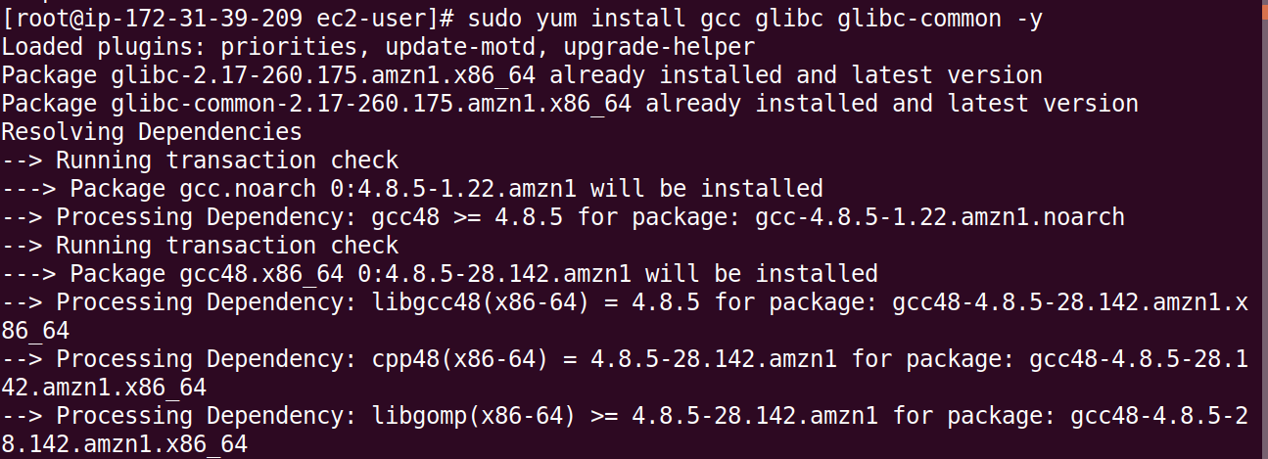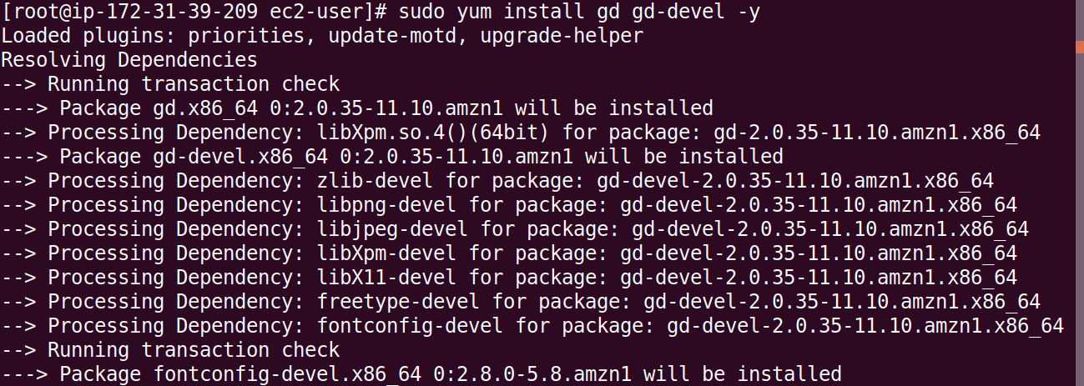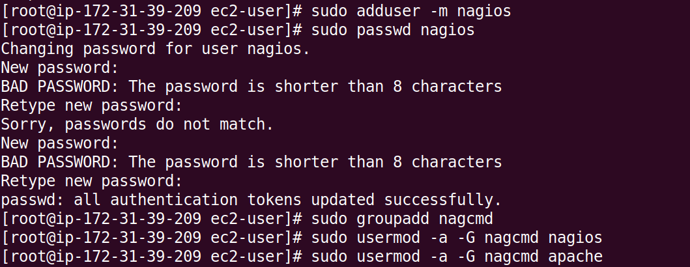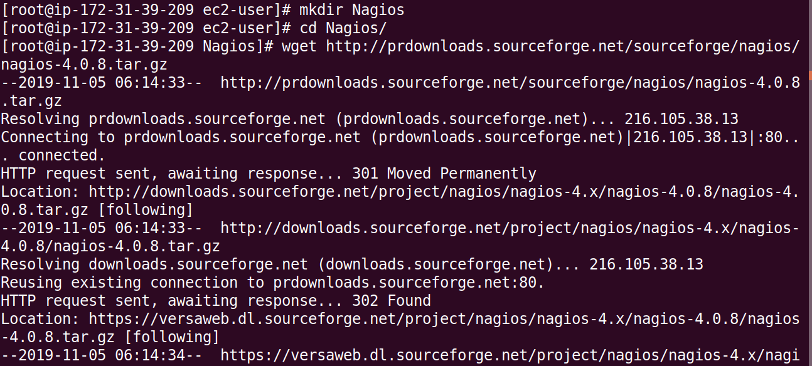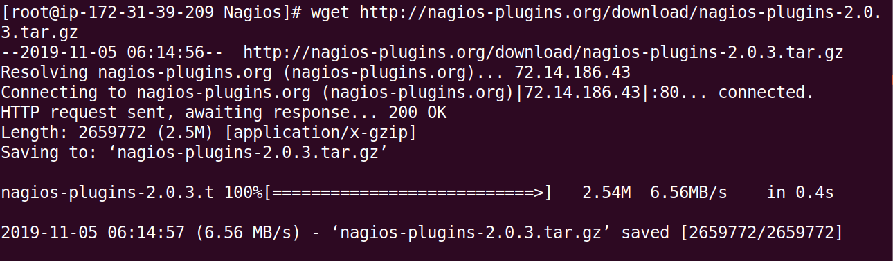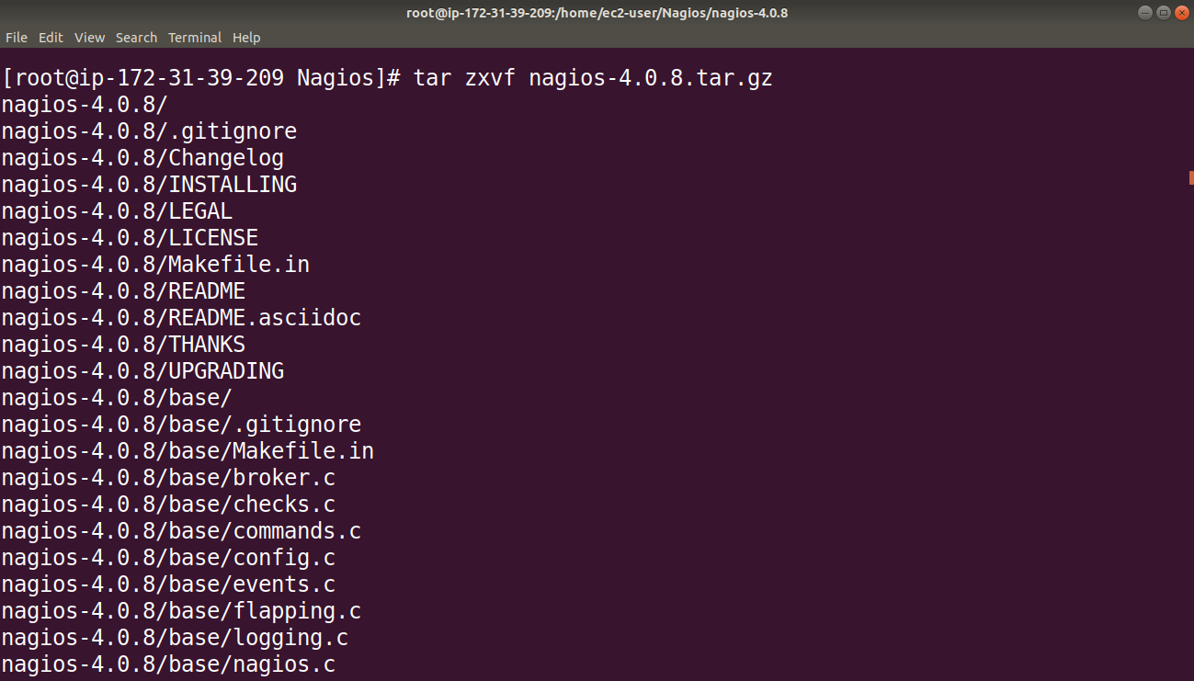

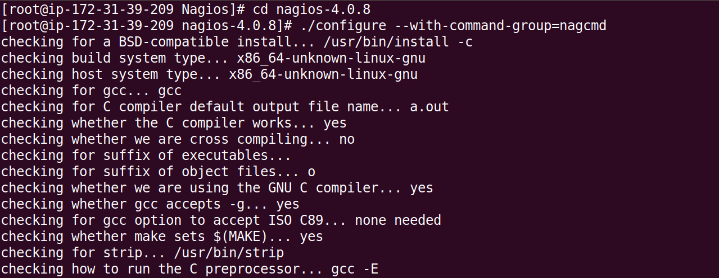

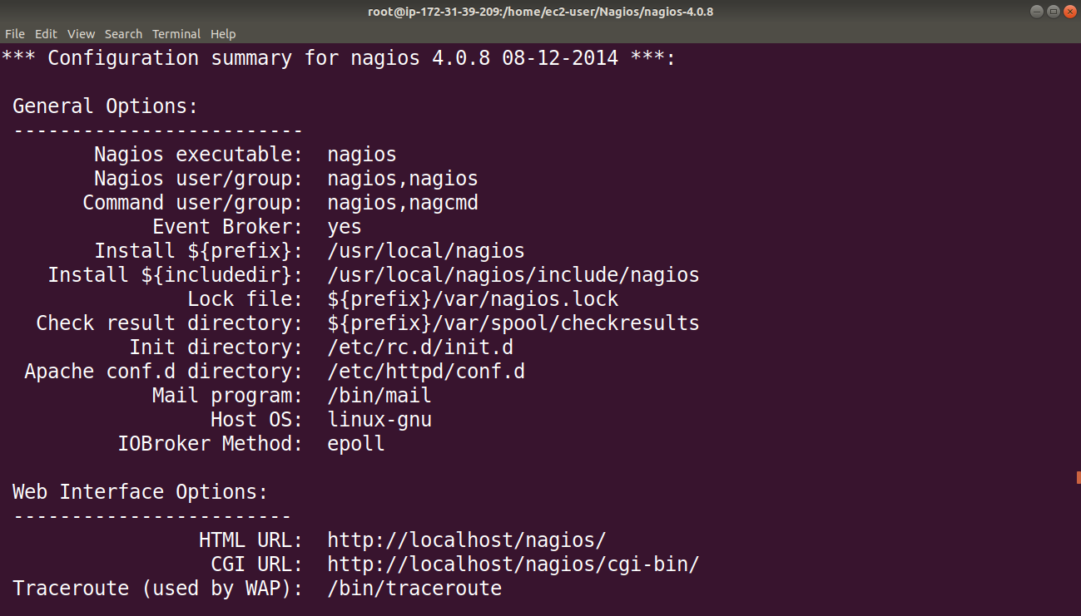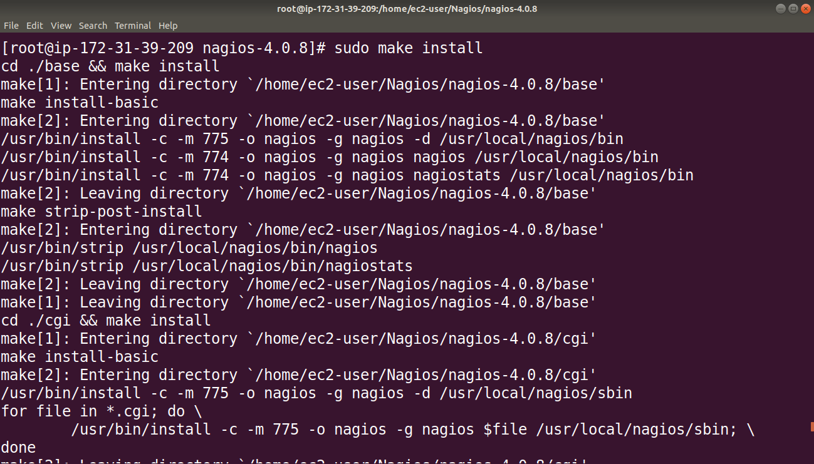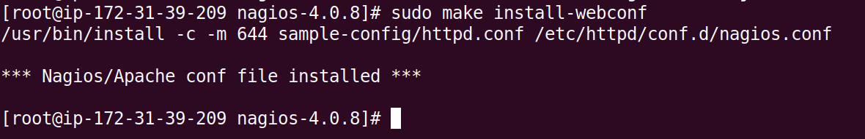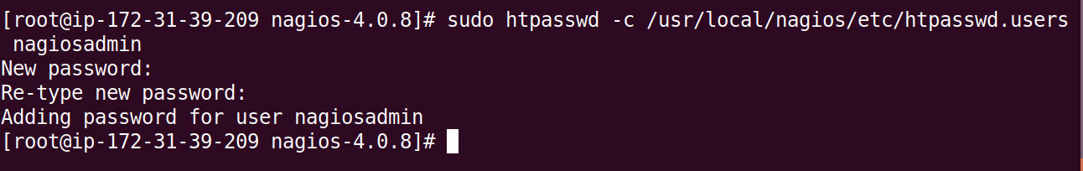

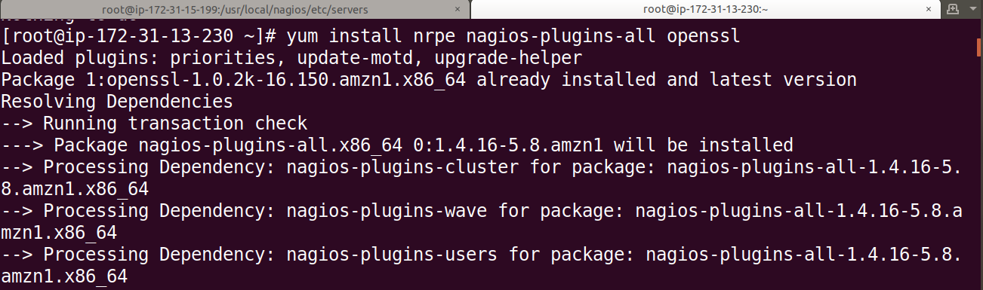

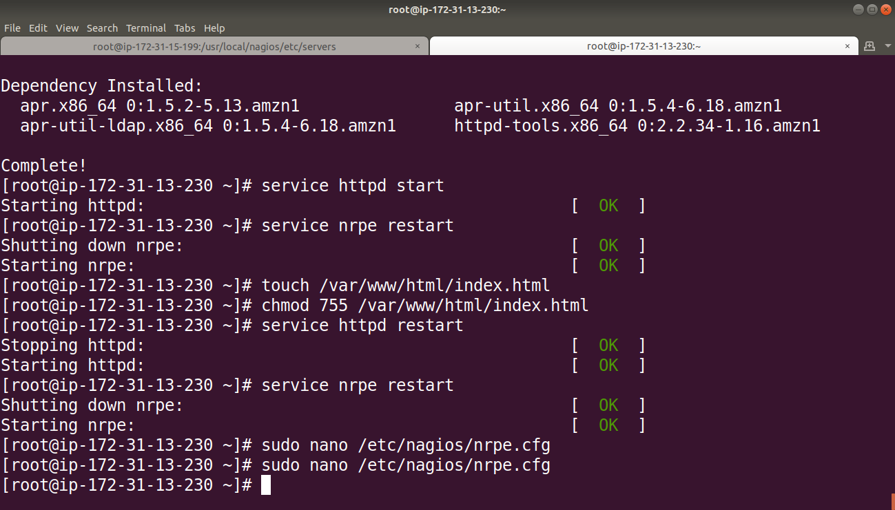

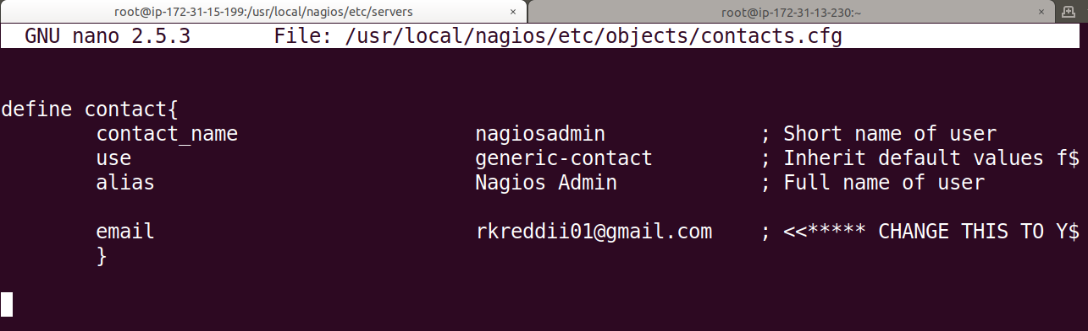

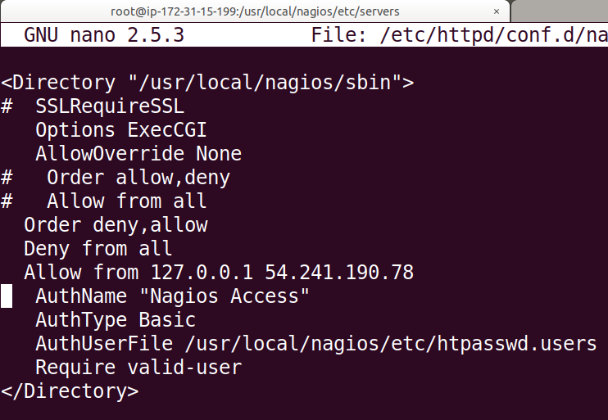

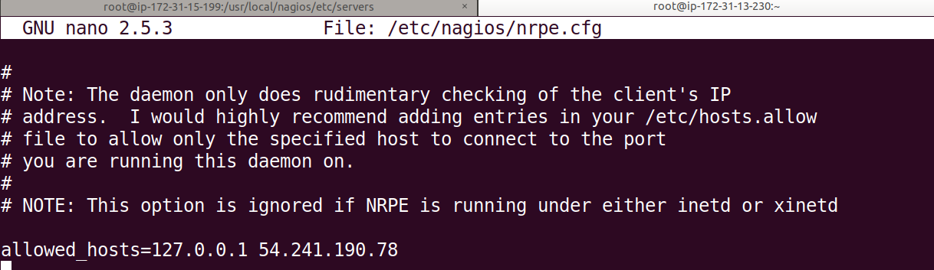

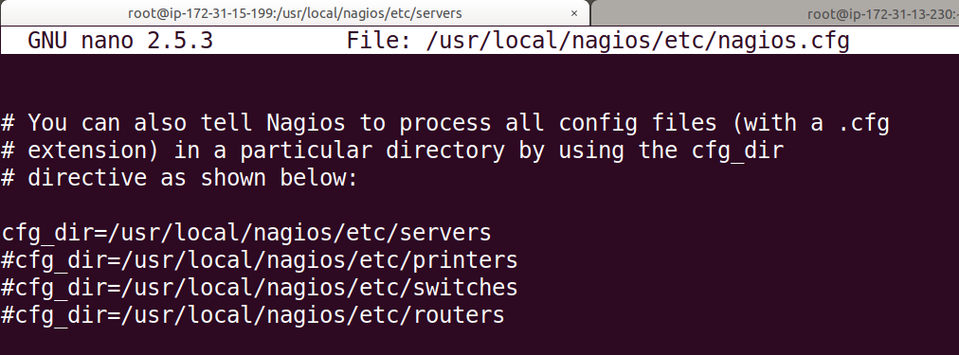

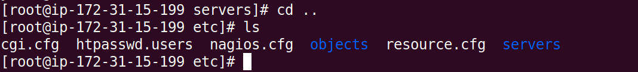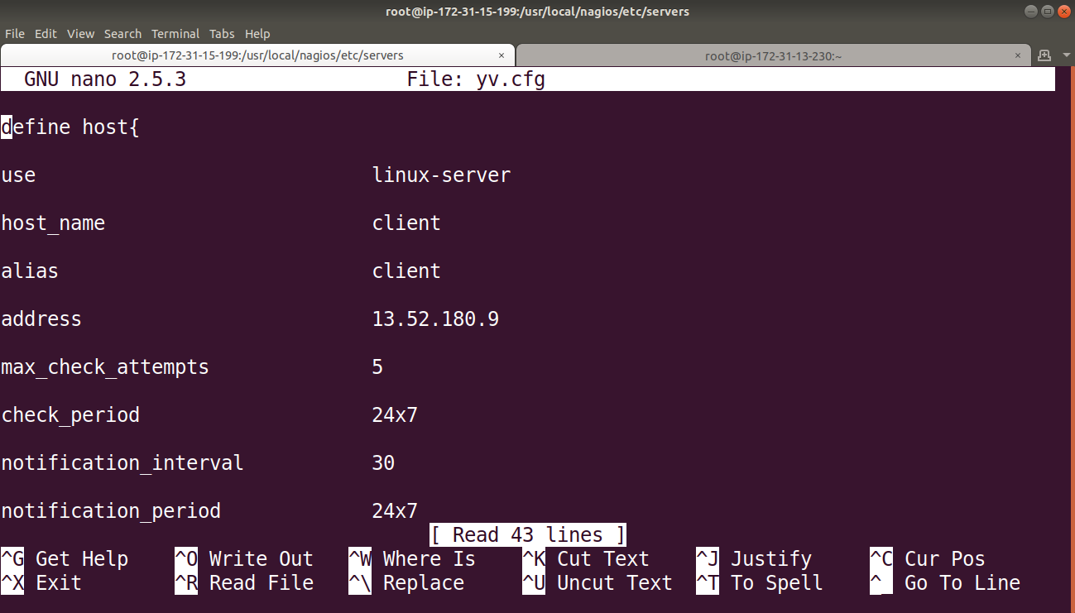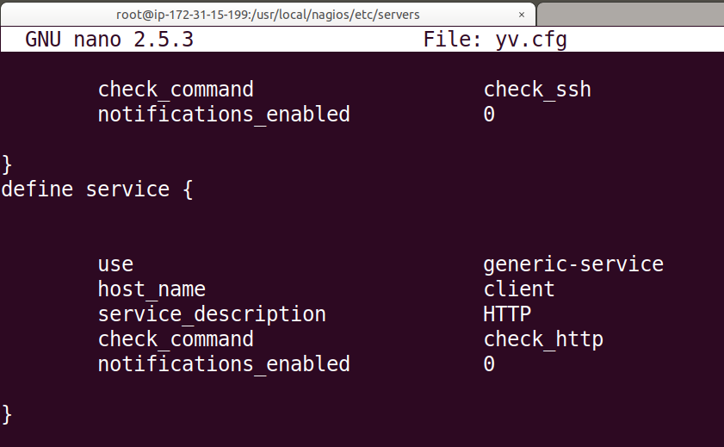

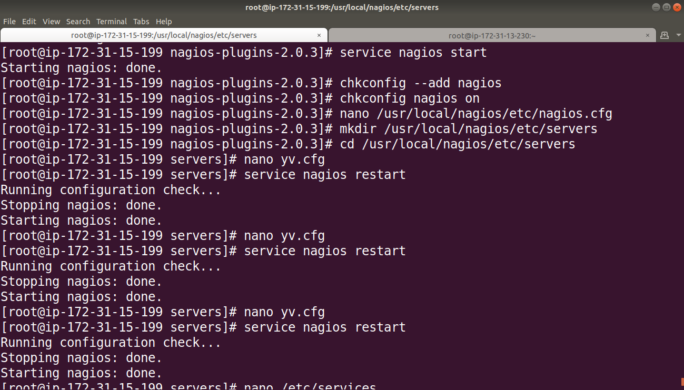

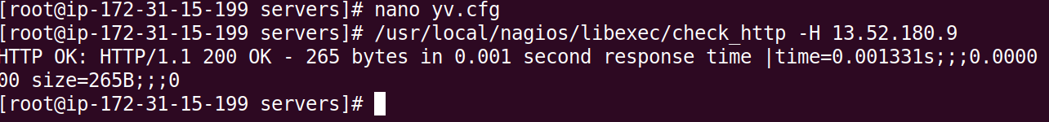

**This is how Nagios administrative console looks:**

