**Jenkins**

**Jenkins** is a [free and open source](https://en.wikipedia.org/wiki/Free_and_open-source_software) automation server. Jenkins helps to automate the non-human part of the [software development](https://en.wikipedia.org/wiki/Software_development) process, with [continuous integration](https://en.wikipedia.org/wiki/Continuous_integration) and facilitating technical aspects of [continuous delivery](https://en.wikipedia.org/wiki/Continuous_delivery). It is a server-based system that runs in [servlet containers](https://en.wikipedia.org/wiki/Java_Servlet#Container_servers) such as [Apache Tomcat](https://en.wikipedia.org/wiki/Apache_Tomcat). It supports [version control](https://en.wikipedia.org/wiki/Version_control) tools, including [AccuRev](https://en.wikipedia.org/wiki/AccuRev_SCM), [CVS](https://en.wikipedia.org/wiki/Concurrent_Versions_System), [Subversion](https://en.wikipedia.org/wiki/Subversion_(software)), [Git](https://en.wikipedia.org/wiki/Git_(software)), [Mercurial](https://en.wikipedia.org/wiki/Mercurial), [Perforce](https://en.wikipedia.org/wiki/Perforce), [TD/OMS](https://en.wikipedia.org/w/index.php?title=TD/OMS&action=edit&redlink=1), [ClearCase](https://en.wikipedia.org/wiki/ClearCase) and [RTC](https://en.wikipedia.org/wiki/Rational_Team_Concert), and can execute [Apache Ant](https://en.wikipedia.org/wiki/Apache_Ant), [Apache Maven](https://en.wikipedia.org/wiki/Apache_Maven) and [sbt](https://en.wikipedia.org/wiki/Sbt) based projects as well as arbitrary [shell scripts](https://en.wikipedia.org/wiki/Shell_script) and Windows [batch commands](https://en.wikipedia.org/wiki/Batch_file). The creator of Jenkins is [Kohsuke Kawaguchi](https://en.wikipedia.org/wiki/Kohsuke_Kawaguchi).Released under the [MIT License](https://en.wikipedia.org/wiki/MIT_License), Jenkins is [free software](https://en.wikipedia.org/wiki/Free_software).

**Jenkins Setup**

> Launch an EC2 server. Allow port number 8080 in its security group.

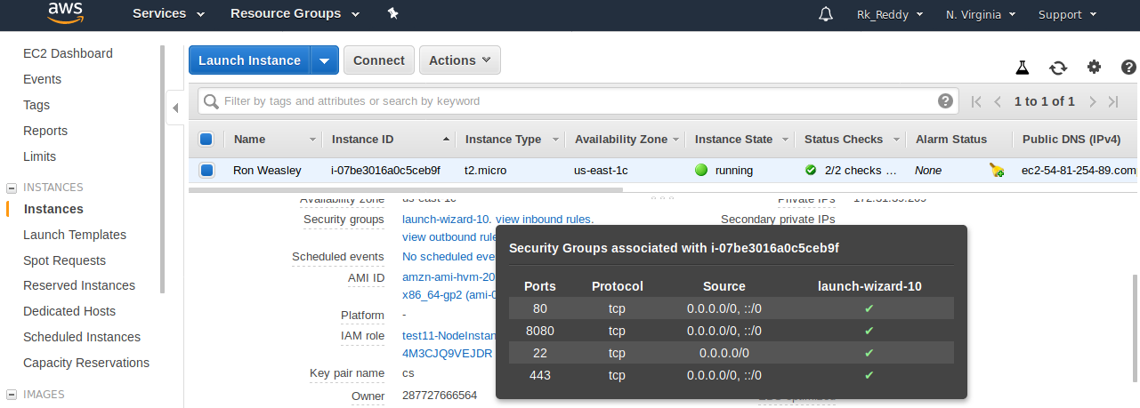

> Launch Jenkins GUI using Instance IP through **8080** port number

> Create a user and role IAM and allow Permission policy of **AmazonS3FullAccess**

> Create a bucket in S3 manually and mention the required details of S3 in post build actions of the Build. Afterwards click on **Build Now.**

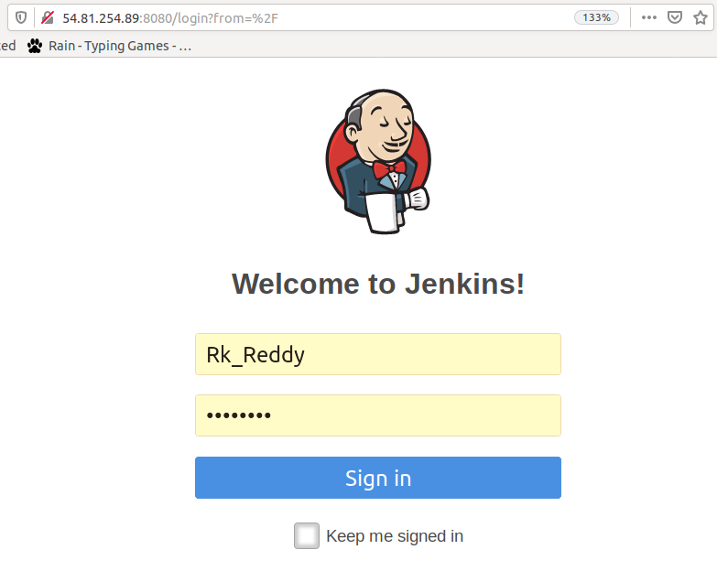

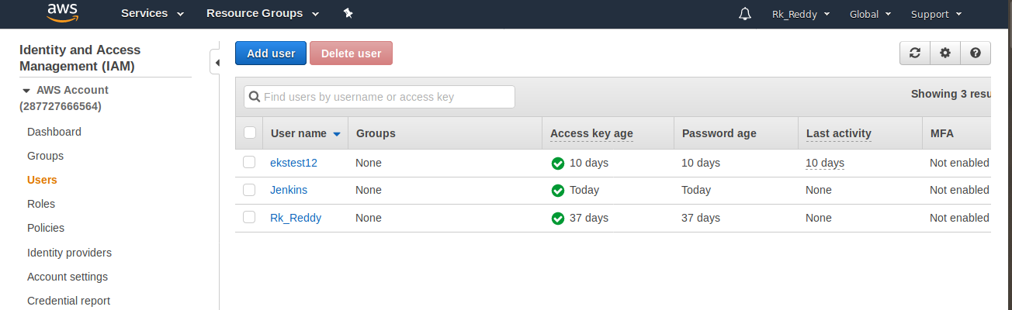

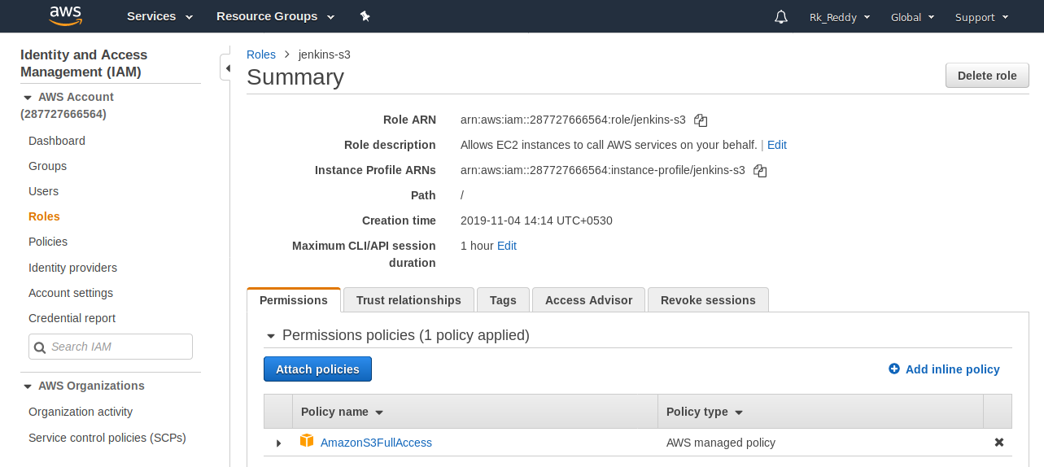

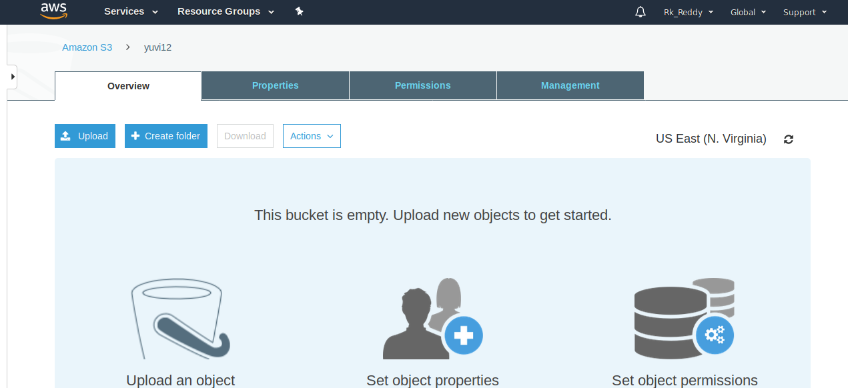

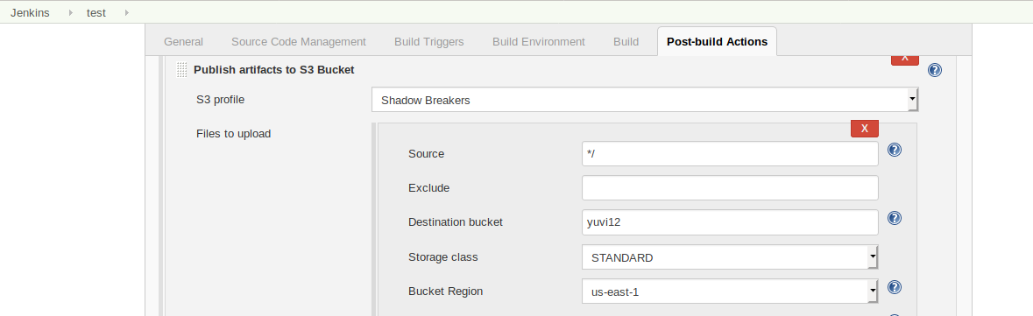

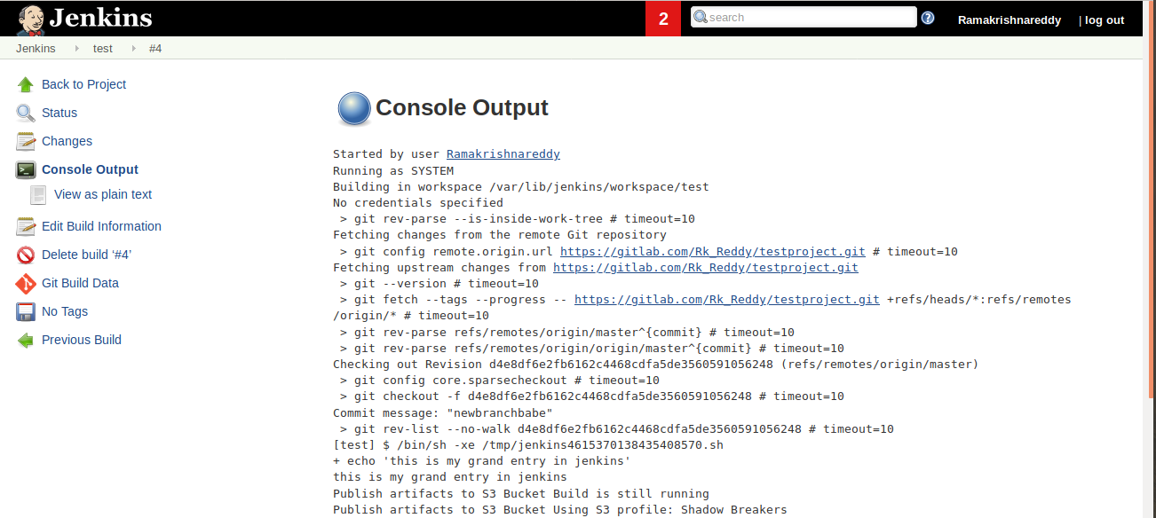

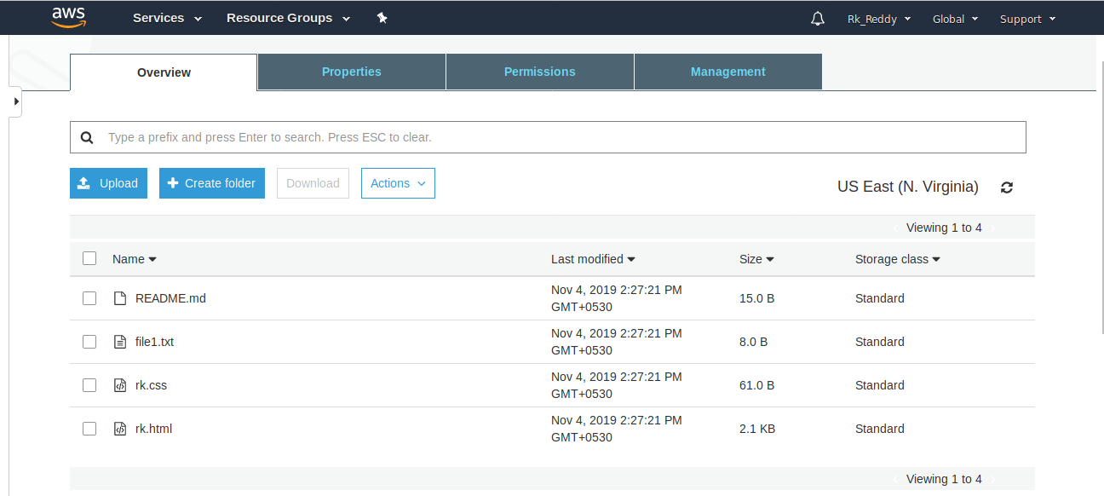

> As you can see the output in the above picture.