DS320 Final Project Report
Predicting Review Sources: IMDB vs RottenTomatoes Using Movie Review Text
Abstract
This project explores the use of data fusion and machine learning to classify the source of movie reviews between IMDB and RottenTomatoes. Initially, sentiment labels were created based on review ratings; however, exploratory data analysis revealed extreme class imbalance, leading to a pivot toward source prediction instead. Two machine learning models, Logistic Regression and Random Forest, were trained on TF-IDF features extracted from review text. Random Forest achieved an accuracy of 92%, significantly outperforming Logistic Regression's 80%. Post-hoc analysis highlighted key words that most strongly predicted each review source. These results demonstrate that simple text-based features can effectively distinguish between different review platforms.
Background
Movie reviews are a rich source of unstructured data, often reflecting nuanced opinions and platform-specific styles. IMDB and RottenTomatoes are two leading review sites, yet their textual content often differs in language, tone, and structure. Classifying the source of a review based solely on its text presents an interesting challenge in natural language processing (NLP) and text classification. Originally, the project aimed to predict sentiment (Positive or Negative) based on review ratings. However, after observing a heavy imbalance favoring Positive reviews, the focus was shifted toward a more feasible task: predicting the review’s source (IMDB or RottenTomatoes) based on text alone.
Methods
Two separate datasets were obtained:
- IMDB Top 1000 Movies: Provided titles, years, overviews, and IMDB ratings.
- RottenTomatoes Top Movies: Provided titles, years, synopses, and critic scores.
After cleaning and aligning the two sources, the datasets were merged into a single file. Each entry contained the review text, release year, and a label indicating the source ('IMDB' or 'RottenTomatoes'). Rows with missing review text were removed. No additional feature engineering was performed beyond text extraction.
The classification models were trained using TF-IDF vectorization to transform the review text into numerical features. Two models were developed and compared:
- Logistic Regression (baseline linear model)
- Random Forest Classifier (ensemble tree-based model)
Data was split into 80% training and 20% testing sets. Hyperparameters were kept simple (default settings with minor adjustments) to prioritize interpretability and rapid prototyping.
Results
Logistic Regression:
- Accuracy: 80%
- Precision (IMDB): 0.86
- Recall (IMDB): 0.58
- F1-Score (IMDB): 0.70
Random Forest:
- Accuracy: 92%
- Precision (IMDB): 0.86
- Recall (IMDB): 0.94
- F1-Score (IMDB): 0.90
The Random Forest model achieved a significantly higher overall performance, particularly balancing precision and recall across both classes.
Feature importance analysis revealed specific words that were highly predictive of each review source. Terms like 'filmmaker' and 'the' appeared more frequently in IMDB reviews, while RottenTomatoes reviews emphasized 'two,' 'man,' and 'woman.' Feature importance plots were generated to visualize these trends.
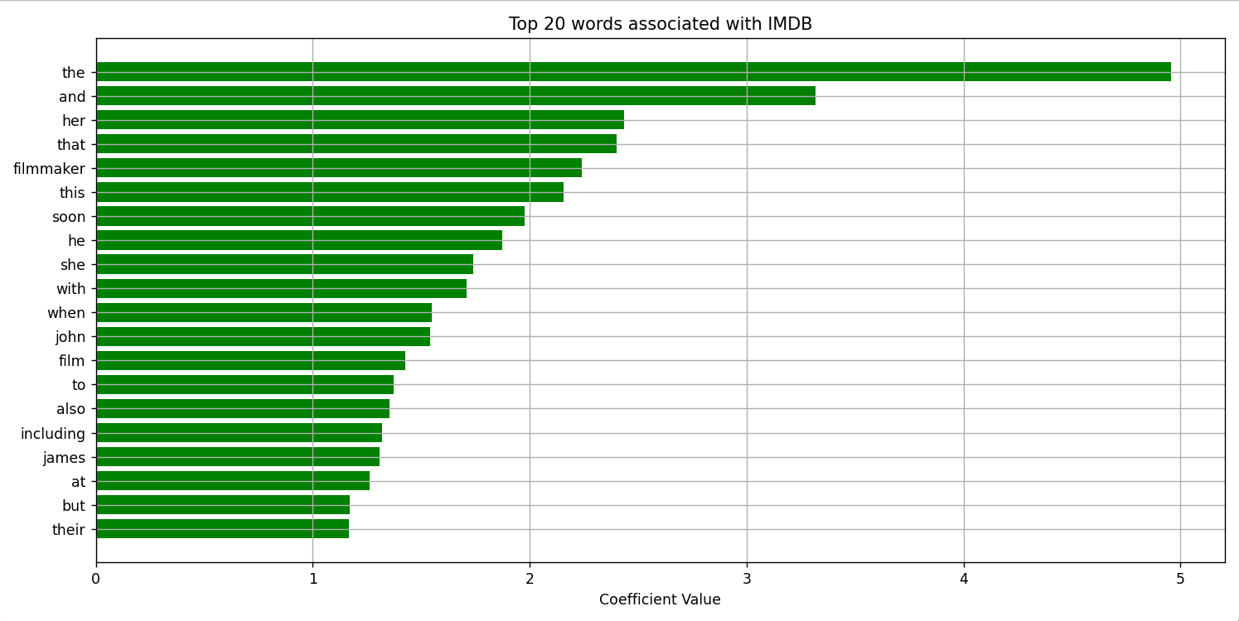
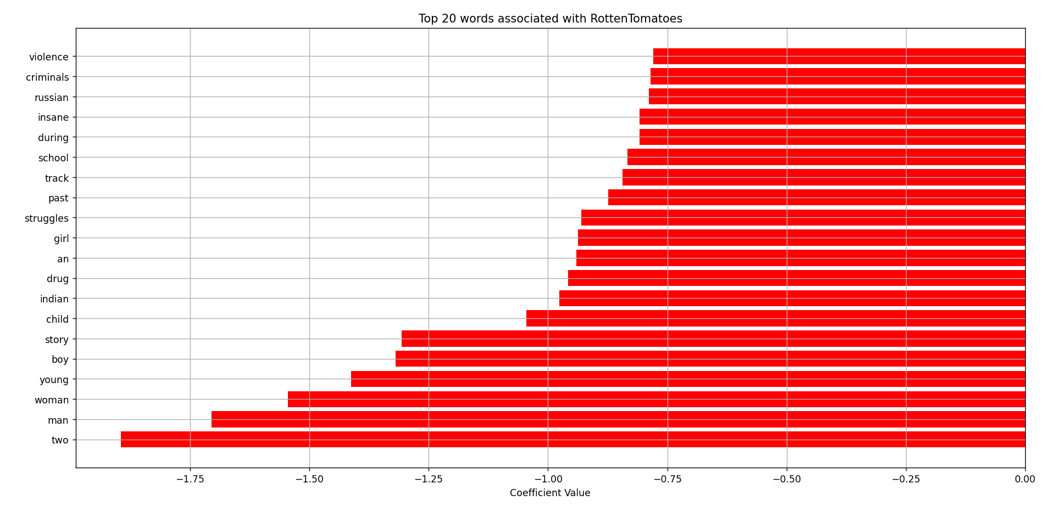
Discussion
The strong performance of both models, especially Random Forest, suggests that linguistic differences between IMDB and RottenTomatoes reviews are significant enough to be machine-learned. The Logistic Regression model, while simpler, struggled with distinguishing IMDB reviews, possibly due to the nuanced and subtle language used.
This project also highlights the importance of exploratory data analysis. Without examining the imbalance in initial sentiment labels, the project could have proceeded toward a much less meaningful and less successful predictive task.
One limitation of the final models is the reliance on shallow textual features (TF-IDF alone) without incorporating metadata like genre or year. Future improvements could explore deep learning models or ensemble methods that consider additional features.
Conclusions
By integrating two major movie review datasets and applying classic machine learning techniques, this project successfully demonstrated the feasibility of classifying the source of a review based solely on its text. The Random Forest model, in particular, provided strong predictive performance, with an overall accuracy of 92%. Exploratory analysis, pivoting the problem based on data realities, and using post-hoc visualization were critical elements to the project's success. This project reinforces the value of flexibility and thorough data understanding when designing real-world predictive models.

