Building Semi-Autonomous Intelligent Pipelines


A Practical Guide to Self-Healing Deployment Pipelines

Author: Randy Kibbe

Forward:
The Death of DevOps & the Rise of AI-Ops

*Adapted from ["The Death of DevOps & the Rise of AI-Ops"](https://medium.com/@rkibbe1/the-death-of-devops-the-rise-of-ai-ops-b35aa20dfd42) by Randy Kibbe*

If you are a DevOps Engineer still performing the same tasks you have for the last year or longer — you're about to be on the next episode of *The Walking Dead*.

You're not going to be writing PowerShell or Bash scripts forever. The days of authoring YAML files, babysitting CI/CD pipelines, and manually gluing services together are coming to an abrupt end. And while many engineers believe they're "on the AI wave" because they use GitHub Copilot for autocomplete in VS Code, that's barely scratching the surface. The newest wave of AI agents isn't just helping you code — they're becoming fully context-aware participants in your environment. The next generation of agents won't simply assist you; they'll replace large portions of what you do today.

But this isn't a doom story — it's a pivot story.

There is a viable, meaningful future for people who embrace AI instead of ignoring it. Imagine a future where you're not authoring brittle scripts, triaging noisy alerts, refreshing dashboards, or jumping onto a Sev-1 call in the middle of dinner. That future is **AI-Ops**.

What is AI-Ops?

AI-Ops isn't just "DevOps with AI sprinkled on top." It's a fundamental rethinking of what operational excellence looks like when execution speed, context-awareness, and real-time decision-making are no longer bottlenecked by humans.

AI-Ops is the integration of autonomous and semi-autonomous agents directly into your operational fabric. These agents don't just observe — they act. They monitor your systems 24/7, correlate telemetry across services, detect anomalies in milliseconds, and in many cases, take the first (or full) remediation steps on your behalf. While DevOps required humans to orchestrate tools, AI-Ops flips that model: **humans orchestrate intent, and AI orchestrates everything else**.

Your pipelines, infrastructure, security posture, performance optimizations, and incident response workflows become living systems that adapt to your environment in real time.

Where AI Agents Fit Today

You don't need to wait for some far-off future to start using these agents. You can embed AI directly into your pipelines today — GitHub Actions, Azure DevOps, GitLab, wherever you ship code. Tools like **Azure SRE Agent** already integrate at every lifecycle touchpoint, acting as a readiness gate before deployment, validating health after deployment, scanning logs, detecting anomalies, and even triggering automated rollback the moment something looks off.

You don't need to rewrite your entire CI/CD architecture. You simply add an AI step that evaluates the environment, analyzes the artifacts, and decides whether to continue, pause, roll back, or alert:

```yaml
- name: AI Pre-Deploy Gate
run: |
curl -X POST $SRE_AGENT_ENDPOINT \
-H "Authorization: Bearer $TOKEN" \
-d '{ "action": "readiness-check", "env": "dev" }'
```

That single block of automation replaces hours of manual checklisting and guesswork. The moment you wire an AI agent into CI/CD, your pipeline stops being a dumb conveyor belt and becomes an intelligent system — one that predicts failures, prevents bad releases, and shortens your operational feedback loop from hours to seconds.

The Shift

Your value as an engineer shifts from *doing the work* to *designing the systems that do the work*. The engineers who thrive in the coming decade won't be those writing the most scripts — they'll be the ones training, guiding, and curating the behaviors of AI agents. They'll design automated policies, evaluate agent recommendations, architect resilient systems that leverage autonomous remediation, and focus on business outcomes instead of mechanical tasks.

This book is a practical guide to making that shift. It documents a working implementation — a real pipeline running in production — that embeds two AI agents into every phase of the deployment lifecycle. It's not theory. It's the blueprint.

Table of Contents
1. Introduction: The Problem with Traditional Pipelines
2. Architecture Overview: Two Agents, One Pipeline
3. The AI Agent: Code Intelligence at Build Time
4. The Azure SRE Agent: Infrastructure Intelligence at Deploy Time
5. MCP Servers: The Connective Tissue
6. Pipeline Design: Composable Template Architecture
7. Pre-Deployment: Readiness Gates and Baseline Capture
8. Post-Deployment: Validation, Rollback, and Incident Response
9. Observability: Health Reports, Baselines, and Reliability Audits
10. Making It Semi-Autonomous: The Trust Spectrum
11. Lessons Learned and What's Next

Chapter 1:
Introduction: The Problem with Traditional Pipelines
The foreword described the macro shift from DevOps to AI-Ops. This chapter gets specific: what exactly breaks in traditional pipelines, and how do intelligent agents fix it? CI/CD pipelines have traditionally been deterministic scripts: run tests, build artifacts, deploy, done. When something fails, a human reads the logs, diagnoses the issue, and either fixes it or rolls back. This model breaks down at scale for three reasons:
1. Log volume: A typical Azure DevOps pipeline generates thousands of lines of output. The signal-to-noise ratio is terrible. Engineers waste hours searching for the one line that matters.
2. Post-deploy blind spots: Most pipelines stop caring the moment deployment finishes. They don't check whether the thing they just deployed is actually working. By the time someone notices a problem, users have already been affected.
3. Tribal knowledge: Knowing what to look for in a deployment — which metrics matter, what "normal" looks like, when to roll back — lives in people's heads. When those people aren't available, deployments stall or fail silently.
This guide describes a working implementation that addresses all three problems by embedding two AI-powered agents directly into the pipeline lifecycle:
- An AI Agent (Azure OpenAI) that reads code, scans for vulnerabilities, reviews logs, and provides expert-level analysis — at build time.
- An Azure SRE Agent (Preview) that monitors infrastructure health, gates deployments, detects anomalies, triggers rollbacks, and files incidents — at deploy time.
Together, they create a pipeline that can reason about what it's deploying, decide whether the environment is ready, validate that the deployment succeeded, and take corrective action when it doesn't — with minimal human intervention.

Chapter 2:
Architecture Overview: Two Agents, One Pipeline
The pipeline is structured as an 8-stage Azure DevOps YAML pipeline. The stages form a linear dependency chain with conditional branches for failure handling:

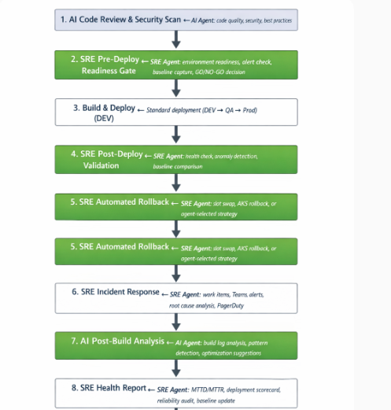

The two agents serve different roles at different lifecycle phases:
AI Agent vs. SRE Agent — Responsibilities Overview

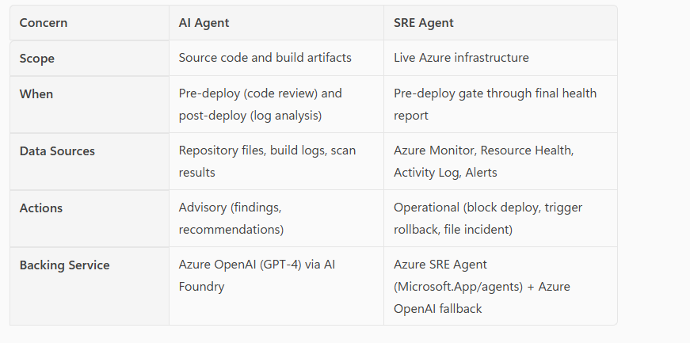

Chapter 3:
The AI Agent
Code Intelligence at Build Time:
The AI Agent is an Azure OpenAI deployment (cicd-ai-agent) accessed through Azure AI Foundry's Responses API. It doesn't have its own resource type in Azure — it's an application endpoint that wraps a GPT-4 model with a project-specific configuration.
What it does - The AI Agent performs three categories of analysis, each implemented as a reusable YAML template:
Five Phases
Phase 1 — File Collection
- Scans the full repository for: .ipynb, .py, .yml
- Converts paths to relative formatting for cleaner reporting
Phase 2 — Security Scanning
- Runs Bandit (Python static analysis)
- Runs a custom secret scanner that checks for:
  - API keys
  - Passwords
  - Connection strings
  - Bearer tokens
  - AWS keys
  - Azure storage keys
  - Private key files
Phase 3 — Best Practices Review
Detects common Databricks/PySpark issues, including:
- SQL injection via f-strings in spark.sql()
- .collect() moving large data to the driver
- Wildcard imports
- Silent exception handling
- print() instead of structured logging
- .toPandas() on large datasets
- Infinite loops and long sleep statements
Phase 4 — AI Deep Analysis
- Sends code samples + static scan findings to Azure OpenAI
- AI reviews:
  - Security
  - Performance
  - Code quality
  - Databricks best practices
  - Data quality
- Produces severity-tagged findings (Critical / Warning / Suggestion)

Phase 5 — Report Generation
- Outputs a Markdown report as a build artifact
Key Design Insight
Automated scanners run first — their findings become part of the AI prompt. This gives the AI deeper context and produces far more accurate, specific analysis.

2. AI Build Log Analysis (ai-build-log-analysis.yml)
Runs after deployment completes or fails.
What It Does
- Fetches full pipeline timeline via Azure DevOps REST API
- Extracts the last 100 lines of each task’s logs
- Combines logs and sends them to the AI Agent
- AI performs:
  - Root cause analysis
  - Warning review
  - Performance issue detection
  - Optimization recommendations

Why It Matters
Instead of engineers manually scrolling through thousands of log lines,
the AI delivers a structured diagnosis with clear remediation steps.

3. AI Resource Optimization (ai-resource-optimization.yml)
Analyzes Databricks configuration and usage for cost and performance.
What It Collects
- Cluster configuration
- Job definitions
- Recent job run history
- Instance pools
- SQL warehouses
What AI Provides
- Cost optimization
- Right-sizing recommendations
- Efficiency improvements

AI Agent Authentication Flow
1. Acquire Azure ML Token
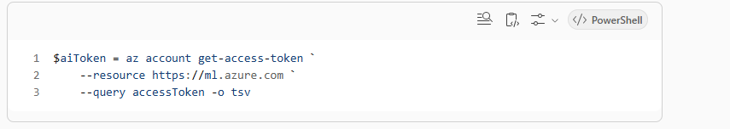

2. Call the AI Responses API
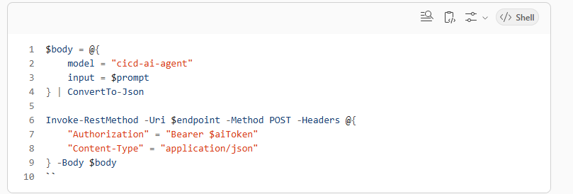

3. Flexible Response Parsing
The template supports multiple Azure OpenAI formats:
- Responses API
- Chat Completions
- Simple text output
This ensures compatibility across evolving API versions.
Chapter 4:
The Azure SRE Agent
Infrastructure Intelligence at Deploy Time:
The Azure SRE Agent is fundamentally different from the AI Agent.
It is a first-party Azure resource (Microsoft.App/agents), currently in preview, with:
- Its own ARM resource type
- Its own Azure CLI extension (az extension add --name sre-agent)
- Its own REST API
This makes it a true infrastructure-aware operational agent, not just an AI endpoint.

Provisioning the SRE Agent
The SRE Agent is provisioned using the ARM REST API, typically via a script such as sre-agent.ps1.
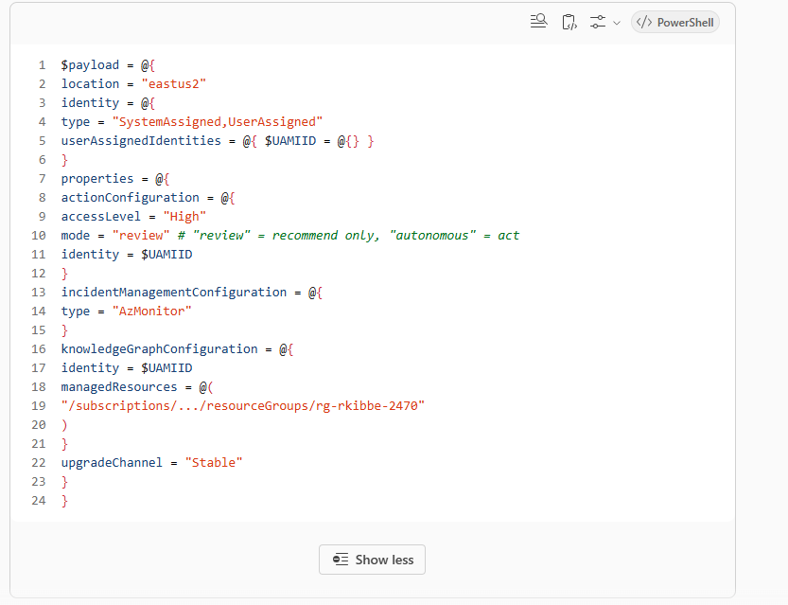 Key Configuration Decisions
- mode = "review"
The agent only recommends actions — safe for initial adoption.
Switching to "autonomous" enables direct, automatic remediation.
- accessLevel = "High"
Grants broad read access across the managed resource scope.
- managedResources
Defines exactly which resource groups the agent can observe.
This acts as a blast radius control.
- User-Assigned Managed Identity (UAMI)
The agent authenticates with a dedicated identity instead of the pipeline’s service connection.
This ensures clean RBAC separation.
Dual-Path Architecture (Native + AI Fallback)
Every SRE Agent action follows the same flow:
- Attempt the native SRE Agent REST API
- If it fails (common during preview), fallback to Azure OpenAI with SRE-specific system prompts
This ensures the pipeline works today, while still future-proofed for full SRE Agent maturity.
PowerShell — Dual-Path SRE Invocation
function Invoke-SREAgentAPI :
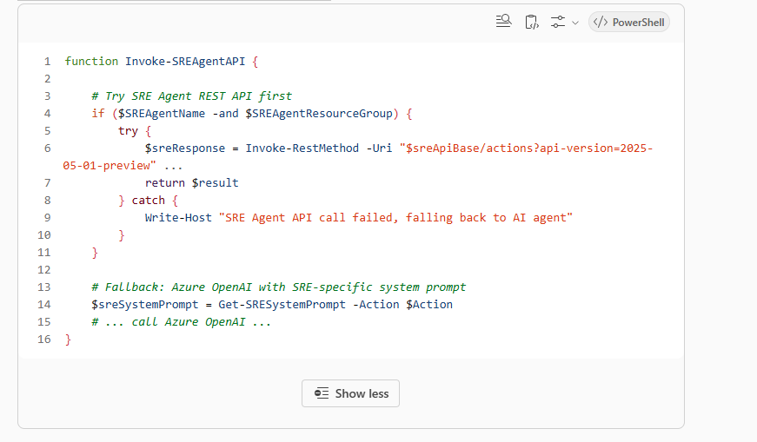
SRE Agent Action Types (Specialized Prompts)
Each SRE action triggers a dedicated system prompt, enabling deep reasoning:
Diagnostics
- Full resource analysis
- Health, error rates, latency percentiles
- Utilization, dependency health, recent changes
Readiness
- Pre-deployment GO/NO-GO decision
- Risk scoring + confidence levels
Audit
- Reliability evaluation
- SLO compliance
- Error budget review
- Configuration drift
- Security posture
Baseline
- Performance comparisons
- Anomaly detection
- Regression identification
Mitigate
- Remediation planning
- Suggested Azure CLI commands
- Impact assessment
- Rollback procedure generation
Why the Dual-Path Matters
This design ensures:
- Immediate reliability through AI fallback
- Future compatibility with the native SRE Agent API
- Consistent behavior even while the service evolves
- Semi-autonomous operations today, fully autonomous operations later

Chapter 5:
MCP Servers: The Connective Tissue
Model Context Protocol (MCP) servers act as the bridge between AI models and external tools/data sources. In this pipeline architecture, MCP plays several roles:
  - Azure Resource Context via MCP
When the AI Agent needs to understand Azure resource topology — what's deployed, how it's configured, what alerts exist — MCP servers provide structured access to Azure Resource Manager, Azure Monitor, and Azure Resource Health APIs. Rather than embedding raw REST calls in prompts, MCP servers expose these as tool calls the model can invoke contextually.
2. Build System Integration
MCP servers can wrap the Azure DevOps REST API, giving the AI Agent structured access to:
- Pipeline run history and trends
- Build timelines and task results
- Work item queries and updates
- Repository metadata
3. Observability Data Pipeline
The SRE Agent's knowledge graph configuration (knowledgeGraphConfiguration) is itself an MCP-like pattern:
it declares which Azure resources the agent can observe, and the agent uses that scope to query Azure Monitor metrics, Resource Health status, and Activity Log events.
4. How MCP Enhances Semi-Autonomy:
Traditional integrations require hardcoded API calls for every data source. MCP inverts this: the model decides what data it needs based on the task context, and MCP servers provide it on demand. This is what enables the
"semi-autonomous" behavior — the agents can explore the environment, discover relevant signals, and make decisions without every query being pre-scripted.
In practice, this means the pipeline can adapt to novel failure modes. If a new type of deployment issue arises that wasn't anticipated when the templates were written, the AI Agent can still reason about it because it has
access to raw data through MCP, not just pre-formatted summaries.

Chapter 6:
Pipeline Design: Composable Template Architecture
The pipeline uses a composable template architecture where every capability is a standalone YAML template with standardized parameters. This design has three important properties:
1. Every template is independently toggleable
yaml
parameters:
- name: runsreagent
type: boolean
default: true
- name: srepredeploygate
type: boolean
default: true
- name: srepostdeployvalidation
type: boolean
default: true
- name: sreautomatedrollback
type: boolean
default: true
Each SRE and AI capability can be turned on or off at pipeline runtime. This is critical for adoption: teams can
start with just AI code review, add the pre-deploy gate once they trust it, enable automated rollback once
they've validated the detection logic, and so on.

2. Shared helper layer
The sre-agent-common.yml template writes a PowerShell helper script to the agent's temp directory, which all
subsequent templates dot-source. This provides:
- Invoke-SREAgentAPI — Unified API client with native/fallback routing
- Get-SRESystemPrompt — Action-specific system prompts
- Get-AIResponseText — Response parsing across API formats
- Get-AzureResourceHealth — Resource Health API wrapper
- Get-AzureMonitorMetrics — Azure Monitor Metrics API wrapper
- Get-AzureMonitorAlerts — Alert Management API wrapper
- Get-AzureActivityLog — Activity Log API wrapper
- Format-SREReport — Standardized report formatting
3. Centralized variables
yaml
variables:
- name: azureOpenAIEndpoint
value: 'https://...services.ai.azure.com/.../responses?api-version=2025-11-15-preview'
- name: azureOpenAIDeployment
value: 'cicd-ai-agent'
The AI endpoint and deployment name are defined once and passed to every template. This avoids
configuration drift when templates are used across multiple pipelines.

Chapter 7:
Pre-Deployment: Readiness Gates and Baseline Capture
Stage 2 of the pipeline is where the SRE Agent earns the "gate" in "readiness gate." Before any code is deployed, two things happen:
1. Environment Readiness Assessment
The pre-deploy gate (sre-pre-deploy-gate.yml) builds a readiness score starting at 100 and deducting points for each risk factor:
- Resource Health Check — Queries Azure Resource Health for every target resource. Any non-"Available"
status is a deduction. "Degraded" loses fewer points than "Unavailable."
- Active Alert Scan — Queries Azure Alert Management for fired alerts. Sev0 alerts can block deployment
entirely. Multiple Sev1 alerts deduct proportionally.
- Recent Activity Analysis — Checks the Azure Activity Log for recent deployments, configuration changes, or
delete operations. Recent changes increase risk.
- SRE Agent Diagnostics — Sends the collected data to the SRE Agent (or AI fallback) for a holistic readiness
assessment. The response includes a GO/NO-GO recommendation.
The final readiness score is compared against the minimumReadinessScore parameter (default: 70). If the
score is below threshold and blockOnNoGo is true, the stage fails and downstream deployment stages are
skipped.

2. Baseline Capture
Before deploying, sre-performance-baseline.yml runs with action: 'capture'. It queries Azure Monitor for key metrics across all target resources:
- Availability
- End-to-end latency (SuccessE2ELatency)
- Server errors
- Transaction counts
For each metric, it calculates statistical properties: average, p50, p95, p99, min, max, standard deviation, and
sample count. This snapshot is saved as a JSON artifact and optionally uploaded to blob storage.
This baseline becomes the comparison point for post-deployment validation. If latency goes up 30% after deployment, the pipeline will detect it.

Chapter 8:
Post-Deployment: Validation, Rollback, and Incident Response
The post-deployment phase is where the pipeline's semi-autonomous capabilities are most visible. Three stages work together as a reactive chain:
Stage 6: Post-Deploy Validation
After deployment completes, the pipeline waits for a configurable warmup period (default: 120 seconds) to let
the new deployment stabilize. Then it runs a multi-step validation:
1. Resource Health Re-check — Are all target resources still healthy?
2. Metrics Snapshot — Current values for availability, latency, errors
3. Anomaly Detection — SRE Agent analyzes metrics for anomalies
4. Baseline Comparison — Current metrics vs. pre-deploy baseline. Any metric deviating more than 20%
(configurable regressionThresholdPercent) flags a regression.
The validation produces a healthScore starting at 100 with deductions for each issue. If failOnUnhealthy is true
and the health score drops below threshold, the stage fails — which triggers the rollback stage.
Stage 8: Automated Rollback
This stage only runs when post-deploy validation fails. It supports five rollback strategies:
| Strategy | How it works |
|----------|-------------|
| slot-swap | Swaps App Service / Functions deployment slots back to the previous version |
| aks-rollback | Runs kubectl rollout undo on the specified AKS deployment |
| revert-deploy | Queues a re-run of the last successful pipeline build |
| custom-script | Executes a user-provided rollback script |
| sre-agent-auto | Sends the failure context to the SRE Agent and lets it choose the strategy |
The sre-agent-auto option is where the semi-autonomous behavior is most apparent. The SRE Agent receives the full failure context — which resources are unhealthy, what metrics regressed, what changed - and recommends the appropriate rollback strategy. In review mode, it recommends. In autonomous mode (not yet enabled), it would execute.
Stage 9: Incident Response
This stage triggers on any failure — deployment failure, validation failure, or even rollback failure. It's the pipeline's "something went wrong, sound the alarm" mechanism:
1. Root Cause Analysis — Sends the full incident context to the SRE Agent for analysis. The response identifies likely causes and recommended remediation.
2. Work Item Creation — Uses the Azure DevOps REST API to create a Bug work item with the incident details, root cause analysis, severity tag, and links back to the build.
3. Teams Notification — Sends an Adaptive Card to a Microsoft Teams channel via webhook. The card includes severity emoji ( / / / ), incident title, build details, and triggers.
4. PagerDuty Integration — Optionally sends a PagerDuty event with severity-mapped urgency levels. The incident response template is designed to always run (condition: always()), even if previous steps failed.
This ensures incidents are always captured, regardless of what went wrong.

Chapter 9:
Observability: Health Reports, Baselines, and Reliability Audits
The final stage of the pipeline generates a comprehensive deployment health report. This isn't just a pass/fail summary — it's a deployment scorecard with operational metrics.
MTTD / MTTR Calculation
The health report template queries the Azure DevOps timeline API to calculate:
- MTTD (Mean Time To Detect) — Approximated as the duration of the post-deploy validation stage. This is the
time between deployment completing and an issue being detected.
- MTTR (Mean Time To Recover) — Approximated as the total pipeline duration for the fix cycle.
These are imperfect approximations, but they establish a measurement baseline that improves over time as the pipeline collects more data.
Deployment Scorecard
Pipeline duration: 14.3 min
Stages: 7 passed, 1 failed, 3 skipped
Est. MTTD: 2.1 min
The scorecard aggregates results across all stages, providing a single-pane view of deployment health.
AI Executive Summary
The health report sends the full pipeline results to the AI Agent with a prompt requesting:
1. Overall health assessment
2. Key risks or issues
3. Recommendations for next deployment
4. Trend observations
This turns raw pipeline data into actionable insights that can be shared with leadership or used in sprint retrospectives.
Baseline Update
On successful deployments, the performance baseline is updated with current metrics. This creates a rolling baseline that adapts to organic changes in traffic patterns and infrastructure, reducing false positives in regression detection.
Reliability Audit
The final step runs a reliability audit that can also be scheduled independently (nightly/weekly). It evaluates:
- SLO Compliance — Current metrics vs. SLO targets (availability 99.9%, p95 latency < 500ms, error rate <
1%)
- Alert History — Volume and severity of recent alerts
- Resource Health Trends — Historical availability status
- Error Budget Status — How much error budget remains

Chapter 10:
Semi-Autonomous: The Trust Spectrum
"Semi-autonomous" is a deliberate design choice, not a limitation. The pipeline operates on a trust spectrum:
Level 1: Advisory Only
- AI code review provides recommendations (engineer decides)
- SRE health reports summarize status (team decides next steps)
- Build log analysis highlights problems (engineer investigates)
Level 2: Gated Automation
- Pre-deploy gate blocks deployment on NO-GO (but can be overridden)
- Post-deploy validation flags unhealthy deployments (rollback is automatic but requires sreautomatedrollback:( true)
- Incident response creates work items and notifications (but doesn't assign or escalate)
Level 3: Supervised Autonomy
- SRE Agent in review mode recommends rollback strategy (human approves)
- sre-agent-auto strategy lets the agent choose the rollback approach
- Agent creates and triages incidents, recommends remediation
Level 4: Full Autonomy (Future)
- SRE Agent in autonomous mode executes remediation directly
- Auto-scaling based on baseline deviations
- Self-healing infrastructure responses
The current implementation operates at Level 2-3. Every parameter has a safe default. Every autonomous
action has a toggle. The pipeline is designed to earn trust incrementally:
yaml
Start conservative
sreblockonnogo: true # Block deploys, but you can override
srefailonunhealthy: true # Flag failures, trigger rollback chain
sreautomatedrollback: true # But rollback strategy is explicit
srerollbackstrategy: 'slot-swap' # Predictable, reversible action
Graduate to semi-autonomous
srerollbackstrategy: 'sre-agent-auto' # Let the agent choose
Eventually actionConfiguration.mode: 'autonomous' # Let the agent act

Chapter 11:
Lessons Learned: What Worked
1. The dual-agent architecture: Separating code-level and infrastructure-level concerns into distinct agents with different backing services was the right call. They have different data sources, different action scopes, and different trust profiles. Forcing them into a single model would have produced worse results for both.
2. The fallback pattern: Having Azure OpenAI as a fallback for the SRE Agent REST API means the pipeline works today, even when the preview service has hiccups. The SRE-specific system prompts in the fallback path produce remarkably good results — they're not as good as the native agent's knowledge graph, but they're good enough to gate deployments.
3. Composable toggles: Making every feature independently toggleable (30+ boolean parameters) initially felt like over-engineering. In practice, it was essential. Teams adopt these capabilities in different orders at different speeds. The inability to turn off one feature without affecting others would have blocked adoption entirely.
4. Statistical baselines over hard thresholds: Using p50/p95/p99 with standard deviation for baseline comparison, rather than fixed thresholds, dramatically reduced false positives. The system learns what "normal" looks like for each resource and adapts.

What's Next
1. Multi-environment baseline correlation: Currently, each environment (dev/qa/prod) has independent baselines. Correlating patterns across environments (e.g., "this regression appeared in dev 3 days before hitting prod") would enable predictive gating.
2. Feedback loops: The AI code review findings should feed back into the best practices pattern list. If the AI consistently flags a pattern that the static scanner misses, that pattern should be added to the automated checks.
3. Cost attribution: The AI Resource Optimization template already collects cluster and job data. Adding cost data from Azure Cost Management would enable ROI calculations: "This pipeline run prevented a $X outage by detecting Y before deployment."
4. Autonomous mode: The SRE Agent's autonomous mode is the logical next step. Start with low-risk actions (creating incidents, adjusting alert thresholds) before graduating to infrastructure changes (scaling, failover).

Appendix A: Template Reference
Repo: Rkibbe123/sre-agent: https://github.com/Rkibbe123/sre-agent
| Template | Agent | Purpose |
|----------|-------|---------|
| ai-code-review.yml | AI | Security scan, best practices, AI code review |
| ai-build-log-analysis.yml | AI | Post-build log analysis and root cause |
| ai-smoke-test.yml | AI | AI-validated smoke tests on Databricks |
| ai-resource-optimization.yml | AI | Databricks workspace optimization recommendations |
| ai-generate-databricks-yml.yml | AI | Auto-generate Databricks bundle YAML |
| ai-test-generation.yml | AI | Auto-generate tests for notebooks |
| sre-agent-common.yml | SRE | Shared helpers, auth, API wrappers |
| sre-pre-deploy-gate.yml | SRE | Pre-deployment readiness assessment |
| sre-post-deploy-validation.yml | SRE | Post-deployment health validation |
| sre-automated-rollback.yml | SRE | Automated rollback on failure |
| sre-incident-response.yml | SRE | Incident creation, notification, RCA |
| sre-performance-baseline.yml | SRE | Baseline capture, compare, update |
| sre-health-report.yml | SRE | Deployment scorecard and executive summary |
| sre-reliability-audit.yml | SRE | SLO compliance and reliability evaluation |
| security-scan.yml | — | Bandit static analysis (no AI) |
| osv-dependency-scan.yml | AI | OSV vulnerability scan with AI triage |

Appendix B: Key Configuration
yaml
Azure OpenAI (AI Agent)
azureOpenAIEndpoint: 'https://...services.ai.azure.com/.../responses?api-version=2025-11-15-preview'
azureOpenAIDeployment: 'cicd-ai-agent'
Azure SRE Agent
sreagentresourcegroup: 'rg-XXXX-2470'
sreagentname: 'rkibbe'
sreagentendpoint: 'https://XXXX--88208374.4650bed8.eastus2.azuresre.ai'
SRE Agent Identity (agent.json)
actionConfiguration.mode: 'review' # review | autonomous
actionConfiguration.accessLevel: 'High'
incidentManagementConfiguration.type: 'AzMonitor'
upgradeChannel: 'Stable'
******** This guide is based on a working implementation. All templates, scripts, and configurations referenced are real and in production use. The Azure SRE Agent is in preview — API versions and capabilities may change.

