Event Capacity Calculation

# Abstract

Land parcel data for Humboldt County was downloaded and spatially analyzed to find suitable locations for a hypothetical music festival. Certain criteria such as proximity to water source and minimum distance to residential areas were considered when searching for the location. A suitable parcel of land was found, and calculations were performed to determine a safe maximum occupancy figure.

# Methods

The first step was to digitize the sections of the land parcel to classify them as parking, event space, and camping zone. After the corresponding shapefiles had been created, geometry calculations were performed to determine adequate maximum occupancy using rough spatial estimates of attendees. For areas housing vehicles, count and capacity were calculated separately.

Parking spaces the equation was and

For the Event field the equation was

For camping area the equation was and

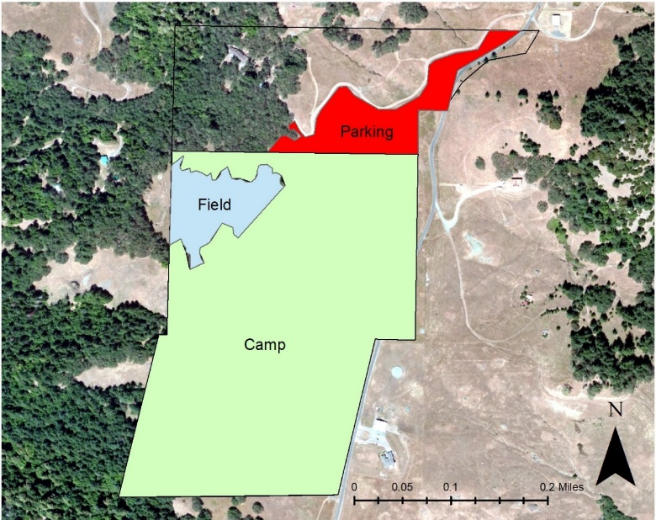

Image 1: Final Map showing field, camp, and parking shapefiles

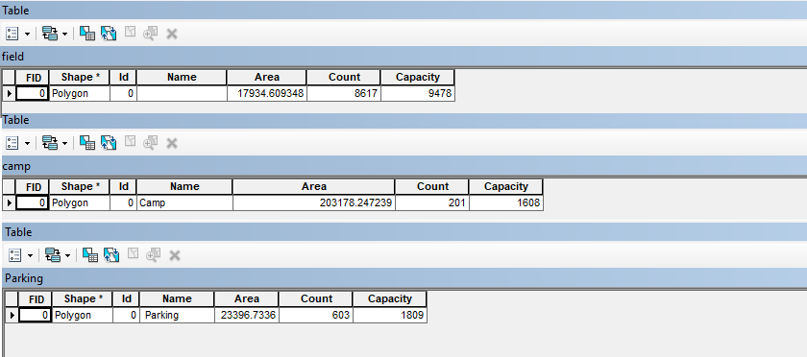

Image 2: Attribute Tables showing count/capacity

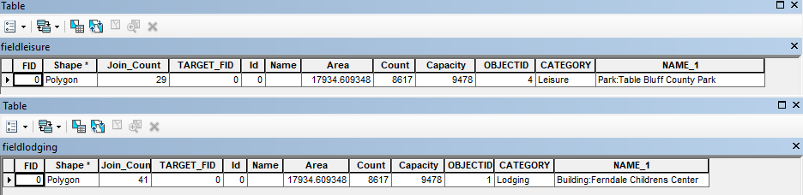

Image 3: Top – Leisure spots: Bottom – Lodging spots

The above attribute tables were used in the final determination of safe maximum occupancy. The capacity of the field is over 9000, more than enough to safely contain every possible eventgoer with the placed limits on camping and parking. These numbers were also calculated keeping the maximum lodging capacity of surrounding areas in mind so as not to potentially overwhelm available facilities.