Name: Rohith Kothandaraman
Github Username: rkothand
purdueID: 31934144
Instructor: Qiu
Problem1_writeup

Estimated Functions:

y1(x) = 21.99x + 92.71
y2(x) = -1.16x^2+ 22.61x + 100.80
y3(x) = 1.67x^3-1.19x^2+ 0.40x + 100.44
y4(x) = -0.0143x^4 1.67x^3-0.91x^2+ 0.34x + 99.76
y5(x) = -2.32x^5-1.96x^4 2.27x^3-0.86x^2+ -2.66x + 99.41

Data Visualization:
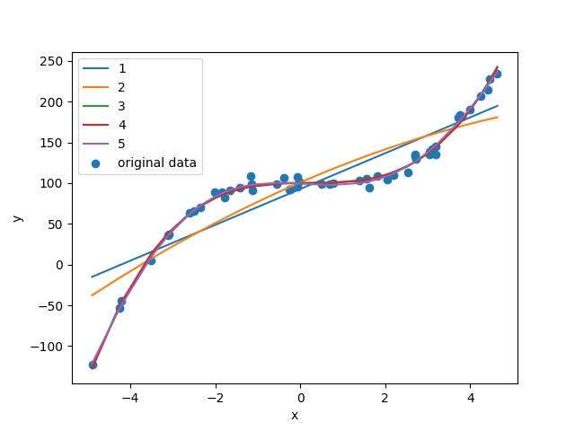
the data best seems to follow a third order polynomial y3 as shown in the low error between the estimated regression function, y3(x), and the data in the plot above. The value of y3(2) is approximately 109.7899139

