Name: Rohith Kothandaraman
Github Username: rkothand
purdueID: 31934144
Instructor: Qiu
Problem1_writeup

Finding best lambda:
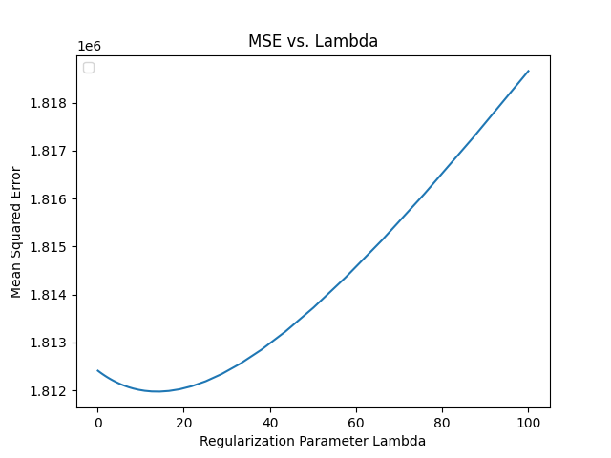
Based on the range of the lambda values tested, the best lambda value is 14.454, which yields an MSE of 1811976.91 as shown on the plot above.

ŷ(x)= 5112.510x1 - 201.034x2 - 207.149x3 - 1331.520x4 + 217.844x5 - 68.752x6 + 500.938x7 + 74.3346825x8 -458.984x9 + 3928.076

The predicted price for a 0.25 carat 3 cut, 3 color, 5 clarity, 60 depth, 55 table, 4x,3y,2z, diamond is -25638.22398 which was determined using the regression model above.

