Q-1. Write an SQL query to fetch “FIRST_NAME” from Worker table using the alias name as <WORKER_NAME>.

A-1. SELECT `First_Name` AS `Worker_Name` FROM `salary`
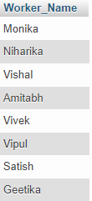

Q-2. Write an SQL query to fetch “FIRST_NAME” from Worker table in upper case.
A-2. SELECT UPPER(`First_Name`) AS `First_Name` FROM `salary`
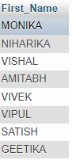

Q-3. Write an SQL query to fetch unique values of DEPARTMENT from Worker table.
A-3. SELECT `Department` FROM `salary`
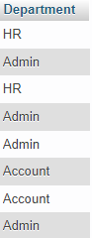

Q-4. Write an SQL query to print the first three characters of FIRST_NAME from Worker table.
A-4. SELECT SUBSTRING(`First_Name`,1,3) AS `First_Name` FROM `salary`
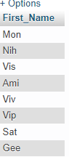

Q-5. Write an SQL query to find the position of the alphabet (‘a’) in the first name column ‘Amitabh’ from Worker table.
A-5. SELECT `First_Name` FROM `salary` WHERE `First_Name` LIKE '%a%'
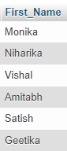

Q-6. Write an SQL query to print the FIRST_NAME from Worker table after removing white spaces from the right side.
A-6. Select RTRIM(“Hii ”) AS `First_Name` from `salary`
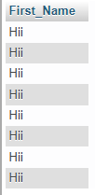

Q-7. Write an SQL query to print the DEPARTMENT from Worker table after removing white spaces from the left side.
A-7. Select LTRIM(" Hey") AS `First_Name` from `salary`
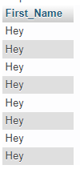

Q-8. Write an SQL query that fetches the unique values of DEPARTMENT from Worker table and prints its length.
A-8. SELECT `Department`,LENGTH(`Department`) AS LENGTH FROM `salary` ;
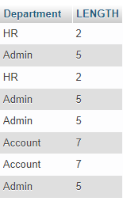

Q-9. Write an SQL query to print the FIRST_NAME from Worker table after replacing ‘a’ with ‘A’.
A-9. SELECT REPLACE(`First_Name`,'a','A') AS 'Replace' FROM `salary`
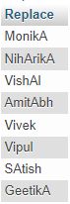

Q-10. Write an SQL query to print the FIRST_NAME and LAST_NAME from Worker table into a single column COMPLETE_NAME. A space char should separate them.
A-10. SELECT CONCAT(`First_Name`," ",`Last_Name`) AS 'Full_Name' FROM `salary`
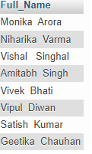

Q-11. Write an SQL query to print all Worker details from the Worker table order by FIRST_NAME Ascending.
A-11. SELECT `Worker_Id`,`First_Name`, `Last_Name`, `Salary`, `Joining_Date`, `Department` FROM `salary`ORDER BY `First_Name` ASC;
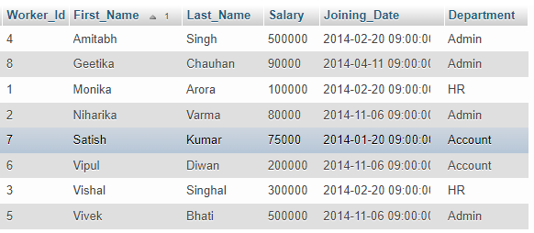

Q-13. Write an SQL query to print details for Workers with the first name as “Vipul” and “Satish” from Worker table.
A-13. SELECT * FROM `salary` WHERE `First_Name`="Vipul" OR `First_Name`="Satish";
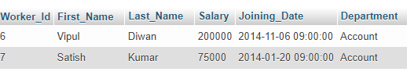

Q-12. Write an SQL query to print all Worker details from the Worker table order by FIRST_NAME Ascending and DEPARTMENT Descending.
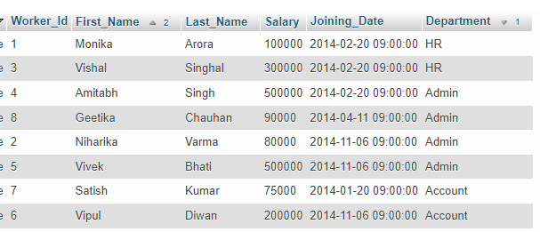
A-12. SELECT `Worker_Id`,`First_Name`, `Last_Name`, `Salary`, `Joining_Date`, `Department` FROM `salary`ORDER BY `Department` DESC, `First_Name` ASC;

Q-14. Write an SQL query to print details of workers excluding first names, “Vipul” and “Satish” from Worker table.
A-14. SELECT * FROM `salary` WHERE NOT `First_Name`="Vipul" OR `First_Name`="Satish";
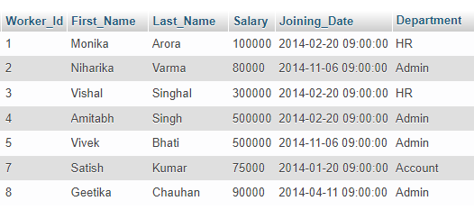

Q-15. Write an SQL query to print details of Workers with DEPARTMENT name as “Admin”.
A-15. SELECT * FROM `salary` WHERE `Department`= "Admin";
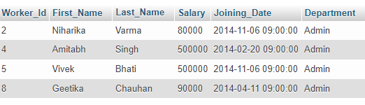

Q-16. Write an SQL query to print details of the Workers whose FIRST_NAME contains ‘a’.
A-16. SELECT * FROM `salary` WHERE `First_Name` LIKE '%a%'
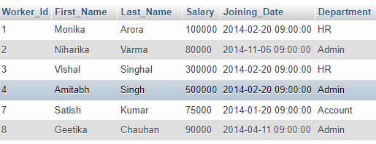

Q-17. Write an SQL query to print details of the Workers whose FIRST_NAME ends with ‘a’.
A-17. SELECT* FROM `salary` WHERE `First_Name` LIKE '%a'
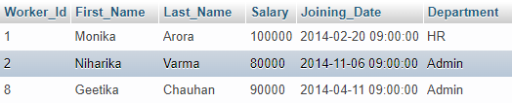

Q-18. Write an SQL query to print details of the Workers whose FIRST_NAME ends with ‘h’ and contains six alphabets.
A-18. SELECT * FROM `salary` WHERE `First_Name` LIKE '______%h'
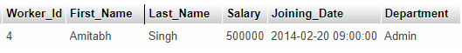

Q-19. Write an SQL query to print details of the Workers whose SALARY lies between 100000 and 500000.
A-19. SELECT * FROM `salary` WHERE `Salary` BETWEEN '100000' AND '500000' ORDER BY `Salary`ASC;
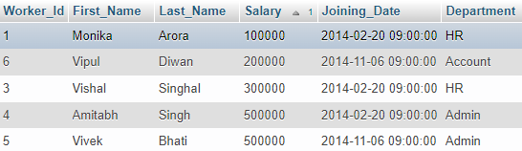

Q-20. Write an SQL query to print details of the Workers who have joined in Feb’2014.
A-20. SELECT * FROM `salary` WHERE `Joining_Date` = '2014-02-20 09:00:00';
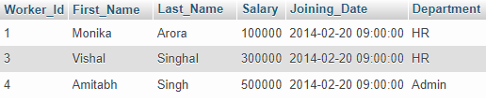

Q-21. Write an SQL query to fetch the count of employees working in the department ‘Admin’.
A-21. SELECT COUNT(`Department`) FROM `salary` WHERE `Department`= 'Admin';
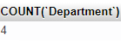

Q-22. Write an SQL query to fetch worker names with salaries >= 50000 and <= 100000.
A-22. SELECT * FROM `salary` WHERE `Salary` BETWEEN '50000' AND '100000' ORDER BY `Salary`ASC;
