1. Select the detail of the employee whose name start with P.
A. SELECT `empname` FROM `empdata` WHERE `empname` LIKE 'P%';
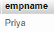

2. How many permanent candidate take salary more than 5000.
A. SELECT COUNT(`salary`) FROM `empsalary` WHERE `salary` > '5000' and `ispermanent` = ‘Yes’;
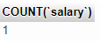

3. Select the detail of employee whose emailId is in gmail.
A. SELECT * FROM `empdata` WHERE `emailid` LIKE '%@gmail.com%';
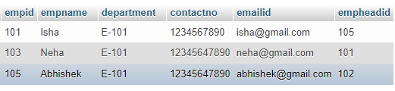

4. Select the details of the employee who work either for department E-104 or E-102.
A. SELECT * FROM `empdata` WHERE `department`= 'E-104' OR `department`='E-102';
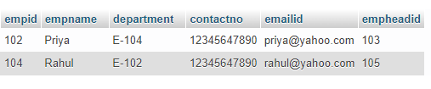

5. What is the department name for DeptID E-102?
A. SELECT LPAD(`deptid`, 5, "E-") AS deptid ,`deptname` FROM `empdept` WHERE `deptid` = '102';
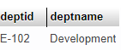

6. What is total salary that is paid to permanent employees?
A. SELECT SUM(`salary`) AS 'Total' FROM `empsalary`;
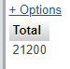

7. List name of all employees whose name ends with a.
A. SELECT `empname` FROM `empdata` WHERE `empname` LIKE '%a';
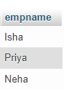

8. List the number of department of employees in each project.
A. SELECT deptname, COUNT(deptname) AS 'Total' FROM empdept GROUP BY deptname;
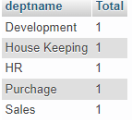

9. How many project started in year 2010.
A. SELECT `startyear`, COUNT(startyear) AS 'TotalProj.' FROM `empproject` WHERE `startyear`='2010'
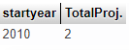

10. How many project started and finished in the same year.
A. SELECT `startyear`,`endyear`,COUNT(*) AS 'Total' FROM `empproject` WHERE startyear = endyear;
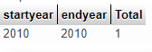

11. select the name of the employee whose name's 3rd charactor is 'h'.
A. SELECT * FROM `empdata` WHERE empname LIKE '__h%'
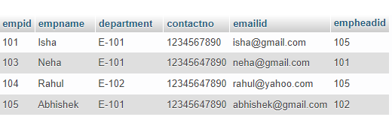

1. Select the department name of the company which is assigned to the employee whose employee id is grater 103.
A. SELECT `deptid`,`deptname` FROM `empdept` WHERE `deptid` > 103;
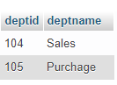

2. Select the name of the employee who is working under Abhishek.
A. SELECT empname FROM empdata WHERE empheadid =(SELECT empid FROM empdata WHERE empname < 'abhishek');//Nothing employee here under Abhishek
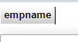

3. Select the name of the employee who is department head of HR.
A. SELECT `empname`,`deptname` FROM `empdept` e1 LEFT JOIN `empdata` e2 ON e1.depthead = e2.empid WHERE deptname = 'HR';
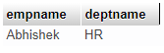

4. Select the name of the employee head who is permanent.
A. SELECT `empname` FROM `empdata` e1 LEFT JOIN `empsalary` e2 ON e1.empid = e2.empid WHERE ispermanent = 'Yes';
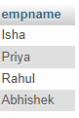

5. Select the name and email of the employee who is not Permanent.
A. SELECT `empname`,`emailid` FROM `empdata` e1 LEFT JOIN `empsalary` e2 ON e1.empid = e2.empid WHERE ispermanent = 'No';
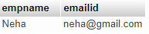

6. Select the employee whose department off is monday
A. SELECT `deptname` FROM `empdept` WHERE `dept_off`='Monday'
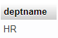

7. select the indian clinets details.
A. SELECT LPAD(`clientid`,4,"cl-")`clientid`, `client_name`,`cname` FROM `clienttable` c1 LEFT JOIN `country` c2 ON c1.cid= c2.cid WHERE cname = 'India';
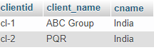

8. select the details of all employee working in development department.
A. SELECT `empid`, `empname`, `department`, `contactno`, `emailid`, `empheadid` FROM `empdept` e1 RIGHT JOIN `empdata` e2 ON e2.empid= e1.depthead WHERE deptname = 'development';
