Q-1. Write an SQL query to fetch “FIRST_NAME” from Worker table using the alias name as <WORKER_NAME>.

A-1. SELECT `First_Name` AS `Worker_Name` FROM `salary`
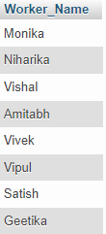

Q-2. Write an SQL query to fetch “FIRST_NAME” from Worker table in upper case.
A-2. SELECT UPPER(`First_Name`) AS `First_Name` FROM `salary`
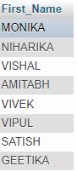

Q-3. Write an SQL query to fetch unique values of DEPARTMENT from Worker table.
A-3. SELECT `Department` FROM `salary`
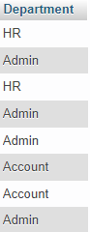

Q-4. Write an SQL query to print the first three characters of FIRST_NAME from Worker table.
A-4. SELECT SUBSTRING(`First_Name`,1,3) AS `First_Name` FROM `salary`
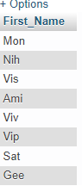

Q-5. Write an SQL query to find the position of the alphabet (‘a’) in the first name column ‘Amitabh’ from Worker table.
A-5. SELECT `First_Name` FROM `salary` WHERE `First_Name` LIKE '%a%'
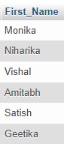

Q-6. Write an SQL query to print the FIRST_NAME from Worker table after removing white spaces from the right side.
A-6. Select RTRIM(“Hii ”) AS `First_Name` from `salary`
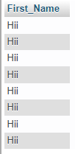

Q-7. Write an SQL query to print the DEPARTMENT from Worker table after removing white spaces from the left side.
A-7. Select LTRIM(" Hey") AS `First_Name` from `salary`


Q-8. Write an SQL query that fetches the unique values of DEPARTMENT from Worker table and prints its length.
A-8. SELECT `Department`,LENGTH(`Department`) AS LENGTH FROM `salary` ;
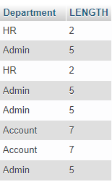

Q-9. Write an SQL query to print the FIRST_NAME from Worker table after replacing ‘a’ with ‘A’.
A-9. SELECT REPLACE(`First_Name`,'a','A') AS 'Replace' FROM `salary`
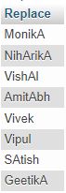

Q-10. Write an SQL query to print the FIRST_NAME and LAST_NAME from Worker table into a single column COMPLETE_NAME. A space char should separate them.
A-10. SELECT CONCAT(`First_Name`," ",`Last_Name`) AS 'Full_Name' FROM `salary`
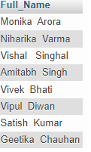

Q-11. Write an SQL query to print all Worker details from the Worker table order by FIRST_NAME Ascending.
A-11. SELECT `Worker_Id`,`First_Name`, `Last_Name`, `Salary`, `Joining_Date`, `Department` FROM `salary`ORDER BY `First_Name` ASC;
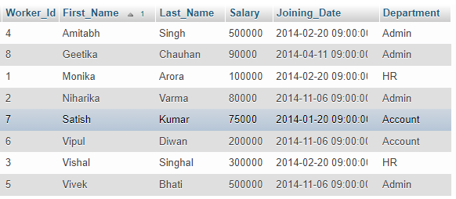

Q-13. Write an SQL query to print details for Workers with the first name as “Vipul” and “Satish” from Worker table.
A-13. SELECT * FROM `salary` WHERE `First_Name`="Vipul" OR `First_Name`="Satish";
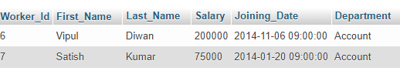

Q-12. Write an SQL query to print all Worker details from the Worker table order by FIRST_NAME Ascending and DEPARTMENT Descending.
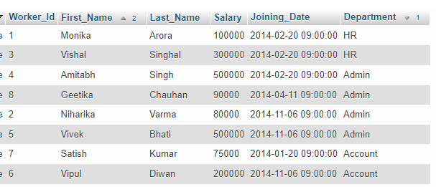
A-12. SELECT `Worker_Id`,`First_Name`, `Last_Name`, `Salary`, `Joining_Date`, `Department` FROM `salary`ORDER BY `Department` DESC, `First_Name` ASC;

Q-14. Write an SQL query to print details of workers excluding first names, “Vipul” and “Satish” from Worker table.
A-14. SELECT * FROM `salary` WHERE NOT `First_Name`="Vipul" OR `First_Name`="Satish";
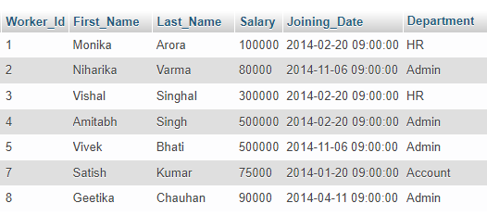

Q-15. Write an SQL query to print details of Workers with DEPARTMENT name as “Admin”.
A-15. SELECT * FROM `salary` WHERE `Department`= "Admin";
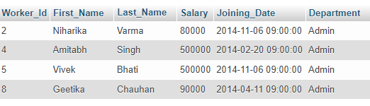

Q-16. Write an SQL query to print details of the Workers whose FIRST_NAME contains ‘a’.
A-16. SELECT * FROM `salary` WHERE `First_Name` LIKE '%a%'
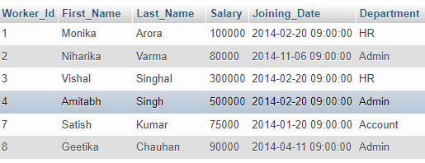

Q-17. Write an SQL query to print details of the Workers whose FIRST_NAME ends with ‘a’.
A-17. SELECT* FROM `salary` WHERE `First_Name` LIKE '%a'
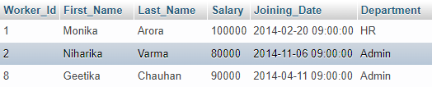

Q-18. Write an SQL query to print details of the Workers whose FIRST_NAME ends with ‘h’ and contains six alphabets.
A-18. SELECT * FROM `salary` WHERE `First_Name` LIKE '______%h'
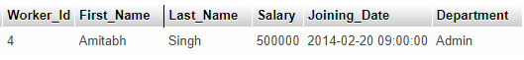

Q-19. Write an SQL query to print details of the Workers whose SALARY lies between 100000 and 500000.
A-19. SELECT * FROM `salary` WHERE `Salary` BETWEEN '100000' AND '500000' ORDER BY `Salary`ASC;
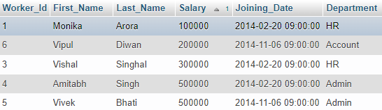

Q-20. Write an SQL query to print details of the Workers who have joined in Feb’2014.
A-20. SELECT * FROM `salary` WHERE `Joining_Date` = '2014-02-20 09:00:00';
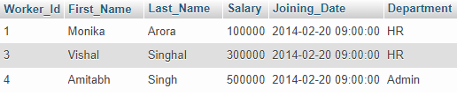

Q-21. Write an SQL query to fetch the count of employees working in the department ‘Admin’.
A-21. SELECT `Department`, COUNT(`Department`) AS 'Count' FROM `salary` WHERE `Department`= 'Admin';
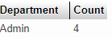

Q-22. Write an SQL query to fetch worker names with salaries >= 50000 and <= 100000.
A-22. SELECT * FROM `salary` WHERE `Salary` BETWEEN '50000' AND '100000' ORDER BY `Salary`ASC;
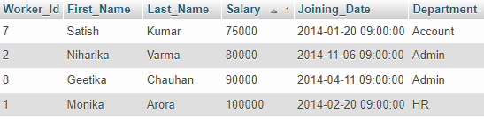

Q-23. Write an SQL query to fetch the no. of workers for each department in the descending order.
A-23. SELECT `Department`, COUNT(`Department`) AS 'Count' FROM `salary` GROUP BY `Department` ORDER BY COUNT(`Department`) DESC;
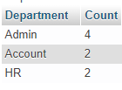

Q-24. Write an SQL query to print details of the Workers who are also Managers.
A-24. SELECT * FROM `title` WHERE `Worker_Title` = 'Manager'
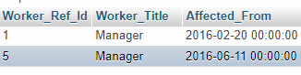

Q-25. Write an SQL query to fetch duplicate records having matching data in some fields of a table.
A-25. SELECT `worker_title`,`affected_from`,COUNT(*) AS 'Duplicate' FROM `title` GROUP BY `worker_title`,`affected_from` HAVING COUNT(*)>1;
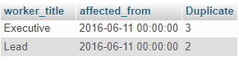

Q-26. Write an SQL query to show only odd rows from a table.
A-26. SELECT * FROM `title` WHERE `Worker_Ref_Id` % 2 = 1
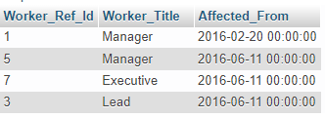

Q-27. Write an SQL query to show only even rows from a table.
A-27. SELECT * FROM `title` WHERE `Worker_Ref_Id` % 2 = 0
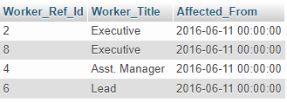

Q-28. Write an SQL query to clone a new table from another table.
A-28. CREATE TABLE `workerclone` LIKE `salary`;
INSERT INTO `workerclone` SELECT*FROM `salary`;
SELECT*FROM `workerclone`;
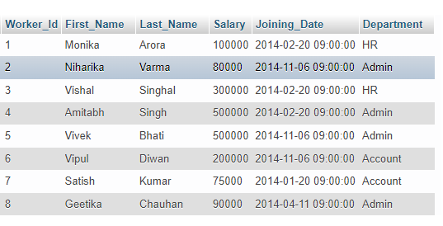

Q-29. Write an SQL query to fetch intersecting records of two tables.
A-29. SELECT `Worker_Ref_Id`, `Worker_Title`,`Bonus_Amount`
FROM `title`
LEFT JOIN `bonus`
ON title.Worker_Ref_Id = bonus.Worker_Id

INTERSECT

SELECT `Worker_Ref_Id`, `Worker_Title`,`Bonus_Amount`
FROM `title`
RIGHT JOIN `bonus`
ON title.Worker_Ref_Id = bonus.Worker_Id;
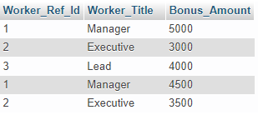

Q-32. Write an SQL query to show the top n (say 10) records of a table.
A-32. SELECT * FROM `salary` LIMIT 10;
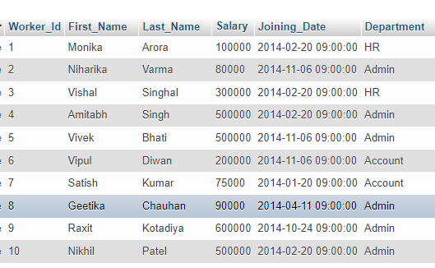

Q-30. Write an SQL query to show records from one table that another table does not have.
A-30. SELECT*FROM salary WHERE First_Name NOT IN(SELECT First_Name FROM workerclone);
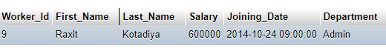

Q-31. Write an SQL query to show the current date and time.
A-31. SELECT CURRENT_TIMESTAMP()


Q-33. Write an SQL query to determine the nth (say n=5) highest salary from a table.
A-33. SELECT DISTINCT * FROM `salary` ORDER BY `Salary` DESC LIMIT 5
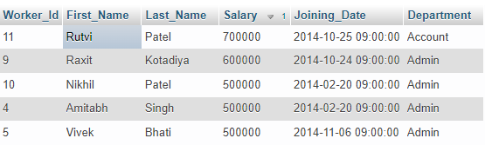

Q-34. Write an SQL query to determine the 5th highest salary without using TOP or limit method.
A-34. SELECT * FROM `salary` s1 WHERE 5=(SELECT COUNT(DISTINCT(s2.Salary))FROM `salary` s2 WHERE s2.Salary>=s1.Salary);
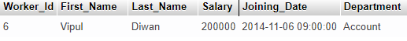

Q-35. Write an SQL query to fetch the list of employees with the same salary.
A-35. SELECT DISTINCT S.worker_id,S.first_name,S.salary from `salary` S, `salary` S1 where S.salary=S1.salary and S.worker_id!=S1.worker_id;
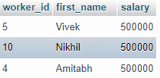

Q-36. Write an SQL query to show the second highest salary from a table.
A-36. SELECT MAX(`salary`) FROM `salary` WHERE `Salary` NOT IN(select Max(`Salary`) from `salary`);
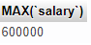

Q-37. Write an SQL query to show one row twice in results from a table.
A-37. Select * from `salary` UNION ALL select * from `salary`
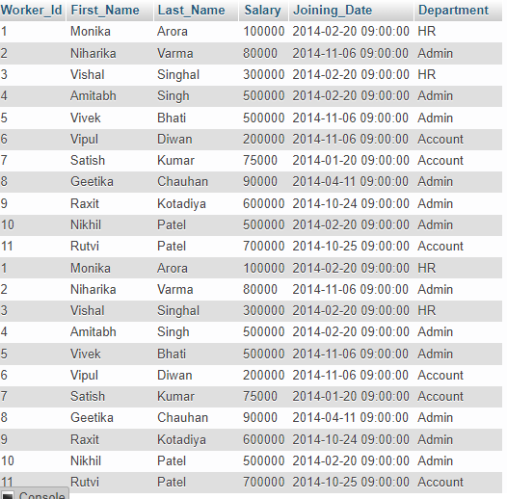

Q-38. Write an SQL query to fetch intersecting records of two tables.
A-38. SELECT*FROM `salary` INTERSECT (SELECT*FROM`workerclone`);
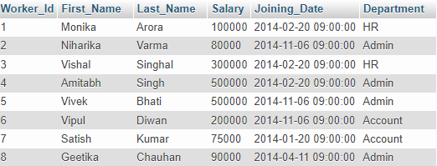

Q-39. Write an SQL query to fetch the first 50% records from a table.
A-39. SELECT*FROM `salary` WHERE Worker_Id<=(SELECT count(Worker_Id)/2 from `salary`);
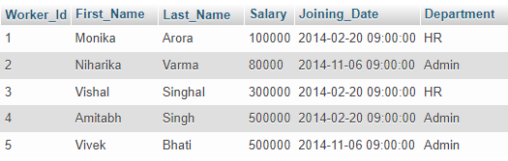

Q-40. Write an SQL query to fetch the departments that have less than five people in it.
A-40. SELECT `Department`,COUNT(`Department`) FROM `salary` GROUP BY `Department` HAVING COUNT(`Department`)<5;
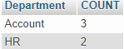

Q-41. Write an SQL query to show all departments along with the number of people in there.
A-41. SELECT `Department`,COUNT(`Department`) FROM `salary` GROUP BY `Department`
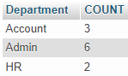

Q-42. Write an SQL query to show the last record from a table.
A-42. SELECT * FROM `salary` WHERE Worker_Id=(SELECT Max(`Worker_Id`) FROM `salary`)
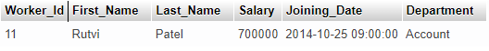

Q-43. Write an SQL query to fetch the first row of a table.
A-43. SELECT * FROM `salary` WHERE Worker_Id=(SELECT MIN(`Worker_Id`) FROM `salary`)
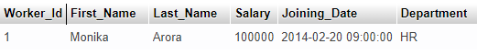

Q-44. Write an SQL query to fetch the last five records from a table.
A-44. (SELECT*FROM `salary` ORDER BY `Worker_Id` DESC LIMIT 5)ORDER BY `Worker_Id` ASC;
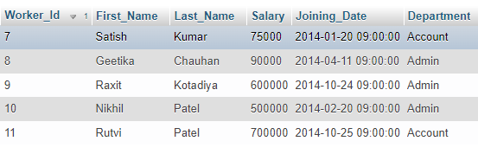

Q-45. Write an SQL query to print the name of employees having the highest salary in each department.
A-45. SELECT `First_Name`,`Department`, `Salary` FROM `salary` WHERE `Salary` IN(SELECT max(`Salary`)AS `Salary` From `salary` GROUP BY `Department`);
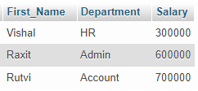

Q-46. Write an SQL query to fetch three max salaries from a table.
A-46. SELECT * FROM `salary` ORDER BY `Salary` DESC LIMIT 3
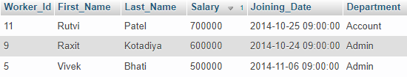

Q-47. Write an SQL query to fetch three min salaries from a table.
A-47. SELECT * FROM `salary` ORDER BY `Salary` ASC LIMIT 3
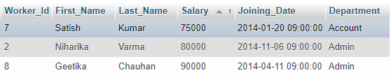

Q-48. Write an SQL query to fetch nth max salaries from a table.
A-48. SELECT `First_Name` ,`Salary` from `salary` order by `salary` DESC limit 3 // 3 Is a nth Value
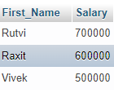

Q-49. Write an SQL query to fetch departments along with the total salaries paid for each of them.
A-49. SELECT `Department`,SUM(`Salary`)FROM `salary` GROUP BY `Department`;
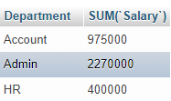

Q-50. Write an SQL query to fetch the names of workers who earn the highest salary.
A-50. SELECT `First_Name`,`Salary` FROM `salary` ORDER BY `Salary` DESC LIMIT 1;
