PRACTICAL-1

Practical 1: Project Initiation, Requirement Analysis, Sitemap, Wireframe, and GitHub Setup.

Problem Definition:Initiate the semester-long StudentHub portal by identifying the problem scope, user roles, key modules,navigation flow, and minimum 10 pages.Create a sitemap, low-fidelity wireframe, project folder structure,README file, and GitHub repository.

A. Theory
- What is URL and parts of URL?
Answer:A URL (Uniform Resource Locator) is the address of a website on the Internet. It helps us open a website or webpage in a browser.
eg.https://www.example.com
Reference link: https://developer.mozilla.org/en-US/docs/Learn_web_development/Howto/Web_mechanics/ What_is_a_URL

- How does HTML file process in web browser?
Answer:When we open an HTML file in a web browser, the browser reads the HTML code. Then it shows the webpage on the screen. If the page has CSS and JavaScript, the browser also loads them.

Reference link:
https://www.w3schools.com/html/

- How will page navigation flow managed among all HTML pages?
Answer:We use links (<a> tag) to move from one page to another. When we click a link, the next HTML page opens. In this way, all HTML pages are connected.

Reference link:
https://www.w3schools.com/html/html_links.asp

- How will GitHub commits be maintained after each practical?
Answer:After every practical, we will upload our work to GitHub and make a commit. This keeps our work updated.

Implementation/ Output/Result (Keep only one option which is suitable to practical)
- Implementation
  - Created the StudentHub project.
  - Created the project folder structure.
  - Created a sitemap and wireframe.
  - Created a README file.
  - Created a GitHub repository.
  - Planned the project pages and navigation.
- Evidence of Work (Screenshots)
Figure 1.1: StudentHub Sitemap
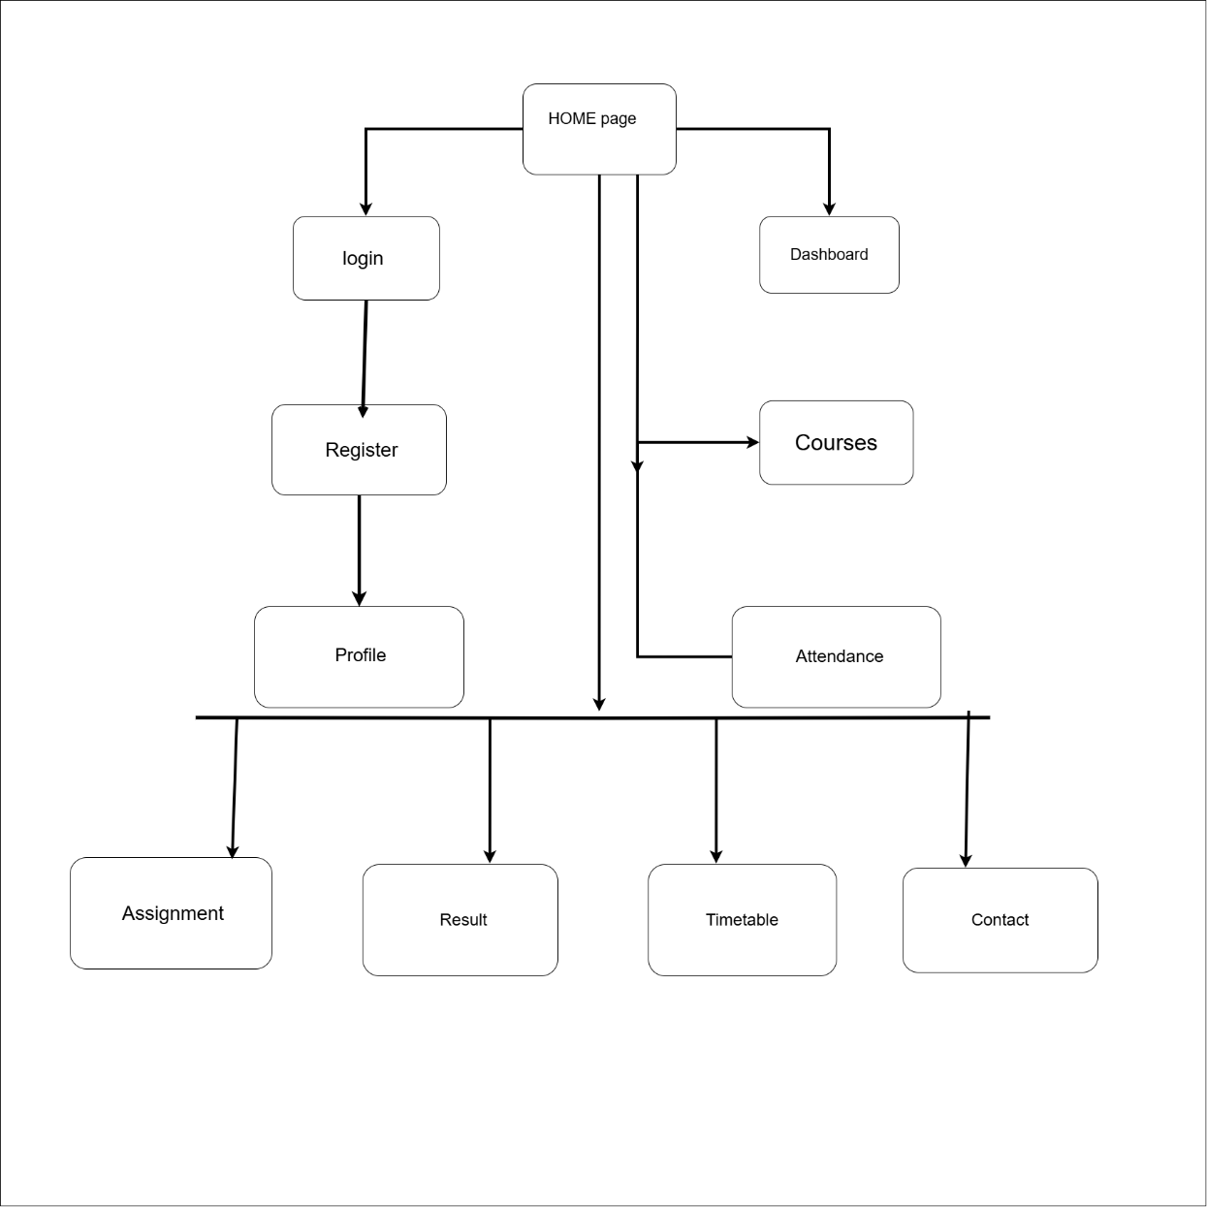
Description: This screenshot shows the sitemap of the StudentHub project.

Figure 1.2: StudentHub Wireframe
Description: This screenshot shows the wireframe of the StudentHub project. 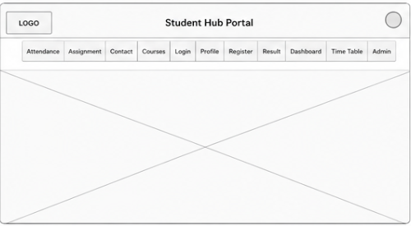
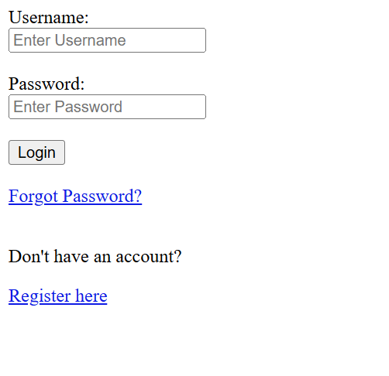
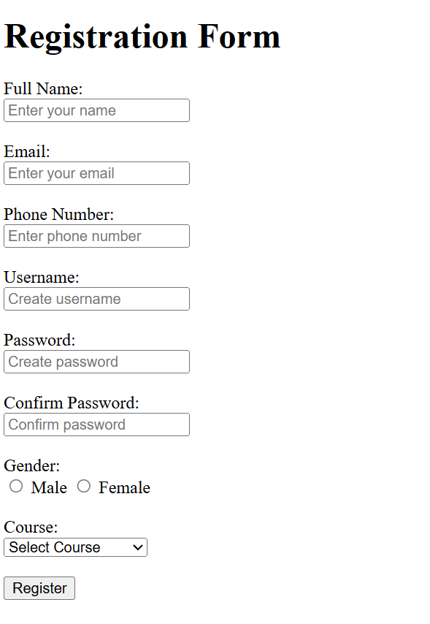
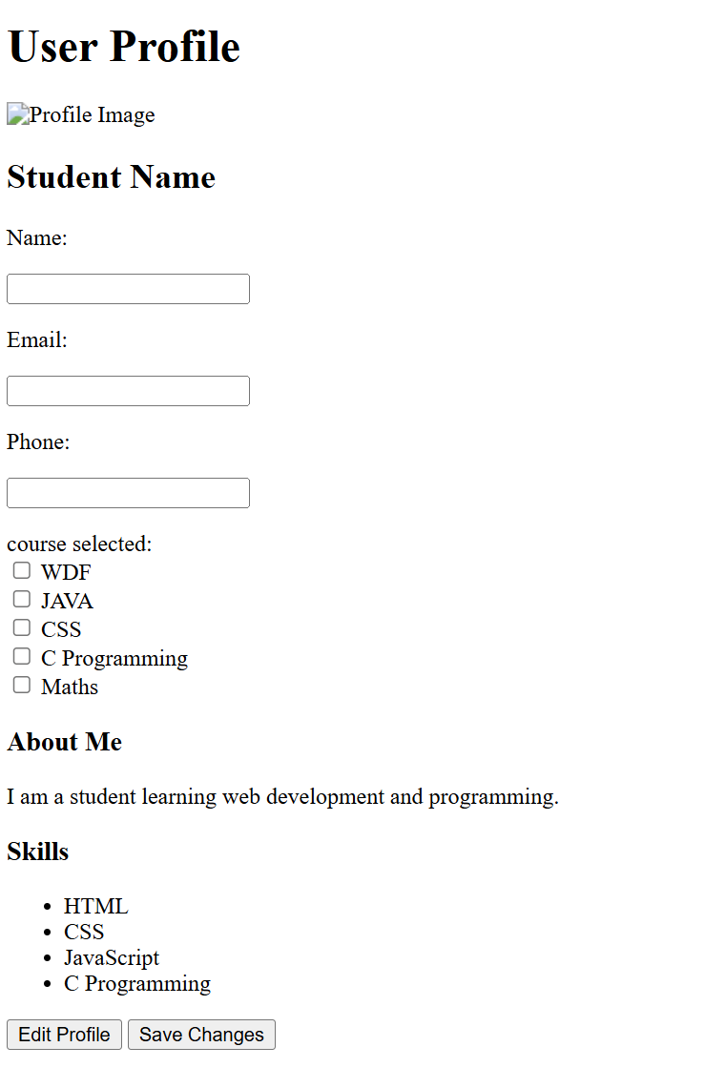
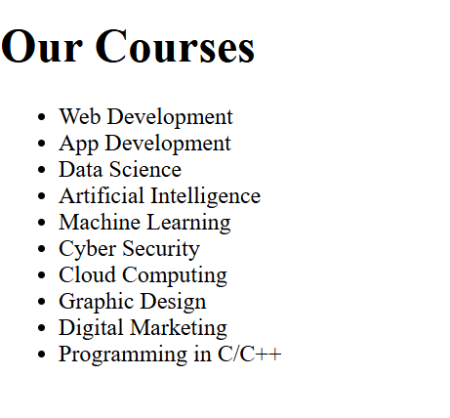
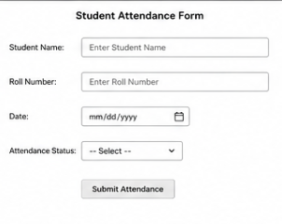
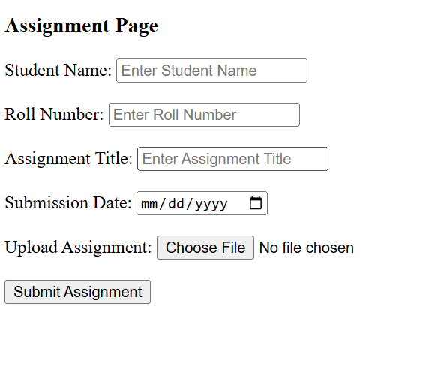
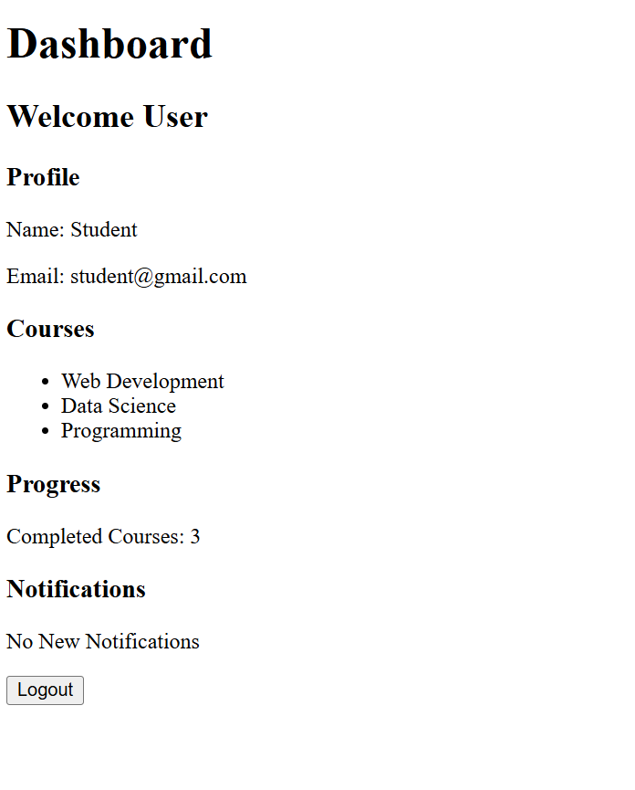

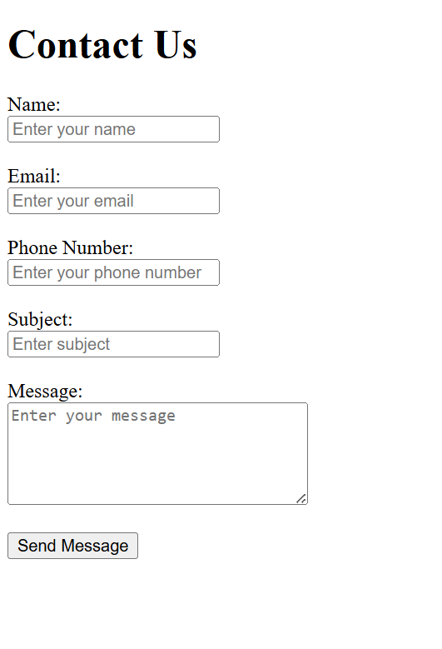
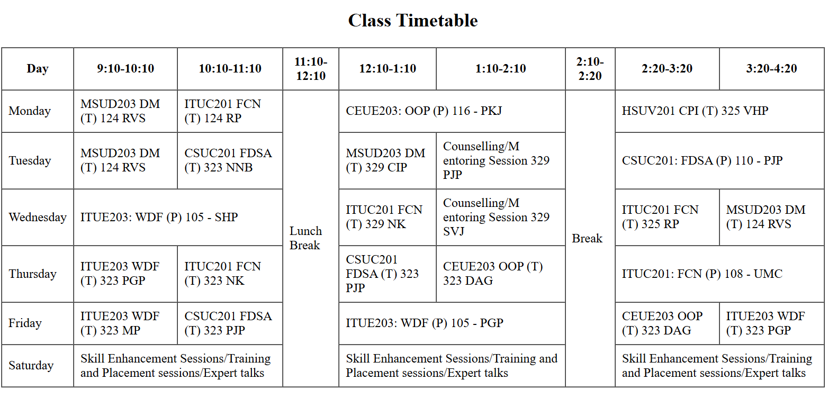
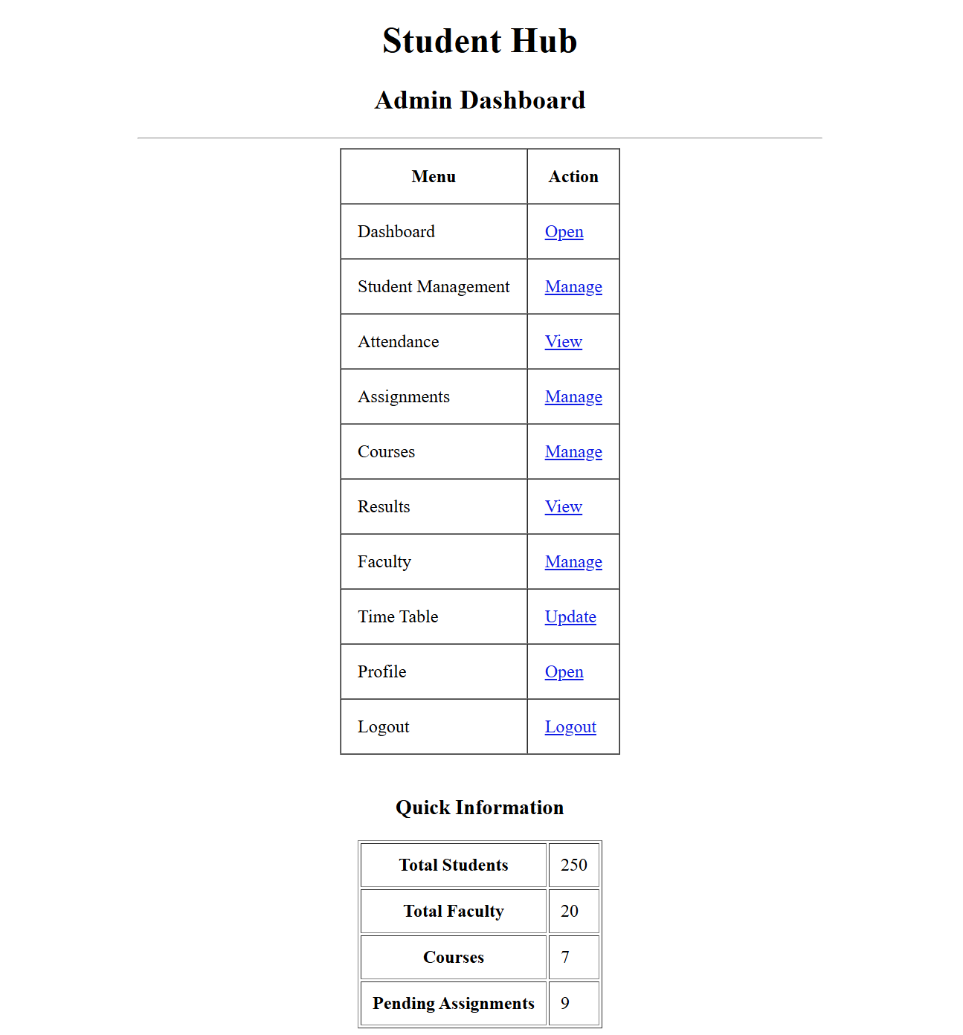

- GitHub Repository Link:
https://github.com/Rkpatel34/StudentHub
- Challenges Faced:
- Understanding the project.
- Creating the sitemap.
- Creating the wireframe.
- Setting up GitHub.

Learning Outcome:
Students will be able to analyze requirements and prepare a structured project foundation before implementation. Creating sitemap and wireframes.

Challenges Faced :
Creating wireframes for all project pages.

