PRACTICALE-3

Practical 3: Responsive UI Design using CSS Grid, Flexbox, and
Bootstrap/Tailwind

Problem Definition:Design responsive layouts for Home, About, Registration, Dashboard, and Events pages using CSS Grid and Flexbox. Optional to use CSS framework such as Bootstrap or Tailwind. Ensure mobile-first responsiveness.

Key Questions

- How does the layout adapt for mobile, tablet, and desktop screens?

Answer:The layout changes to fit the screen size. It works on mobile, tablet, and desktop.
Reference Link https://www.w3schools.com/css/css_rwd_intro.asp

- Which layout technique is used and why?

Answer:A simple HTML and CSS layout is used. It is easy to create and easy to understand. Reference Link
https://www.w3schools.com/css/

- Are typography, spacing, colors, and contrast readable?

Answer:Yes. The text, colors, and spacing are clear and easy to read.

- Is the framework used consistently without unnecessary inline CSS?

Answer:Yes. Most of the CSS is in the style.css file. Only a few inline styles are used.

Implementation
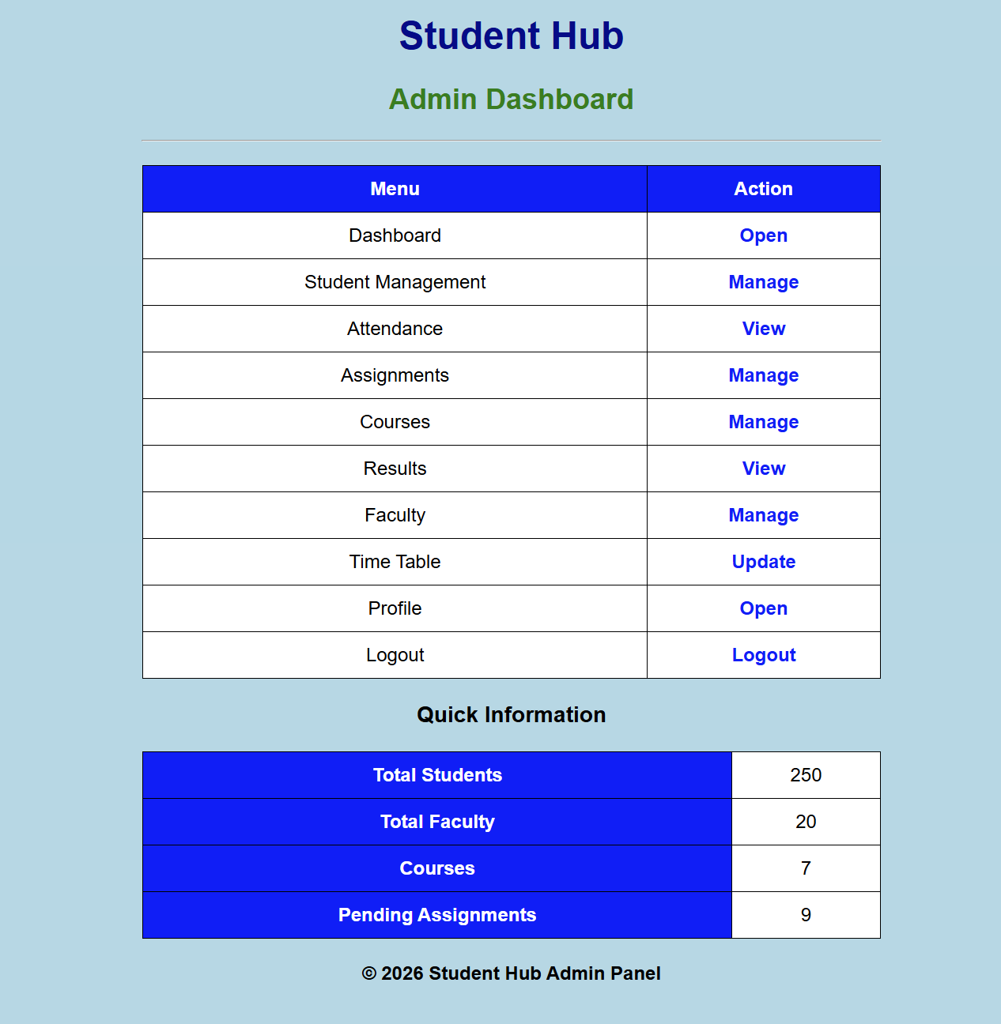

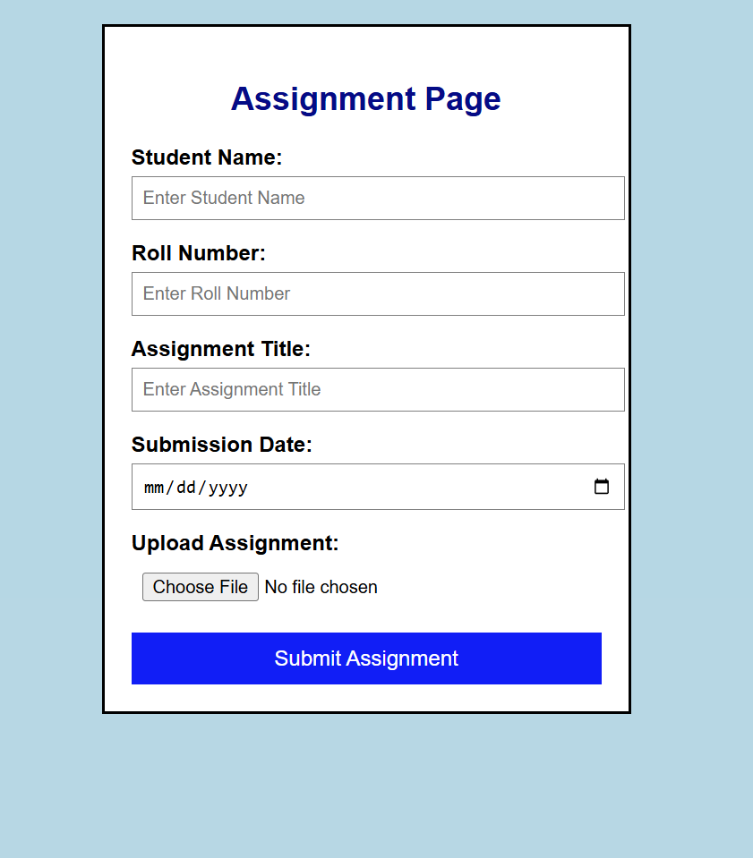

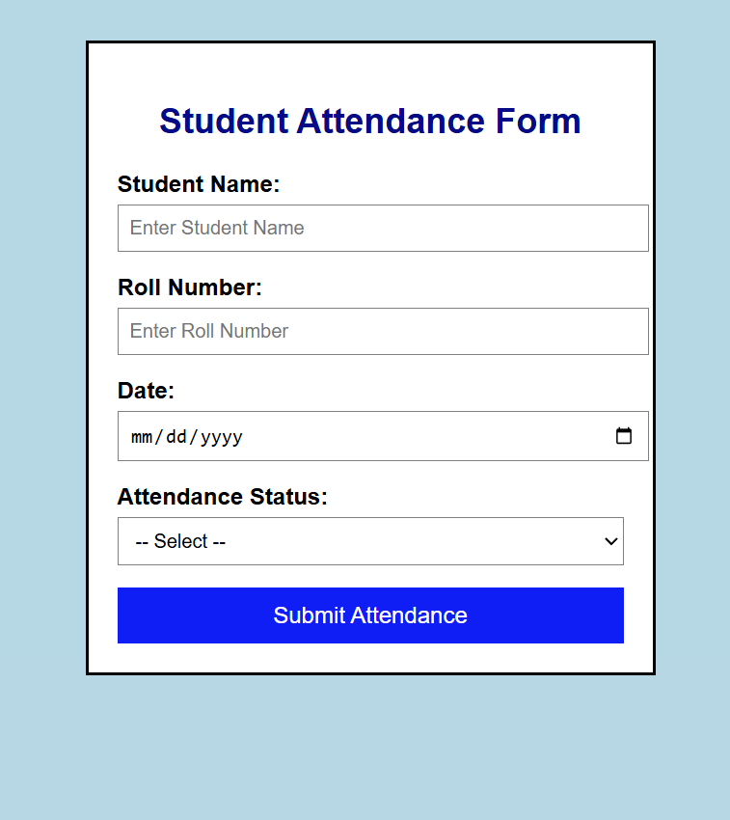

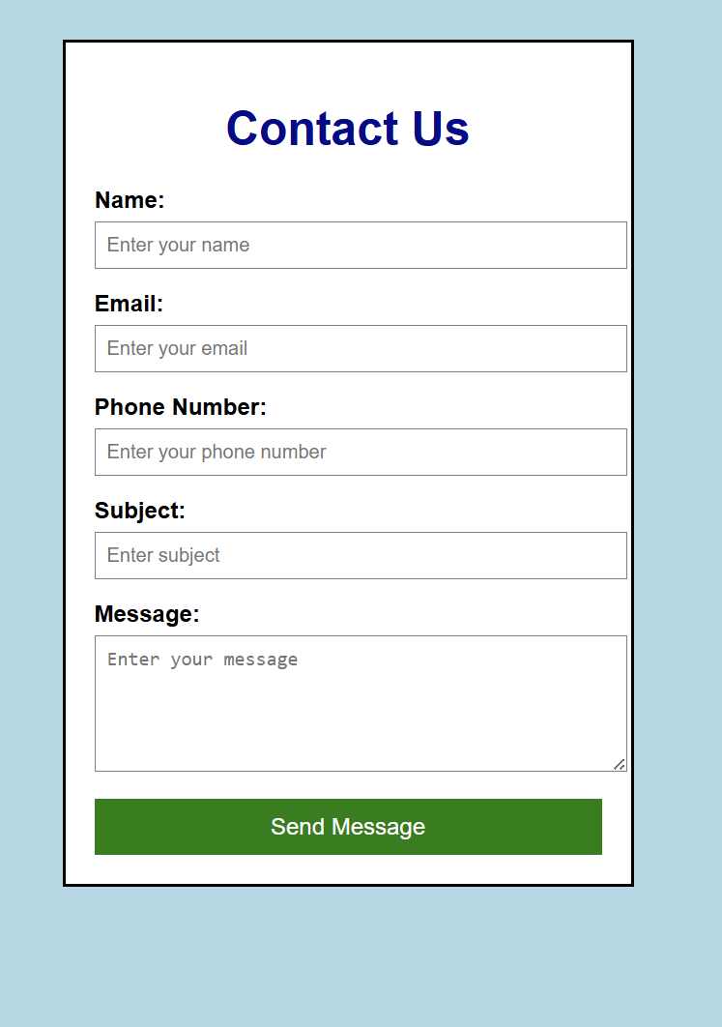

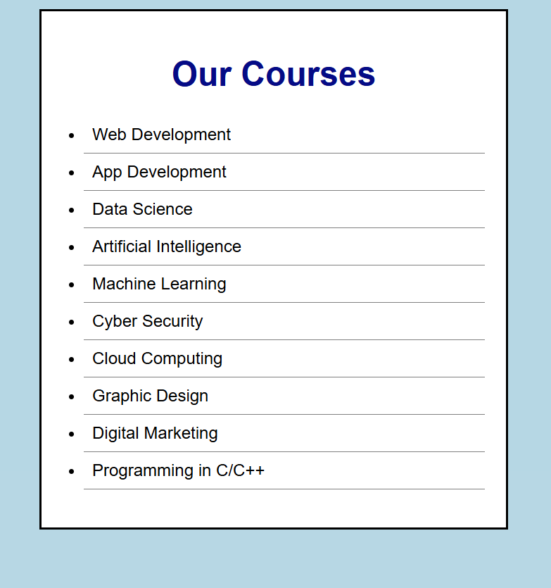

</html>
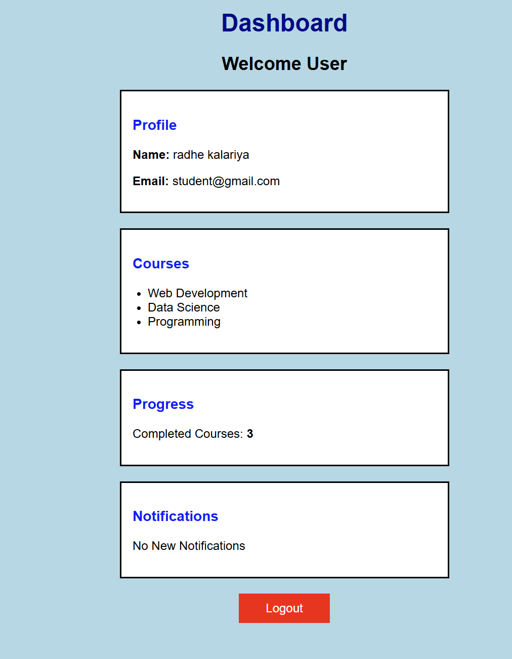

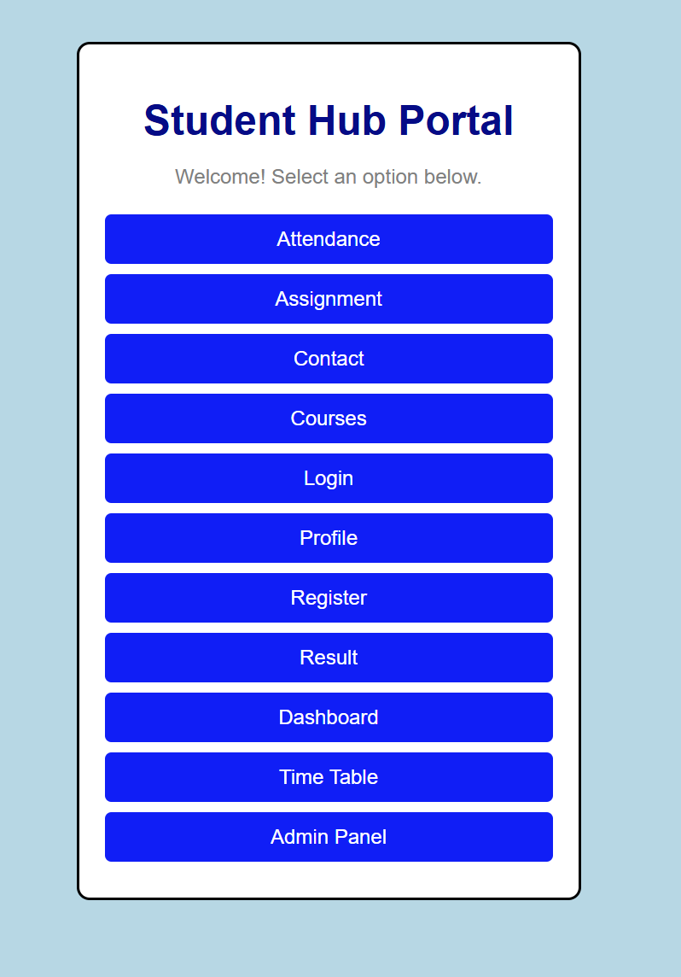

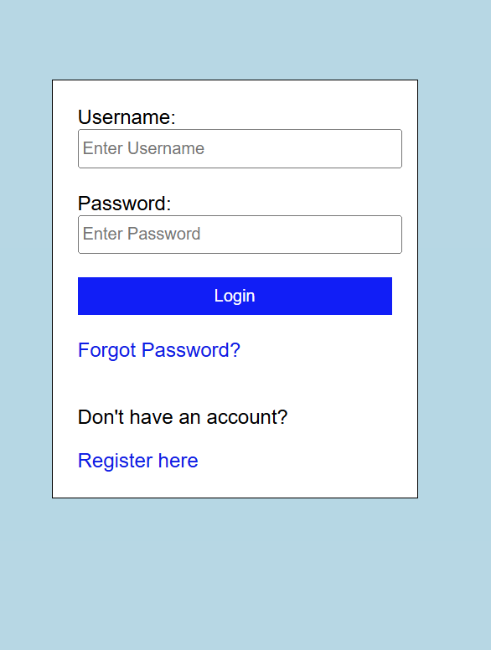

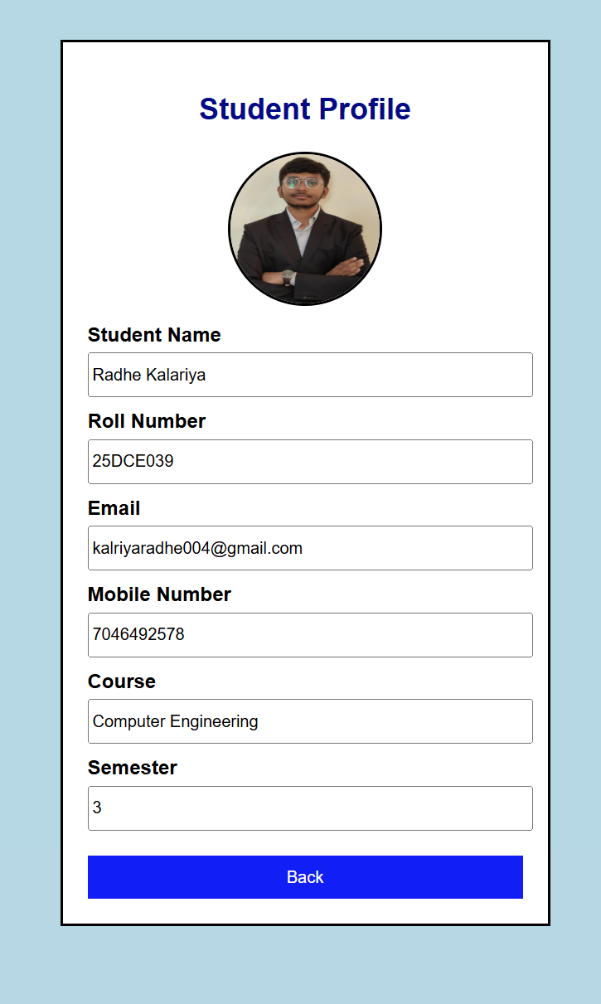

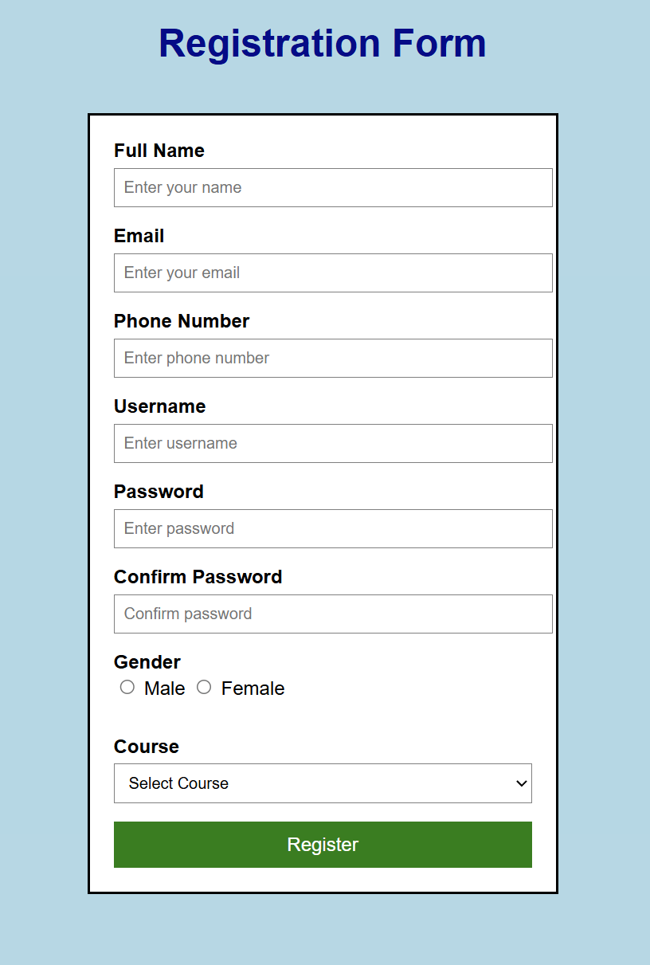

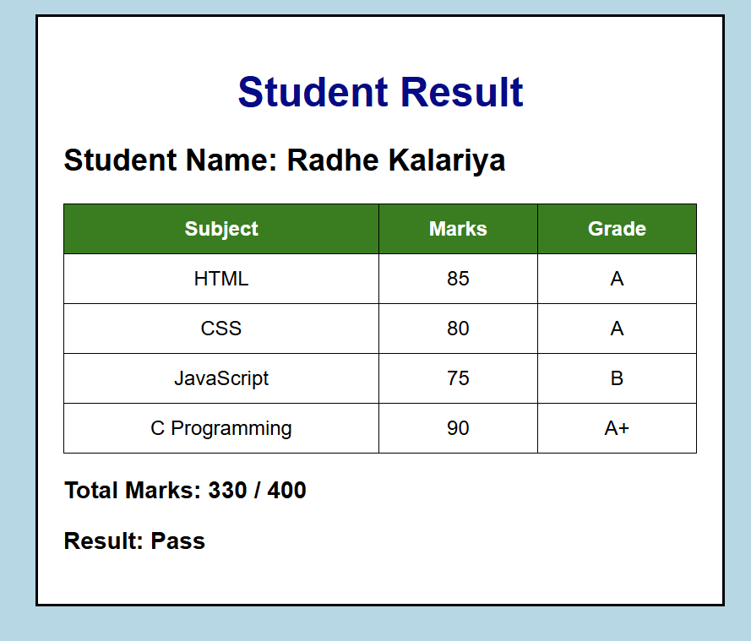

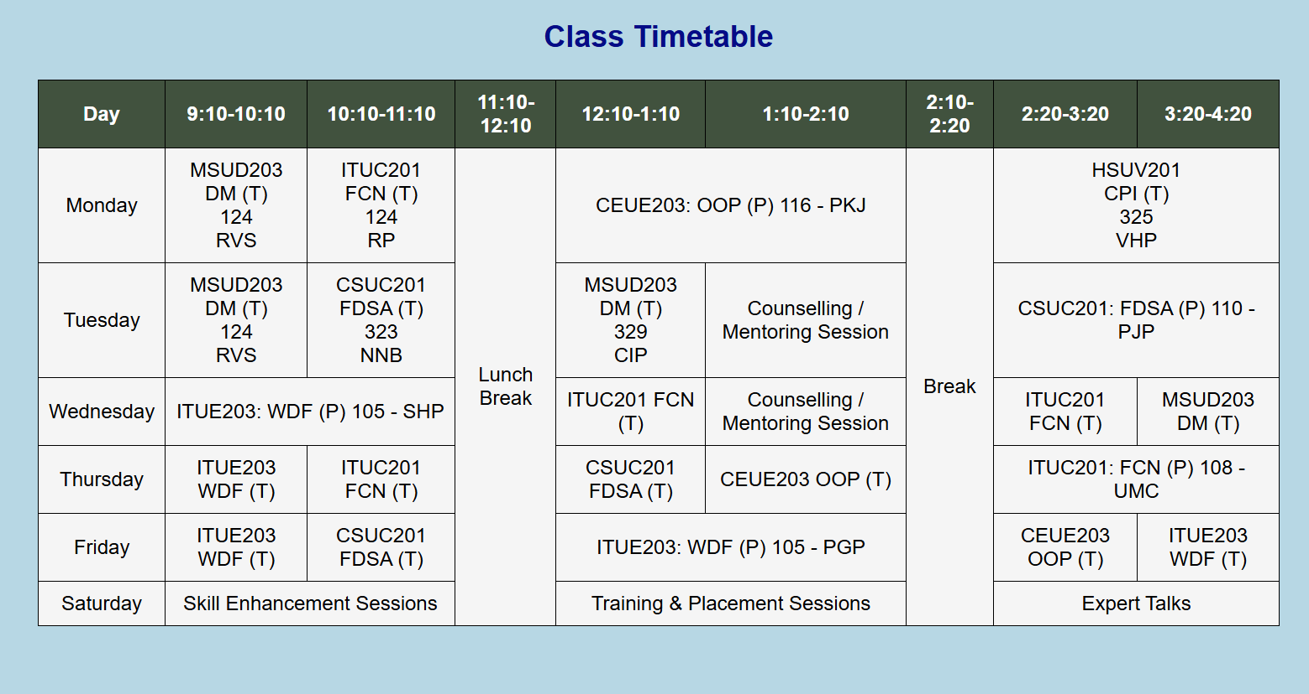

GitHub Repository Link: https://github.com/Rkpatel34/StudentHub
Challenge:
Making the webpage look good on different screen sizes.
Solution:
I adjusted the CSS to improve the layout.
Challenge 2
Challenge:
Managing colors, spacing, and alignment.
Solution:
I used CSS properties to make the page neat and readable.

LEARNING OUTCOME:I learned how to use CSS to design web pages. I also learned to improve the layout, colors, spacing, and make the webpage easy to use.

