PRACTICAL-6

Rendering External JSON Data using Fetch API, Search and Filter

Problem Definition :Display event lists, student profiles, notices, or FAQs from external JSON files using Fetch API. Implement dynamic rendering, search, filter,
sorting, and pagination.

OUTPUT :
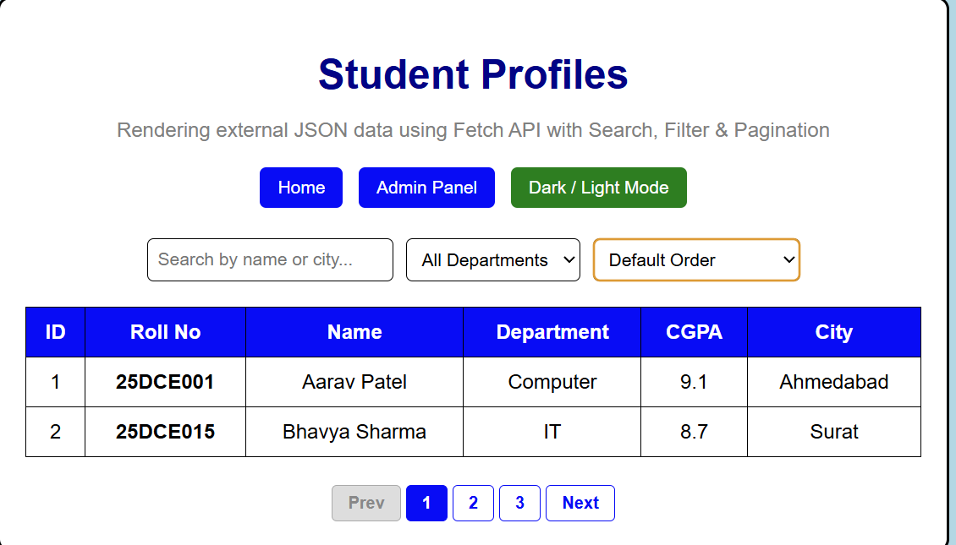

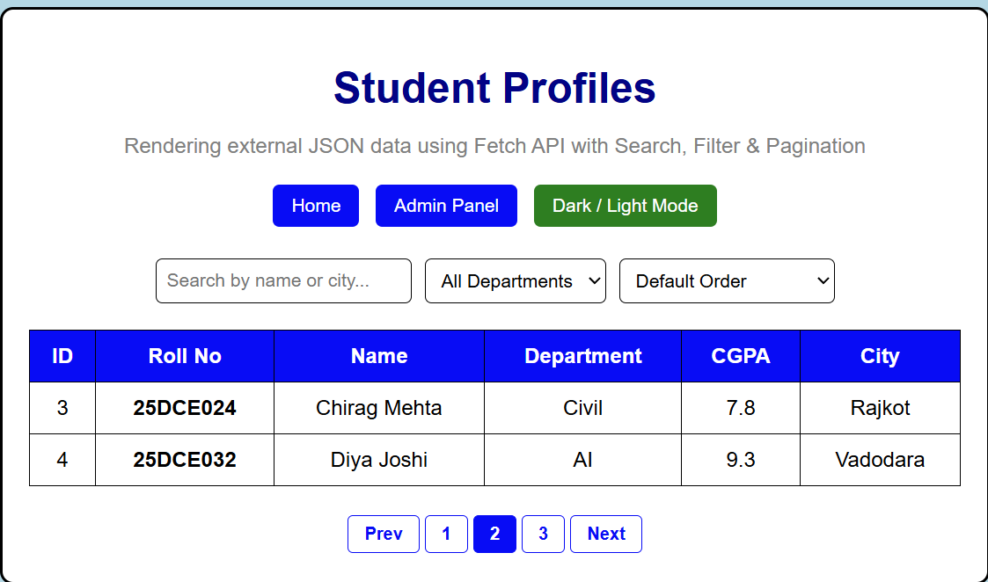
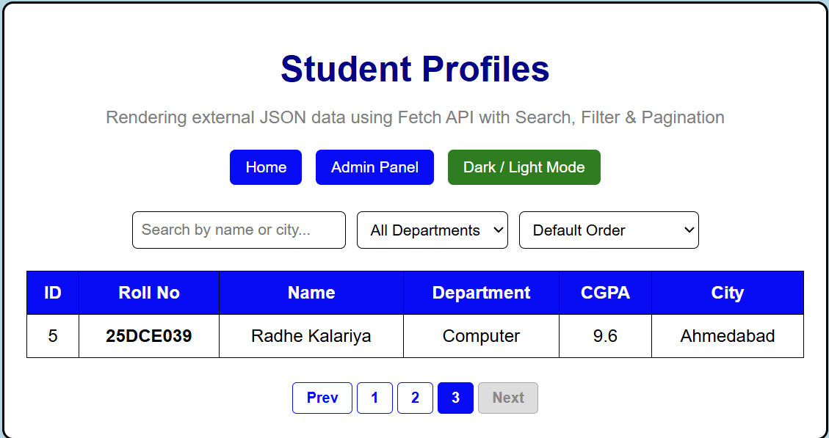

Challenges

Problem Faced

Initially, the output was not displayed properly. The student table was appearing at the bottom of the page instead of inside the Student Information section

Reason
This happened because the JavaScript was displaying the JSON data in the studentData div, but the existing page structure and CSS were not properly arranged for the dynamically generated table. Also, the JavaScript file was running on other pages where the studentData element was not present.

Mistake in Code
I had added the JSON rendering code in the common script.js file, which is loaded on multiple pages. Because of this, the student table was generated separately at the bottom of the profile page.

Correction
I checked the HTML structure and JavaScript execution and corrected the placement of the JSON data section so that the student data is displayed in the required section.

