PRACTICAL-5

Problem Definition:

Create a student registration form with HTML5 input types and JavaScript validation for name, email, mobile number, password, confirm password,course, year, gender, and terms acceptance. Use Regular Expression for validations.

Key Questions / Analysis/ Interpretation

1. Are correct input types and attributes used?

Yes. Correct HTML5 input types and attributes like text, email, tel, password, radio, checkbox, id, and placeholder are used appropriately.

2. Are validation errors displayed near the relevant fields?

No. Currently, validation errors are displayed using alert pop-ups, not directly near the relevant fields.

3. Is password strength checked?

Yes. Password strength is checked using Regex for a minimum of 8 characters, including at least one letter and one number.

4. Is the form accessible using keyboard and screen-reader-friendly
Labels?

Yes. The form can be accessed using the keyboard, and labels are provided for the input fields, making it screen-reader-friendly.

Output:

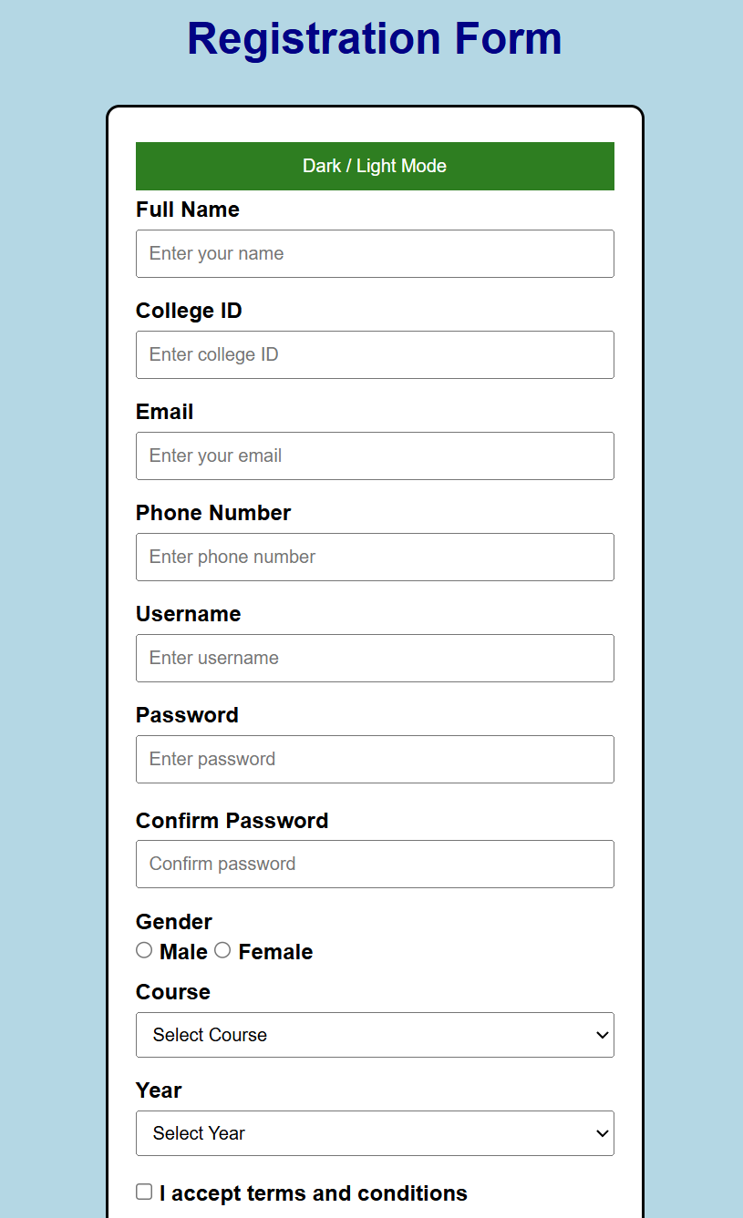

Challenges faced:

Challenge 1: Connecting HTML Form with JavaScript

Initially, the form was submitted directly without showing any validation message. The validateForm() function was not connected to the form. I solved this by adding onsubmit="return validateForm()" to the form.

Before:

<form id="registrationForm">
After:
<form id="registrationForm" onsubmit="return validateForm()">

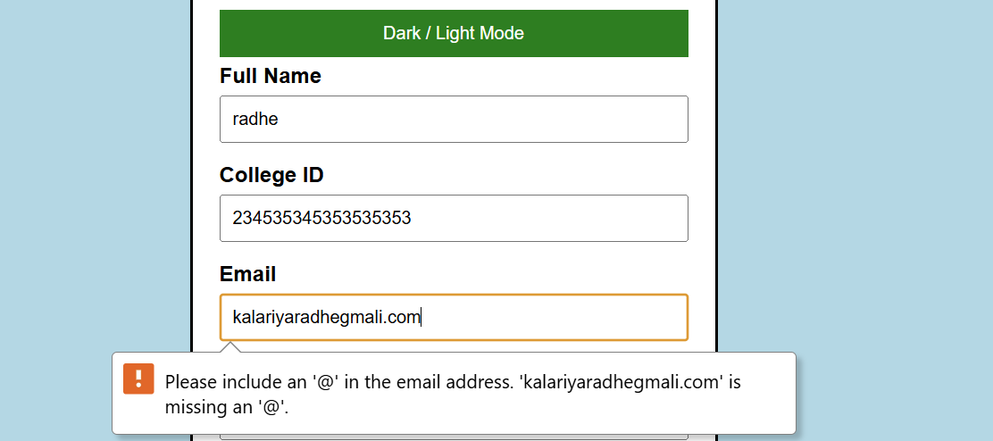

Challenge 2: Using regex(College ID)

OUTPUT:

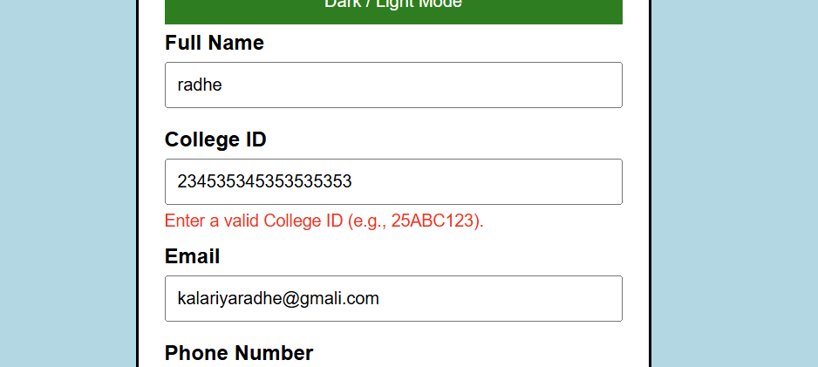

Challenge 3: Mobile Number Validation
let mobileRegex = /^[6-9][0-9]{9}$/;

OUTPUT:

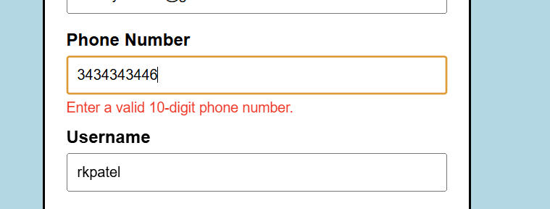

Challenge 4: Password Validation

OUTPUT: