PRACTICAL- 4

Problem Definition
Add dynamic UI components such as collapsible FAQ, modal popup,image/content slider, notification banner, hamburger menu, and light/dark theme switcher using JavaScript.

1.How are DOM elements selected and modified?
DOM elements are selected using methods like getElementById(), querySelector(), and querySelectorAll(). They can be modified using properties like innerHTML, textContent, style, and classList

2.Are event listeners attached correctly?
Yes. Event listeners are attached using addEventListener(), which allows JavaScript to respond to events such as click, submit, change, etc.

3.Is localStorage used for remembering theme choice?
Yes. localStorage can store the user's selected light/dark theme so that the same theme is applied when the page is opened again.
4.Does interactivity improve usability without breaking accessibility? Yes. Features like menus, modals, notifications, and theme switching improve usability. They should also provide clear controls, readable text, keyboard access, and proper labels so accessibility is maintained.

SCREENSHOT:

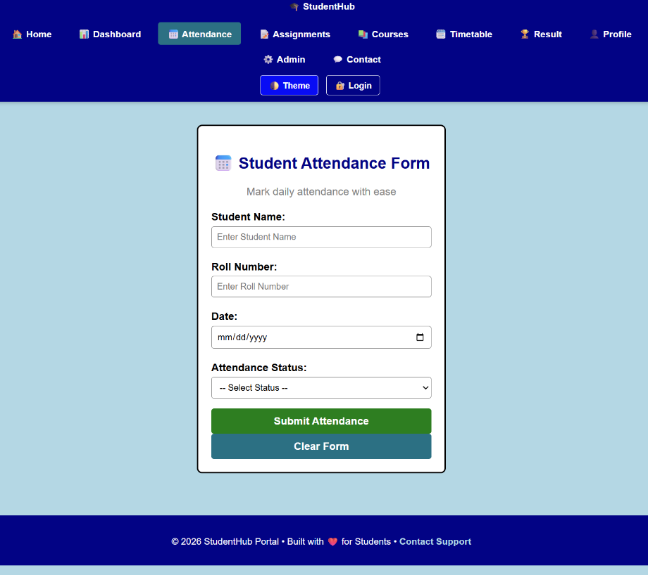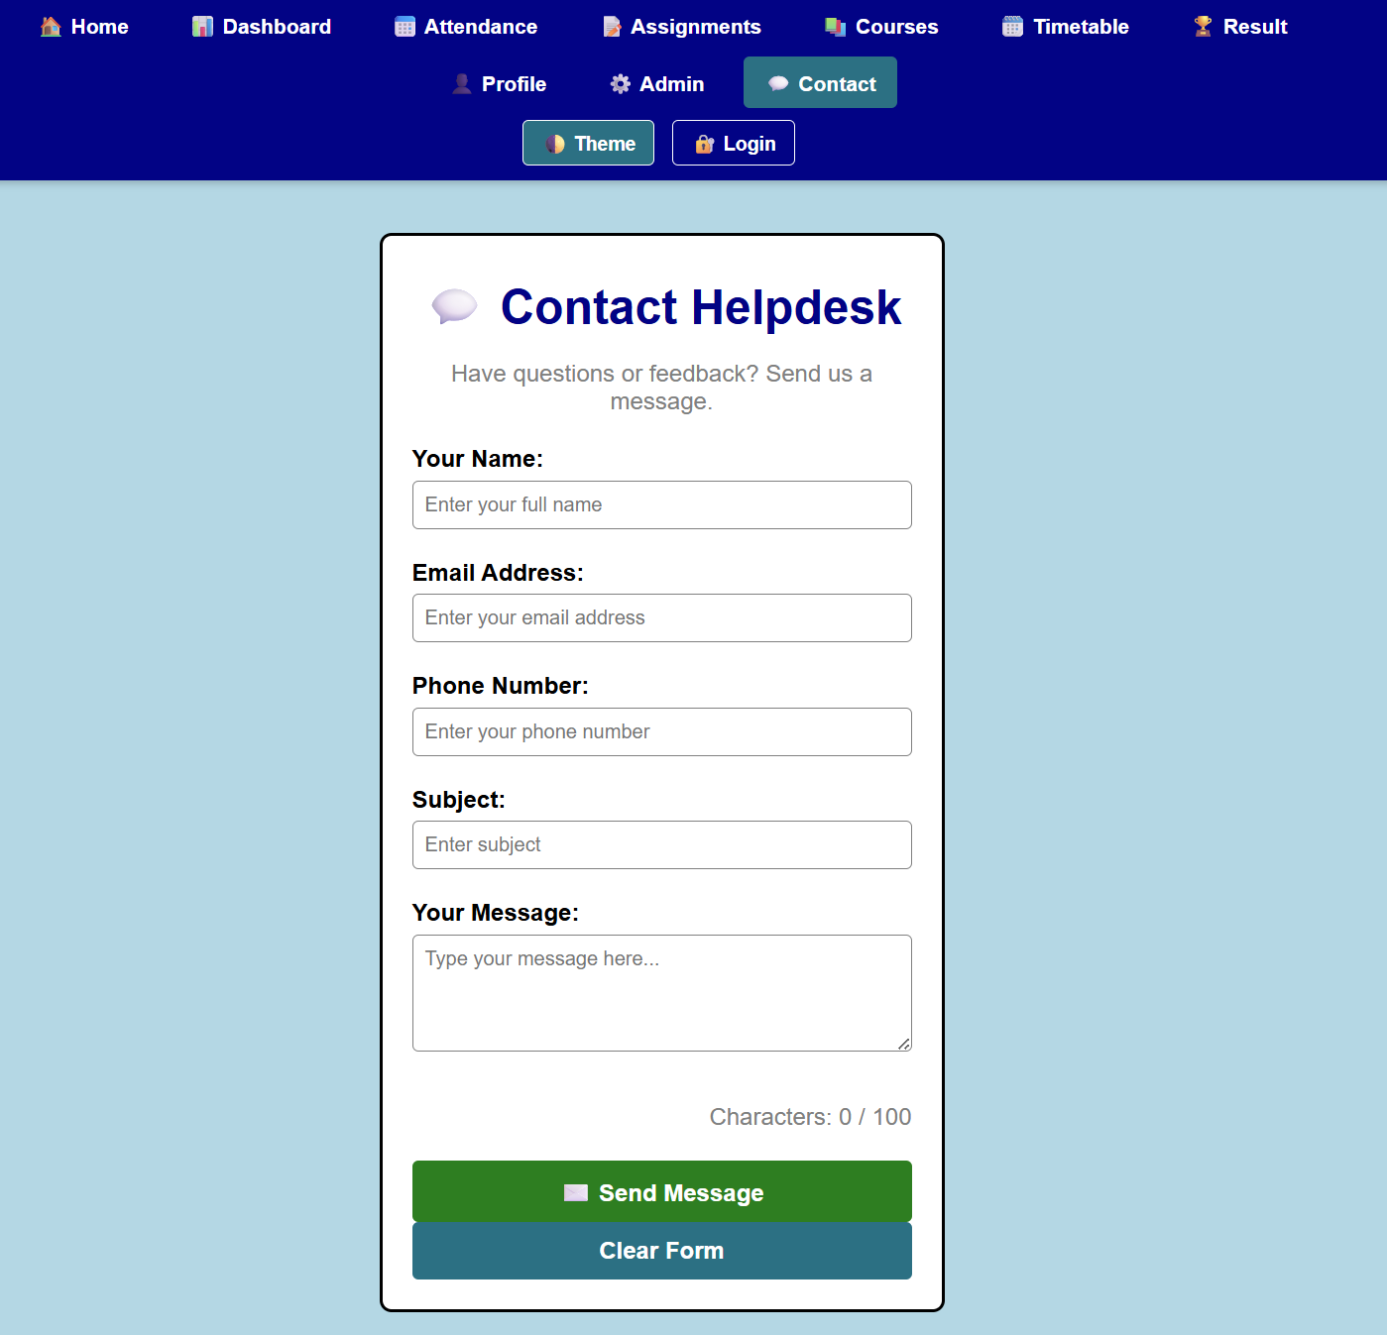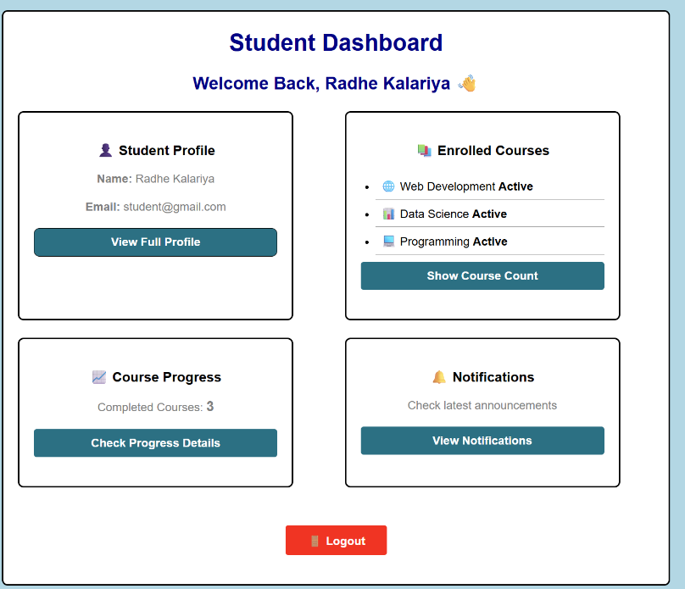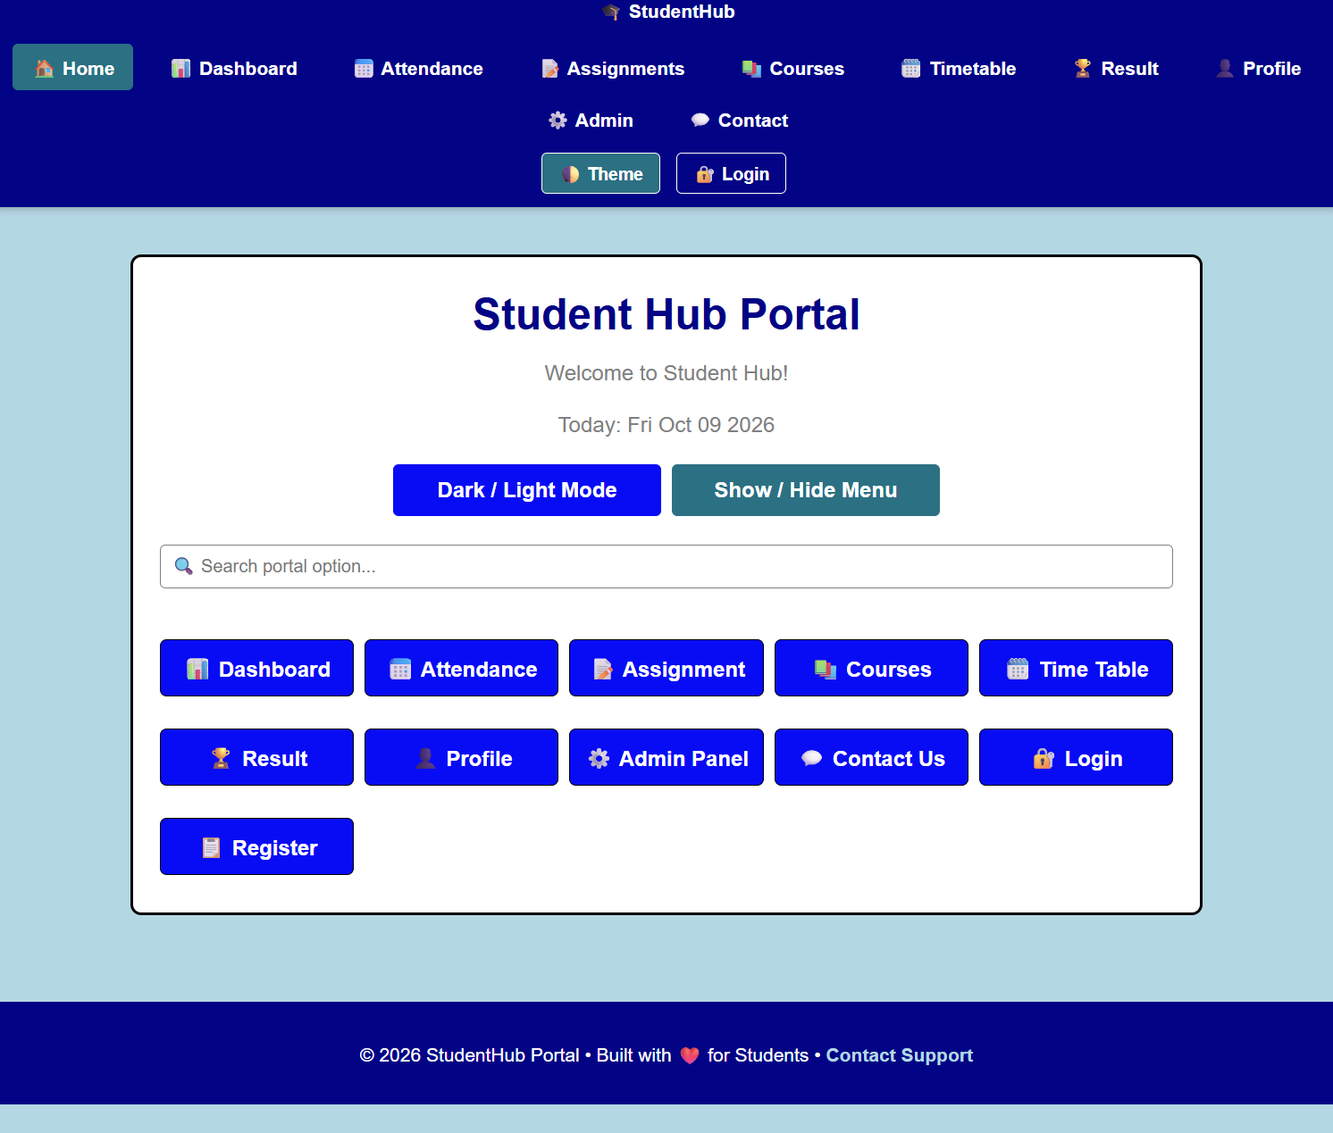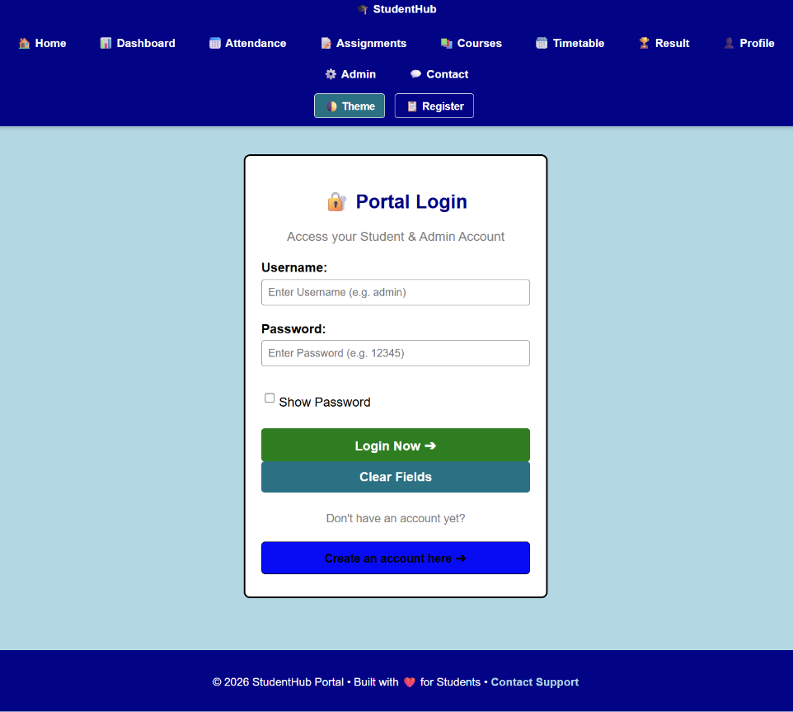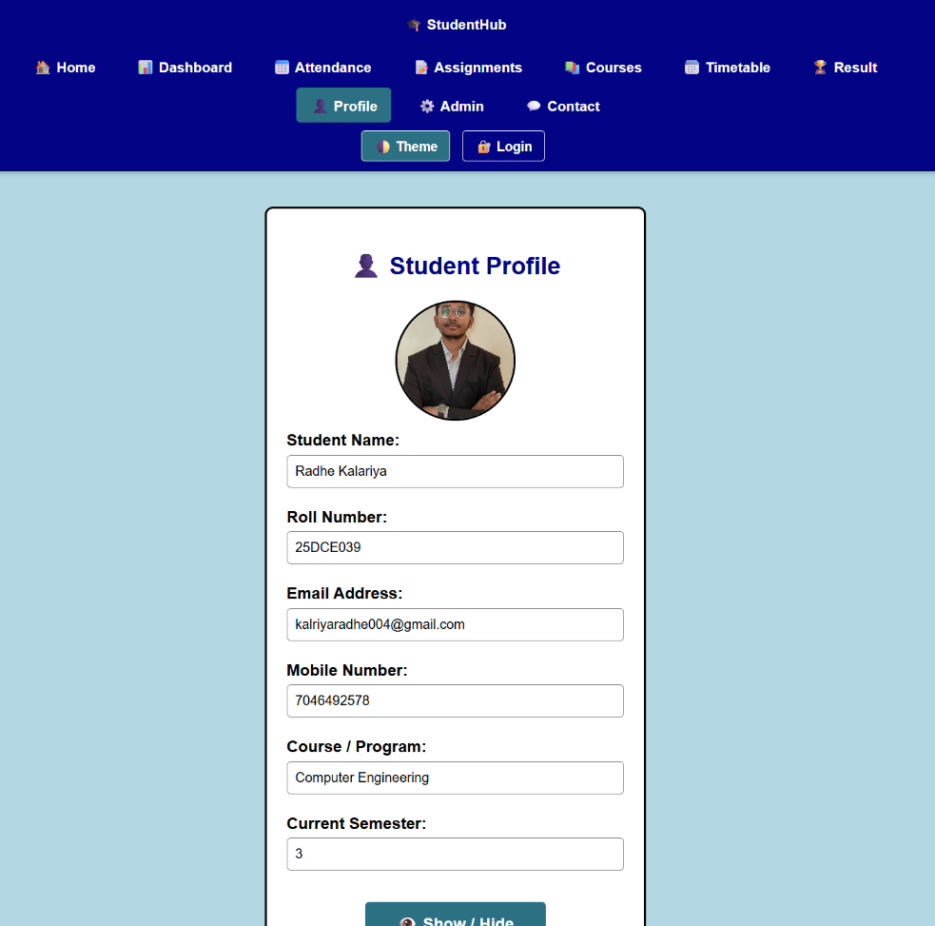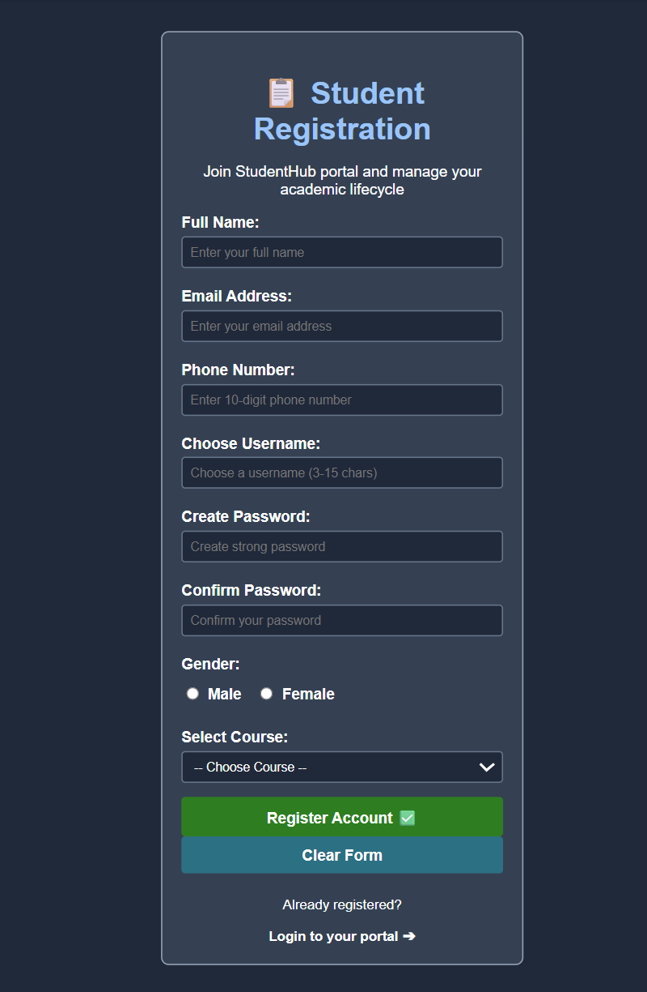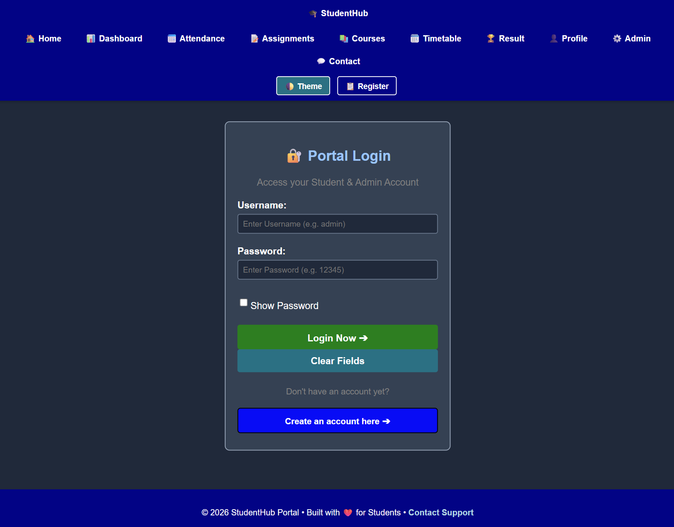

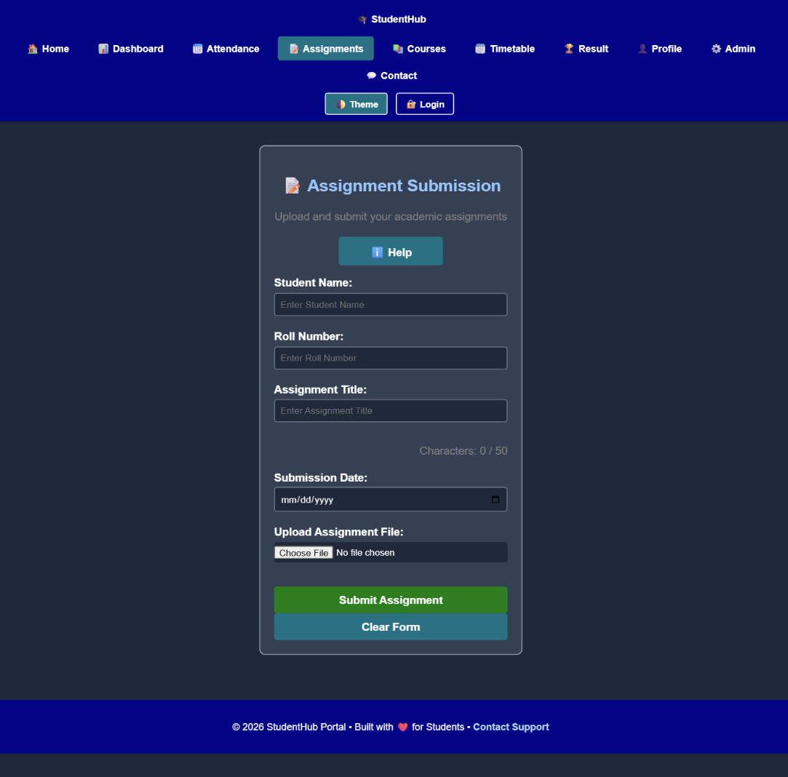

Implementation
- Created dynamic UI components using JavaScript.
- Implemented collapsible FAQ to show/hide answers.
- Added a modal popup that opens and closes on button clicks.
- Added a notification banner for user messages.
- Implemented a hamburger menu for navigation.
- Added a light/dark theme switcher using JavaScript.
- Used DOM manipulation and event handling to make the UI interactive. Challenges
- Handling click events for different UI components.
- Selecting and modifying DOM elements correctly.
- Managing show/hide functionality for FAQ, modal, and menu.
- Applying light and dark themes consistently.
- Making the components responsive and user-friendly.

GitHub Repository
Link: https://github.com/Rkpatel34/StudentHub
Conclusion :
The website successfully uses HTML, CSS, and JavaScript to create an interactive and user-friendly interface. DOM manipulation and event listeners provide dynamic functionality, while localStorage remembers the user's theme preference. Interactive components such as the menu, modal, notification, and slider improve usability while maintaining accessibility. Overall, the project demonstrates how JavaScript can make a web page more interactive, responsive, and user-friendly.

