PRACTICALE-2

Practical 2: Semantic HTML5 Pages with Accessibility-Ready Structure.

Problem Definition:Develop static HTML5 skeletons for at least 10 StudentHub pages such as Home, About, Register, Login, Dashboard, Events, Profile, Contact, Admin, FAQ, and Feedback. Use semantic tags and accessibility-friendly Structure.

Key Questions

- Are semantic tags such as header, nav, main, section, article, aside, and footer used properly?

Answer:Yes, semantic tags are used correctly. They make the webpage easy to read and understand.

Reference link:
https://www.w3schools.com/html/html5_semantic_elements.asp

- Are form labels, headings, image alt text, and navigation links accessible?

Answer:Yes. Form labels, headings, image alt text, and navigation links are easy to use

Reference link:
https://www.w3schools.com/html/

- Is the page structure consistent across all pages?

Answer:Yes. All pages have the same layout and navigation. This makes the website easy to use.

Implementation
  - Created StudentHub HTML pages.
  - Used semantic HTML tags.
  - Added navigation links.
  - Added images and forms.
  - Connected all pages.
CODE:
INDEX PAGE:
<!DOCTYPE html>
<html>
<head>
<title>Student Hub Portal</title>
</head>
<body style="background-color: rgb(102, 225, 223);">

<h1 align="center">Student Hub Portal</h1>

<main>

<nav align="center">
<hr>
<br>
<a href="Attendance.html">Attendance</a>
<a href="assigments.html">Assignment</a>
<a href="contect.html">Contact</a>
<a href="courese.html">Courses</a>
<a href="login.html">Login</a>

<a href="profile.html">Profile</a>
<a href="register.html">Register</a>
<a href="result.html">Result</a>
<a href="dashboard.html">Dashboard</a>
<a href="Timetable.html">Time Table</a>
<a href="admin.html">Admin</a>
</nav>
</main>
</body>
</html>
Evidence of Work (Screenshots):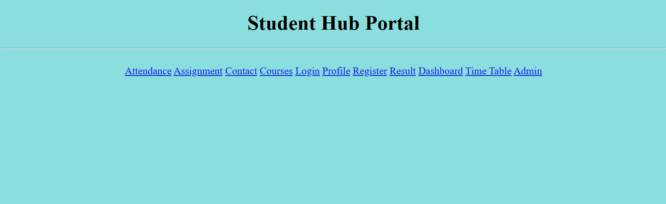
Description: This screenshot shows the INDEX page of the StudentHub website. It includes navigation and header.

LOGIN PAGE:

<!DOCTYPE html>
<html>

<head>
<title>Login Page</title>
</head>

<body>

<!-- <h1>Login</h1> -->

<form>

<label>Username:</label><br>

<input type="text" placeholder="Enter Username" required>
<br><br>

<label>Password:</label><br>

<input type="password" placeholder="Enter Password" required>
<br><br>

<button type="submit">Login</button>
<br><br>

<a href="#">Forgot Password?</a>
<br><br>

<p>Don't have an account?</p>
<a href="register.html">Register here</a>

</form>

</body>

</html>

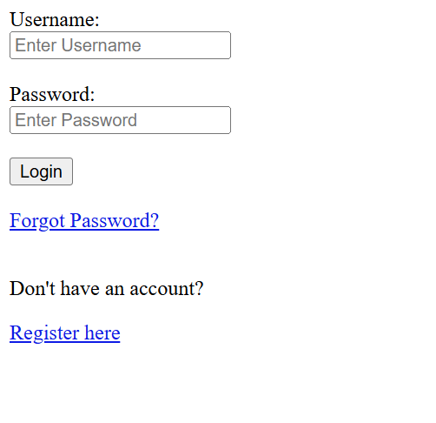

Description:
This screenshot shows the StudentHub Login page with username, password,login button,forgot password and also register here button.

REGISTER PAGE:

<!DOCTYPE html>
<html>
<head>
<title>Register Page</title>
</head>

<body>

<h1>Registration Form</h1>

<form>

<label>Full Name:</label><br>
<input type="text" placeholder="Enter your name" required>
<br><br>

<label>Email:</label><br>
<input type="email" placeholder="Enter your email" required>
<br><br>

<label>Phone Number:</label><br>
<input type="tel" placeholder="Enter phone number">
<br><br>

<label>Username:</label><br>
<input type="text" placeholder="Create username" required>
<br><br>

<label>Password:</label><br>
<input type="password" placeholder="Create password" required>
<br><br>

<label>Confirm Password:</label><br>
<input type="password" placeholder="Confirm password" required>
<br><br>

<label>Gender:</label><br>
<input type="radio" name="gender"> Male
<input type="radio" name="gender"> Female
<br><br>

<label>Course:</label><br>
<select>
<option>Select Course</option>
<option>Web Development</option>
<option>Data Science</option>
<option>Cyber Security</option>
<option>Programming</option>
</select>
<br><br>

<button type="submit">Register</button>

</form>

</body>
</html>

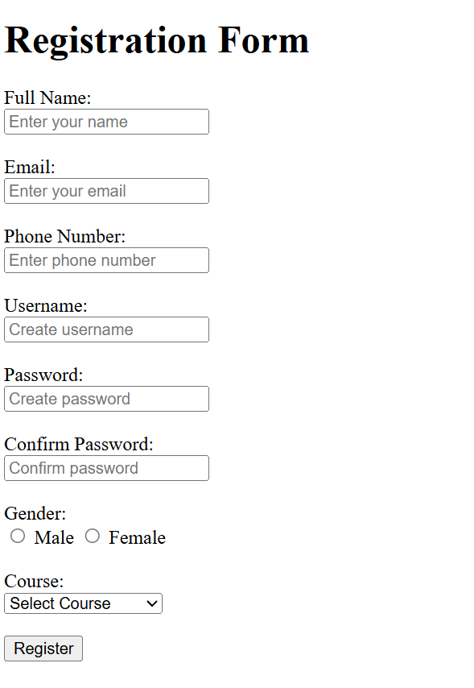
PROFILE PAGE:

<!DOCTYPE html>
<html>
<head>
<title>Profile</title>
</head>

<body>

<h1>User Profile</h1>

<img src="#" alt="Profile Image" width="150" height="150">

<h2>Student Name</h2>
<label for="name">Name:</label>
<p><input type="text" id="name"></p>
<label for="email">Email:</label>
<p><input type="email" id="email"></p>
<label for="phone">Phone:</label>
<p><input type="tel" id="phone"></p>
<label>course selected:</label><br>

<input type="checkbox" name="course[]" value="WDF"> WDF<br>
<input type="checkbox" name="course[]" value="JAVA"> JAVA<br>
<input type="checkbox" name="course[]" value="CSS"> CSS<br>
<input type="checkbox" name="course[]" value="C Programming"> C Programming<br>
<input type="checkbox" name="course[]" value="Maths"> Maths<br>

<h3>About Me</h3>
<p>
I am a student learning web development and programming.
</p>

<h3>Skills</h3>
<ul>
<li>HTML</li>
<li>CSS</li>
<li>JavaScript</li>
<li>C Programming</li>
</ul>

<button>Edit Profile</button>
<button>Save Changes</button>

</body>
</html>
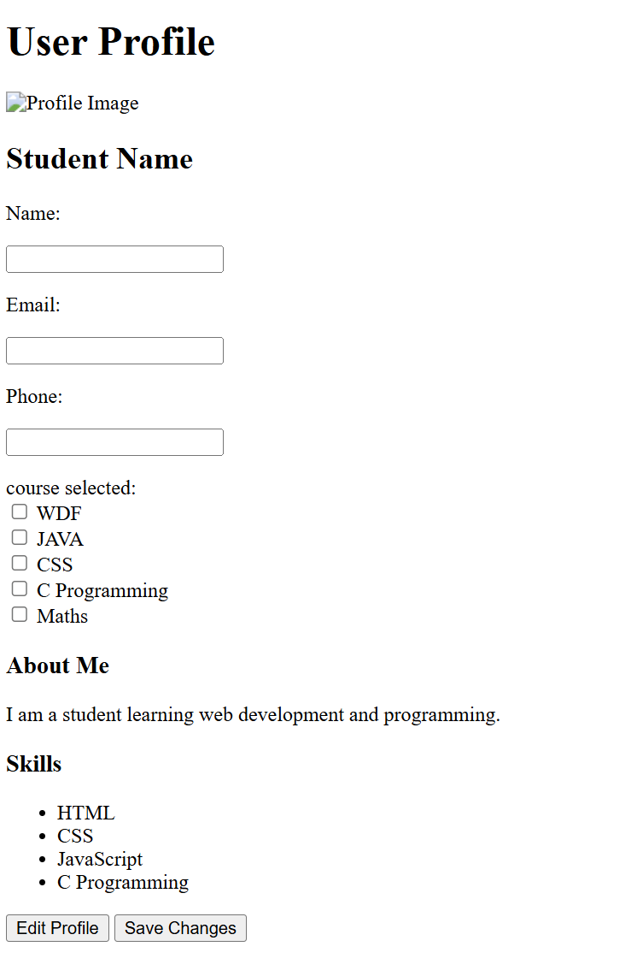

COURSES PAGE:

<!DOCTYPE html>
<html>
<head>
<title>Courses</title>
</head>

<body>

<h1>Our Courses</h1>

<ul>
<li>Web Development</li>
<li>App Development</li>
<li>Data Science</li>
<li>Artificial Intelligence</li>
<li>Machine Learning</li>
<li>Cyber Security</li>
<li>Cloud Computing</li>
<li>Graphic Design</li>
<li>Digital Marketing</li>
<li>Programming in C/C++</li>
</ul>

</body>
</html>


ADMIN REPORT:

<!DOCTYPE html>
<html lang="en">
<head>
<meta charset="UTF-8">
<title>Student Hub - Admin Panel</title>
</head>
<body>

<center>
<h1>Student Hub</h1>
<h2>Admin Dashboard</h2>
<hr width="60%">

<table border="1" cellpadding="15" cellspacing="0">
<tr>
<th>Menu</th>
<th>Action</th>
</tr>

<tr>
<td>Dashboard</td>
<td><a href="dashboard.html">Open</a></td>
</tr>

<tr>
<td>Student Management</td>
<td><a href="students.html">Manage</a></td>
</tr>

<tr>
<td>Attendance</td>
<td><a href="attendance.html">View</a></td>
</tr>

<tr>
<td>Assignments</td>
<td><a href="assignments.html">Manage</a></td>
</tr>

<tr>
<td>Courses</td>
<td><a href="courses.html">Manage</a></td>
</tr>

<tr>
<td>Results</td>
<td><a href="result.html">View</a></td>
</tr>

<tr>
<td>Faculty</td>
<td><a href="faculty.html">Manage</a></td>
</tr>

<tr>
<td>Time Table</td>
<td><a href="Timetable.html">Update</a></td>
</tr>

<tr>
<td>Profile</td>
<td><a href="profile.html">Open</a></td>
</tr>

<tr>
<td>Logout</td>
<td><a href="login.html">Logout</a></td>
</tr>
</table>

<br>

<h3>Quick Information</h3>

<table border="1" cellpadding="10">
<tr>
<th>Total Students</th>
<td>250</td>
</tr>

<tr>
<th>Total Faculty</th>
<td>20</td>
</tr>

<tr>
<th>Courses</th>
<td>7</td>
</tr>

<tr>
<th>Pending Assignments</th>
<td>9</td>
</tr>
</table>

<br>

<p>2026 Student Hub Admin Panel</p>

</center>

</body>
</html>
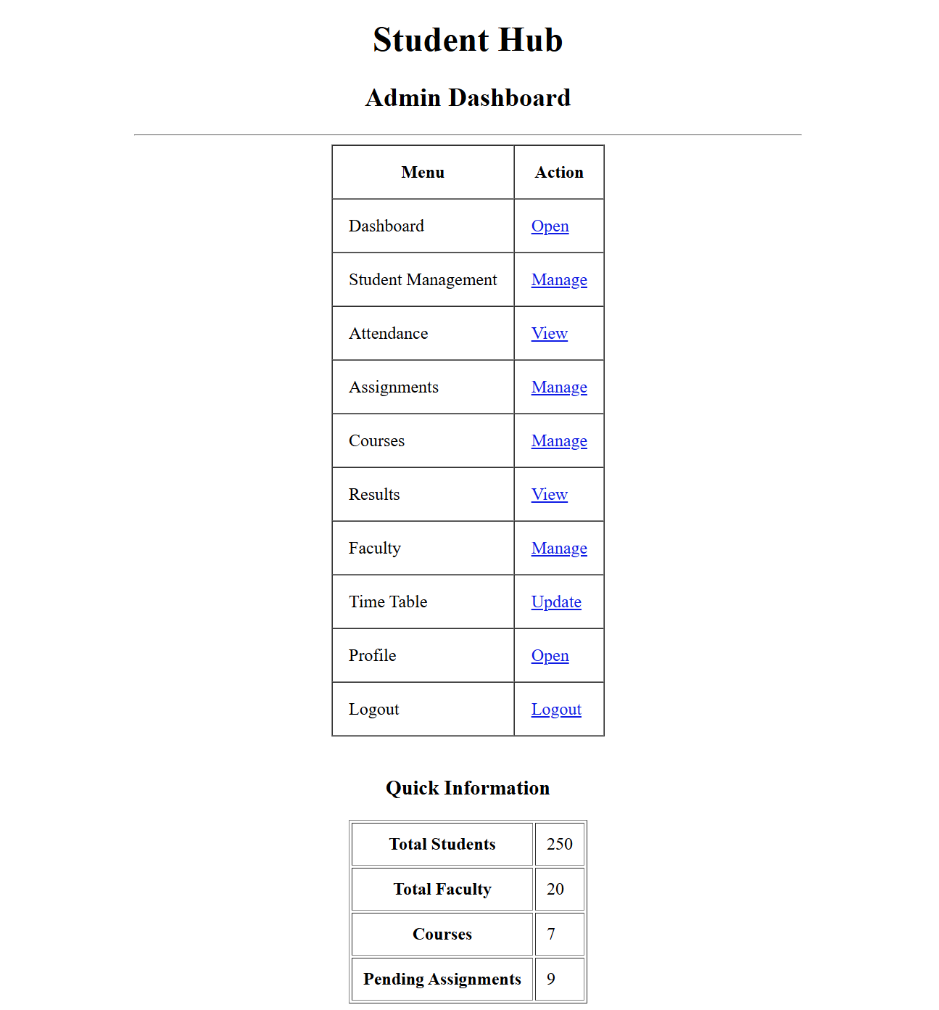

ASSIGNMENT PAGE:

<!DOCTYPE html>
<html lang="en">
<head>
<meta charset="UTF-8">
<meta name="viewport" content="width=device-width, initial-scale=1.0">
<title>Assigment</title>
</head>
<body backgroundimage="studenthub/62351907-9b4c-4cbf-a53b-251e573591b8.png?w=2000">

<h3>Assignment Page</h3>
<form>
<label>Student Name:</label>
<input type="text" placeholder="Enter Student Name" required>
<br><br>
<label>Roll Number:</label>
<input type="text" placeholder="Enter Roll Number" required>
<br><br>
<label>Assignment Title:</label>
<input type="text" placeholder="Enter Assignment Title" required>
<br><br>
<label>Submission Date:</label>
<input type="date" required>
<br><br>
<label>Upload Assignment:</label>
<input type="file" required>
<br><br>

<button type="submit">Submit Assignment</button>

</form>
</body>
</html>
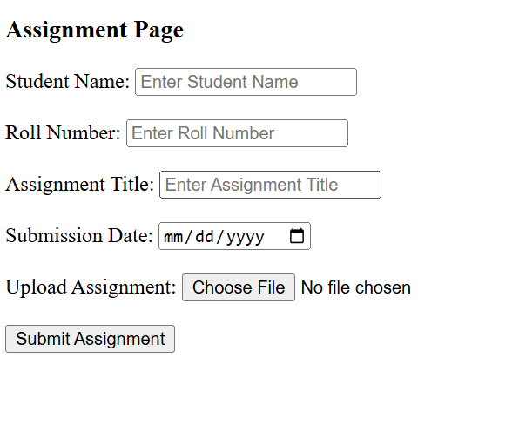

ATTENDANCE PAGE:

<!DOCTYPE html>
<html lang="en">
<head>
<meta charset="UTF-8">
<meta name="viewport" content="width=device-width, initial-scale=1.0">
<title>Student Attendance</title>
</head>
<body>

<h2>Student Attendance Form</h2>

<form>
<label>Student Name:</label>
<input type="text" placeholder="Enter Student Name" required>
<br><br>

<label>Roll Number:</label>
<input type="text" placeholder="Enter Roll Number" required>
<br><br>

<label>Date:</label>
<input type="date" required>
<br><br>

<label>Attendance Status:</label>
<select required>
<option value="">-- Select --</option>
<option value="Present">Present</option>
<option value="Absent">Absent</option>
</select>
<br><br>

<button type="submit">Submit Attendance</button>
</form>

</body>
</html>
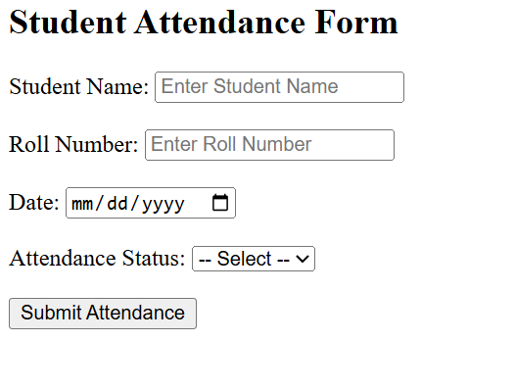

RESULT PAGE:

<!DOCTYPE html>
<html>
<head>
<title>Result</title>
</head>

<body>

<h1>Student Result</h1>

<h2>Student Name: xyz</h2>

<table border="1">
<tr>
<th>Subject</th>
<th>Marks</th>
<th>Grade</th>
</tr>

<tr>
<td>HTML</td>
<td>85</td>
<td>A</td>
</tr>

<tr>
<td>CSS</td>
<td>80</td>
<td>A</td>
</tr>

<tr>
<td>JavaScript</td>
<td>75</td>
<td>B</td>
</tr>

<tr>
<td>C Programming</td>
<td>90</td>
<td>A+</td>
</tr>

</table>

<h3>Total Marks: 330 / 400</h3>
<h3>Result: Pass</h3>

</body>
</html>
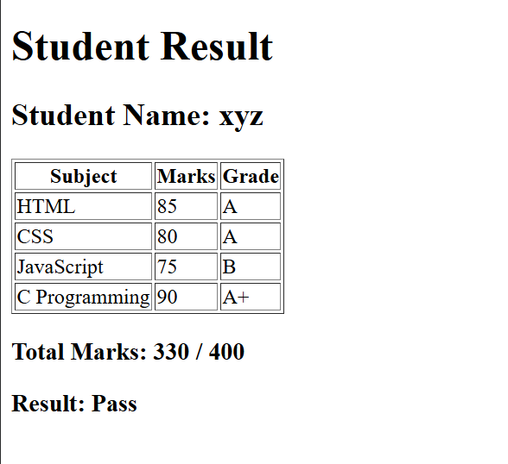

DASHBOARD:

<!DOCTYPE html>
<html>
<head>
<title>Dashboard</title>
</head>

<body>

<h1>Dashboard</h1>

<h2>Welcome User</h2>

<div>
<h3>Profile</h3>
<p>Name: Student</p>
<p>Email: student@gmail.com</p>
</div>

<div>
<h3>Courses</h3>
<ul>
<li>Web Development</li>
<li>Data Science</li>
<li>Programming</li>
</ul>
</div>

<div>
<h3>Progress</h3>
<p>Completed Courses: 3</p>
</div>

<div>
<h3>Notifications</h3>
<p>No New Notifications</p>
</div>

<button>Logout</button>

</body>
</html>
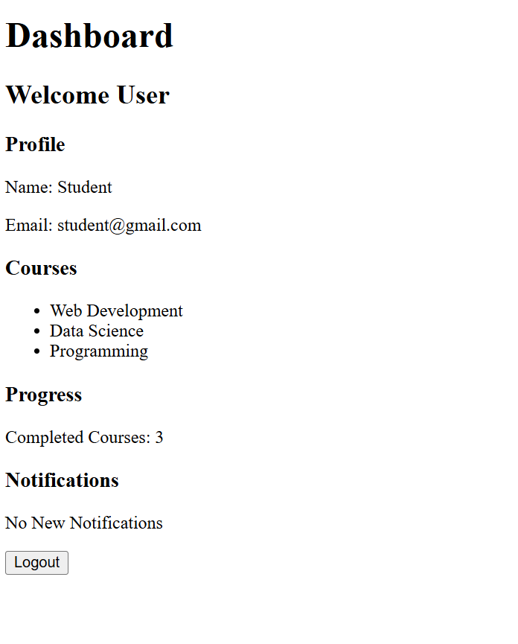

TIME TABLE:

<!DOCTYPE html>
<html>
<head>
<title>Class Timetable</title>
</head>
<body>

<h2 align="center">Class Timetable</h2>

<table border="1" cellspacing="0" cellpadding="8">

<tr>
<th>Day</th>
<th>9:10-10:10</th>
<th>10:10-11:10</th>
<th>11:10-12:10</th>
<th>12:10-1:10</th>
<th>1:10-2:10</th>
<th>2:10-2:20</th>
<th>2:20-3:20</th>
<th>3:20-4:20</th>
</tr>

<tr>
<td>Monday</td>
<td>MSUD203
DM (T)
124
RVS</td>
<td>ITUC201
FCN (T)
124
RP
</td>
<td rowspan="6">Lunch Break</td>
<td colspan="2">CEUE203: OOP (P) 116 - PKJ</td>
<td rowspan="6">Break</td>
<td colspan="2">HSUV201
CPI (T)
325
VHP</td>
</tr>

<tr>
<td>Tuesday</td>
<td>MSUD203
DM (T)
124
RVS</td>
<td>CSUC201
FDSA (T)
323
NNB
</td>
<td>MSUD203
DM (T)
329
CIP

</td>
<td>Counselling/M
entoring
Session
329
PJP
</td>
<td colspan="2">CSUC201: FDSA (P) 110 - PJP

</td>
</tr>

<tr>
<td>Wednesday</td>
<td colspan="2"> ITUE203: WDF (P) 105 - SHP</td>
<td>ITUC201
FCN (T)
329
NK
</td>
<td>Counselling/M
entoring
Session
329
SVJ</td>
<td>ITUC201
FCN (T)
325
RP</td>
<td>MSUD203
DM (T)
124
RVS</td>

</tr>

<tr>
<td>Thursday</td>
<td>ITUE203
WDF (T)
323
PGP</td>
<td>ITUC201
FCN (T)
323
NK</td>
<td>CSUC201
FDSA (T)
323
PJP</td>
<td>CEUE203
OOP (T)
323
DAG</td>
<td colspan="2"> ITUC201: FCN (P) 108 - UMC</td>
</tr>

<tr>
<td>Friday</td>
<td>ITUE203
WDF (T)
323
MP</td>
<td>CSUC201
FDSA (T)
323
PJP
</td>
<td colspan="2"> ITUE203: WDF (P) 105 - PGP</td>
<td>CEUE203
OOP (T)
323
DAG</td>
<td>ITUE203
WDF (T)
323
PGP
</td>
</tr>

<tr>
<td>Saturday</td>
<td colspan="2">Skill Enhancement Sessions/Training
and Placement sessions/Expert talks</td>
<td colspan="2">Skill Enhancement
Sessions/Training and Placement
sessions/Expert talks</td>
<td colspan="2">Skill Enhancement
Sessions/Training and Placement
sessions/Expert talks </td>
</tr>

</table>

</body>
</html>
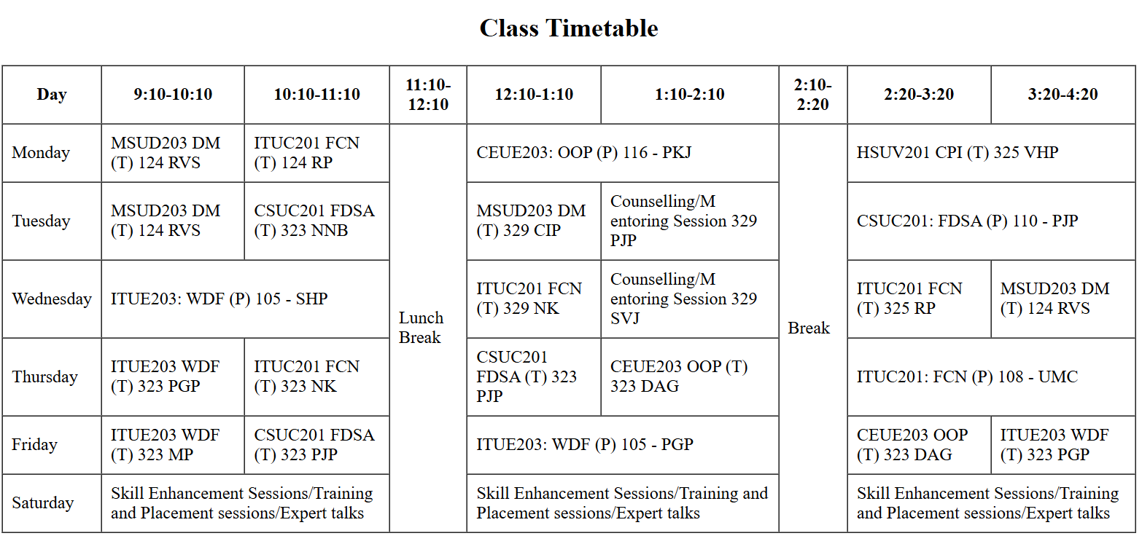

CONTECT:

<!DOCTYPE html>
<html>
<head>
<title>Contact Us</title>
</head>

<body>

<h1>Contact Us</h1>

<form>

<label>Name:</label><br>
<input type="text" placeholder="Enter your name" required>
<br><br>

<label>Email:</label><br>
<input type="email" placeholder="Enter your email" required>
<br><br>

<label>Phone Number:</label><br>
<input type="tel" placeholder="Enter your phone number">
<br><br>

<label>Subject:</label><br>
<input type="text" placeholder="Enter subject">
<br><br>

<label>Message:</label><br>
<textarea rows="5" cols="30" placeholder="Enter your message"></textarea>
<br><br>

<button type="submit">Send Message</button>

</form>

</body>
</html>

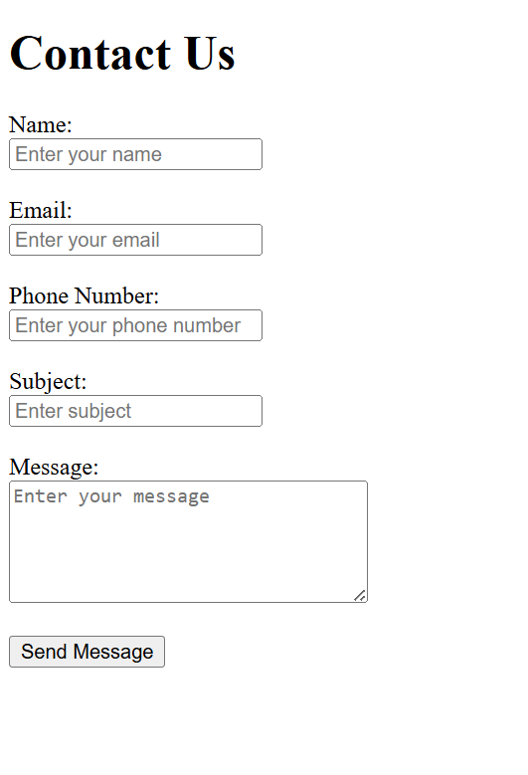

GitHub Repository Link:
https://github.com/Rkpatel34/StudentHub

Challenges Faced
- Creating the proper structure of the Student Hub Portal using only HTML.
- Linking different pages such as Home, Login, and Dashboard correctly.
- Organizing student information and sections using appropriate HTML elements.
- Creating forms for login and other user inputs.
- Maintaining a clear and simple page structure.
- Managing multiple HTML pages and ensuring proper navigation between them.
- Understanding and using HTML tags correctly while developing the website.
Learning Outcome:
Students will create clean, linked, and accessibility-ready HTML page structures.

