PRACTICALE-3

Practical 3: Responsive UI Design using CSS Grid, Flexbox, and
Bootstrap/Tailwind

Problem Definition:Design responsive layouts for Home, About, Registration, Dashboard, and Events pages using CSS Grid and Flexbox. Optional to use CSS framework such as Bootstrap or Tailwind. Ensure mobile-first responsiveness.

Key Questions

- How does the layout adapt for mobile, tablet, and desktop screens?

Answer:The layout changes to fit the screen size. It works on mobile, tablet, and desktop.
Reference Link https://www.w3schools.com/css/css_rwd_intro.asp

- Which layout technique is used and why?

Answer:A simple HTML and CSS layout is used. It is easy to create and easy to understand. Reference Link
https://www.w3schools.com/css/

- Are typography, spacing, colors, and contrast readable?

Answer:Yes. The text, colors, and spacing are clear and easy to read.

- Is the framework used consistently without unnecessary inline CSS?

Answer:Yes. Most of the CSS is in the style.css file. Only a few inline styles are used.

Implementation
  - Created StudentHub web pages.
  - Used HTML and CSS.
  - Added colors and spacing.
  - Connected all pages with links.
  - Made the webpage easy to use.
Evidence of Work (Screenshots):

ADMIN PAGE:
<!DOCTYPE html>
<html lang="en">
<head>
<meta charset="UTF-8">
<title>Student Hub - Admin Panel</title>

<style>
body{
background-color: lightblue;
font-family: Arial, sans-serif;
}

h1{
color: darkblue;
}

h2{
color: green;
}

table{
width: 60%;
background-color: white;
border-collapse: collapse;
margin: 20px auto;
}

th{
background-color: blue;
color: white;
}

th, td{
border: 1px solid black;
padding: 10px;
text-align: center;
}

tr:hover{
background-color: lightgray;
}

a{
text-decoration: none;
color: blue;
font-weight: bold;
}

a:hover{
color: red;
}

p{
font-weight: bold;
}
</style>

</head>

<body>

<center>
<h1>Student Hub</h1>
<h2>Admin Dashboard</h2>
<hr width="60%">

<table>
<tr>
<th>Menu</th>
<th>Action</th>
</tr>

<tr>
<td>Dashboard</td>
<td><a href="dashboard.html">Open</a></td>
</tr>

<tr>
<td>Student Management</td>
<td><a href="students.html">Manage</a></td>
</tr>

<tr>
<td>Attendance</td>
<td><a href="attendance.html">View</a></td>
</tr>

<tr>
<td>Assignments</td>
<td><a href="assignments.html">Manage</a></td>
</tr>

<tr>
<td>Courses</td>
<td><a href="courses.html">Manage</a></td>
</tr>

<tr>
<td>Results</td>
<td><a href="result.html">View</a></td>
</tr>

<tr>
<td>Faculty</td>
<td><a href="faculty.html">Manage</a></td>
</tr>

<tr>
<td>Time Table</td>
<td><a href="Timetable.html">Update</a></td>
</tr>

<tr>
<td>Profile</td>
<td><a href="profile.html">Open</a></td>
</tr>

<tr>
<td>Logout</td>
<td><a href="login.html">Logout</a></td>
</tr>
</table>

<h3>Quick Information</h3>

<table>
<tr>
<th>Total Students</th>
<td>250</td>
</tr>

<tr>
<th>Total Faculty</th>
<td>20</td>
</tr>

<tr>
<th>Courses</th>
<td>7</td>
</tr>

<tr>
<th>Pending Assignments</th>
<td>9</td>
</tr>
</table>

<p>© 2026 Student Hub Admin Panel</p>

</center>

</body>
</html>
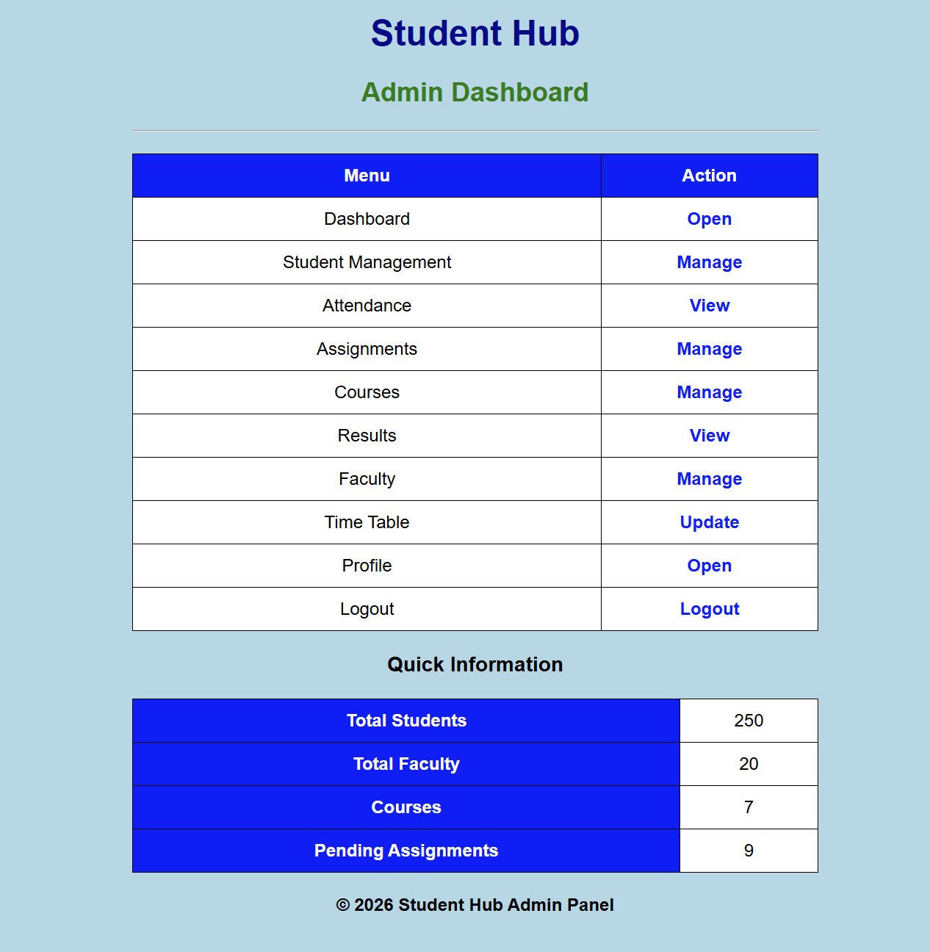

ASSIGMENT PAGE:

<!DOCTYPE html>
<html lang="en">
<head>
<meta charset="UTF-8">
<meta name="viewport" content="width=device-width, initial-scale=1.0">
<title>Assignment</title>

<style>
body{
background-color: lightblue;
/* If you have an image, use:
background-image: url("62351907-9b4c-4cbf-a53b-251e573591b8.png");
background-size: cover;
*/
font-family: Arial, sans-serif;
}

h2{
text-align: center;
color: darkblue;
}

.box{
width: 350px;
background-color: white;
margin: 40px auto;
padding: 20px;
border: 2px solid black;
}

label{
font-weight: bold;
}

input{
width: 100%;
padding: 8px;
margin-top: 5px;
margin-bottom: 15px;
border: 1px solid gray;
}

input[type="file"]{
border: none;
}

button{
width: 100%;
padding: 10px;
background-color: blue;
color: white;
border: none;
font-size: 16px;
}

button:hover{
background-color: darkblue;
}
</style>
</head>

<body>

<div class="box">

<h2>Assignment Page</h2>

<form>

<label>Student Name:</label>
<input type="text" placeholder="Enter Student Name" required>

<label>Roll Number:</label>
<input type="text" placeholder="Enter Roll Number" required>

<label>Assignment Title:</label>
<input type="text" placeholder="Enter Assignment Title" required>

<label>Submission Date:</label>
<input type="date" required>

<label>Upload Assignment:</label>
<input type="file" required>

<button type="button">Submit Assignment</button>

</form>

</div>

</body>
</html>

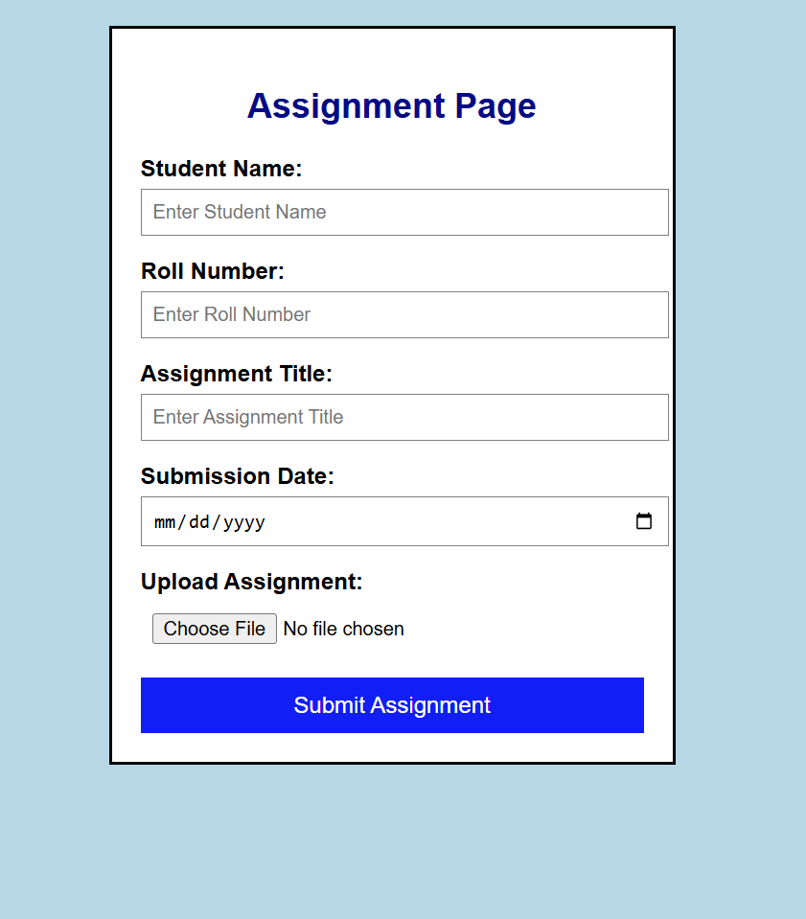

ATTENDANCE PAGE:

<!DOCTYPE html>
<html lang="en">
<head>
<meta charset="UTF-8">
<meta name="viewport" content="width=device-width, initial-scale=1.0">
<title>Student Attendance</title>

<style>
body{
background-color: lightblue;
font-family: Arial, sans-serif;
}

h2{
text-align: center;
color: darkblue;
}

.box{
width: 350px;
margin: 40px auto;
background-color: white;
border: 2px solid black;
padding: 20px;
}

label{
font-weight: bold;
}

input, select{
width: 100%;
padding: 8px;
margin-top: 5px;
margin-bottom: 15px;
border: 1px solid gray;
}

button{
width: 100%;
padding: 10px;
background-color: blue;
color: white;
border: none;
font-size: 16px;
}

button:hover{
background-color: darkblue;
}
</style>

</head>
<body>

<div class="box">

<h2>Student Attendance Form</h2>

<form>

<label>Student Name:</label>
<input type="text" placeholder="Enter Student Name" required>

<label>Roll Number:</label>
<input type="text" placeholder="Enter Roll Number" required>

<label>Date:</label>
<input type="date" required>

<label>Attendance Status:</label>
<select required>
<option value="">-- Select --</option>
<option value="Present">Present</option>
<option value="Absent">Absent</option>
</select>

<button type="submit">Submit Attendance</button>
</form>
</div>
</body>
</html>
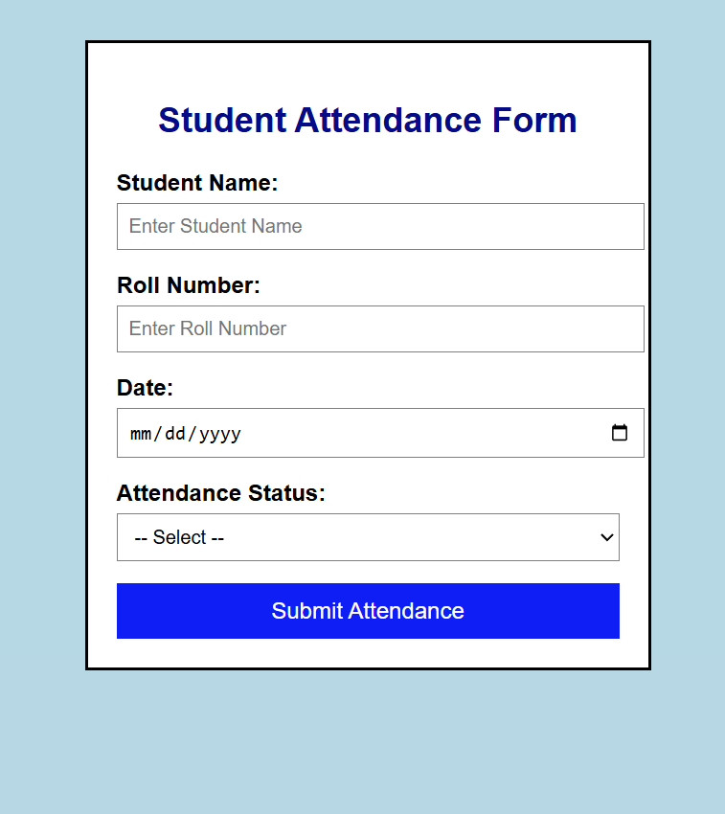

CONTECT PAGE:

<!DOCTYPE html>
<html>
<head>
<title>Contact Us</title>

<style>
body{
background-color: lightblue;
font-family: Arial, sans-serif;
}

h1{
text-align: center;
color: darkblue;
}

.box{
width: 350px;
margin: 30px auto;
background-color: white;
border: 2px solid black;
padding: 20px;
}

label{
font-weight: bold;
}

input, textarea{
width: 100%;
padding: 8px;
margin-top: 5px;
margin-bottom: 15px;
border: 1px solid gray;
}

button{
width: 100%;
padding: 10px;
background-color: green;
color: white;
border: none;
font-size: 16px;
}

button:hover{
background-color: darkgreen;
}
</style>
</head>

<body>

<div class="box">

<h1>Contact Us</h1>

<form>

<label>Name:</label><br>
<input type="text" placeholder="Enter your name" required>

<label>Email:</label><br>
<input type="email" placeholder="Enter your email" required>

<label>Phone Number:</label><br>
<input type="tel" placeholder="Enter your phone number">

<label>Subject:</label><br>
<input type="text" placeholder="Enter subject">

<label>Message:</label><br>
<textarea rows="5" placeholder="Enter your message"></textarea>

<button type="button">Send Message</button>

</form>
</div>
</body>
</html>

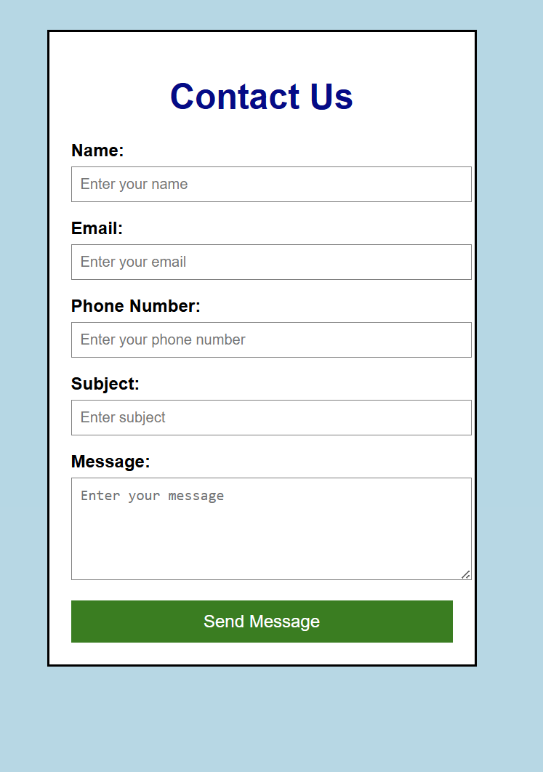

COURESE PAGE:

<!DOCTYPE html>
<html>
<head>
<title>Courses</title>

<style>
body{
background-color: lightblue;
font-family: Arial, sans-serif;
}

h1{
text-align: center;
color: darkblue;
}

.box{
width: 400px;
margin: 30px auto;
background-color: white;
border: 2px solid black;
padding: 20px;
}

ul{
padding-left: 20px;
}

li{
padding: 8px;
border-bottom: 1px solid gray;
}
</style>

</head>

<body>

<div class="box">

<h1>Our Courses</h1>

<ul>
<li>Web Development</li>
<li>App Development</li>
<li>Data Science</li>
<li>Artificial Intelligence</li>
<li>Machine Learning</li>
<li>Cyber Security</li>
<li>Cloud Computing</li>
<li>Graphic Design</li>
<li>Digital Marketing</li>
<li>Programming in C/C++</li>
</ul>

</div>

</body>
</html>

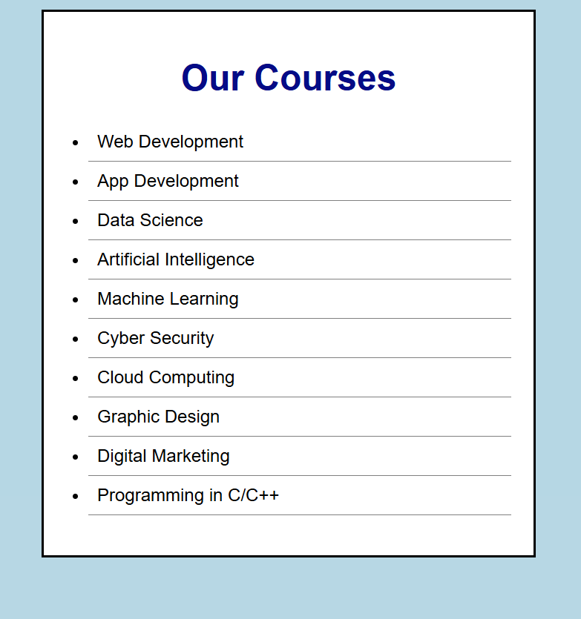

DASHBOARD PAGE:

<!DOCTYPE html>
<html>
<head>
<title>Dashboard</title>

<style>
body{
background-color: lightblue;
font-family: Arial, sans-serif;
}

h1{
text-align: center;
color: darkblue;
}

h2{
text-align: center;
}

.box{
width: 400px;
margin: 20px auto;
background-color: white;
border: 2px solid black;
padding: 15px;
}

h3{
color: blue;
}

ul{
padding-left: 20px;
}

button{
display: block;
width: 120px;
margin: 20px auto;
padding: 10px;
background-color: red;
color: white;
border: none;
font-size: 16px;
}

button:hover{
background-color: darkred;
}
</style>

</head>

<body>

<h1>Dashboard</h1>

<h2>Welcome User</h2>

<div class="box">
<h3>Profile</h3>
<p><b>Name:</b> radhe kalariya </p>
<p><b>Email:</b> student@gmail.com</p>
</div>

<div class="box">
<h3>Courses</h3>
<ul>
<li>Web Development</li>
<li>Data Science</li>
<li>Programming</li>
</ul>
</div>

<div class="box">
<h3>Progress</h3>
<p>Completed Courses: <b>3</b></p>
</div>

<div class="box">
<h3>Notifications</h3>
<p>No New Notifications</p>
</div>

<button>Logout</button>

</body>
</html>
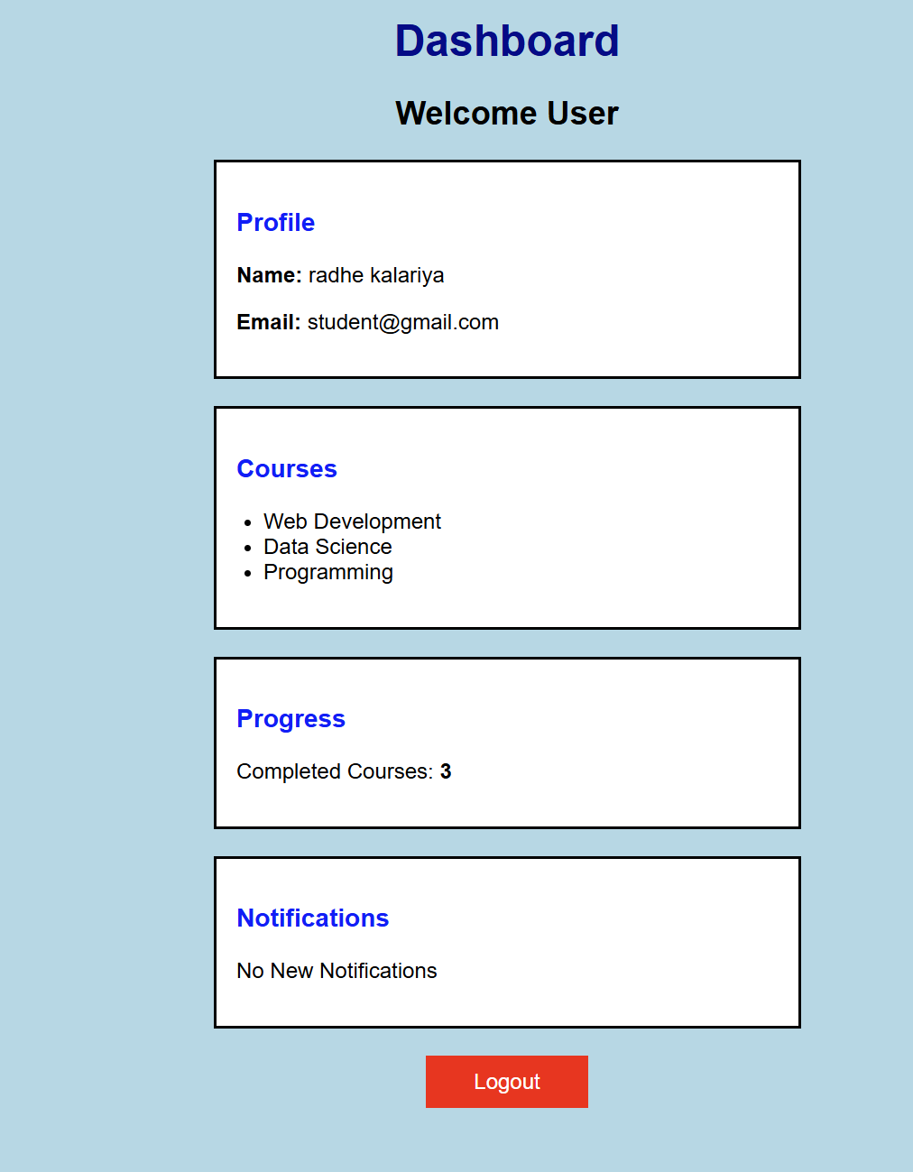

INDEX PAGE:

<!DOCTYPE html>
<html>
<head>
<title>Student Hub Portal</title>

<style>
body{
background-color: lightblue;
font-family: Arial, sans-serif;
}

.box{
width: 350px;
margin: 40px auto;
background-color: white;
border: 2px solid black;
border-radius: 10px;
padding: 20px;
text-align: center;
}

h1{
color: darkblue;
margin-bottom: 10px;
}

p{
color: gray;
margin-bottom: 20px;
}

a{
display: block;
background-color: blue;
color: white;
text-decoration: none;
padding: 10px;
margin: 8px 0;
border-radius: 5px;
}

a:hover{
background-color: darkblue;
}
</style>
</head>

<body>

<div class="box">

<h1>Student Hub Portal</h1>

<p>Welcome! Select an option below.</p>

<a href="Attendance.html">Attendance</a>

<a href="assignments.html">Assignment</a>

<a href="contact.html">Contact</a>

<a href="courses.html">Courses</a>

<a href="login.html">Login</a>

<a href="profile.html">Profile</a>

<a href="register.html">Register</a>

<a href="result.html">Result</a>

<a href="dashboard.html">Dashboard</a>

<a href="Timetable.html">Time Table</a>

<a href="admin.html">Admin Panel</a>

</div>

</body>
</html>

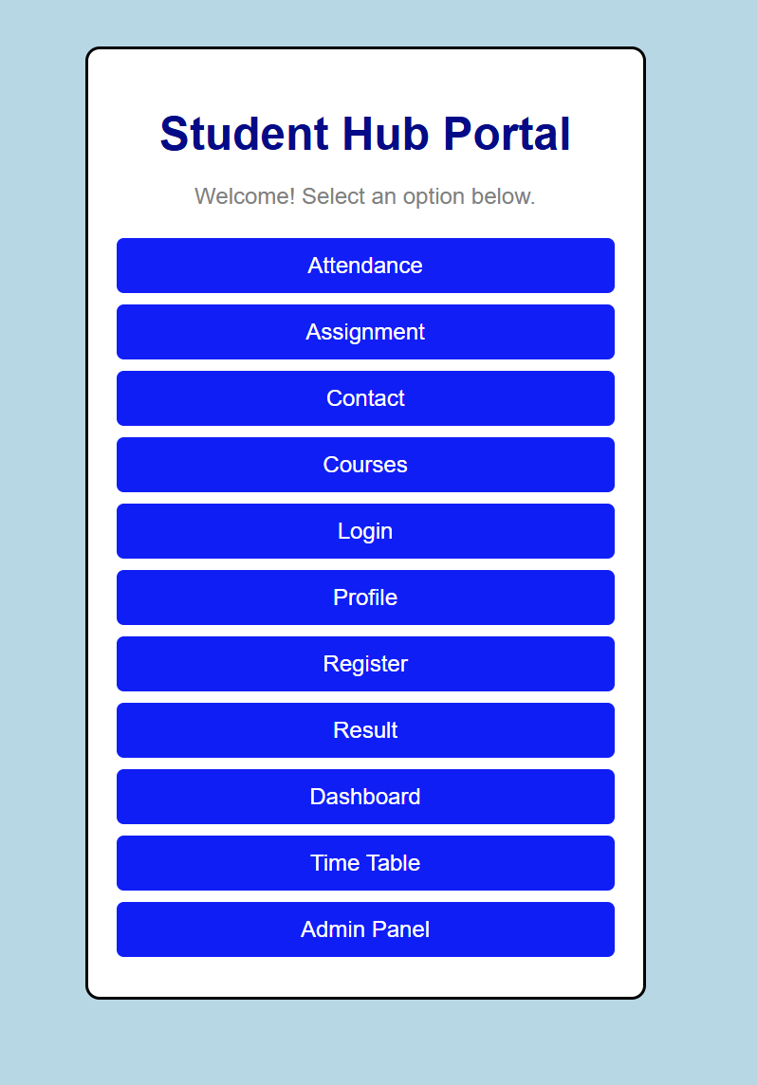

LOGIN PAGE:

<!DOCTYPE html>
<html>
<head>
<title>Login Page</title>
</head>
<style>

body{
background-color: lightblue;
font-family: Arial;
}

form{
background-color: white;
width: 250px;
margin: 100px auto;
padding: 20px;
border: 1px solid black;
}

input{
width: 100%;
height: 25px;
}

button{
width: 100%;
height: 30px;
background-color: blue;
color: white;
border: none;
}

button:hover{
background-color: darkblue;
}

a{
text-decoration: none;
}

h2{
text-align: center;
}
</style>
<body>

<!-- <h1>Login</h1> -->

<form>

<label>Username:</label><br>
<input type="text" placeholder="Enter Username" required>
<br><br>

<label>Password:</label><br>
<input type="password" placeholder="Enter Password" required>
<br><br>

<button type="button">Login</button>
<br><br>

<a href="#">Forgot Password?</a>
<br><br>

<p>Don't have an account?</p>
<a href="register.html">Register here</a>

</form>

</body>
</html>

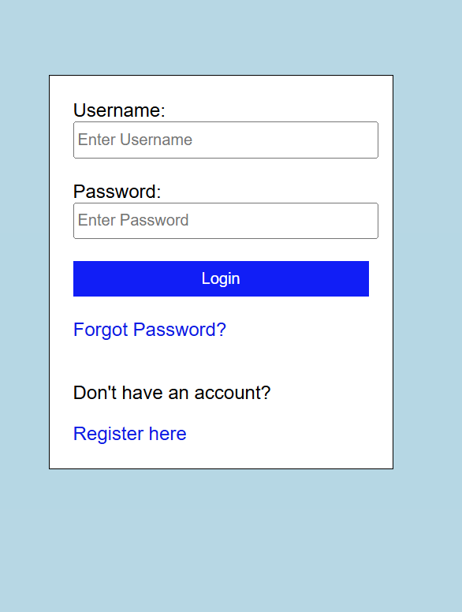

PROFILE PAGE:

<!DOCTYPE html>
<html>
<head>
<title>Student Profile</title>

<style>
body{
background-color: lightblue;
font-family: Arial;
}

.box{
width: 350px;
background-color: white;
margin: 50px auto;
padding: 20px;
border: 2px solid black;
text-align: center;
}

img{
width: 120px;
height: 120px;
border: 2px solid black;
border-radius: 50%;
}

h2{
color: darkblue;
}

label{
display: block;
text-align: left;
font-weight: bold;
margin-top: 10px;
}

input{
width: 100%;
height: 30px;
margin-top: 5px;
}

button{
width: 100%;
height: 35px;
margin-top: 20px;
background-color: blue;
color: white;
border: none;
}

button:hover{
background-color: green;
}
</style>

</head>
<body>

<div class="box">

<h2>Student Profile</h2>

<img src="e:\second year\studenthub\New folder\WhatsApp Image 2026-08-04 at 9.41.36 PM.jpeg" alt="Profile Image">

<form>

<label>Student Name</label>
<input type="text" value="Radhe Kalariya" readonly>

<label>Roll Number</label>
<input type="text" value="25DCE039" readonly>

<label>Email</label>
<input type="email" value="kalriyaradhe004@gmail.com" readonly>

<label>Mobile Number</label>
<input type="text" value="7046492578" readonly>

<label>Course</label>
<input type="text" value="Computer Engineering" readonly>

<label>Semester</label>
<input type="text" value="3" readonly>

<button type="button">Back</button>

</form>

</div>

</body>
</html>

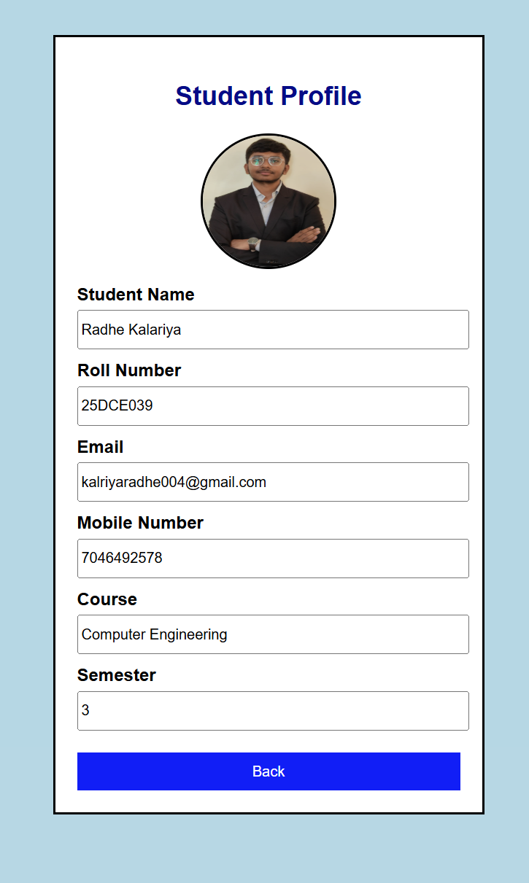

REGISTER PAGE:

<!DOCTYPE html>
<html>
<head>
<title>Registration Form</title>

<style>
body{
background-color: lightblue;
font-family: Arial, sans-serif;
}

h1{
text-align: center;
color: darkblue;
}

.form-box{
width: 350px;
background-color: white;
margin: 40px auto;
padding: 20px;
border: 2px solid black;
}

label{
font-weight: bold;
}

input, select{
width: 100%;
padding: 8px;
margin-top: 5px;
margin-bottom: 15px;
border: 1px solid gray;
}

input[type="radio"]{
width: auto;
}

button{
width: 100%;
padding: 10px;
background-color: green;
color: white;
border: none;
font-size: 16px;
}

button:hover{
background-color: darkgreen;
}
</style>

</head>

<body>

<h1>Registration Form</h1>

<div class="form-box">
<form>

<label>Full Name</label>
<input type="text" placeholder="Enter your name">

<label>Email</label>
<input type="email" placeholder="Enter your email">

<label>Phone Number</label>
<input type="tel" placeholder="Enter phone number">

<label>Username</label>
<input type="text" placeholder="Enter username">

<label>Password</label>
<input type="password" placeholder="Enter password">

<label>Confirm Password</label>
<input type="password" placeholder="Confirm password">

<label>Gender</label><br>
<input type="radio" name="gender"> Male
<input type="radio" name="gender"> Female
<br><br>

<label>Course</label>
<select>
<option>Select Course</option>
<option>Web Development</option>
<option>Data Science</option>
<option>Cyber Security</option>
<option>Programming</option>
</select>

<button type="button">Register</button>
</form>
</div>

</body>
</html>

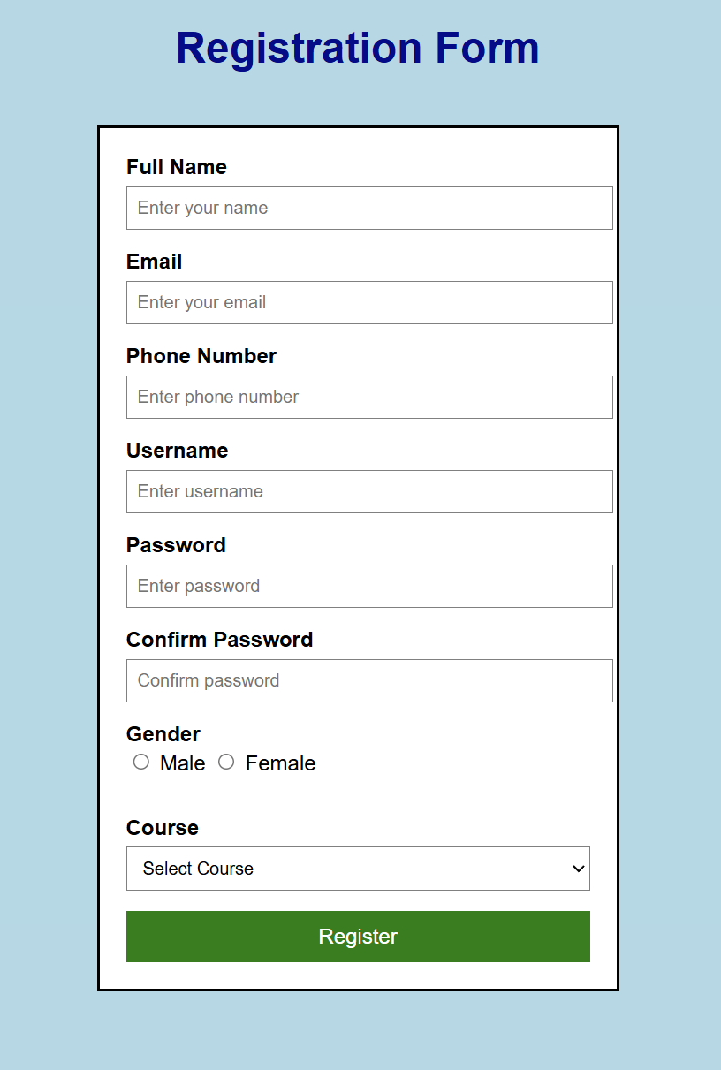

RESULT PAGE:

<!DOCTYPE html>
<html>
<head>
<title>Student Result</title>

<style>
body{
background-color: lightblue;
font-family: Arial, sans-serif;
}

h1{
text-align: center;
color: darkblue;
}

.box{
width: 500px;
margin: 30px auto;
background-color: white;
border: 2px solid black;
padding: 20px;
}

h2, h3{
color: black;
}

table{
width: 100%;
border-collapse: collapse;
margin-top: 15px;
}

th{
background-color: green;
color: white;
}

th, td{
border: 1px solid black;
padding: 10px;
text-align: center;
}

tr:hover{
background-color: lightgray;
}
</style>

</head>

<body>

<div class="box">

<h1>Student Result</h1>

<h2>Student Name: Radhe Kalariya </h2>

<table>
<tr>
<th>Subject</th>
<th>Marks</th>
<th>Grade</th>
</tr>

<tr>
<td>HTML</td>
<td>85</td>
<td>A</td>
</tr>

<tr>
<td>CSS</td>
<td>80</td>
<td>A</td>
</tr>

<tr>
<td>JavaScript</td>
<td>75</td>
<td>B</td>
</tr>

<tr>
<td>C Programming</td>
<td>90</td>
<td>A+</td>
</tr>

</table>

<h3>Total Marks: 330 / 400</h3>
<h3>Result: Pass</h3>

</div>

</body>
</html>
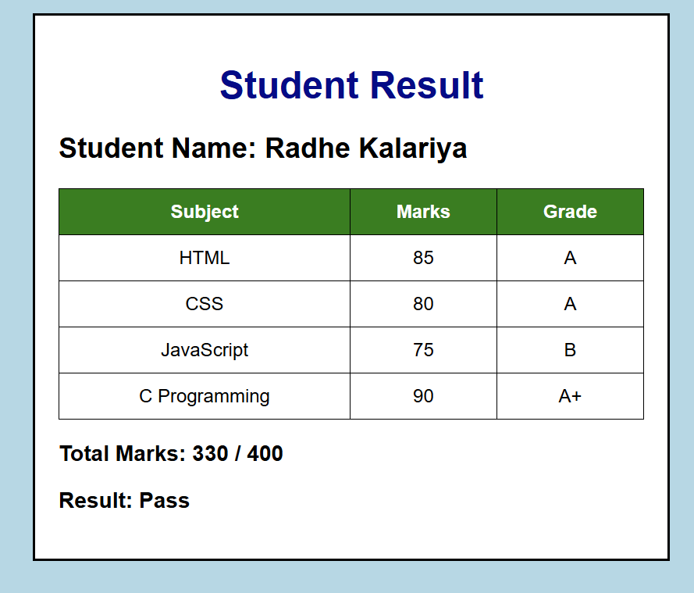

TIME TABLE :
<!DOCTYPE html>
<html>
<head>
<title>Class Timetable</title>

<style>
body{
background-color: lightblue;
font-family: Arial, sans-serif;
}

h2{
text-align: center;
color: darkblue;
}

table{
width: 95%;
margin: auto;
border-collapse: collapse;
background-color: rgb(245, 245, 245);
}

th{
background-color: rgb(60, 83, 60);
color: white;
}

th, td{
border: 1px solid black;
padding: 8px;
text-align: center;
}
</style>

</head>

<body>

<h2>Class Timetable</h2>

<table>

<tr>
<th>Day</th>
<th>9:10-10:10</th>
<th>10:10-11:10</th>
<th>11:10-12:10</th>
<th>12:10-1:10</th>
<th>1:10-2:10</th>
<th>2:10-2:20</th>
<th>2:20-3:20</th>
<th>3:20-4:20</th>
</tr>

<tr>
<td>Monday</td>
<td>MSUD203<br>DM (T)<br>124<br>RVS</td>
<td>ITUC201<br>FCN (T)<br>124<br>RP</td>
<td rowspan="6">Lunch Break</td>
<td colspan="2">CEUE203: OOP (P) 116 - PKJ</td>
<td rowspan="6">Break</td>
<td colspan="2">HSUV201<br>CPI (T)<br>325<br>VHP</td>
</tr>

<tr>
<td>Tuesday</td>
<td>MSUD203<br>DM (T)<br>124<br>RVS</td>
<td>CSUC201<br>FDSA (T)<br>323<br>NNB</td>
<td>MSUD203<br>DM (T)<br>329<br>CIP</td>
<td>Counselling / Mentoring Session</td>
<td colspan="2">CSUC201: FDSA (P) 110 - PJP</td>
</tr>

<tr>
<td>Wednesday</td>
<td colspan="2">ITUE203: WDF (P) 105 - SHP</td>
<td>ITUC201 FCN (T)</td>
<td>Counselling / Mentoring Session</td>
<td>ITUC201 FCN (T)</td>
<td>MSUD203 DM (T)</td>
</tr>

<tr>
<td>Thursday</td>
<td>ITUE203 WDF (T)</td>
<td>ITUC201 FCN (T)</td>
<td>CSUC201 FDSA (T)</td>
<td>CEUE203 OOP (T)</td>
<td colspan="2">ITUC201: FCN (P) 108 - UMC</td>
</tr>

<tr>
<td>Friday</td>
<td>ITUE203 WDF (T)</td>
<td>CSUC201 FDSA (T)</td>
<td colspan="2">ITUE203: WDF (P) 105 - PGP</td>
<td>CEUE203 OOP (T)</td>
<td>ITUE203 WDF (T)</td>
</tr>

<tr>
<td>Saturday</td>
<td colspan="2">Skill Enhancement Sessions</td>
<td colspan="2">Training & Placement Sessions</td>
<td colspan="2">Expert Talks</td>
</tr>

</table>

</body>
</html>

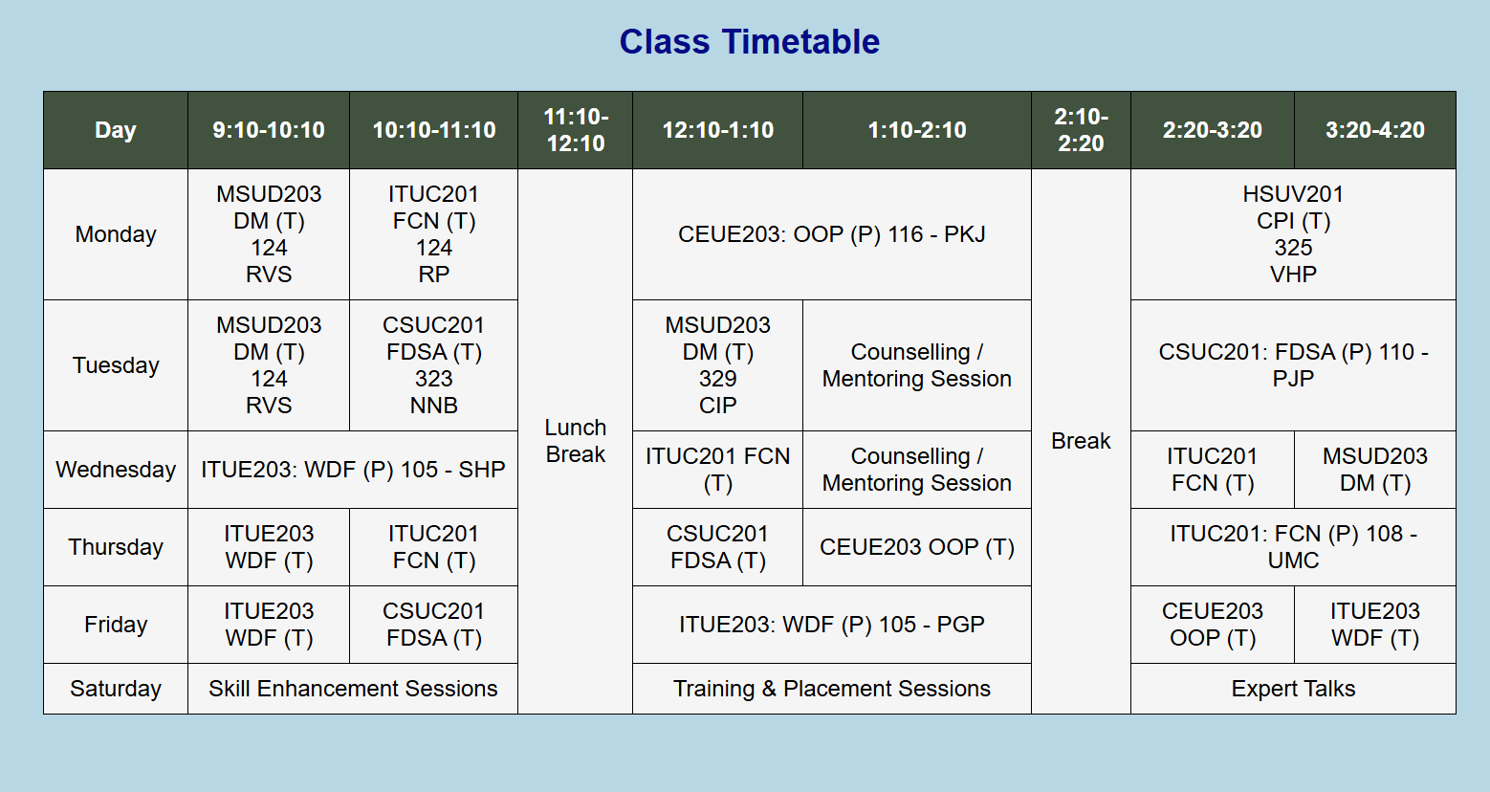

GitHub Repository Link: https://github.com/Rkpatel34/StudentHub
Challenge:
Making the webpage look good on different screen sizes.
Solution:
I adjusted the CSS to improve the layout.
Challenge 2
Challenge:
Managing colors, spacing, and alignment.
Solution:
I used CSS properties to make the page neat and readable.

LEARNING OUTCOME:I learned how to use CSS to design web pages. I also learned to improve the layout, colors, spacing, and make the webpage easy to use.

