TECHNO SOFTWARE PVT, LTD.

Ph 0612£530880. 2355332. 0431673155

E-matl cern com

Date. . IA.,) l..if,û /

Offer Letter

Dear Rohit Kumar,

With reference to the discussions we had with you. we on behalf of IRIYA TECHNO SOFTWARE PVT LTD) are pleased to offer you the Position of "Android Developer" and invite you to join (RIYA TECHNO SOFTWARE PVT family.

You Cost to the Company (CTC) would be Rs. 15,000.00 Monthly.

The allowances, benefits and other terms and conditions of your employment will be as per Company policies as applicable from time to time. Your compensation will be reviewed in future as per Company policy.

On joining the company you shall be on probation for One Year. You will abide by the rules and regulations of the company as may be in force from time to time.

We welcome you aboard and the detailed appointment letter will be given to you at the time of joining we expect you to join on or before 19/07/2021.in the line with discussion with you, otherwise this Offer will stand withdrawn automatically.

The company looks for a long-term association with all its employees and expects the same from you. Again, congratulations and welcome to the (RIYA TECHNO SOFTWARE PVT LTD) family.

 SOFTWARE PVT.LTD. Employment offer Accepted

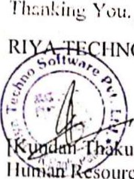

HNO

•url

•ources (Rohit Kumar)



CS Scanned with CamScanner