**Introduction**

To solve the given problem, you need to follow the following steps:

- Start Hive services and ensure that Hive daemons are running in your Hadoop Cluster

- Use HIveQL to create a table with same column names as given in csv file

- Load the csv file in Hive table - Execute the HiveQL query to get the desired results

**1. Problem Solution**

1.1 Create Hive Table Use ‘create table’ hive command to create the Hive table for your dataset:

hive> create table nyse (exchange_data String,stock_symbol String,stock_date String,stock_price_open double, stock_price_high double, stock_price_low double, stock_price_close double, stock_volume double, stock_price_adj_close double) row format delimited fields terminated by ",";

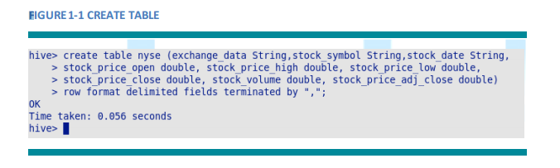

**1.2 Load Data to Hive Table**

Use the following Hive command to load data into Hive table:

hive> load data local inpath '/home/cloudera/NYSE_daily_prices_Q.csv' into table nyse;

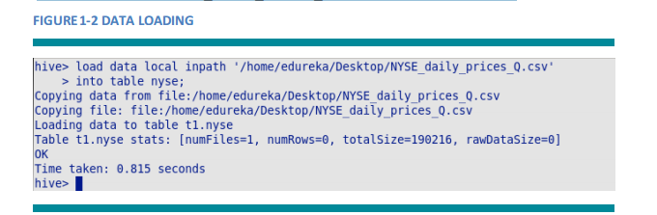

**1.3 Calculate the Covariance**

Use the following query to calculate the covariance between stocks.

hive> select a.STOCK_SYMBOL, b.STOCK_SYMBOL, month(a.STOCK_DATE), (AVG(a.STOCK_PRICE_HIGH*b.STOCK_PRICE_HIGH) - (AVG(a.STOCK_PRICE_HIGH)*AVG(b.STOCK_PRICE_HIGH))) from nyse a join nyse b on a.STOCK_DATE=b.STOCK_DATE where a.STOCK_SYMBOL, month(a.STOCK_DATE);

