**ASTHMA**

# **What is asthma?**

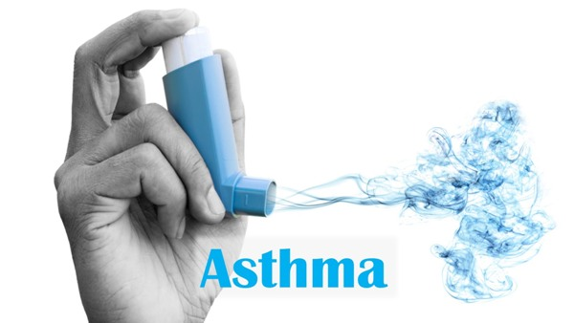ASTHMA = RESPIRATORY ILLNESS

Swelling in lungs which led to the lack of weakness and low energy level even weakens the immunity level of human body is known as **asthma.**

This is one of the most dangerous disease with no cure treatment (according to the doctors, if someone is suffering from asthma then it is tough to recover it, they advise what medical science teach them).

If you ever notice doctors said that asthma is the disease that a person will have to carry it for his/her life time along with treatment. The treatment will only give relief but can’t cure it permanently.

# **How it affects on body?**

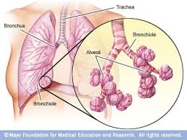Our oxidative nature follows a path starts from our nose to **alveoli** in lungs.

Alveoli is the minor part of lungs in which air entrapped and here the first step of asthma comes:

* The lungs start swelling and alveoli unable to trap air for sufficient time as compared to normal human lungs
* It starts reducing the body energy level
* Immunity system weakens and if immunity level drop the body feel difficult to fight against any disease
* Asthma only affect lungs as major affected area

# **SYMPTOMS**

* Breathing shortness
* Very low energy level
* Chest tightness or pain
* Coughing or cold flu that caused by breathing shortness
* Rarely pain in ribs

# **CAN ASTHMA GO AWAY FOREVER?**

Yes, it can go away with the proper treatment and effective exercises.

# **NATURAL PROTECTION OF LUNGS**

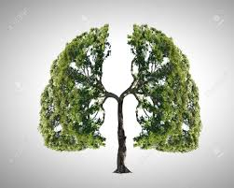**Epithelial lining fluids (ELF)** is the first protective phenomenon. All the cells from nose to lungs are covered with the thick layer of **(Mucus)**. These ELF has **cilia** in it which can throw out all bacteria and virus from body. This mucus has a thick lines in which **antioxidants** are present that led to diffuse all pollutants and harmful gases which we inhale.

Vitamin C, Vitamin E, Glutathione (antioxidants) present in mucus helps a lot in the protection of lungs.

Proper consumption of fruits like oranges, kiwi, avocado, grapes, papaya, etc.. fruits gives enough nutrition and vitamins, minerals.

# **CURE OF ASTHMA ACCORDING TO MEDICAL STUDIES**

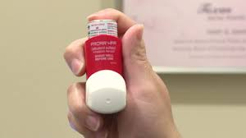Initially doctors check your heart beats from stethoscope and then they find out that, is patients have cough, cold flu, chest pain, and shortness in breathe. After they’ll suggest you 14 days of treatment for trial whether the medicine is helpful or not and will give you some **medicine and inhaler.**

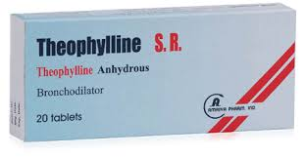**Theophylline** is the medicine (it helps to expand air pipe).

The same treatment goes for long because this is the only way that relief but will not cure permanently.

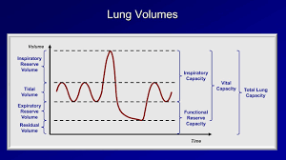If the condition of the patient become worst, then after they will suggest you for **Pulmonary function test** which helps to know that how much percent of lungs are working and how much are not.

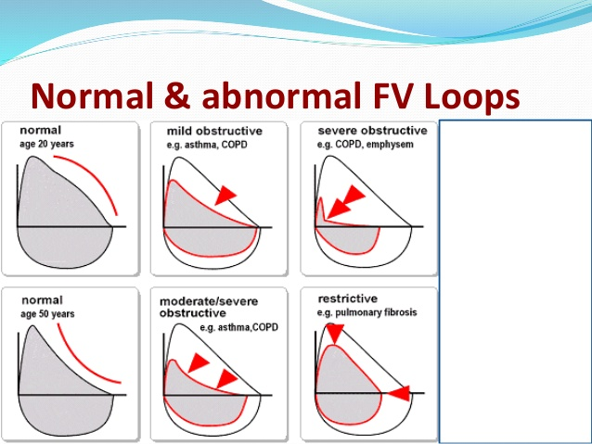

**PULMONARY FUNCTION TEST**

# **CURE OF ASTHMA ACCORDING TO AYURVEDA**

Ayurveda is final solution for any disease problem, it can help to cure asthma very efficiently. **Ayurvedic treatment** is followed from thousand of years even from the Shri Ram’s empire.

Here are some ayurvedic medicines:

* Tulsi
* Vasaka
* Mulethi
* Surasa
* Ashwagandha
* Vitamin C **(extract from acerola cherry)**

**Tulsi:** It helps in reducing cough, cold flu and even helps to build immunity stronger, there are so many benefits of tulsi.

**Vasaka:** It helps in **Bronchitis + Tuberculosis** and any issue related to lungs and shortness of breathe and cough.

**Mulethi:** It helps in asthma and windpipe inflammation and also helpful in Bronchitis and Respiratory area from nose no lungs. Mulethi is an **anti-infammatory and antiulcer.**

**Sursa:** It is like (sone pe suhaga). This one is also extremely helpful for respiratory related problems.

**Ashwagandha:** In case of asthma the body feel low in energy level so ashwagandha helps to provide good amount of energy and helps body to be more energetic. This is optional you can go with it if you want.

**Vitamin C:** There are so many vitamin C products available in market but which one is best is difficult to choose, I suggest you all to go with the source of vitamin C extracted from **acerola** **cherry** this cherry is one of the best source of vit. C among all others.

# **PERSONAL REVIEW**

If asked that asthma can be cure? With 100% surety I can say YES because, I have gone through this stage from past 4-5 years ago and I did it.. not with doctors treatments but with same ayurvedic treatment as I have discussed above.