Plots for 1 KHz

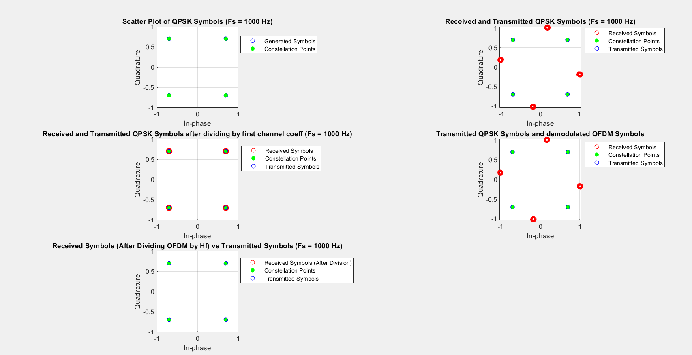

Plots for 10 KHz

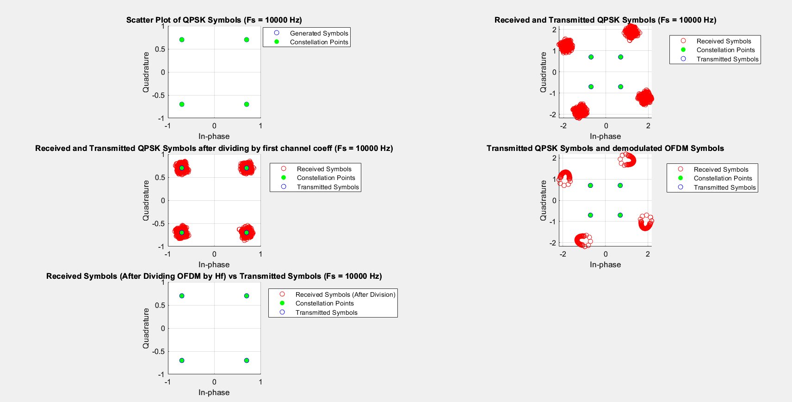

Plots for 1 MHz

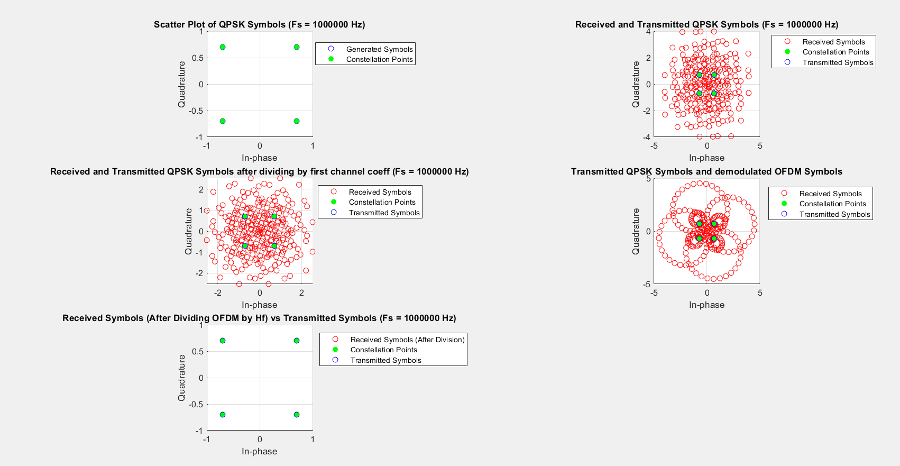

Subplot (3,2,1) = Part 2

Subplot (3,2,2) = Part 3

Subplot (3,2,3) = Part 4

Subplot (3,2,4) = Part 6

Subplot (3,2,5) = Part 7

Part 1) Sampling Frequencies have been changed according to the question and channel coefficients (gn) have been computed in the code.

Part 5 ) Difference between part 3 and part 4

We can notice that the scatter points appear closer to constellation points in part 4. This is because in part 4, we are normalizing by dividing with the first channel coefficient.

In part 3, after convolution with channel, the scatter plots spread apart from constellation points due to the channel effect.

By normalizing, we align amplitude of scatter points with the constellation points, which results in scatter points moving closer to constellation points.

Part 7) We have to choose subcarriers in order to avoid frequency selective fading.

We also have to make sure the length is a power of 2.

We know that the delay spread of channel is 15 us (Ds)

For Flat Fading, Bs/n < 1/Ds

This implies that, n> Bs*Ds

For the highest frequency of 1 MHz(Bs), n>15

Therefore, we can use length(n) as 16 for the edge case but for better results we have used length as 64. Thus to include all 1024 qpsk points we have to divide these points in 16 parallel sub carriers with length of each sub carrier as 64. We have chosen 15 cyclic points because it is mentioned in the question to pick cyclic points, one less than the length of channel (16).

Part 8) Difference between part 6 and part 7

We can observe that in the graph of part 7, scatter points lie exactly on the constellation points.

This is because in part 7, we are dividing ofdm_output with Hf (element wise division).

This Normalises the channel effects, including attenuation and phase shift during transmission and we received the exact data.