Rajvi Lathia

101034808

Space shooter

2D Shooter

**TABLE OF CONTENTS:**

GAME DESCRIPTION ………………………………..……………………………………………………………………….…….2

CONTROLS DESCRIPTION …………………………..……………………………………………………………………………2

SCORING SYSTEM …………..……………………………………………………………………………………………………….2

ENEMIES ……………………….…………………………………………………………………………………………………………2

ART/MULTIMEDIA INDEX …………………………………………………………………………………………………………3

SCREEN DESCRIPTION……………………………………………………………………………………………………………….4

SOUND INDEX ………………………………………………………………………………………………………………………….6

**GAME DESCRIPTION:**

2D Shooter is a very easy to play shooter game. The Blue Spaceship travels in the space. There are stars as the objects that increases the score of the player and enemy spaceship as the enemy which decreases the life of the player and decreases the score if collided.

**CONTROLS DESCRIPTION:**

Keyboard controls include the keys A, S, W and D or the up, down, left and right for the movement of the Player spaceship. Spacebar or primary mouse button to shoot the fireballs.

**SCORING:**

The Blue Spaceship has total 3 lives and travels in the space. There are **stars** as the objects that increases the score of the player by 10 and enemy spaceship as the enemy which decreases the life of the player by 1 and decreases the score by 5 if collided with the player. When life becomes 0, the game ends.

**ENEMIES:**

Enemy spaceship travels at increasing speed from right to left at random position. When it collides with the player spaceship, the life of the player decreases by 1.

**ART/MULTIMEDIA INDEX:**

|  |  |
| --- | --- |
|  | Player Spaceship |
|  | Enemy Spaceship |
|  | Fireball |
|  | Space (Background) |
| C:\Users\rajvi\AppData\Local\Microsoft\Windows\INetCache\Content.Word\Star.png | Star |

**SCREEN DESCRIPTION:**

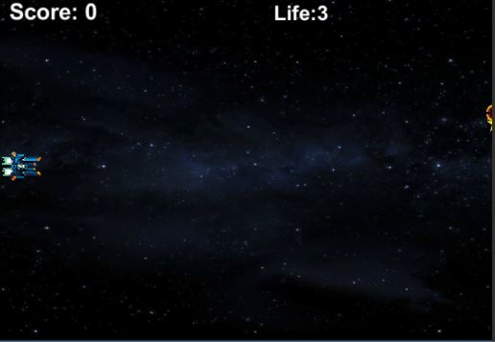Game-Start State

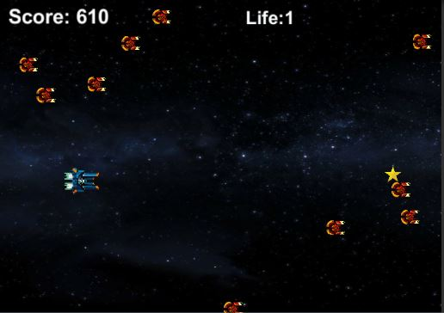Game-Play State

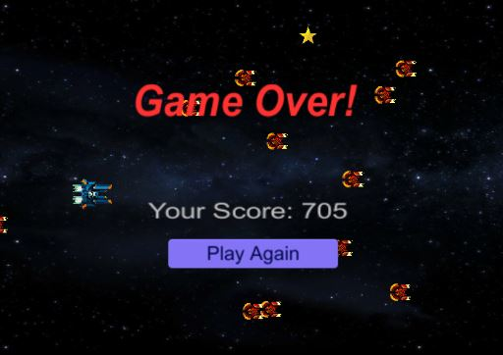Game-End State