**Drugs, death and crimes**

**A crisis in New England**

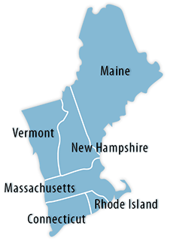

**2015-2019**



Drug use in New England and the deaths and crime associated with it have been increasing to a point of great concern. Numerous public hearings have been held to address this crisis as it affects a growing number of residents in this region of the United States.

This project confirms that drug related deaths and crimes have increased significantly in New England during a five-year period from 2015 to 2019.

The statistics that recorded drug overdoses and crimes during this time were taken from CDC and FBI data sources respectively.

Source of information:

**FBI Crime Data Explorer (CDE)**



<https://crime-data-explorer.app.cloud.gov/pages/downloads>

Under Crime Incident-Based Data by State and Year

The FBI’s Crime Data Explorer (CDE) has Incident-based data that was downloaded as CSV files.

From this source, five years (2015 – 2019) of recorded crime incidents from the states in New England was queried across multiple files. Results were filtered to show only crimes that were tagged as drug related. Data from the CDE that was distinguished per gender was combined to show total crimes per year across all genders in order to coordinate with the CDC data described below that did not include gender.

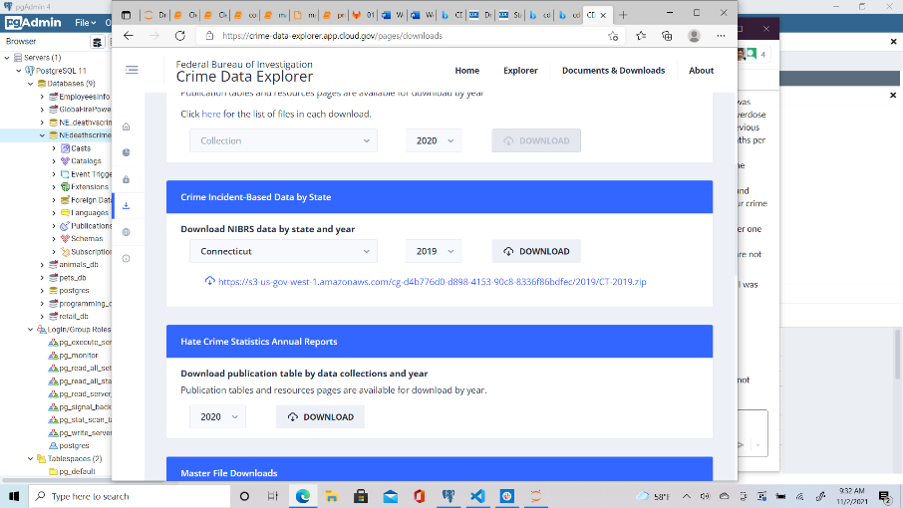

30 Files were extracted from CDE site:

/Connecticut

Ct_2019.csv Ct_2018.csv Ct_2017.csv Ct_2016.csv Ct_2015.csv

/Massachusetts

Ma_2019.csv, ma_2018.csv ma_2017.csv, ma_2016.csv, ma_2015.csv

/Maine

ME_2019_nibrs_arrestee.csv, ME_2018_nibrs_arrestee.csv,

ME_2017_nibrs_arrestee.csv, ME_2016_nibrs_arrestee.csv, ME_2015_nibrs_arrestee.csv

/New Hampshire

MH_2019_nibrs_arrestee.csv, NH_2018_nibrs_arrestee.csv, NH_2017_nibrs_arrestee.csv, NH_2015_nibrs_arrestee.csv, NH_2015_nibrs_arrestee.csv

/Rhode Island

NIBRS_ARRESTEE_2019.csv, NIBRS_ARRESTEE_2018.csv, NIBRS_ARRESTEE_2017.csv, nibrs_arrestee_2016.csv, nibrs_arrestee_2015.csv

/Vermont

NIBRS_ARRESTEE_2019.csv, NIBRS_ARRESTEE_2018.csv, NIBRS_ARRESTEE_2017.csv, nibrs_arrestee_2016.csv, nibrs_arrestee_2015.csv

Fields extracted per file:

Arrest_date: Date of crime committed

Offense_type_id: Only got offense id number 35 which was according to another table the drug offense type.

Sex_code: Gender of whom the crime was committed by.

|  |  |  |  |  |  |  |  |  |  |  |  |  |  |  |  |  |  |  |
| --- | --- | --- | --- | --- | --- | --- | --- | --- | --- | --- | --- | --- | --- | --- | --- | --- | --- | --- |
|  |  |  |  |  |  |  |  |  |  |  |  |  |  |  |  |  |  |  |

**Centers for Disease Control and Prevention**

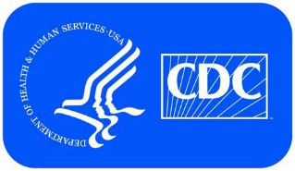

The CDC’s Drug Overdose Mortality by State data was downloaded as a single CSV file that contains the number of drug related deaths by state per year.

From this source, five years (2015 – 2019) of recorded drug overdoses from the states in New England was queried. The results show the number of drug related deaths by state per year across all genders.

https://www.cdc.gov/nchs/pressroom/sosmap/drug_poisoning_mortality/drug_poisoning.htm

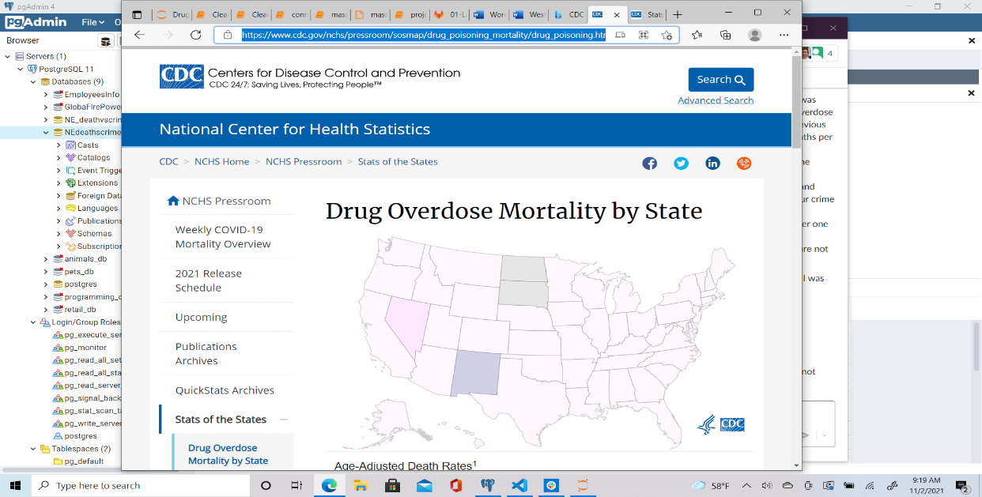

Fields Extracted from CDC CSV file:

YEAR: Year of Deaths

STATE: Location of deaths

DEATH: Number of deaths per State in that year.

This file called CSV.csv file was renamed for the project as Death_overdose.csv, this file was transformed and manipulated to meet the requirements of the crimes files to be able to put this in a database and finally join with our other source by state and year.

The exact changes of the transformation of this file would be found in detail in the PROJECT_ETL.IPYNB, as well as the final database load and comparison.

Output Datasets

Crime Deaths

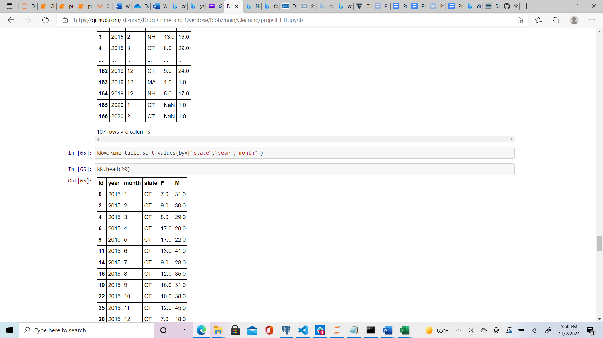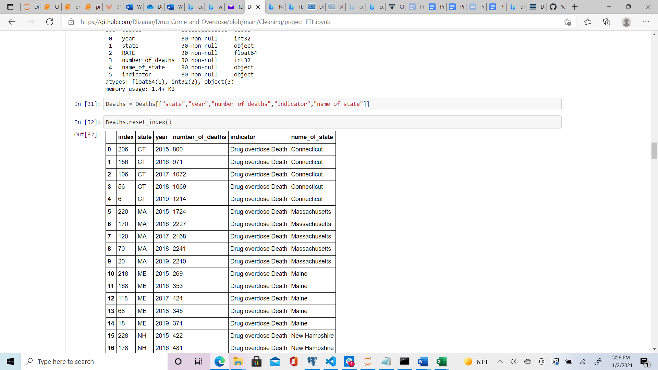

Schemas structures were the datasets were loaded

|  |
| --- |
| Drug Crimes |
|  |
| *Index* |
| *State------------ PK* |
| *Year------------ PK* |
| Number_of_crimes |
| Number_female |
| Number_male |

|  |
| --- |
| Overdose Deaths |
|  |
| *Index* |
| *State---------------pk* |
| *Year---------------pk* |
| *Number of deaths* |
| *Indicator* |
| *Name of State* |

Final SQL query with joined tables Drug crimes vs Overdose deaths

