**Mage**

*Game Design Document*

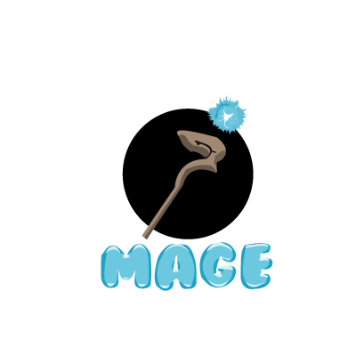

Revision: 0.0.1

Robson Allein F. Miguelles

**Project Description**

This game design document describes the details for a multi-platform touch based 2D adventure game with original story and characters. The game plays like other match-3 games but introduces some innovations.

**Characters**

Little mage is the main characters in this game. Mages are people who seek for knowledge and hidden secret of the world and practice sorcery.

Mage they can use their mana to create or produce spell element like fire, ice, and Etc. that they used to attack their enemies.

**Story**

In its earliest, and some would say most potent form, magic was primarily the art of memory. It required no technology, no wands or appurtenances other than the mind of the magician. All the trappings of ritual were merely mnemonic devices, meant to allow the practitioner to recall in rich detail the specific mental formulae that unlocked a spell's power. But some of the mage use their power to harm the other to dominate the world they called the black mage and this is the beginning of the journey of our little mage to stop the evil plan of black mage.

**Theme**

This is a game about the journey of the mage. Game theme is adventure and fantasy a mage go for a journey to stop the black mage in his journey he will encounter different mages that help him to enhance his knowledge/power.

**Gameplay**

Adventure and fantasy game. A journey of the Little mage to defeat the Black mage to bring back the peace and harmony to the world.

* **Goals:** Defeat the Black Mage . Gameplay (short term): Defeat the enemies, advance to the next level, etc...
* **User Skills:** Tap on the screen, Strategize
* **Items and power-ups (optional)**
* **Progression and Challenge -** Difficulty will advance by making the enemies harder.
* **Losing:** These are the losing conditions: losing by lose your 3 life in the game.

**Art Style**

This is a 2D isometric game, with high quality 2D sprites. The character design should resemble that of Studio Ghibli. Everything should be very colorful and feel alive, with highly animated scenarios and layered backgrounds.

**Music and Sounds**

* The music should have a Retro style, appealing to 8 bit nostalgia but high quality.
* It’s important that a lot of sound effects praise the user when he does something good. There should be immediate and positive feedback.
* The sad scenes should be accompanied by Accordion/Violin music and sound like a sorrowful Tango.
* For In-Game music, use a more relaxed approach with happy tunes and going up on tempo as the level progresses. When in caves the music should sound muffled.

**Technical Description**

The game will be Desktop platform: With PC standalone version and Facebook Canvas.

* **Controls**
* Key-Arrow-Up to jump
* Key-Arrow-Left to move backward
* Key-Arrow-Right to move forward
* Mouse-Leftclick to attack
* **Fonts**
* **Audio / Music**
* **Graphics**

1. Characters

* Little mage (idle, walking, running)
* Normal mage (idle, walking, running).
* Black mage (idle, walking, flying)

1. Blocks
   1. Dirt
   2. Dirt/Grass
   3. Stone Block
   4. Stone Bricks
2. Ambient (Background)
   1. Tall Grass
   2. Old Trees
   3. Torch
   4. Crow and bats

**Demographics**

Age: 12 to 50 , Sex: Everyone, Casual players mostly.

**Platforms & Monetization**

This game is Free to play with Ads.