**TERM WORK – V**

**MOVIE DATABASE**

**Consider the Movie Database:**

**Director (directorid:string, fname:string, lname:string, mno:number)**

**Movie (movid:string, movname:string, year:string, movtype:string, dirid:string, lang:string)**

**Actor (actid:string, actfname:string, actlname:string, mid:string)**

**Rating (rid:string, movieid:string, rating:number)**

1. Draw ER and Schema Diagram
2. Create above tables by properly specifying primary and foreign keys.
3. Insert at least 5 values to all tables.
4. Retrieve details of movies which are released in 2021.
5. Retrieve director name of kabhi khushi kabhi gham
6. Display movie name in which Ajay Devghan has acted in.
7. Retrieve details of Kannada language movies.
8. Display count of movies according to languages.
9. Display movie name, director name and ratings.
10. Display movie names of all actors.

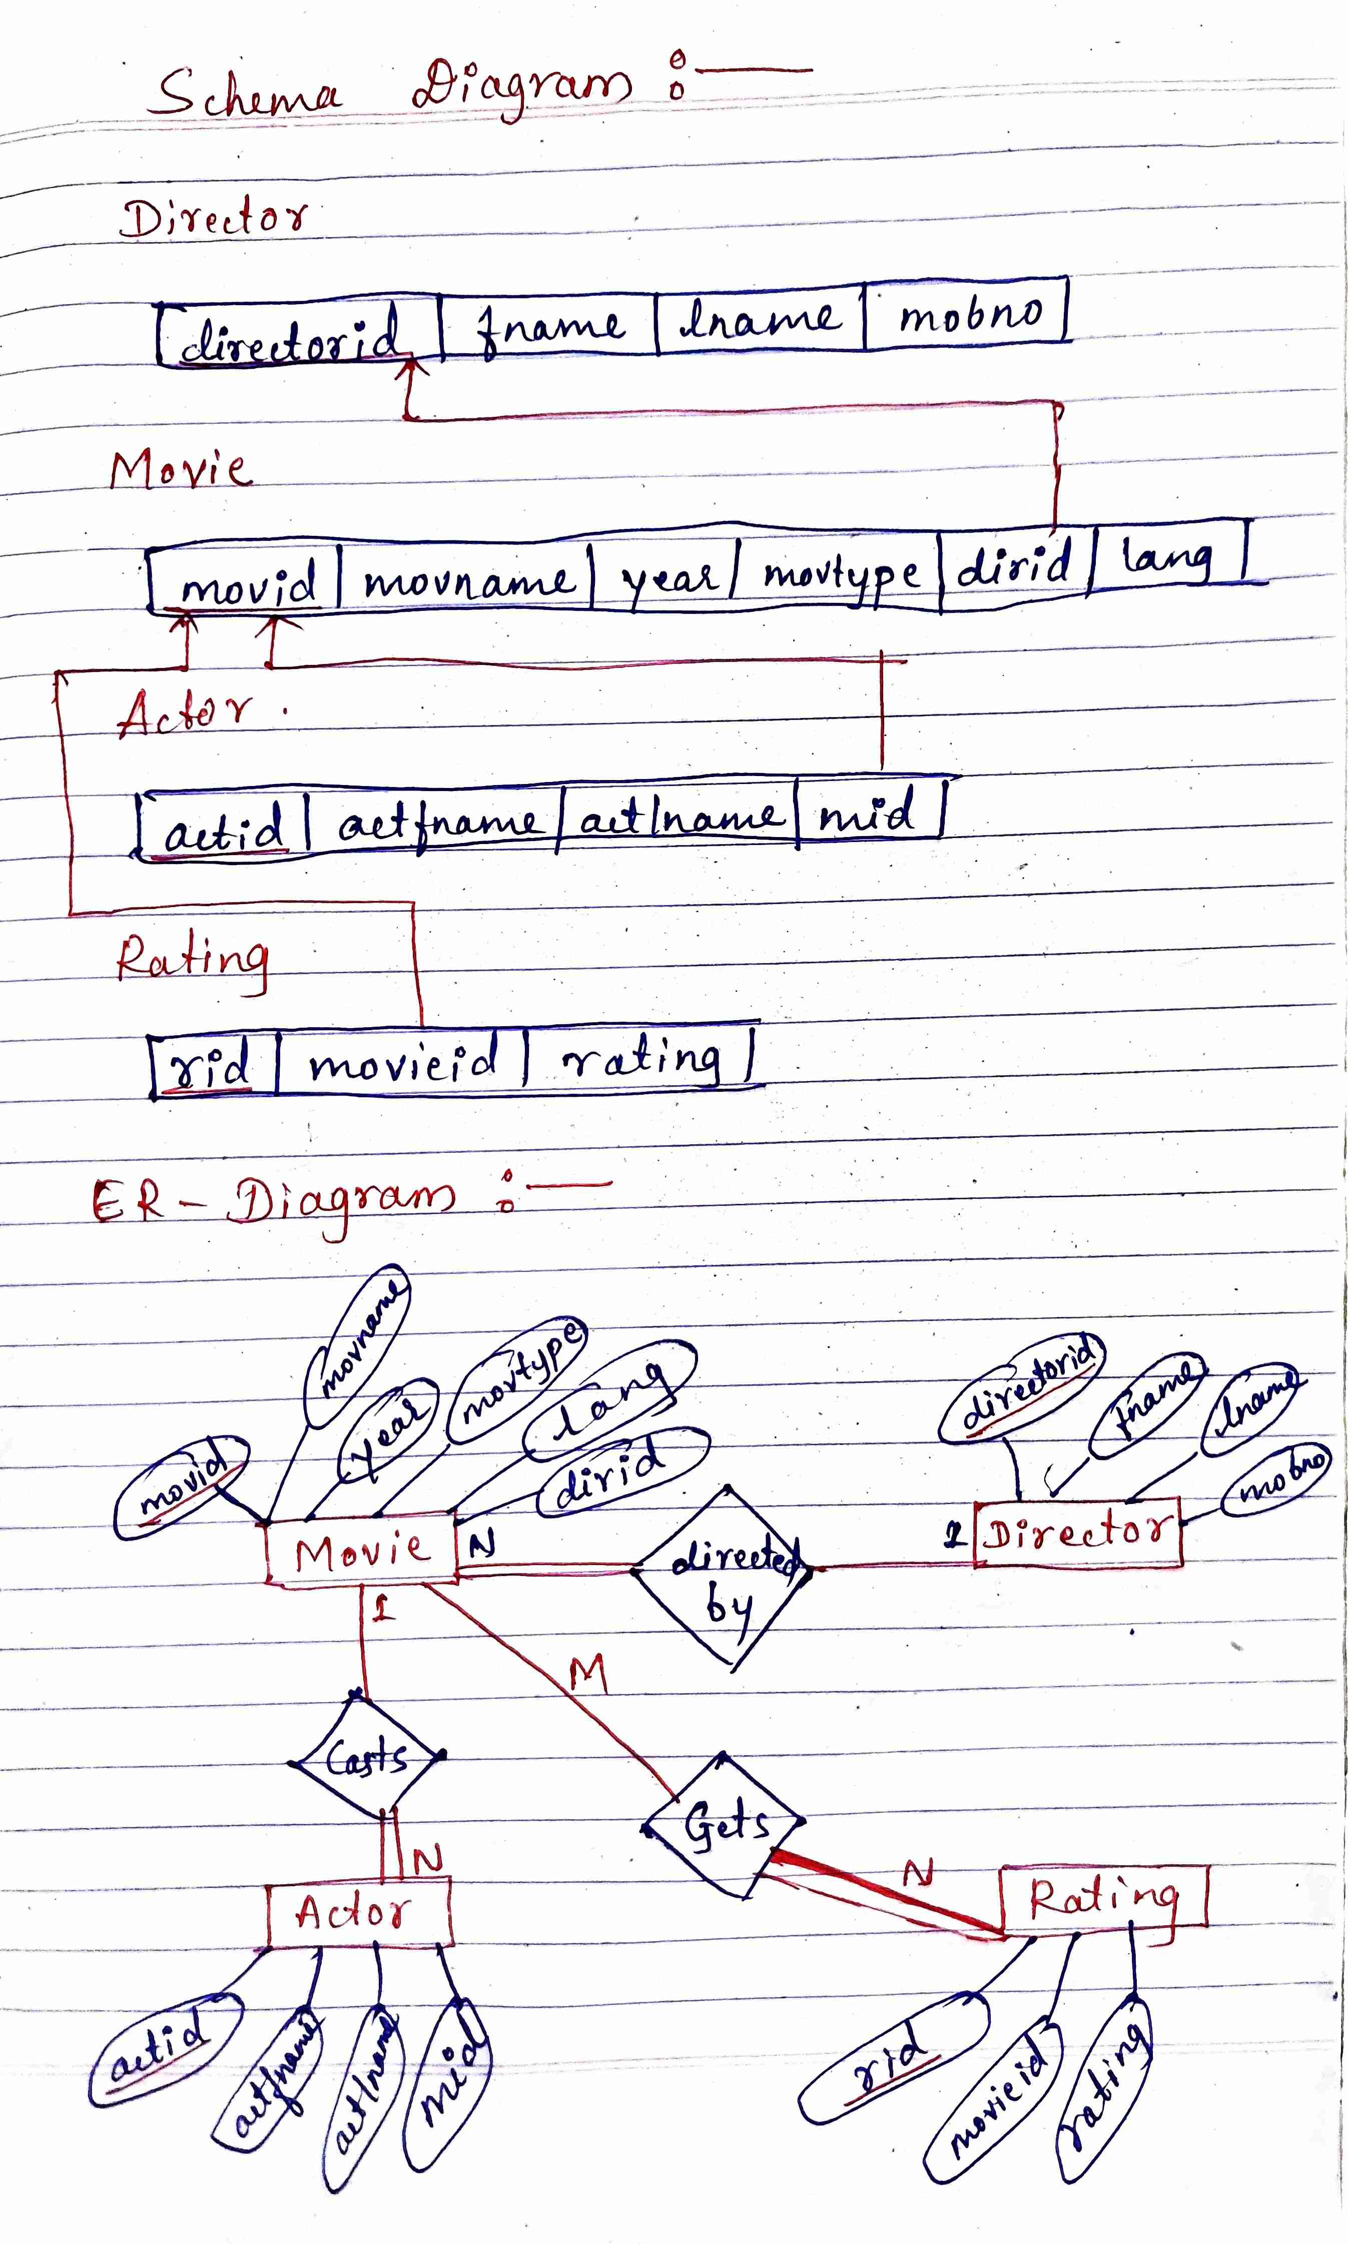

create table director

(

directorid varchar(10) primary key,

fname varchar(15) not null,

lname varchar(15),

mno number(10)

);

insert into director values('D001','Karan','Johar',7895632140);

insert into director values('D002','Rohit','Shetty',5595632140);

insert into director values('D003','S.S','Rajmouli',6395632140);

insert into director values('D004','Anup','B',9209717800);

insert into director values('D005','Prashant','Neel',9209817800);

insert into director values('D006','Mahesh','Bhat',8209817800);

insert into director values('D007','Christofer','Nolan',9609817800);

insert into director values('D008','Nagraj','Manjule',6709817800);

select * from director;

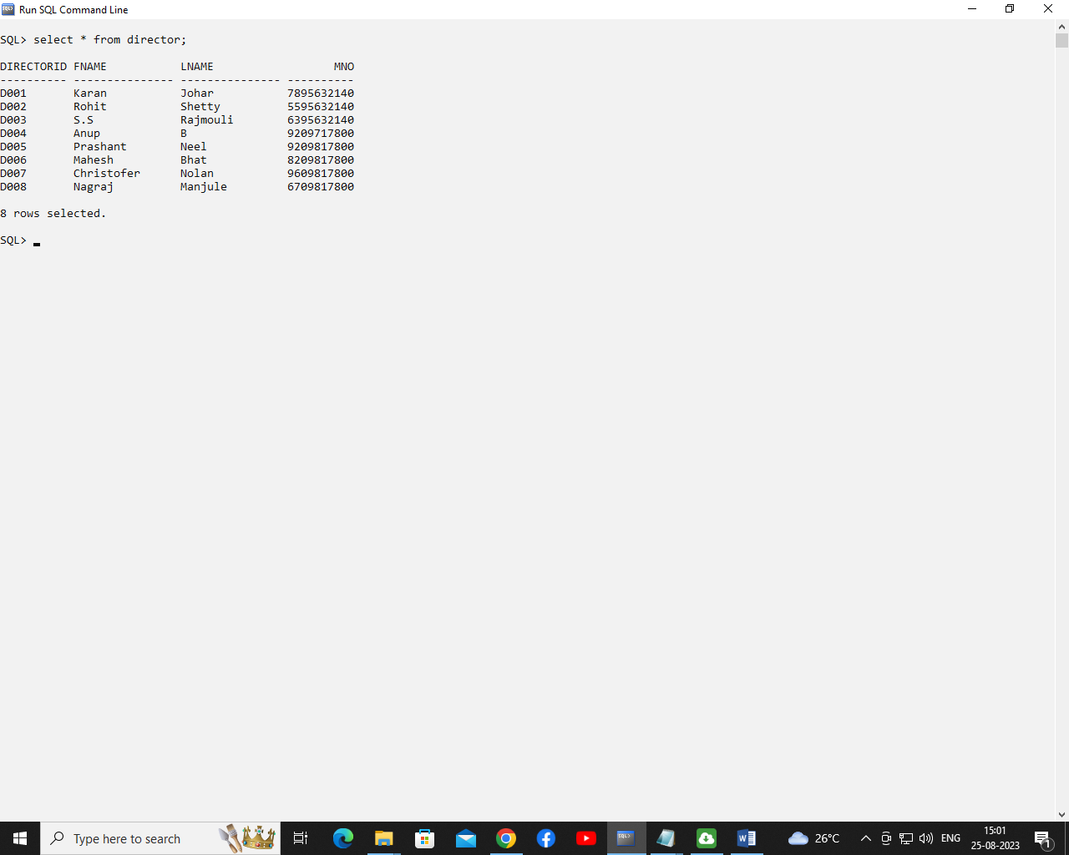

Create table movie

(

Movid varchar(10) primary key,

movname varchar(20) not null,

year varchar(5),

movtype varchar(20),

dirid varchar(10),

lang varchar(10),

foreign key (dirid) references director(directorid) on delete cascade

);

insert into movie values('M001','Std of year','2014','Comedy','D001','Hindi');

insert into movie values('M002','Kabhi K gam','2001','Romantic','D001','Hindi');

insert into movie values('M003','Simbha','2022','Action','D002','Hindi');

insert into movie values('M004','RRR','2022','Action','D003','Kannada');

insert into movie values('M005','Vikrant','2022','Thriller ','D004','Kannada');

insert into movie values('M006','Zakham','1999','Romantic','D006','Hindi');

insert into movie values('M007','Oppenheimer','2023','Biography','D007','English');

insert into movie values('M008','Sairat','2016','Romatic','D008','Marathi');

select * from movie;

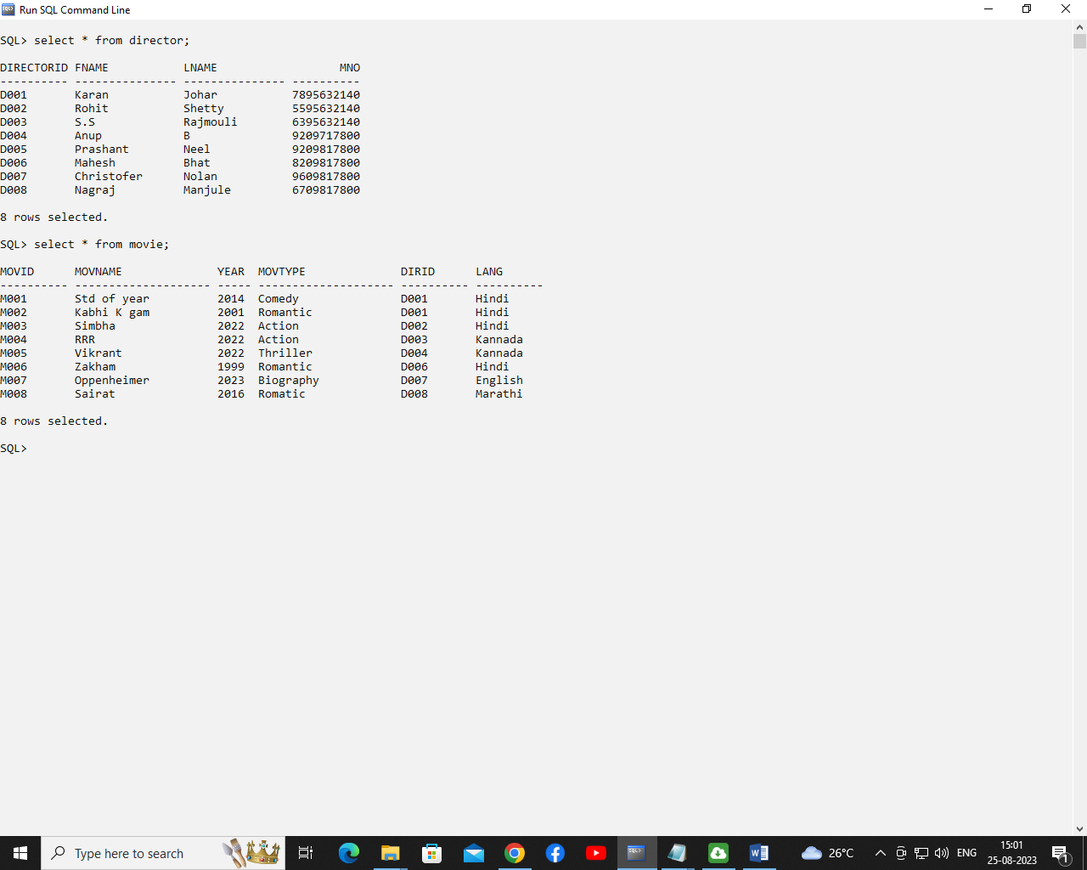

create table actor

(

actid varchar(10) ,

actfname varchar(10),

actlname varchar(10),

mid varchar(10),

primary key(actid,mid),

foreign key (mid) references movie( Movid) on delete cascade

);

insert into actor values('A001','Varun','Dhawan','M001');

insert into actor values('A002','Sharukh','Khan','M002');

insert into actor values('A003','Ranvir','Singh','M003');

insert into actor values('A004','Ram','Charan','M004');

insert into actor values('A005','Sudip','Kiccha','M005');

insert into actor values('A006','Ajay','Devgan','M006');

insert into actor values('A007','Cillian','Murphy','M007');

insert into actor values('A008','Akash','K','M008');

select * from actor;

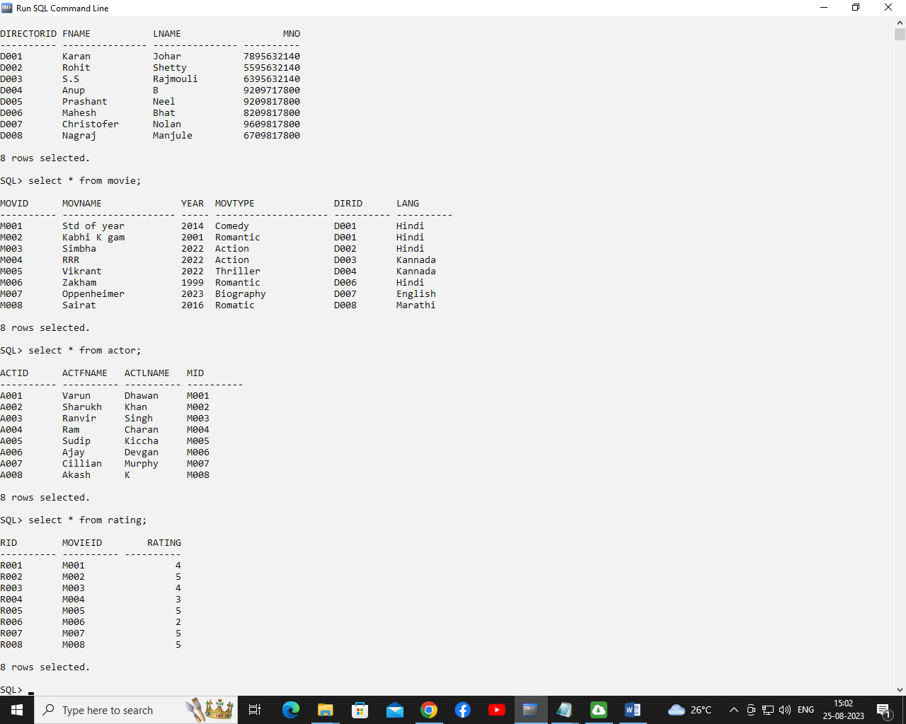

create table rating

(

rid varchar(10) primary key,

movieid varchar(10),

rating number(2),

foreign key (movieid) references movie( Movid) on delete cascade

);

insert into rating values('R001','M001',4);

insert into rating values('R002','M002',5);

insert into rating values('R003','M003',4);

insert into rating values('R004','M004',3);

insert into rating values('R005','M005',4.5);

insert into rating values('R006','M006',2);

insert into rating values('R007','M007',5);

insert into rating values('R008','M008',5);



**MAIN QUERIES:**

4. Retrieve details of movies which are released in 2021.

select * from movie where year='2022';

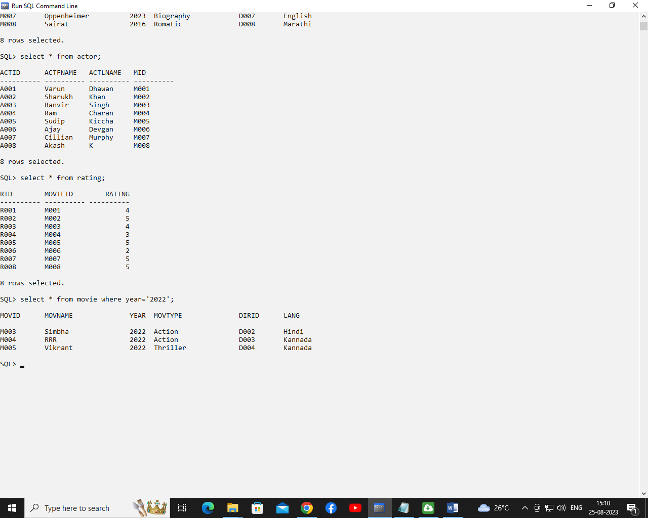

5. Retrieve director name of kabhi khushi kabhi gham.

select fname,lname

from director d,movie m

where

d.directorid=m.dirid and movname='Kabhi K gam';

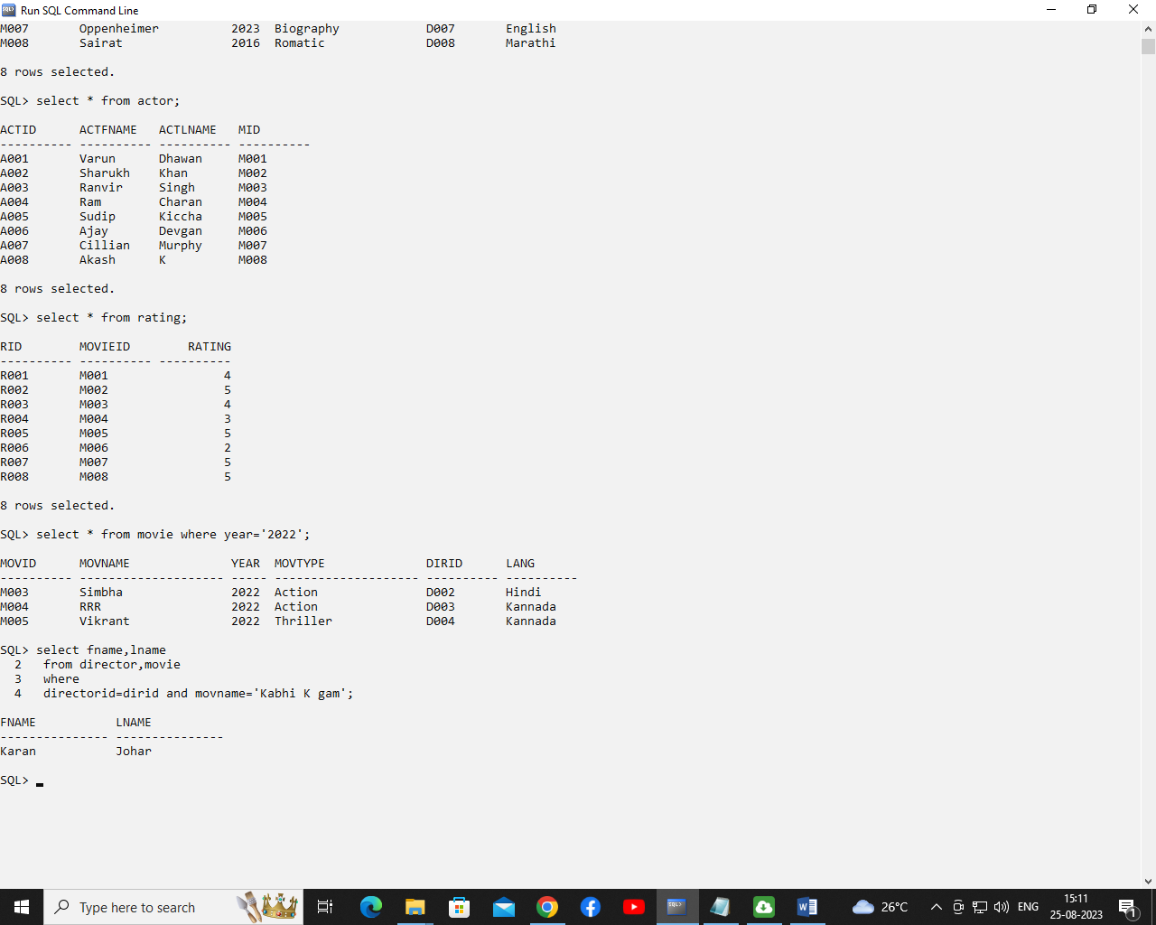

6. Display movie name in which Ajay Devghan has acted in.

select movname

from movie m,actor a

where a.mid=m.movid and actfname='Ajay' and actlname='Devgan';

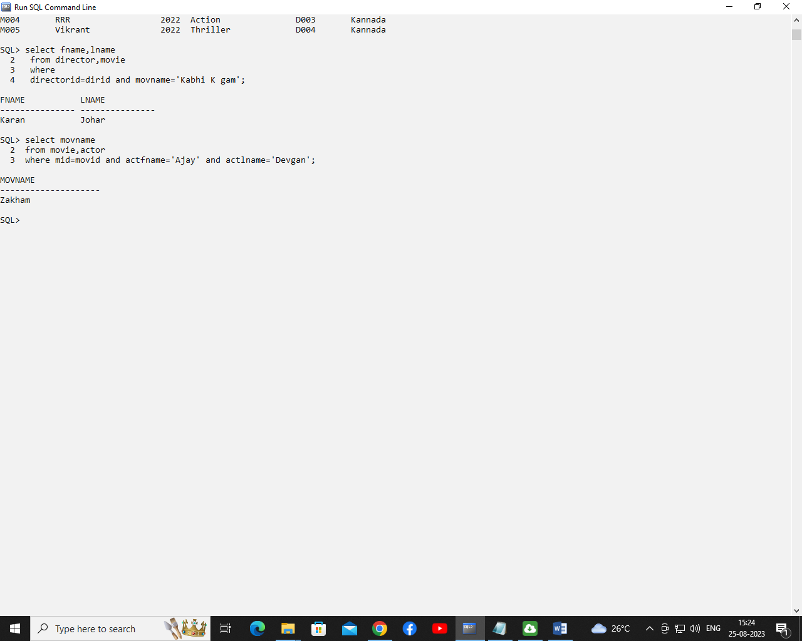

7. Retrieve details of Kannada language movies.

select movname,lang from movie where lang='Kannada';

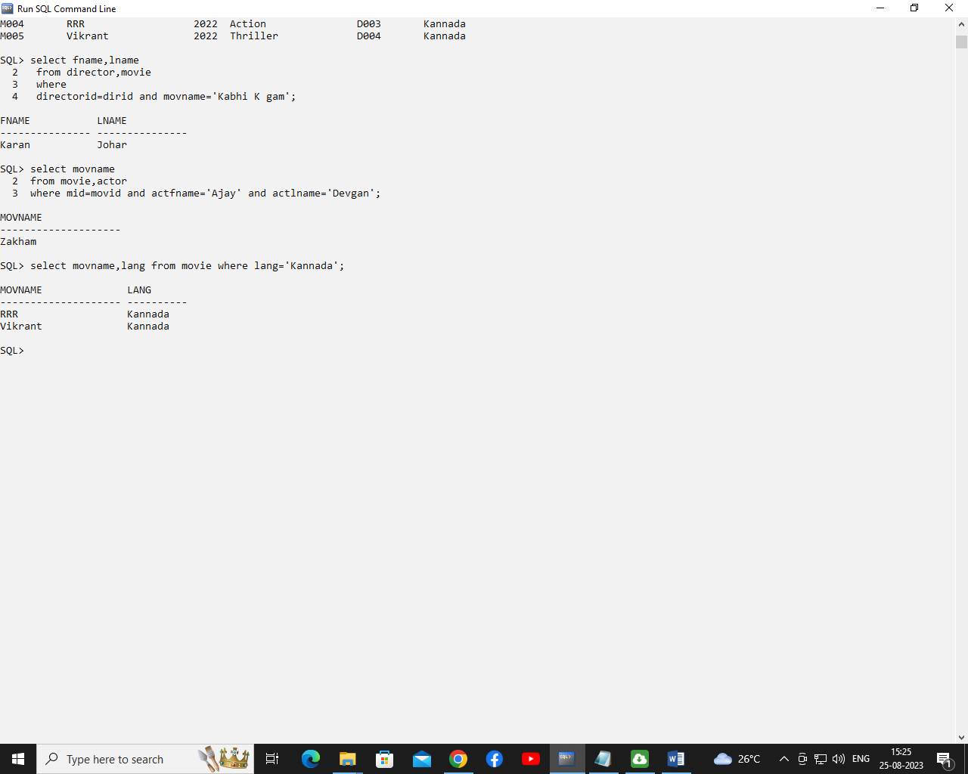

8. Display count of movies according to languages.

select lang,count(*) from movie group by lang;

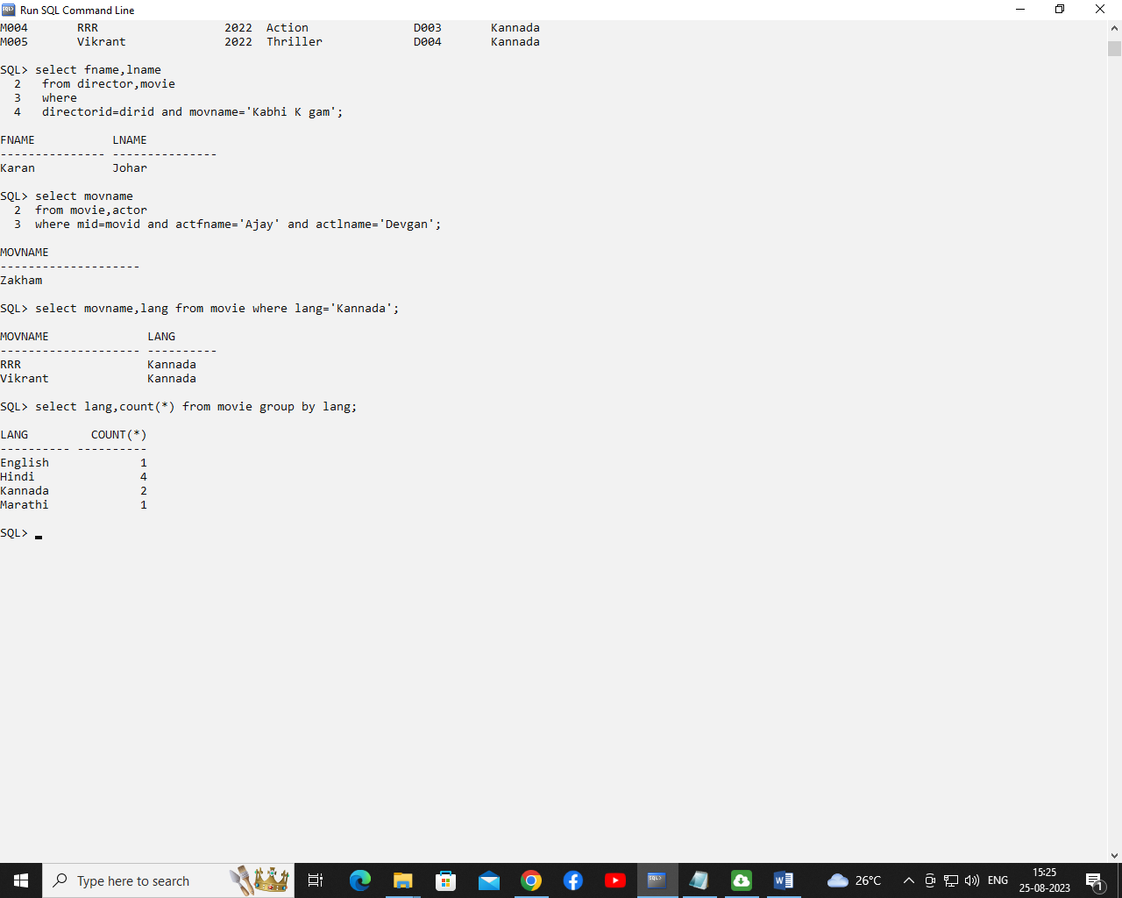

9. Display movie name, director name and ratings.

select movname,fname,lname,rating

from movie m,rating r,director d

where

m.dirid=d.directorid

and

m.movid=r.movieid;

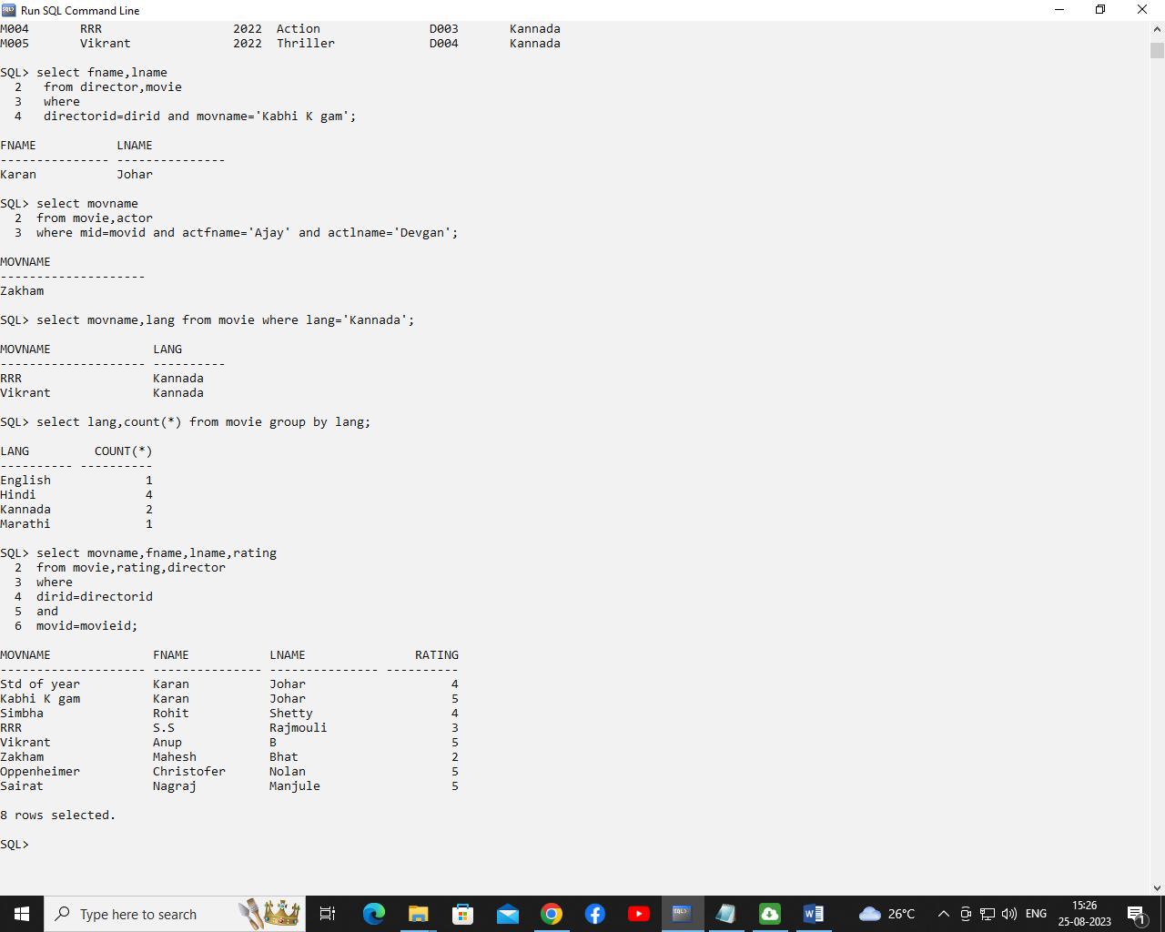

1. Display movie names of all actors.

select movname,actfname,actlname

from movie m,actor a

where m.movid=a.mid;

