1. hw
2. arrays
3. loops
   1. for – 99%
   2. while - 0.99%
   3. do while – maybe – 0.01%
4. arrays functions
5. math
6. date

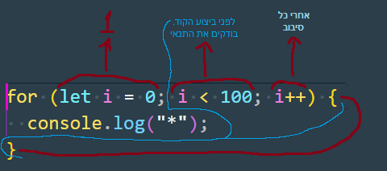

TK 1:

1. create for loop that will display hello for loop 152 times
2. create for loop that will display numbers from 1 to 10

TK 2:

1. create array with names
2. add to each name @gmail.com at the end of each name