Node.js Introduction
Node.js is a runtime environment that allows JavaScript to run outside the browser for building server-side applications.
- Built on the V8 JavaScript engine.
- Supports asynchronous, event-driven programming.
- Efficient for scalable network applications.
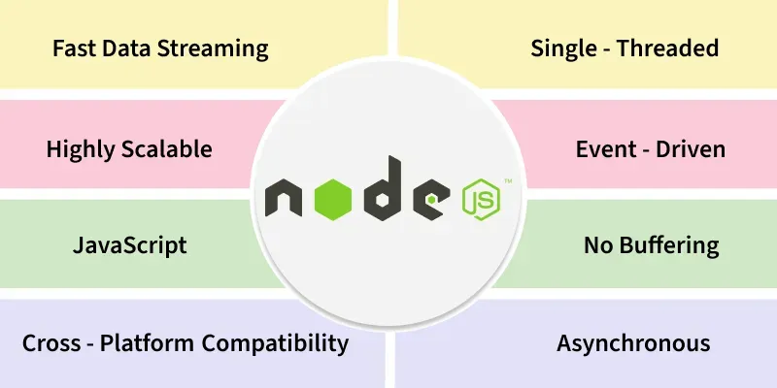
Features of Node.JS
- Server-Side JavaScript: Runs JavaScript outside the browser for backend development.
- Asynchronous & Non-Blocking: Handles multiple requests efficiently using an event-driven model.
- Single-Threaded Event Loop: Manages concurrent tasks without thread overhead.
- V8 Engine: Uses Google’s high-performance engine to execute JavaScript quickly.
- Scalable & Lightweight: Suitable for microservices and high-traffic applications.
- Rich NPM Ecosystem: Provides access to thousands of reusable open-source packages.
HOW NODE WORK (EVENT LOOP)
The event loop is an important concept in JavaScript that enables asynchronous programming by handling tasks efficiently. Since JavaScript is single-threaded, it uses the event loop to manage the execution of multiple tasks without blocking the main thread.
How the Event Loop Works
The event loop continuously checks whether the call stack is empty and whether there are pending tasks in the callback queue or microtask queue.
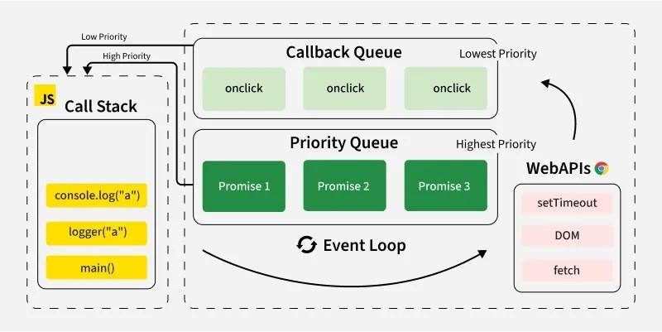
- Call Stack: JavaScript has a call stack where function execution is managed in a Last-In, First-Out (LIFO) order.
- Web APIs (or Background Tasks): These include setTimeout, setInterval, fetch, DOM events, and other non-blocking operations.
- Callback Queue (Task Queue): When an asynchronous operation is completed, its callback is pushed into the task queue.
- Microtask Queue: Promises and other microtasks go into the microtask queue, which is processed before the task queue.
- Event Loop: It continuously checks the call stack and, if empty, moves tasks from the queue to the stack for execution.

Common Issues Related to the Event Loop
1. Blocking the Main Thread
Heavy computations block the event loop, making the app unresponsive.
while(true)
{
console.log('Blocking...')
}
An infinite while(true) loop continuously runs, blocking the event loop and freezing the browser by preventing any other task from executing.

2. Delayed Execution of setTimeout
setTimeout doesn’t always run exactly after the specified time.
console.log("Start");
setTimeout(() => console.log("Inside setTimeout"), 1000);
for (let i = 0; i < 1e9; i++) {} // Long loop
console.log("End");

The blocking loop delays setTimeout execution because the Call Stack is busy so, this code will also lead to Time Limit Exceed Error or will freeze the Browser.

3. Priority of Microtasks Over Callbacks
Microtasks run before setTimeout, even if set with 0ms delay.
setTimeout(() => console.log("setTimeout"), 0);
Promise.resolve().then(() => console.log("Promise"));
console.log("End");

Explain: The event loop first check's for function in the microtask queue and then in the call back queue always in JavaScript microtask queue is given more priority than the call back queue that's why the functions present in the microtask queue are executed first.

4. Callback Hell
Too many nested callbacks make code unreadable.

setTimeout(() => {
console.log("Step 1");
setTimeout(() => {
console.log("Step 2");
setTimeout(() => {
console.log("Step 3");
}, 1000);
}, 1000);
}, 1000);

This creates Callback Hell, making it hard to read and maintain. Use Promises or async/await instead.

