**Hands-On Practice Case: Assisgnment-4**

1. Examine the site map in Figure 2.30. What type of site organization is used for the JavaJam website? Is it the most appropriate organization for the site? Why or why not?

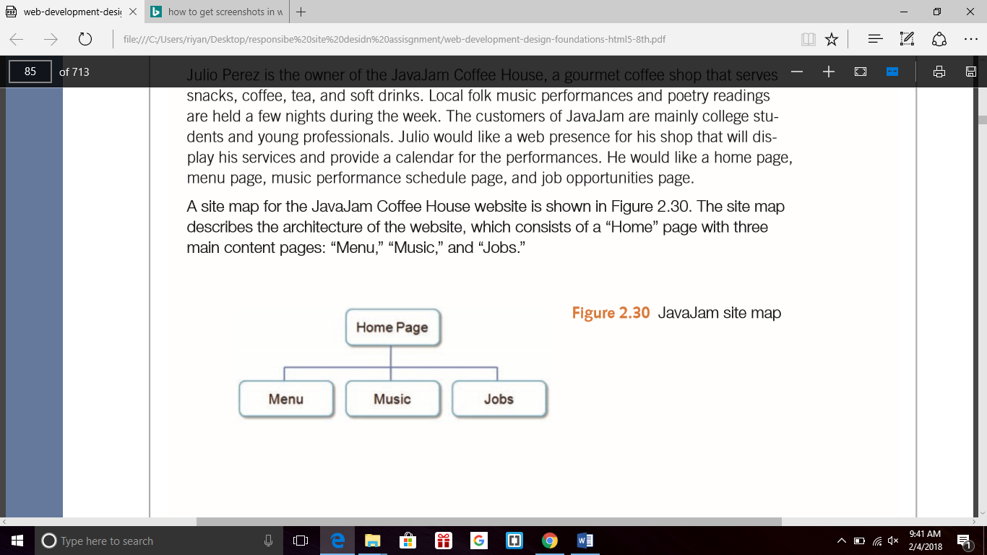

Ans 1: The JavaJam Web site uses a hierarchical organization system. Seeing how it is a website to promote a business I believe it is definitely the most appropriate type of organization for it. A linear organization could be used but would not be appropriate for this type of website. Linear is more used for lessons and step by step tutorials/presentations. The hierarchical organization allows the users of the site to view what they want/need to view, unlike the linear, the user would have to go through several slides/web pages to find what they needed to find. The JavaJam site has a clearly defined home page with links to major sections of the site, menu, music and jobs.

This is the most appropriate organization for the site, since this is for a business, hierarchical is most appropriate. Even if the site were to expand, chunking and dynamic navigation could be implemented to keep the site simple and easy to navigate.

1. Review the recommended web design practices from this chapter. Use the Web Design Best Practices Checklist (Table 5.1) to evaluate the JavaJam site that you created in earlier chapters. Cite three design practices that have been well implemented. Cite three design practices that could be implemented in a better way. How else would you improve the website?

Ans 2: Three design practices that have been well implemented in the JavaJam website are:

* Consistent site header/logo.
* Consistent navigation area.
* Home pages downloads within 10 seconds.
* Main navigation links are clearly and consistently labeled.
* Color is used consistently.
* Common fonts are used.

Three design practices that could have been implemented in a better way are:

* Appealing to target audience, I believe the design does fit in with the target audience, but it’s very dull and boring. By using more gradients, animations, or interesting photos, I believe it would make it more appealing.
* The web page needs to be tested in all browsers to see for conformity across any browser. I believe the picture on the main page is unnecessary, and does not serve a clear purpose.
* Navigation structured in an unordered list for accessibility Links are just there in the
* <nav> tag.
* Timeliness: date of the last revision No date for last revision.
* Displays without horizontal scrolling at 1024x768 and higher resolutions Horizontal scrolling is necessary when browser is minimized on higher resolutions screens.

We can improve this website with the following:

* Viewport meta tag and media queries to enhance the display on mobile devices.
* Change the winding road picture or add a caption that matches the feel of JavaJam Coffee House.
* Hyperlinks need to be configured to look decorative and display as visited/no visited.