1.已知下列方程

，

首先给出该方程对应的Jacobi迭代格式和G-S迭代格式，再利用Jabobi迭代法和G-S迭代法求解该方程，其中初值为 ，并记录迭代次数k=1，2，3，4时的计算结果。



表1 Jacobi迭代法结果

|  |  |  |  |
| --- | --- | --- | --- |
| *k* |  |  |  |
| 0 | 0 | 1 | 1 |
| 1 | 1 | 1.125 | 1.1333 |
| 2 | 0.9675 | 0.9833 | 1.025 |
| 3 | 0.9979 | 1.009 | 1.001 |
| 4 | 0.9998 | 1.001 | 1.0005 |

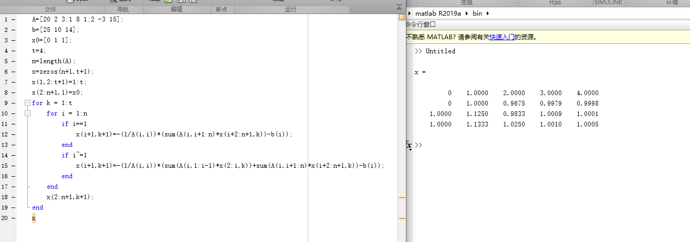A=[20 2 3;1 8 1;2 -3 15];

b=[25 10 14];

x0=[0 1 1];

t=4;

n=length(A);

x=zeros(n+1,t+1);

x(1,2:t+1)=1:t;

x(2:n+1,1)=x0;

for k = 1:t

for i = 1:n

if i==1

x(i+1,k+1)=-(1/A(i,i))*(sum(A(i,i+1:n)*x(i+2:n+1,k))-b(i));

end

if i~=1

x(i+1,k+1)=-(1/A(i,i))*(sum(A(i,1:i-1)*x(2:i,k))+sum(A(i,i+1:n)*x(i+2:n+1,k))-b(i));

end

end

x(2:n+1,k+1);

end

X

>> Untitled

x =

0 1.0000 2.0000 3.0000 4.0000

0 1.0000 0.9675 0.9979 0.9998

1.0000 1.1250 0.9833 1.0009 1.0001

1.0000 1.1333 1.0250 1.0010 1.0005

>>



表2 G-S迭代法结果

|  |  |  |  |
| --- | --- | --- | --- |
| *k* |  |  |  |
| 0 | 0 | 1 | 1 |
| 1 | 1 | 1 | 1 |
| 2 | 1 | 1 | 1 |
| 3 | 1 | 1 | 1 |
| 4 | 1 | 1 | 1 |

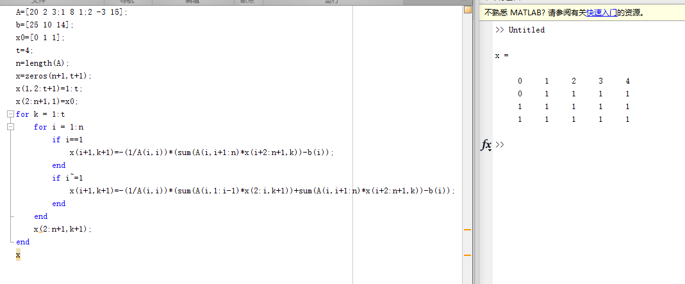

A=[20 2 3;1 8 1;2 -3 15];

b=[25 10 14];

x0=[0 1 1];

t=4;

n=length(A);

x=zeros(n+1,t+1);

x(1,2:t+1)=1:t;

x(2:n+1,1)=x0;

for k = 1:t

for i = 1:n

if i==1

x(i+1,k+1)=-(1/A(i,i))*(sum(A(i,i+1:n)*x(i+2:n+1,k))-b(i));

end

if i~=1

x(i+1,k+1)=-(1/A(i,i))*(sum(A(i,1:i-1)*x(2:i,k+1))+sum(A(i,i+1:n)*x(i+2:n+1,k))-b(i));

end

end

x(2:n+1,k+1);

end

X

>> Untitled

x =

0 1 2 3 4

0 1 1 1 1

1 1 1 1 1

1 1 1 1 1

>>

2.已知下列方程



真解为 。首先给出该方程对应的Jacobi迭代格式和G-S迭代格式，再利用Jabobi迭代法和G-S迭代法求解该方程，其中初值为 ，并记录迭代次数k=1，2，3，4，5，6，7时的计算结果。



雅可比

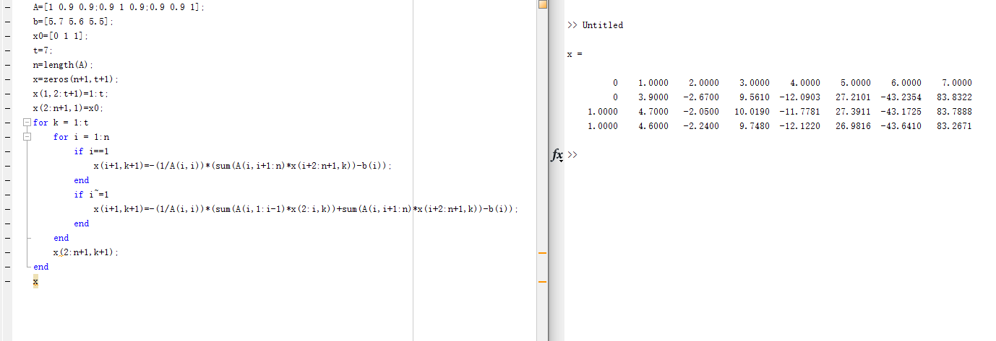A=[1 0.9 0.9;0.9 1 0.9;0.9 0.9 1];

b=[5.7 5.6 5.5];

x0=[0 1 1];

t=7;

n=length(A);

x=zeros(n+1,t+1);

x(1,2:t+1)=1:t;

x(2:n+1,1)=x0;

for k = 1:t

for i = 1:n

if i==1

x(i+1,k+1)=-(1/A(i,i))*(sum(A(i,i+1:n)*x(i+2:n+1,k))-b(i));

end

if i~=1

x(i+1,k+1)=-(1/A(i,i))*(sum(A(i,1:i-1)*x(2:i,k))+sum(A(i,i+1:n)*x(i+2:n+1,k))-b(i));

end

end

x(2:n+1,k+1);

end

x

>> Untitled

x =

0 1.0000 2.0000 3.0000 4.0000 5.0000 6.0000 7.0000

0 3.9000 -2.6700 9.5610 -12.0903 27.2101 -43.2354 83.8322

1.0000 4.7000 -2.0500 10.0190 -11.7781 27.3911 -43.1725 83.7888

1.0000 4.6000 -2.2400 9.7480 -12.1220 26.9816 -43.6410 83.2671

Gs：

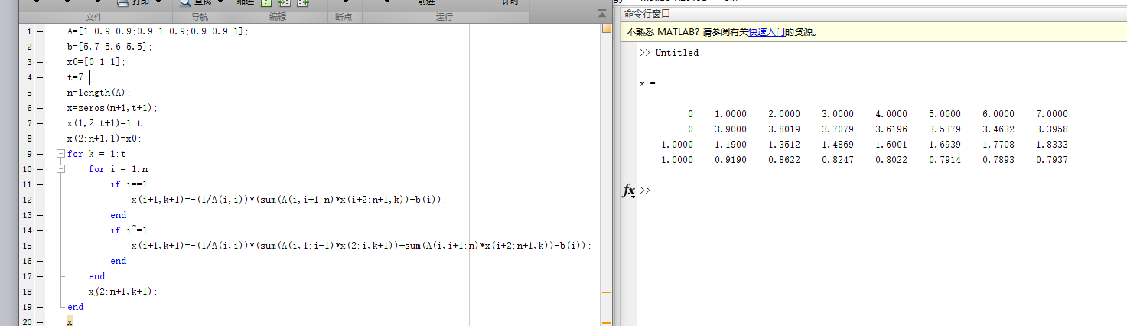A=[1 0.9 0.9;0.9 1 0.9;0.9 0.9 1];

b=[5.7 5.6 5.5];

x0=[0 1 1];

t=7;

n=length(A);

x=zeros(n+1,t+1);

x(1,2:t+1)=1:t;

x(2:n+1,1)=x0;

for k = 1:t

for i = 1:n

if i==1

x(i+1,k+1)=-(1/A(i,i))*(sum(A(i,i+1:n)*x(i+2:n+1,k))-b(i));

end

if i~=1

x(i+1,k+1)=-(1/A(i,i))*(sum(A(i,1:i-1)*x(2:i,k+1))+sum(A(i,i+1:n)*x(i+2:n+1,k))-b(i));

end

end

x(2:n+1,k+1);

end

x

>> Untitled

x =

0 1.0000 2.0000 3.0000 4.0000 5.0000 6.0000 7.0000

0 3.9000 3.8019 3.7079 3.6196 3.5379 3.4632 3.3958

1.0000 1.1900 1.3512 1.4869 1.6001 1.6939 1.7708 1.8333

1.0000 0.9190 0.8622 0.8247 0.8022 0.7914 0.7893 0.7937

3.已知下列方程



真解为 。首先给出该方程对应的Jacobi迭代格式和G-S迭代格式，再利用Jabobi迭代法和G-S迭代法求解该方程，其中初值为 ，并记录迭代次数k=1，2，3，4，5，6，7时的计算结果。



雅可比

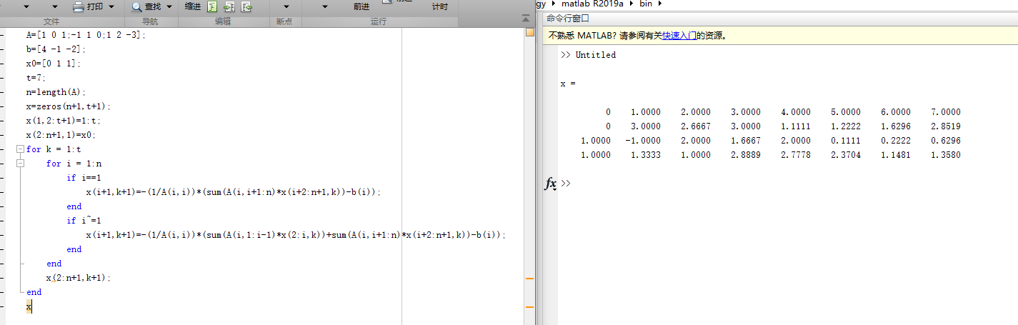

A=[1 0 1;-1 1 0;1 2 -3];

b=[4 -1 -2];

x0=[0 1 1];

t=7;

n=length(A);

x=zeros(n+1,t+1);

x(1,2:t+1)=1:t;

x(2:n+1,1)=x0;

for k = 1:t

for i = 1:n

if i==1

x(i+1,k+1)=-(1/A(i,i))*(sum(A(i,i+1:n)*x(i+2:n+1,k))-b(i));

end

if i~=1

x(i+1,k+1)=-(1/A(i,i))*(sum(A(i,1:i-1)*x(2:i,k))+sum(A(i,i+1:n)*x(i+2:n+1,k))-b(i));

end

end

x(2:n+1,k+1);

end

x

>> Untitled

x =

0 1.0000 2.0000 3.0000 4.0000 5.0000 6.0000 7.0000

0 3.0000 2.6667 3.0000 1.1111 1.2222 1.6296 2.8519

1.0000 -1.0000 2.0000 1.6667 2.0000 0.1111 0.2222 0.6296

1.0000 1.3333 1.0000 2.8889 2.7778 2.3704 1.1481 1.3580

Gs；

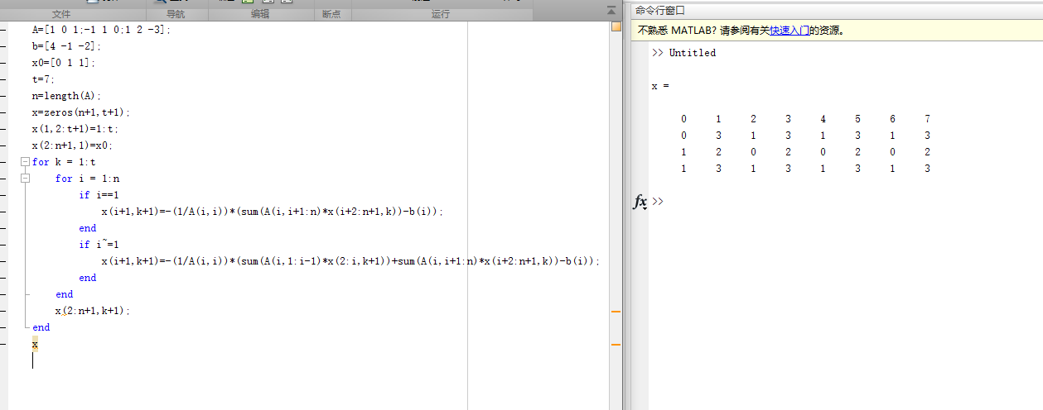A=[1 0 1;-1 1 0;1 2 -3];

b=[4 -1 -2];

x0=[0 1 1];

t=7;

n=length(A);

x=zeros(n+1,t+1);

x(1,2:t+1)=1:t;

x(2:n+1,1)=x0;

for k = 1:t

for i = 1:n

if i==1

x(i+1,k+1)=-(1/A(i,i))*(sum(A(i,i+1:n)*x(i+2:n+1,k))-b(i));

end

if i~=1

x(i+1,k+1)=-(1/A(i,i))*(sum(A(i,1:i-1)*x(2:i,k+1))+sum(A(i,i+1:n)*x(i+2:n+1,k))-b(i));

end

end

x(2:n+1,k+1);

end

x

>> Untitled

x =

0 1 2 3 4 5 6 7

0 3 1 3 1 3 1 3

1 2 0 2 0 2 0 2

1 3 1 3 1 3 1 3