代码：clear

clc

t=15;

syms x0 x1 y x n x_para

x0=-1:0.002:-0.25;

y=1./(1+66*x0.^4);

n=9;

k=0:n;

x(k+1)=-1+2*k/n;

for i=1:(n+1)

pax(i)=(x_para-x(i));

end

for i=1:(n+1)

Wx1(i)=1;

for j=1:(n+1)

if i~=j

Wx1(i)=Wx1(i)*(x(i)-x(j));

end

end

end

Wx(n+1)=prod(pax);

for j=1:(n+1)

lgx(j)=(1/(1+25*(x(j)^2))) * Wx(n+1) / ( (x_para-x(j))*(Wx1(j)) );

end

LGX=sum(lgx);

xter=-0.9999:0.0002:-0.2499;

LGX=subs(LGX,x_para,xter);

plot(x0,y);

hold on

plot(xter,LGX);

x0=-0.25:0.002:0.25;

y=1./(1+66*x0.^4);

n=t;

k=0:n;

x(k+1)=-1+2*k/n;

for i=1:(n+1)

pax(i)=(x_para-x(i));

end

for i=1:(n+1)

Wx1(i)=1;

for j=1:(n+1)

if i~=j

Wx1(i)=Wx1(i)*(x(i)-x(j));

end

end

end

Wx(n+1)=prod(pax);

for j=1:(n+1)

lgx(j)=(1/(1+25*(x(j)^2))) * Wx(n+1) / ( (x_para-x(j))*(Wx1(j)) );

end

LGX=sum(lgx);

xter=-0.2499:0.002:0.2499;

LGX=subs(LGX,x_para,xter);

plot(x0,y);

hold on

plot(xter,LGX);

x0=0.25:0.002:1;

y=1./(1+66*x0.^4);

n=t;

k=0:n;

x(k+1)=-1+2*k/n;

for i=1:(n+1)

pax(i)=(x_para-x(i));

end

for i=1:(n+1)

Wx1(i)=1;

for j=1:(n+1)

if i~=j

Wx1(i)=Wx1(i)*(x(i)-x(j));

end

end

end

Wx(n+1)=prod(pax);

for j=1:(n+1)

lgx(j)=(1/(1+25*(x(j)^2))) * Wx(n+1) / ( (x_para-x(j))*(Wx1(j)) );

end

LGX=sum(lgx);

xter=0.2501:0.002:0.9999;

LGX=subs(LGX,x_para,xter);

plot(x0,y);

hold on

plot(xter,LGX);

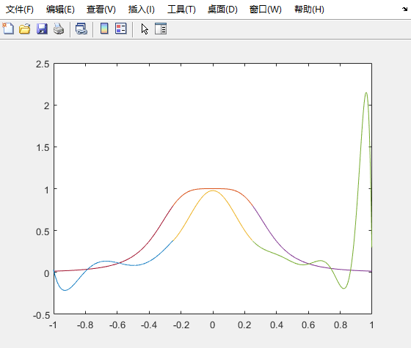

结论：此图上方的图像为原函数，下方的图为插值算法后的成像，右端是普通拉格朗日的插值算法得到的效果，有明显的龙格现象，左半部分是使用分段式拉格朗日算法，优化了现象。

（上课讲过不再赘述