原题

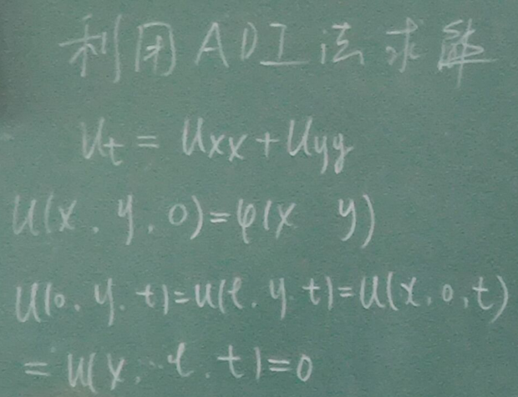

代码

clear all;

clc;

two_dimensional_adi_t = 1; %时间范围，计算到1秒

two_dimensional_adi_x = 1;two_dimensional_adi_y = 1; %空间范围，0-1米

two_dimensional_adi_m = 1000; %时间t方向分1000个格子

two_dimensional_adi_n = 10; %空间x方向分10个格子

two_dimensional_adi_k = 10; %空间y方向分10个格子

two_dimensional_adi_ht = two_dimensional_adi_t/(two_dimensional_adi_m-1); %时间步长dt

two_dimensional_adi_hx = two_dimensional_adi_x/(two_dimensional_adi_n-1); %空间步长dx

two_dimensional_adi_hy = two_dimensional_adi_y/(two_dimensional_adi_k-1); %空间步长dy

two_dimensional_adi_f=[];

two_dimensional_adi_N = two_dimensional_adi_n;

two_dimensional_adi_x = linspace(0,1,two_dimensional_adi_N);%得到N个差分点

two_dimensional_adi_y = linspace(0,1,two_dimensional_adi_N);%得到N个差分点

for i = 1:two_dimensional_adi_N

for j = 1:two_dimensional_adi_N

two_dimensional_adi_f(i,j) = two_dimensional_adi_x(i)*two_dimensional_adi_x(j);

end

end

two_dimensional_adi_u = zeros(two_dimensional_adi_m,two_dimensional_adi_n,two_dimensional_adi_k);

[two_dimensional_adi_x,two_dimensional_adi_y] = meshgrid(0:two_dimensional_adi_hx:1,0:two_dimensional_adi_hy:1);

two_dimensional_adi_u(1,:,:) = two_dimensional_adi_f;

two_dimensional_adi_r = two_dimensional_adi_ht/(2*two_dimensional_adi_hx^2);

two_dimensional_adi_dia = repmat(1+2*two_dimensional_adi_r,[1,two_dimensional_adi_n-2]);

two_dimensional_adi_dia1 = repmat(two_dimensional_adi_r,[1,two_dimensional_adi_n-3]);

two_dimensional_adi_A = diag(two_dimensional_adi_dia,0);

two_dimensional_adi_A = two_dimensional_adi_A + diag(two_dimensional_adi_dia1,-1);

two_dimensional_adi_A = two_dimensional_adi_A + diag(two_dimensional_adi_dia1,1);

for ii=1:two_dimensional_adi_m-1

for kk=2:two_dimensional_adi_k-1

two_dimensional_adi_b=[];

for i = 1:two_dimensional_adi_n-2

j=i+1;

two_dimensional_adi_b(i) = two_dimensional_adi_u(ii,j,kk) + two_dimensional_adi_r*(two_dimensional_adi_u(ii,j,kk+1)+two_dimensional_adi_u(ii,j,kk-1)-...

2*two_dimensional_adi_u(ii,j,kk));

end

two_dimensional_adi_b(1) = two_dimensional_adi_b(1) + two_dimensional_adi_r*two_dimensional_adi_u(ii,1,kk);

two_dimensional_adi_b(two_dimensional_adi_n-2) = two_dimensional_adi_b(two_dimensional_adi_n-2) + two_dimensional_adi_r*two_dimensional_adi_u(ii,two_dimensional_adi_n,kk);

temp = inv(two_dimensional_adi_A)*two_dimensional_adi_b';

two_dimensional_adi_b2=[];

for i = 1:two_dimensional_adi_n-2

j=i;

if j == 1

two_dimensional_adi_b2(i) = temp(j) + two_dimensional_adi_r*(temp(j+1)+0-2*temp(j));

elseif j==two_dimensional_adi_n-2

two_dimensional_adi_b2(i) = temp(j) + two_dimensional_adi_r*(temp(j-1)+0-2*temp(j));

else

two_dimensional_adi_b2(i) = temp(j) + two_dimensional_adi_r*(temp(j+1)+temp(j-1)-2*temp(j));

end

end

two_dimensional_adi_temp2 = inv(two_dimensional_adi_A)*two_dimensional_adi_b2';

for i = 2:two_dimensional_adi_n-1

j = i-1;

two_dimensional_adi_u(ii+1,i,kk) = two_dimensional_adi_temp2(j);

end

end

end

for i=1:two_dimensional_adi_m

figure(1);

mesh(two_dimensional_adi_x,two_dimensional_adi_y,reshape(two_dimensional_adi_u(i,:,:),[two_dimensional_adi_n two_dimensional_adi_k]));

axis([0 1 0 1 -2 2]);

end

