智能计算第四次实验报告

第五次实验 粒子群算法实验题目

分析求解以下三个问题的粒子群算法原理，并利用粒子群算法实现该问题。

1.北京等六城市的距离表如下。请据此表求解TSP（Travelling Salesman Problem） 问题。即给定N个城市，从某一城市开始走遍所有城市但不许重复，最后回到出发点，要求总路径最短。

表1 六城市间距离表（单位km）

|  |  |  |  |  |  |
| --- | --- | --- | --- | --- | --- |
|  | 上海 | 天津 | 石家庄 | 太原 | 呼和浩特 |
| 北京 | 1078 | 119 | 263 | 398 | 401 |
| 上海 | 0 | 963 | 989 | 1096 | 1381 |
| 天津 |  | 0 | 262 | 426 | 504 |
| 石家庄 |  |  | 0 | 171 | 394 |
| 太原 |  |  |  | 0 | 341 |

1. 下面展示了13个城市之间的距离，现要求从城市A出发，找一条最短的旅游顺序，使得游览所有城市后回到城市A。

表2 13个城市间距离表（单位km）

|  |  |  |  |  |  |  |  |  |  |  |  |  |  |
| --- | --- | --- | --- | --- | --- | --- | --- | --- | --- | --- | --- | --- | --- |
|  | A | B | C | D | E | F | G | H | I | J | K | L | M |
| A | 0 | 2.2 | 18.1 | 4.8 | 9.2 | 8.4 | 5.2 | 0.4 | 9.3 | 11.3 | 10.2 | 0.4 | 10.4 |
| B | 2.2 | 0 | 17.5 | 2.8 | 7.9 | 6.6 | 3.3 | 1.8 | 8.5 | 9.8 | 8.7 | 2.4 | 9.6 |
| C | 18.1 | 17.5 | 0 | 14.7 | 9.6 | 10.9 | 14.2 | 18.2 | 9.1 | 7.6 | 8.7 | 18.3 | 8.0 |
| D | 4.8 | 2.8 | 14.7 | 0 | 5.4 | 3.8 | 0.5 | 4.4 | 6.4 | 7.0 | 6.0 | 5.1 | 7.4 |
| E | 9.2 | 7.9 | 9.6 | 5.4 | 0 | 2.4 | 4.9 | 9.0 | 1.7 | 2.3 | 1.2 | 9.5 | 2.2 |
| F | 8.4 | 6.6 | 10.9 | 3.8 | 2.4 | 0 | 3.3 | 8.1 | 4.1 | 3.3 | 2.5 | 8.7 | 4.6 |
| G | 5.2 | 3.3 | 14.2 | 0.5 | 4.9 | 3.3 | 0 | 4.8 | 6.0 | 6.6 | 5.5 | 5.5 | 6.9 |
| H | 0.4 | 1.8 | 18.2 | 4.4 | 9.0 | 8.1 | 4.8 | 0 | 9.2 | 11.1 | 10.0 | 0.6 | 10.3 |
| I | 9.3 | 8.5 | 9.1 | 6.4 | 1.7 | 4.1 | 6.0 | 9.2 | 0 | 3.3 | 2.5 | 9.6 | 1.1 |
| J | 11.3 | 9.8 | 7.6 | 7.0 | 2.3 | 3.3 | 6.6 | 11.1 | 3.3 | 0 | 1.2 | 11.7 | 2.8 |
| K | 10.2 | 8.7 | 8.7 | 6.0 | 1.2 | 2.5 | 5.5 | 10.0 | 2.5 | 1.2 | 0 | 10.5 | 2.5 |
| L | 0.4 | 2.4 | 18.3 | 5.1 | 9.5 | 8.7 | 5.5 | 0.6 | 9.6 | 11.7 | 10.5 | 0 | 10.7 |
| M | 10.4 | 9.6 | 8.0 | 7.4 | 2.2 | 4.6 | 6.9 | 10.3 | 1.1 | 2.8 | 2.5 | 10.7 | 0 |

3.寻找函数y=1-cos(3*x)*exp(-x)在[0,4]最大值。

三、实验基本原理

3.1 TSP问题描述

TSP问题是典型的组合优化问题。给定 $n$ 个城市以及各个城市之间的距离，要求找到一条遍历所有城市且每个城市只被访问一次的路线，并使得总路线距离最短。其可用数学式来表达：

设有一个城市集合 $C=(c_{1},c_{2}⋯{,c}_{n})$，其中每对城市之间的距离 $d(c_{i},c_{j})∈R^{*}$。求一对经过 $C$ 中每个城市一次的路线 $({cn}_{1},{cn}_{2}⋯{,cπ}_{n})$。使

$$min\sum_{i=1}^{n-1}{d({cπ}_{i},{cπ}_{(i+1)})}+d({cπ}_{n},{cπ}_{1})$$

其中 $π_{1},π_{2}⋯,π_{n}$ 是 $(1,2,⋯,n)$ 的一个置换。

3.2 粒子群算法概述

粒子群(PSO）算法最早是由Eberhart和Kennedy于1995年提出，其是智能计算领域中除了蚁群算法，鱼群算法外的一种群体智能的优化算法，它的基本概念源于对鸟群觅食行为的研究。鸟群中有个体和群体，个体和群体的信息是可以互通的。个体在随机搜寻食物的过程中，只要跟踪离食物最近的群体，就能最有效地找到食物。

四、程序简述

4.1 用粒子群算法求解TSP问题

4.1.1问题的求解

在TSP问题中，粒子的位置可以使用路径来表示。而速度的表示需要进行优化，原本的公式已经不再适用。以下给出基本粒子群算法速度位置更新公式：

基本粒子群算法速度位置更新公式：

$$V_{id}^{k+1}=ωV_{id}^{k}+c_{1}r_{1}\left(P_{id}^{k}-X_{id}^{k}\right)+c_{2}r_{2}\left(P_{gd}^{k}-X_{id}^{k}\right)$$

$$X_{id}^{k+1}=X_{id}^{k}+V_{id}^{k+1}$$

4.2用遗传算法求解TSP问题

4.2.1问题的求解

算法的流程与3.5一致，其与4.1属于同一问题，不做过多解释。

4.3寻找函数在特定区间的最大值

4.3.1问题的求解

已知这样的一个函数

$$y=1-cos(3x)e^{-x}$$

Step1：绘图

先画出其在区间[0,4]内的图像，即

此时需要寻找这个函数在定义域内的最高点（最大值）。这里使用的是粒子群算法解决该问题，

五、实验结果与分析

5.1用粒子群算法求解TSP问题

对于city.mat文件中的城市序列，参数在代码注释中写的较为详细，在此不再赘述。

运行代码后得到如下结果：

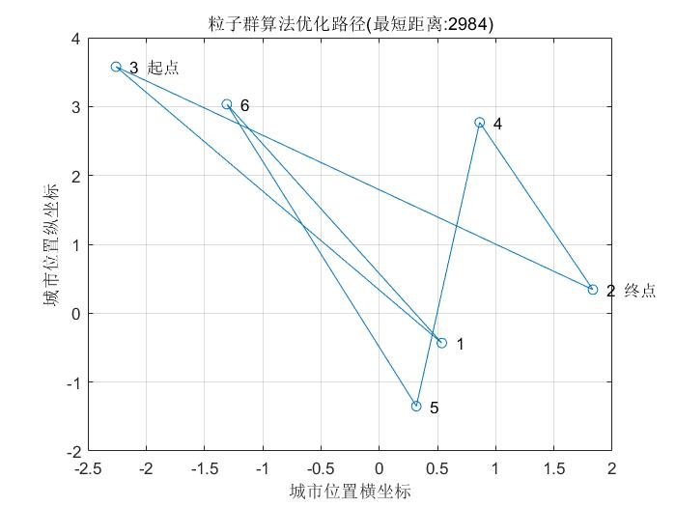

上图为粒子群算法优化路径示意图，横坐标和纵坐标是随机生成的城市位置。

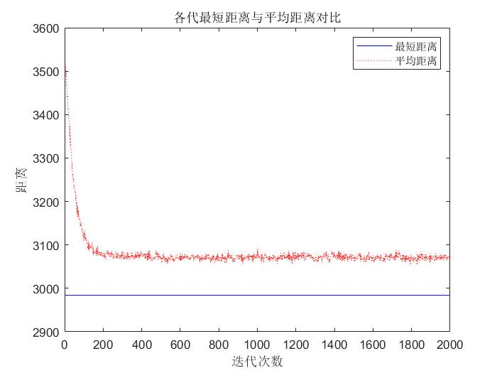

上图为经过各代最短距离与平均距离的对比图，可以清晰的发现在迭代200次左右趋于平稳

最短距离:2984

最终路径：3,1,6,5,4,2，（3）[3为起点，2为终点]

注：1-北京，2-上海，3-天津，4-石家庄，5-太原，6-呼和浩特

5.2用粒子群解决TSP问题（13个城市）

继续沿用上图代码，并加做参数上的修改，

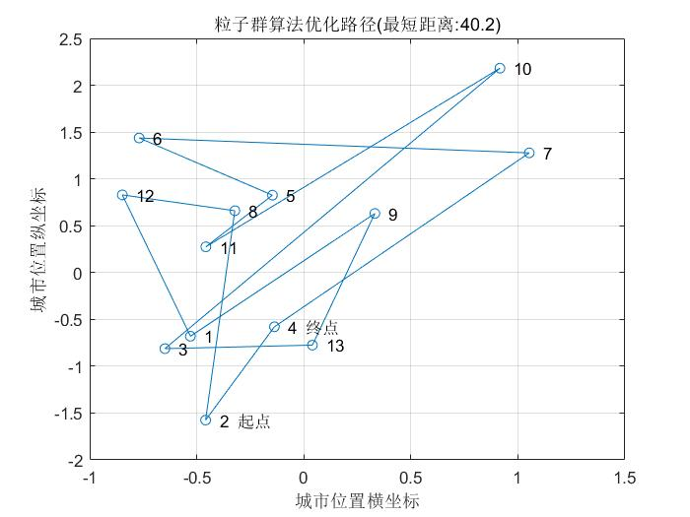

上图为粒子群算法优化路径示意图，横坐标和纵坐标是随机生成的城市位置。

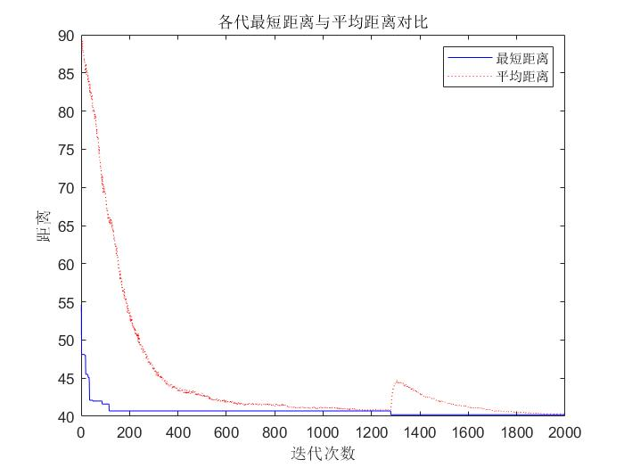

上图为经过各代最短距离与平均距离的对比图，可以清晰的发现在迭代190多次左右趋于平稳

最优路径解2 8 12 1 9 13 3 10 11 5 6 7 4 2，得到的最优路程解的最小路程为40.2

5.3寻求函数在特定区间的最大值

该函数在区间[0,4]之间的图像：

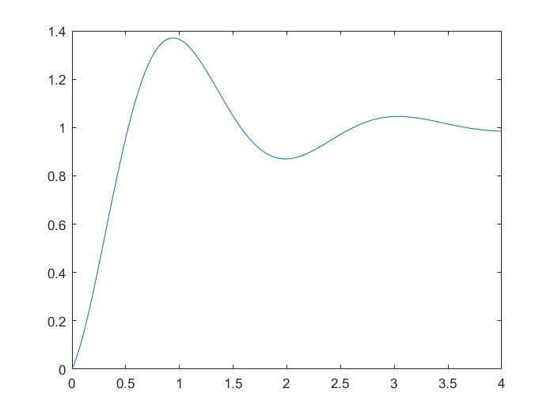

运行6.3的实验代码后，得到如下结果

可以得出当x=1时得最大值1.3642

六、实验代码

liziqunsuanfa_text_N=6;

liziqunsuanfa_text_citys=randn(liziqunsuanfa_text_N,2);

save citys.mat

function change=liziqunsuanfa_text_position_minus_position(liziqunsuanfa_text_best,liziqunsuanfa_text_pop)

for liziqunsuanfa_text_i=1:size(liziqunsuanfa_text_best,1)

for liziqunsuanfa_text_j=1:size(liziqunsuanfa_text_best,2)

change(liziqunsuanfa_text_i,liziqunsuanfa_text_j)=find(liziqunsuanfa_text_pop(liziqunsuanfa_text_i,:)==liziqunsuanfa_text_best(liziqunsuanfa_text_i,liziqunsuanfa_text_j));

temp=liziqunsuanfa_text_pop(liziqunsuanfa_text_i,liziqunsuanfa_text_j);

liziqunsuanfa_text_pop(liziqunsuanfa_text_i,liziqunsuanfa_text_j)=liziqunsuanfa_text_pop(liziqunsuanfa_text_i,change(liziqunsuanfa_text_i,liziqunsuanfa_text_j));

liziqunsuanfa_text_pop(liziqunsuanfa_text_i,change(liziqunsuanfa_text_i,liziqunsuanfa_text_j))=temp;

end

end

end

function liziqunsuanfa_text_change = liziqunsuanfa_text_constant_times_velocity(liziqunsuanfa_text_constant,liziqunsuanfa_text_change)

for liziqunsuanfa_text_i=1:size(liziqunsuanfa_text_change,1)

for liziqunsuanfa_text_j=1:size(liziqunsuanfa_text_change,2)

if rand>liziqunsuanfa_text_constant

liziqunsuanfa_text_change(liziqunsuanfa_text_i,liziqunsuanfa_text_j)=0;

end

end

end

end

function liziqunsuanfa_text_pop = position_plus_velocity(liziqunsuanfa_text_pop,liziqunsuanfa_text_v)

for liziqunsuanfa_text_i=1:size(liziqunsuanfa_text_pop,1)

for liziqunsuanfa_text_j=1:size(liziqunsuanfa_text_pop,2)

if liziqunsuanfa_text_v(liziqunsuanfa_text_i,liziqunsuanfa_text_j)~=0

liziqunsuanfa_text_temp=liziqunsuanfa_text_pop(liziqunsuanfa_text_i,liziqunsuanfa_text_j);

liziqunsuanfa_text_pop(liziqunsuanfa_text_i,liziqunsuanfa_text_j)=liziqunsuanfa_text_pop(liziqunsuanfa_text_i,liziqunsuanfa_text_v(liziqunsuanfa_text_i,liziqunsuanfa_text_j));

liziqunsuanfa_text_pop(liziqunsuanfa_text_i,liziqunsuanfa_text_v(liziqunsuanfa_text_i,liziqunsuanfa_text_j))=liziqunsuanfa_text_temp;

end

end

end

end

clear all;

clc;

load citys.mat;

liziqunsuanfa_text_D=[ 0,1078,119,263,398,401;

1078,0,963,989,1096,1381;

119,963,0,262,426,504;

263,989,262,0,171,394;

398,1096,426,171,0,341;

401,1381,504,394,341,0];

liziqunsuanfa_text_n=6;

liziqunsuanfa_text_c1=0.1;

liziqunsuanfa_text_c2=0.075;

liziqunsuanfa_text_w=1;

liziqunsuanfa_text_m=500;

liziqunsuanfa_text_pop=zeros(liziqunsuanfa_text_m,liziqunsuanfa_text_n);

liziqunsuanfa_text_v=zeros(liziqunsuanfa_text_m,liziqunsuanfa_text_n);

liziqunsuanfa_text_gen=1;

liziqunsuanfa_text_genmax=2000;

liziqunsuanfa_text_fitness=zeros(liziqunsuanfa_text_m,1);

liziqunsuanfa_text_Pbest=zeros(liziqunsuanfa_text_m,liziqunsuanfa_text_n);

liziqunsuanfa_text_Pbest_fitness=zeros(liziqunsuanfa_text_m,1);

liziqunsuanfa_text_Gbest=zeros(liziqunsuanfa_text_genmax,liziqunsuanfa_text_n);

liziqunsuanfa_text_Gbest_fitness=zeros(liziqunsuanfa_text_genmax,1);

liziqunsuanfa_text_Length_ave=zeros(liziqunsuanfa_text_genmax,1);

liziqunsuanfa_text_ws=1;

liziqunsuanfa_text_we=0.8;

for liziqunsuanfa_text_i=1:liziqunsuanfa_text_m

liziqunsuanfa_text_pop(liziqunsuanfa_text_i,:)=randperm(liziqunsuanfa_text_n);

liziqunsuanfa_text_v(liziqunsuanfa_text_i,:)=randperm(liziqunsuanfa_text_n);

end

for liziqunsuanfa_text_i=1:liziqunsuanfa_text_m

for liziqunsuanfa_text_j=1:liziqunsuanfa_text_n-1

liziqunsuanfa_text_fitness(liziqunsuanfa_text_i)=liziqunsuanfa_text_fitness(liziqunsuanfa_text_i) + liziqunsuanfa_text_D(liziqunsuanfa_text_pop(liziqunsuanfa_text_i,liziqunsuanfa_text_j),liziqunsuanfa_text_pop(liziqunsuanfa_text_i,liziqunsuanfa_text_j+1));

end

liziqunsuanfa_text_fitness(liziqunsuanfa_text_i)=liziqunsuanfa_text_fitness(liziqunsuanfa_text_i) + liziqunsuanfa_text_D(liziqunsuanfa_text_pop(liziqunsuanfa_text_i,end),liziqunsuanfa_text_pop(liziqunsuanfa_text_i,1));

end

liziqunsuanfa_text_Pbest_fitness=liziqunsuanfa_text_fitness;

liziqunsuanfa_text_Pbest=liziqunsuanfa_text_pop;

[liziqunsuanfa_text_Gbest_fitness(1),liziqunsuanfa_text_min_index]=min(liziqunsuanfa_text_fitness);

liziqunsuanfa_text_Gbest(1,:)=liziqunsuanfa_text_pop(liziqunsuanfa_text_min_index,:);

liziqunsuanfa_text_Length_ave(1)=mean(liziqunsuanfa_text_fitness);

while liziqunsuanfa_text_gen<liziqunsuanfa_text_genmax

liziqunsuanfa_text_gen=liziqunsuanfa_text_gen+1;

liziqunsuanfa_text_w = liziqunsuanfa_text_ws - (liziqunsuanfa_text_ws-liziqunsuanfa_text_we)*(liziqunsuanfa_text_gen/liziqunsuanfa_text_genmax)^2;

liziqunsuanfa_text_change1=liziqunsuanfa_text_position_minus_position(liziqunsuanfa_text_Pbest,liziqunsuanfa_text_pop);

liziqunsuanfa_text_change1=liziqunsuanfa_text_constant_times_velocity(liziqunsuanfa_text_c1,liziqunsuanfa_text_change1);

change2=liziqunsuanfa_text_position_minus_position(repmat(liziqunsuanfa_text_Gbest(liziqunsuanfa_text_gen-1,:),liziqunsuanfa_text_m,1),liziqunsuanfa_text_pop);

change2=liziqunsuanfa_text_constant_times_velocity(liziqunsuanfa_text_c2,change2);

liziqunsuanfa_text_v=liziqunsuanfa_text_constant_times_velocity(liziqunsuanfa_text_w,liziqunsuanfa_text_v);

for liziqunsuanfa_text_i=1:liziqunsuanfa_text_m

for liziqunsuanfa_text_j=1:liziqunsuanfa_text_n

if liziqunsuanfa_text_change1(liziqunsuanfa_text_i,liziqunsuanfa_text_j)~=0

liziqunsuanfa_text_v(liziqunsuanfa_text_i,liziqunsuanfa_text_j)=liziqunsuanfa_text_change1(liziqunsuanfa_text_i,liziqunsuanfa_text_j);

end

if change2(liziqunsuanfa_text_i,liziqunsuanfa_text_j)~=0

liziqunsuanfa_text_v(liziqunsuanfa_text_i,liziqunsuanfa_text_j)=change2(liziqunsuanfa_text_i,liziqunsuanfa_text_j);

end

end

end

liziqunsuanfa_text_pop=position_plus_velocity(liziqunsuanfa_text_pop,liziqunsuanfa_text_v);

liziqunsuanfa_text_fitness=zeros(liziqunsuanfa_text_m,1);

for liziqunsuanfa_text_i=1:liziqunsuanfa_text_m

for liziqunsuanfa_text_j=1:liziqunsuanfa_text_n-1

liziqunsuanfa_text_fitness(liziqunsuanfa_text_i)=liziqunsuanfa_text_fitness(liziqunsuanfa_text_i) + liziqunsuanfa_text_D(liziqunsuanfa_text_pop(liziqunsuanfa_text_i,liziqunsuanfa_text_j),liziqunsuanfa_text_pop(liziqunsuanfa_text_i,liziqunsuanfa_text_j+1));

end

liziqunsuanfa_text_fitness(liziqunsuanfa_text_i)=liziqunsuanfa_text_fitness(liziqunsuanfa_text_i) + liziqunsuanfa_text_D(liziqunsuanfa_text_pop(liziqunsuanfa_text_i,end),liziqunsuanfa_text_pop(liziqunsuanfa_text_i,1));

end

for liziqunsuanfa_text_i=1:liziqunsuanfa_text_m

if liziqunsuanfa_text_fitness(liziqunsuanfa_text_i)<liziqunsuanfa_text_Pbest_fitness(liziqunsuanfa_text_i)

liziqunsuanfa_text_Pbest_fitness(liziqunsuanfa_text_i)=liziqunsuanfa_text_fitness(liziqunsuanfa_text_i);

liziqunsuanfa_text_Pbest(liziqunsuanfa_text_i,:)=liziqunsuanfa_text_pop(liziqunsuanfa_text_i,:);

end

end

[liziqunsuanfa_text_minvalue,liziqunsuanfa_text_min_index]=min(liziqunsuanfa_text_fitness);

if liziqunsuanfa_text_minvalue<liziqunsuanfa_text_Gbest_fitness(liziqunsuanfa_text_gen-1)

liziqunsuanfa_text_Gbest_fitness(liziqunsuanfa_text_gen)=liziqunsuanfa_text_minvalue;

liziqunsuanfa_text_Gbest(liziqunsuanfa_text_gen,:)=liziqunsuanfa_text_pop(liziqunsuanfa_text_min_index,:);

else

liziqunsuanfa_text_Gbest_fitness(liziqunsuanfa_text_gen)=liziqunsuanfa_text_Gbest_fitness(liziqunsuanfa_text_gen-1);

liziqunsuanfa_text_Gbest(liziqunsuanfa_text_gen,:)=liziqunsuanfa_text_Gbest(liziqunsuanfa_text_gen-1,:);

end

liziqunsuanfa_text_Length_ave(liziqunsuanfa_text_gen)=mean(liziqunsuanfa_text_fitness);

end

[liziqunsuanfa_text_Shortest_Length,liziqunsuanfa_text_index] = min(liziqunsuanfa_text_Gbest_fitness);

liziqunsuanfa_text_Shortest_Route = liziqunsuanfa_text_Gbest(liziqunsuanfa_text_index,:);

disp(['最短距离:' num2str(liziqunsuanfa_text_Shortest_Length)]);

disp(['最短路径:' num2str([liziqunsuanfa_text_Shortest_Route liziqunsuanfa_text_Shortest_Route(1)])]);

figure(1)

plot([liziqunsuanfa_text_citys(liziqunsuanfa_text_Shortest_Route,1);liziqunsuanfa_text_citys(liziqunsuanfa_text_Shortest_Route(1),1)],...

[liziqunsuanfa_text_citys(liziqunsuanfa_text_Shortest_Route,2);liziqunsuanfa_text_citys(liziqunsuanfa_text_Shortest_Route(1),2)],'o-');

grid on

for liziqunsuanfa_text_i = 1:size(liziqunsuanfa_text_citys,1)

text(liziqunsuanfa_text_citys(liziqunsuanfa_text_i,1),liziqunsuanfa_text_citys(liziqunsuanfa_text_i,2),[' ' num2str(liziqunsuanfa_text_i)]);

end

text(liziqunsuanfa_text_citys(liziqunsuanfa_text_Shortest_Route(1),1),liziqunsuanfa_text_citys(liziqunsuanfa_text_Shortest_Route(1),2),' 起点');

text(liziqunsuanfa_text_citys(liziqunsuanfa_text_Shortest_Route(end),1),liziqunsuanfa_text_citys(liziqunsuanfa_text_Shortest_Route(end),2),' 终点');

xlabel('城市位置横坐标')

ylabel('城市位置纵坐标')

title(['粒子群算法优化路径(最短距离:' num2str(liziqunsuanfa_text_Shortest_Length) ')'])

figure(2)

plot(1:liziqunsuanfa_text_genmax,liziqunsuanfa_text_Gbest_fitness,'b',1:liziqunsuanfa_text_genmax,liziqunsuanfa_text_Length_ave,'r:')

legend('最短距离','平均距离')

xlabel('迭代次数')

ylabel('距离')

title('各代最短距离与平均距离对比')

liziqunsuanfa_text_D=[ 0 2.2 18.1 4.8 9.2 8.4 5.2 0.4 9.3 11.3 10.2 0.4 10.4;

2.2 0 17.5 2.8 7.9 6.6 3.3 1.8 8.5 9.8 8.7 2.4 9.6;

18.1 17.5 0 14.7 9.6 10.9 14.2 18.2 9.1 7.6 8.7 18.3 8.0;

4.8 2.8 14.7 0 5.4 3.8 0.5 4.4 6.4 7.0 6.0 5.1 7.4;

9.2 7.9 9.6 5.4 0 2.4 4.9 9.0 1.7 2.3 1.2 9.5 2.2;

8.4 6.6 10.9 3.8 2.4 0 3.3 8.1 4.1 3.3 2.5 8.7 4.6;

5.2 3.3 14.2 0.5 4.9 3.3 0 4.8 6.0 6.6 5.5 5.5 6.9;

0.4 1.8 18.2 4.4 9.0 8.1 4.8 0 9.2 11.1 10.0 0.6 10.3;

9.3 8.5 9.1 6.4 1.7 4.1 6.0 9.2 0 3.3 2.5 9.6 1.1;

11.3 9.8 7.6 7.0 2.3 3.3 6.6 11.1 3.3 0 1.2 11.7 2.8;

10.2 8.7 8.7 6.0 1.2 2.5 5.5 10.0 2.5 1.2 0 10.5 2.5;

0.4 2.4 18.3 5.1 9.5 8.7 5.5 0.6 9.6 11.7 10.5 0 10.7;

10.4 9.6 8.0 7.4 2.2 4.6 6.9 10.3 1.1 2.8 2.5 10.7 0];

clc

clear all

liziqunsuanfa_text_x=0:0.01:4;

liziqunsuanfa_text_y=1-cos(3*liziqunsuanfa_text_x).*exp(-liziqunsuanfa_text_x);

figure

plot(liziqunsuanfa_text_x, liziqunsuanfa_text_y)

hold on

liziqunsuanfa_text_c1 = 1.49445;

liziqunsuanfa_text_c2 = 1.49445;

liziqunsuanfa_text_maxgen = 50;

liziqunsuanfa_text_sizepop = 10;

liziqunsuanfa_text_Vmax = 0.5;

liziqunsuanfa_text_Vmin = -0.5;

liziqunsuanfa_text_popmax = 2;

liziqunsuanfa_text_popmin = 1;

fun=@(x)1-cos(3*x).*exp(-x);

for liziqunsuanfa_text_i = 1:liziqunsuanfa_text_sizepop

liziqunsuanfa_text_pop(liziqunsuanfa_text_i,:) = (rands(1) + 1) / 2 + 1;

liziqunsuanfa_text_V(liziqunsuanfa_text_i,:) = 0.5 * rands(1);

liziqunsuanfa_text_fitness(liziqunsuanfa_text_i) = fun(liziqunsuanfa_text_pop(liziqunsuanfa_text_i,:));

end

[liziqunsuanfa_text_bestfitness liziqunsuanfa_text_bestindex] = max(liziqunsuanfa_text_fitness);

liziqunsuanfa_text_zbest = liziqunsuanfa_text_pop(liziqunsuanfa_text_bestindex,:);

liziqunsuanfa_text_gbest = liziqunsuanfa_text_pop;

liziqunsuanfa_text_fitnessgbest = liziqunsuanfa_text_fitness;

liziqunsuanfa_text_fitnesszbest = liziqunsuanfa_text_bestfitness;

for liziqunsuanfa_text_i = 1:liziqunsuanfa_text_maxgen

for liziqunsuanfa_text_j = 1:liziqunsuanfa_text_sizepop

liziqunsuanfa_text_V(liziqunsuanfa_text_j,:) = liziqunsuanfa_text_V(liziqunsuanfa_text_j,:) + liziqunsuanfa_text_c1*rand*(liziqunsuanfa_text_gbest(liziqunsuanfa_text_j,:) - liziqunsuanfa_text_pop(liziqunsuanfa_text_j,:)) + liziqunsuanfa_text_c2*rand*(liziqunsuanfa_text_zbest - liziqunsuanfa_text_pop(liziqunsuanfa_text_j,:));

liziqunsuanfa_text_V(liziqunsuanfa_text_j,find(liziqunsuanfa_text_V(liziqunsuanfa_text_j,:)>liziqunsuanfa_text_Vmax)) = liziqunsuanfa_text_Vmax;

liziqunsuanfa_text_V(liziqunsuanfa_text_j,find(liziqunsuanfa_text_V(liziqunsuanfa_text_j,:)<liziqunsuanfa_text_Vmin)) = liziqunsuanfa_text_Vmin;

liziqunsuanfa_text_pop(liziqunsuanfa_text_j,:) = liziqunsuanfa_text_pop(liziqunsuanfa_text_j,:) + liziqunsuanfa_text_V(liziqunsuanfa_text_j,:);

liziqunsuanfa_text_pop(liziqunsuanfa_text_j,find(liziqunsuanfa_text_pop(liziqunsuanfa_text_j,:)>liziqunsuanfa_text_popmax)) = liziqunsuanfa_text_popmax;

liziqunsuanfa_text_pop(liziqunsuanfa_text_j,find(liziqunsuanfa_text_pop(liziqunsuanfa_text_j,:)<liziqunsuanfa_text_popmin)) = liziqunsuanfa_text_popmin;

liziqunsuanfa_text_fitness(liziqunsuanfa_text_j) = fun(liziqunsuanfa_text_pop(liziqunsuanfa_text_j,:));

end

for liziqunsuanfa_text_j = 1:liziqunsuanfa_text_sizepop

if liziqunsuanfa_text_fitness(liziqunsuanfa_text_j) > liziqunsuanfa_text_fitnessgbest(liziqunsuanfa_text_j)

liziqunsuanfa_text_gbest(liziqunsuanfa_text_j,:) = liziqunsuanfa_text_pop(liziqunsuanfa_text_j,:);

liziqunsuanfa_text_fitnessgbest(liziqunsuanfa_text_j) = liziqunsuanfa_text_fitness(liziqunsuanfa_text_j);

end

if liziqunsuanfa_text_fitness(liziqunsuanfa_text_j) > liziqunsuanfa_text_fitnesszbest

liziqunsuanfa_text_zbest = liziqunsuanfa_text_pop(liziqunsuanfa_text_j,:);

liziqunsuanfa_text_fitnesszbest = liziqunsuanfa_text_fitness(liziqunsuanfa_text_j);

end

end

yy(liziqunsuanfa_text_i) = liziqunsuanfa_text_fitnesszbest;

end

[liziqunsuanfa_text_fitnesszbest liziqunsuanfa_text_zbest]

plot(liziqunsuanfa_text_zbest, liziqunsuanfa_text_fitnesszbest,'r*')

figure

plot(yy)

title('最优个体适应度','fontsize',12);

xlabel('进化代数','fontsize',12);ylabel('适应度','fontsize',12);

liziqunsuanfa_text_x=0:0.0001:4;

liziqunsuanfa_text_y=1-cos(3.*liziqunsuanfa_text_x).*exp(-liziqunsuanfa_text_x);

[liziqunsuanfa_text_ymax,liziqunsuanfa_text_xmax]=max(liziqunsuanfa_text_y)