ABSTRACT
Farmo is a digital solution that helps both farmers and farm managers manage their agricultural activities and store farm products more efficiently. The application is user-friendly and suitable for small farms, large agricultural fields, and individual growers.
A major feature of Farmo is ability to store detailed information about harvested products, such as quantity, type, quality, and storage duration. Another important function of the application is its built-in platform that connects farmers directly to buyers. By listing their stored products on the app, farmers can easily reach wholesalers, retailers, and customers without depending on middleman. This makes the selling process faster, more transparent, and more profitable.
Farmo is accessible on mobile platforms, ensuring convenience and flexibility for farmers during fieldwork or storage management. The database is designed to securely store all farm-related information, while the intuitive user interface makes the application easy for farmers with limited technical experience.
This project aims to reduce workload, improve visibility of stored farm products, and solve common challenges farmers face when trying to find buyers and fair prices. Overall, Farmo is a practical and efficient tool for modern agricultural management and smooth farmer-to-buyer connections.

ACKNOWLEDGMENT
It is our pleasure to express our sincere gratitude to all those who have directly or indirectly contributed to the development of this project Farmo and who influence our thinking, behavior and acts during study. We are thankful for the valuable advice and suggestions provided by our teachers and friends during this project.
We would like to thank the Department of Computer Engineering of the National Academy of Science and Technology for giving permission to develop a project in this instance.
We express our sincere gratitude to Mr. Sunil Bahadur Bist, project supervisor, for providing essential suggestions, help and the solution to undergo final project. We are thankful to his support, cooperation and motivation provided to us during the final year project for constant inspiration, presence, and blessings. We would also like to thank our project team members for their cooperation, coordination, and teamwork throughout the successful completion of this project.

Project Team:
Rabin Dangaura (21075077)
Raman Chaudhary (21075079)
Rohit Chaudhary (21075080)
Sushil Chaudhary (21075088)

TABLE OF CONTENTS
ABSTRACT i
ACKNOWLEDGMENT ii
TABLE OF FIGURES vi
LIST OF ABBREVIATIONS vii
LIST OF TABLES viii
CHAPTER 1 1
INTRODUCTION 1
  - Background 1
  - Objective 2
  - Purpose, Scope and Applicability 3
    - Purpose 3
    - Scope and Limitations 3
    - Applicability 4
  - Achievements 5
  - Organization of the report 5
CHAPTER 2 7
SURVEY OF RELATED WORKS 7
  - Related work Review 7
  - Tools and Technologies 7
    - Android Studio 7
    - VS Code 8
    - Postman 8
    - JAVA Programming Language 8
    - Django 9
    - React 9
    - Ngrok 9
    - PostgreSQL 9
CHAPTER 3 10
REQUIREMENT AND ANALYSIS 10
  - Problem Definition 10
  - Requirement Specifications 10
    - Functional Requirements 10
    - Non-Functional Requirements 11
  - Planning and Scheduling 13
    - Cost Scheduling 13
    - Task Scheduling 14
    - Time Scheduling 15
  - Software and Hardware Requirements 16
  - Preliminary Product Description 17
  - Conceptual Models 17
CHAPTER 4 18
DESIGN 18
  - Introduction 18
  - System Design 18
    - Architectural Design 18
  - Interface Design 19
    - Use Case Diagram 19
4.3.2 Data Flow Diagram 22
  - Database design 25
  - Summary 27
CHAPTER 5 28
IMPLEMENTATION AND TESTING 28
  - Implementation Approaches 28
  - Coding Details and Code Efficiency 28
    - Code Efficiency 28
  - Testing Approach 29
    - Unit Testing 29
    - Integration Testing 29
  - Modifications and Improvements 30
  - Test Cases 31
CHAPTER 6 33
RESULTS AND DISCUSSION 33
  - Test Reports 33
  - User Documentation 34
CHAPTER 7 36
CONCLUSION AND RECOMMENDATION 36
  - Conclusion 36
    - Significance of the System 36
  - Recommendations 36
REFERENCES 37
ANNEX I 38
ANNEX II 47

TABLE OF FIGURES
Figure 4.2.1: Architectural design 18
Figure 4.3.1.1: Use case Diagram for Admin 20
Figure 4.3.1.2: Use case Diagram for Farmer/Consumer 21
Figure 4.3.2.1: 0 Level DFD 22
Figure 4.3.2.2: 1 Level DFD 23
Figure 4.4: Schema Diagram 26

LIST OF ABBREVIATIONS
API: Application Programming Interface
BE: Bachelor’s in Engineering
DB: Database
GUI: Graphical User Interface
E-R Diagram: Entity-Relationship Diagram
HOD: Head of Department
IDE: Integrated Development Environment
OS: Operating System
RAM: Random Access Memory
UI/UX: User Interface/User Experience
JSON: JavaScript Object Notation
RDMS: Relational Database Management System
DOM: Document Object Model
REST API : Representation State Transfer API
URL: Uniform Resource Locator
HTTP: Hypertext Transfer Protocol
HTTPs: Hypertext Transfer Protocol Secure
SQL: Structured Query Language
DFD: Data Flow Diagram

LIST OF TABLES
Table 3.3.1: Cost Scheduling 13
Table 3.3.2: Task Scheduling 14
Table 3.3.3: Time Scheduling 15

CHAPTER 1

INTRODUCTION

1.1 Background
Traditionally, farmers have relied on local middleman, informal markets, or manual bargaining to sell their produce. These traditional methods often result in unfair pricing, lack of transparency, and limited access to wider markets. Farmers frequently face challenges such as exploitation by intermediaries, delayed payments, and insufficient information about prevailing market rates. As a result, their hard work does not always translate into fair income, and the agricultural supply chain remains inefficient.
With the increasing number of farmers and the growing demand for agricultural products, managing fair trade through manual systems has become difficult and unreliable. Tasks such as price negotiation, market access, and transaction management often consume significant amounts of time and effort, while still leaving farmers vulnerable to unfair practices. These problems not only reduce farmers’ earnings but also discourage them from adopting farming techniques and expanding production.
Many modern agricultural systems are moving towards digital platforms to ensure transparency, efficiency, and fairness in trade. The FARMO app provides a centralized and secure platform where farmers can directly connect with buyers, access real-time market prices, and sell their products at fair rates. This reduces dependency on middleman, minimizes exploitation, and empowers farmers to make informed decisions.
Therefore, the development of the FARMO app is necessary to replace traditional manual trading systems with a fast, reliable, and user-friendly digital solution. This platform will help improve the efficiency, transparency, and sustainability of agricultural trade, ensuring that farmers receive fair value for their produce and contributing to the overall growth of the agricultural sector.

Objectives
The main objective of FARMO is:
- To enable farmers to list crops via mobile app.
- To allow consumers to make payments securely using wallets and banks.
- To empower admins with tools for user verification and transaction monitoring.

Purpose, Scope and Applicability

Purpose
The purpose of this is to design and develop Farmo, a digital platform that automates and streamlines the activities related to fair-pricing, transparent transactions and efficient market access for farmers. The system focuses specifically on handling crop data, calculating fair prices based on predefined rules and market trends, and making those prices available to farmers and buyers in a digital format.
The system is intended to manage agricultural produce information, process pricing data entered by authorized users or generated through integrated market feeds and automatically determine fair prices that ensure both farmer profitability and buyer affordability. By automating calculations such as cost of production, market demand, and profit margins, the system will greatly reduce the possibility of exploitation, ensure consistency in pricing, and promote sustainable agricultural practices. In addition, the system will support the generation of structured reports and digital receipts that can be stored and retrieved easily.
Another important purpose of this project is to improve accessibility and transparency in agricultural trade. The system will allow farmers to view and download their crop prices, transaction histories, and receipts through both a web-based application and a mobile application. This eliminates the need for middlemen and repeated visits to local markets, making the trading process faster, more convenient, and more secure.

Scope and Limitations Scope
The FARMO is designed to facilitate convenient, efficient, and farmer market interaction. Its key scopes include:
- Market Trend Integration: The system can integrate with external market data sources to provide real-time price comparison and updates.
- Inventory Tracking: Farmers can record and manage their crop inventory, helping them plan sales and avoid wastage.
- Transactional History: The app maintains detailed transaction logs for farmers and buyers, ensuring accountability and easy record retrieval.
- Fair Price Access: Farmers can securely view and download fair price information for their crops using both the web application and the mobile application.
- Web and Mobile Support: Farmers and buyers can access crop prices, receipts, and transactional histories through both web and android mobile application.
- Fast Price Publishing: Verified crop prices can be published online quickly, reducing delays in communication between farmers and buyers.
- Price Entry and Update: Authorized users such as administrators or market officials can enter, update, and verify crop price data.
- Scalable Design: Initially designed for local farmers groups, the system can be extended to regional and national-level agricultural trade networks.

Limitations
Although every effort has been made to design and implement a reliable and efficient Farmo App, certain limitations still exist in the current version of the project. These limitations mainly arise due to time constraints and the limited scope of the project, as it had to be completed within a fixed academic period. As a result, some advanced features and enhancements could not be included in this version of the system. The current system focuses only on core fair-pricing and transaction functionalities and further improvements can be made in future versions. The key limitations are as follows:
      - Internet Dependency: The system requires a stable internet connection for farmers and buyers to access the web and mobile application.
      - Data Accuracy Dependency: The correctness of fair pricing fully depends on the accuracy of crops and cost data entered by authorized.
      - Manual Verification Needed: Administrators or farmers cooperatives must still manually verify crop details before finalizing fair price calculation.

Applicability
The proposed FARMO app is applicable to farmer groups, cooperatives, and agricultural markets for efficient and transparent pricing and trading of crops. It can be used by agricultural organizations, local market authorities, and farmer collectives to manage crop data, calculate fair prices, and facilitate secure transitions. The system is especially useful in context where traditional trading practices are slow, exploitative, or prone to inconsistencies.
Farmo supports digital crop price management and allows farmers to access fair prices information, transaction records, and receipts easily through both web and mobile applications. By reducing reliance on middleman and manual processes, the app ensures faster communication, improved transparency, and greater convenience for farmers and buyers alike.

Achievements

Several important milestones of the Farmo app have been successfully achieved. The basic system architecture has been designed and implemented using modern frameworks suitable for web and mobile platforms. The authentication system, including secure login and OTP-based password recovery, has been fully implemented and tested to ensure data security for farmers and buyers. The admin dashboard has been developed with functional modules such as farmers profile management, crop data entry, price management, and transaction verification. Farmers can view crop prices, transaction histories, and receipts through both the web and mobile application. The system can store retrieve crop and transaction data from the centralized database correctly. Initial testing has been performed on these modules, and the system is working reliably for the implemented features.

Organization of the report
The report on the FARMO is organized into seven chapters, each systematically addressing the stages of development.
Chapter 1: The introduction sets the foundation by presenting the motivation for the Farmo App, emphasizing the need for a reliable and efficient platform to overcome the limitations of traditional agricultural trading practices. Farmers often face challenges such as unfair pricing, dependence on middlemen, lack of transparency, and limited access to digital tools. Farmo is designed to address these issues by providing a modernized, farmer-centric solution that ensures fair pricing, secure transactions, and easy access to market information.
Chapter 2: Existing platforms like BigBasket, Amazon Fresh, and Daraz Mart connect farmers or vendors with consumers but often involve high fees, limited rural access, and weak transparency. Farmo fills this gap by enabling direct farmer-to-consumer trade in Nepal with fair pricing, instant wallet payments, and trust through ratings. It also justifies the use of tools and technologies such as Django, Java, PostgreSQL, Android Studio, and Postman to ensure reliability, performance, and scalability.
Chapter 3: Requirements and Analysis specify functional requirements (e.g., authentication, farmer profile management, crop data entry, and notification system.) and non-functional requirements (e.g., performance, security, usability). It also includes project planning, team responsibilities, hardware and software requirements, and system models such as DFDs, ER diagrams, and use-case diagrams.
Chapter 4: Design translates requirements into architectural, interface, and database designs, focusing on client-server architecture, modularity, usability, and database normalization for efficient data handling, while justifying design choices for long-term maintainability.
Chapter 5: Implementation and Testing documents the coding phase, highlighting practices such as modular programming, proper error handling, API integration, and optimized database queries. It details testing approaches including unit testing, integration testing, and system testing, along with test cases, bug fixes, and improvements made during development.
Chapter 6: Results and Discussion present the outcomes of system testing and implementation, analyzing system performance, accuracy, and usability. It also includes user guidance and discusses feedback, limitations, and possible improvements to ensure that the system meets its objectives.
Chapter 7: Conclusion and Recommendations summarize the project’s contributions, significance, and achievements, noting how the system simplifies and improves the FARMO. It also provides recommendations for future enhancements such as advanced reporting, notification systems, performance analysis features, and support for university-level deployment.

CHAPTER 2

SURVEY OF RELATED WORKS

Related work Review
Farm management systems have been studied and implemented in many agricultural sectors to replace traditional manual methods of managing farm activities and records. Earlier, farm data such as crop details, expenses, production records, and sales information were maintained using paper registers or basic spreadsheet tools. These methods required a lot of time and were highly prone to data loss, calculation errors, and inconsistencies.
Many existing farm management solutions use database-driven systems and web-based platforms to store farm-related data and manage activities centrally. These systems provide features such as secure data entry, and digital report generation. Some platforms have also introduced mobile-based access so that farmers can monitor their farm activities anytime and anywhere. The use of authentication and role-based access control further improves the reliability and security of farms.
During the study phase of the Farmo system, it was observed that many farmers still rely on manual methods or basic tools such as notebooks and spreadsheets for managing farm information. These methods require repeated checking, manual calculations, and record maintenance, and are still vulnerable to errors and delays. This situation clearly indicates the need for a dedicated and automated Farmo System to make farm management more efficient, accurate, and reliable.

Tools and Technologies

Android Studio
Android Studio is the official integrated development environment (IDE) for developing Android applications and is widely used by developers worldwide. In this project, Android Studio is used to develop the mobile application part of the Result Processing System, which allows students to view their results easily using their smartphones.
Android Studio provides a powerful and user-friendly environment for designing, coding, testing, and debugging Android applications. It supports programming languages such as Java and Kotlin and offers built-in tools for user interface design, performance analysis, and error detection.

VS Code
VS Code (Visual Studio Code) is a free and lightweight code editor developed by Microsoft. It is used to write, edit, and run programs in many languages like Java, Python, C/C++, JavaScript, HTML, XML, etc. It provides useful features such as syntax highlighting, auto-completion, error detection, debugging support, and extensions. VS Code is fast, easy to use, and widely preferred by students and developers for application and software development.

Postman

Postman is a popular API testing tool. It is used to assess and verify the communication between the web application, Android application, and backend server. Since the system uses REST APIs to transfer data such as login details, marks, and results, Postman is used to send different types of requests like GET, POST, PUT, and DELETE and check whether the server returns correct responses in JSON format. It helps in testing important functions such as user authentication, marks entry, result generation, and result retrieval without needing the actual user interface. By showing response status codes, error messages, and execution time, Postman helps in finding bugs early and ensures that the backend services are working correctly, making the overall system more reliable, stable, and efficient.

JAVA Programming Language

Java is a widely used, high-level, object-oriented programming language known for its platform independence, reliability, and security. It follows the principle of “write once, run anywhere,” which allows applications to run on different operating systems without modification. Java provides strong support for building scalable and maintainable applications using object-oriented concepts. It also offers a rich set of libraries and frameworks for web development, database connectivity, and API development.

Django
Django is a high-level, open-source Python web framework that is used to develop dynamic, secure, and scalable web applications efficiently. Django provides many built-in features such as user authentication, database connectivity through ORM (Object Relational Mapping), URL routing, form handling, and an automatic admin interface. These features reduce the need to write repetitive code and help developers build applications faster.

React
React is a popular JavaScript library used for building fast and interactive user interfaces, especially for single-page web applications. It was developed by Facebook and focuses on creating reusable UI components that make application development more efficient. React uses a component-based architecture and a virtual DOM, which improves performance by updating only the required parts of the user interface instead of reloading the entire page. It also supports features such as state management, props, and one-way data binding, making applications easier to debug and maintain. React is widely used for developing modern, responsive web applications.

Ngrok
Ngrok is a tool that lets you securely expose a local server or application to the internet. It creates a public URL (HTTP or HTTPS) that tunnels traffic directly to your local machine, allowing you to test web applications, share demos, or receive webhooks without deploying them to a live server. Ngrok is widely used by developers for development, testing, and debugging purposes because it provides a fast and secure way to make local projects accessible online.

PostgreSQL
PostgreSQL is a powerful, open-source relational database management system (RDBMS) that stores and manages structured data. It supports SQL for querying and provides advanced features like ACID compliance, data integrity, complex queries, indexing, and support for JSON and other data types. PostgreSQL is highly reliable, scalable, and suitable for both small applications and large enterprise systems. It also supports extensions, stored procedures, and concurrency, making it a popular choice for modern web and software development projects.

CHAPTER 3

REQUIREMENT AND ANALYSIS

Problem Definition
In many agricultural markets, farmers still rely on traditional intermediaries and manual methods to sell their produce. This approach is often exploitative, inefficient, and opaque, especially when dealing with large numbers of farmers and diverse crops. Manual price negotiation and record-keeping frequently lead to unfair pricing, miscommunication, and disputes which directly affect farmers’ income and trust in the system.
Another major problem is the lack of a centralized, transparent platform for managing crop data, pricing information, and transactions. Without proper role-based access control, unauthorized middleman may manipulate or conceal market data, creating security and integrity issues. The process of verifying fair prices and ensuring timely payments is also slow, causing in farmer compensation.

Requirement Specifications

Functional Requirements
In a Fair-Pricing Agricultural platform like Farmo, functional requirements define the core features and operation that the system must support to manage farm records, ensure transparent crop pricing and facilitate transactions. These requirements cover everything from user management to crop data entry, Product management, and transaction publication.

User Management:
The system allows different types of users such as Admin, Farmer, and Buyer to create and manage their accounts. It supports secure login and logout, password management, role-based access control to ensure that each user can access only the features permitted to them. Admin can manage users and oversee platform operation, farmers can register crops, updates harvest details, and track their sales, and buyers can browse available produce, negotiate or accept fair prices and complete transactions.

Crop Data Entry:
Farmers should be able to enter detailed information about their crops, including type, quantity, quality, and harvest date. The system must validate these entries to avoid duplication or errors and allow uploading of supporting documents such as certifications. This ensures accurate, organized, and transparent data storage that supports fair pricing and reliable transactions.

Transactional Management:
Farmo must support secure digital contracts between farmers and buyers, integrate payment gateways for instant or scheduled payouts, and maintain transaction history logs for auditing and dispute resolution.

Record Management:
A centralized database should store products, sell crop histories, and transaction logs. The system must provide search and filter options for quick access, along with backup and recovery mechanism to ensure data integrity.

Security and Access Control:
Farmo must encrypt sensitive information such as farmer details and payment data. Role-based permission should prevent unauthorized access, while audit trails track all activities to maintain accountability.

Non-Functional Requirements
While functional requirements define what the system does, non-functional requirements focus on how well it performs. These requirements ensure the system is reliable, user-friendly, and capable of supporting future growth.

Performance: The system processes farmer records and calculates crop prices efficiently. Crop entry, price calculation, and transaction repot generation are performed without significant delay, even when multiple users such as farmers and buyers access the platform simultaneously.
- Security: The system uses secure login, password protection, and role-based access control to ensure that only authorized users can access specific features.
- Reliability: The system ensures that farmer’s records, crops details, and transaction data are stored accurately in the database. It is designed to operate continuously without frequent failures and to safeguard data loss during normal operation. This reliability guarantees that farmers and buyers can depend on faro for consistent access to secure and trustworthy agricultural information.
- Usability: The system provides a simple, clean, and user-friendly interface so that Admin, Farmers, and Buyers can use it without needing special technical knowledge or training.
- Scalability: The system is designed to support a growing number of Farmers, Crops, and Transactional Records. In the future, it can be expanded for use across larger agricultural communities, cooperatives, and even nationwide farming networks, ensuring scalability and adaptability to meet increasing demands.
- Maintainability: The system is developed in a modular way, making it easier to fix bugs, update features, and improve performance without disrupting the whole system.
- Compatibility: The system works properly on common web browsers and Android devices, allowing farmers and buyers to access crop data, pricing information, and transactional records form both web and mobile applications. This ensures flexibility and convenience, enabling stakeholders to use Farmo seamlessly across different platforms.

Planning and Scheduling
Planning and Scheduling consist of cost scheduling task scheduling and time scheduling.

Cost Scheduling
The development cost of this proposed project will be estimated as:
S.N. | Title | Price (Rs.)
1 | Equipment and Internet Charges | 45,00
2 | Documentation | 5,000
3 | Developer Cost | 1,52,000
4 | Miscellaneous | 15,000
 | Total | 1,76,500

Table 3.3.1: Cost Scheduling

3.3.2 Task Scheduling
This project has been carried out for almost 4 months (Nov 2025 to Feb 2026). In the development of the project, we 4 members will work together to achieve the goal. Further information about the development schedule module is given below:
Module | Dec, 2025 |  | Jan, 2026 |  |  |  | Feb, 2026
 | Week |  | Week |  |  |  | Week
 | 3 | 4 | 1 | 2 | 3 | 4 | 1 | 2
System Design
Setup System and Database
User authentication, Product Management, Order Management (Backend)
UI/UX (Web and App)
Connection Frontend and Backend
Reviewing and Updating Frontend and Backend

Table 3.3.2: Task Scheduling

3.3.3 Time Scheduling
The project work is divided into various activities which will be carried out as per given schedule:
Activities | 2025  Nov-Dec |  |  |  | 2025-2026  Dec-Jan |  |  |  | 2026  Jan-Feb
 | Week |  |  |  | Week |  |  |  | Week
 | 1 | 2 | 3 | 4 | 5 | 6 | 7 | 8 | 9 | 10 | 11 | 12
Feasibility Study
Proposal submission
Proposal Defense
System design & Specification
Coding & verification
Testing and Refining
Mid-term Defense
Final testing
Documentation
Final presentation
Table 3.3.3: Time Scheduling

Software and Hardware Requirements

Hardware recommendation
- Computer or laptop & Android Mobile
- RAM (Minimum 8 GB or Above)
- Hard Disk (Minimum 100 GB or Above)
- Stable Internet Connection

Software recommendation
- VS Code
- Android Studio 2025.1
- Python 3.14
- JDK 25
- Next.js
- Postman
- Operating System windows 10 or above
- Android OS with version 7 or above

Preliminary Product Description

This system offers:
- A web application for Admin, Farmers and Buyers to manage user, farm profiles, products, crop listing, pricing, orders, and transaction.
- An Android app for farmers and customers to easily list farm products, browse available items, place orders, track deliveries, and view order history anytime.
- Smooth, role-specific workflows that support product listing, order management, payment, tracking, delivery updates, reporting, real-time interaction in a centralized and integrated environment.

Conceptual Models

Stakeholders:
- Admin: Manages users, farmers, buyers, product categories, pricing rules, and overall system control. Monitors system activities and platform performance.
- Farmer: Add and updates farm products, manage crop details, set prices, views orders, and track sales.
- Customer: Logs in to browse farm products, place orders, track deliveries, and view purchase history through the web or mobile application.

Use Cases:
- Farmer: Register/Login →Create/Update Farm Profile → Add Products/Crops →Set Price & Quantity→View Orders→ Update Order Status→ Logout
- Customer: Register/Login → Browse Products → Place Orders → Make Payment → Track Order → View Order History→ Logout
- Admin: Login → Manage Users → Manage Farmers & Buyers → Manage Product Categories → Monitor Order & Payments → Generate Reports → Logout

CHAPTER 4
DESIGN
  - Introduction
This chapter outlines the system design blueprint capturing architecture, data structure, user interface, and the logical flow of operations for the FARMO. It establishes a foundation that supports development, ensures clarity among stakeholders, and guides future scalability.

System Design
The design phase is the architecture phase of system design. The flow of data processing is developed into charts and project team determines the most logical design and structure for the data flow and storage. It provides us with guidelines, based on the requirements and detailed analysis, the new system is designed. We use different tools while designing such as use-case diagrams, flowchart, E-R diagram, etc.

Architectural Design
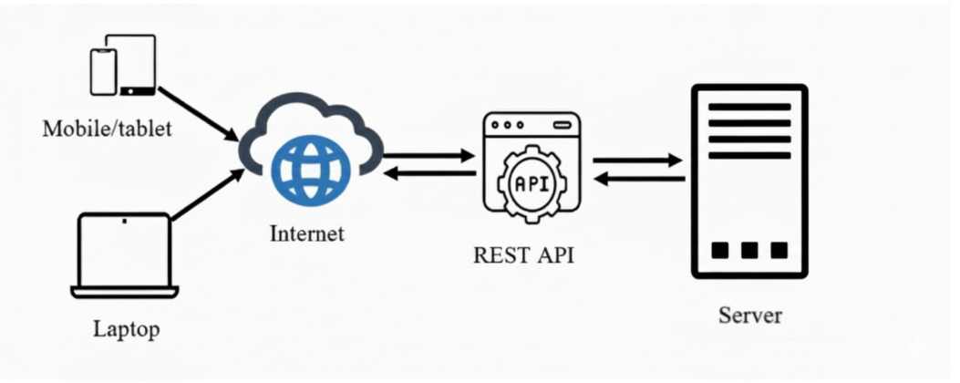
Figure 4.2.1: Architectural design
The system architecture is based on a client-server model, where users such as Admin, Farmer, and Buyer interact with the system through the internet using a web application or an Android mobile application. User requests such as login, product listing, order placement, and order tracking are sent to the server for processing. The requests are handled by the Web Server, which hosts a REST API server developed using Spring Boot. The API acts as the middle layer, managing core business logic including user authentication, farm profile management, product and order processing, payment handling, and report generation, while ensuring secure communication between the frontend and backend. The backend is supported by a MySQL database, which stores all essential data such as user details, farmer profile, product information, orders, transactions, and delivery status. Based on user actions, the server retrieves or updates data in the database and sends appropriate responses back to the client application.

Interface Design

Use Case Diagram
A Use Case Diagram is a vital tool in system design it provides a visual representation of how users interact with a system. It serves as a blueprint for understanding the functional requirements of a system from a user’s perspective, aiding in the communication between stakeholders and guiding the development process. In our system the Use case diagram is designed as given below.

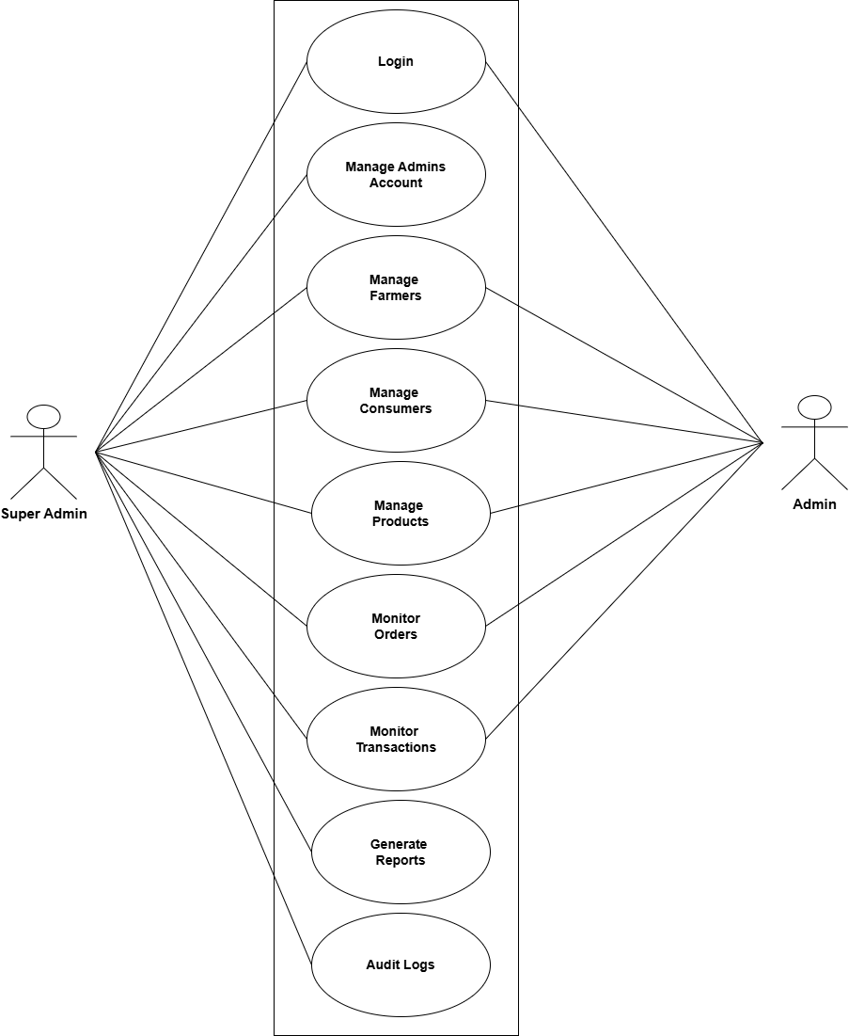

Figure 4.3.1.1: Use case Diagram for Admin

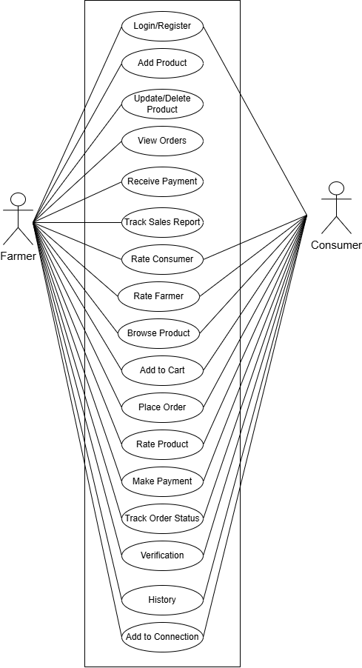

Figure 4.3.1.2: Use case Diagram for Farmer/Consumer

4.3.2 Data Flow Diagram
A DFD is a graphical representation that depicts the flow of data within a system.

4.3.2.1: 0 Level DFD
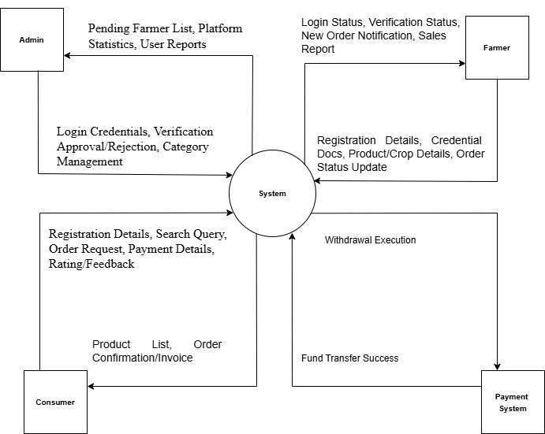
Figure 4.3.2.1: 0 Level DFD
The above figure illustrates the Level 0 Data Flow Diagram (DFD) of the FARMO, which provides a high-level overview of how different entities interact with the system. The central process, labeled as FARMO, acts as the main processing unit where all requests and responses are handled.
The Admin interacts with the system to manage users, farmers, buyers, product categories, and overall system settings as well as to monitor platform activities. The farmer interacts with the system to add and update farm products, manage crop details, set prices, and view customer orders. The customer/buyer interacts with the system to browse available farm products, place orders, track order status. This level 0 DFD shows only the major external entities and their data interactions with the Farmo system without detailing internal processes, thereby providing a clear and simplified overview of the system’s overall functionality.

4.3.2.2: 1 Level DFD

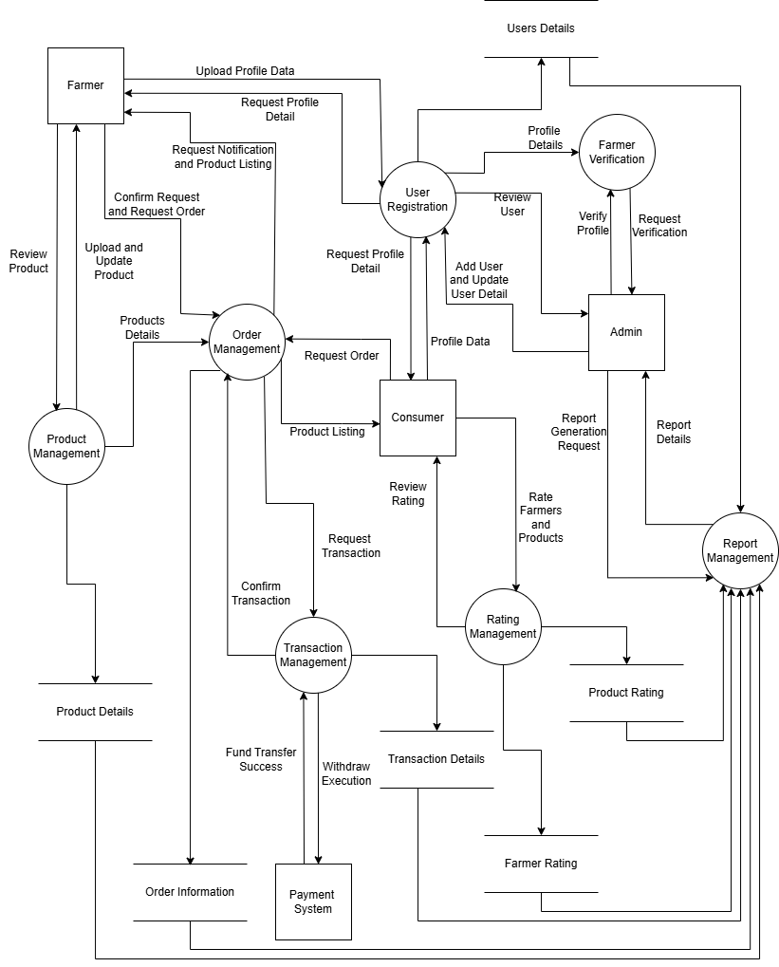
Figure 4.3.2.2: 1 Level DFD

The Level 1 Data Flow Diagram (DFD) of the FARMO illustrates how data flows between the main entities—Farmer and Consumer—and the internal system processes. In this system, both Farmer and Consumer must first complete an authentication process, which validates their credentials against the user database to ensure secure access. After successful login, farmers can manage their farm activities through the managing product/crop records process, where they add or update product details such as crop name, quantity and price. This information is stored in the product database. Consumer interacts with the system by browsing available farm products through the view products process, which fetches data from the product database. When a consumer places an order, the create order process records the order details and stores them in the order database, the order processing process updates order status and prepares delivery information. Finally, the order confirmation and history process stores finalized order and transactional details in the order and transactional databases, making them accessible for both farmer and consumer to view or track.

4.4 Database design
The database diagram shows the relationships among the tables. Different tables are created in the database, and they have various attributes. Each entity has its primary key, which is used by other tables as a foreign key to access different attribute values from other tables. By using foreign keys, relationships are established between the tables. The database diagram is used to visualize the system’s blueprint and is utilized in software-based systems, business modeling, and associated operations for analysis and design.

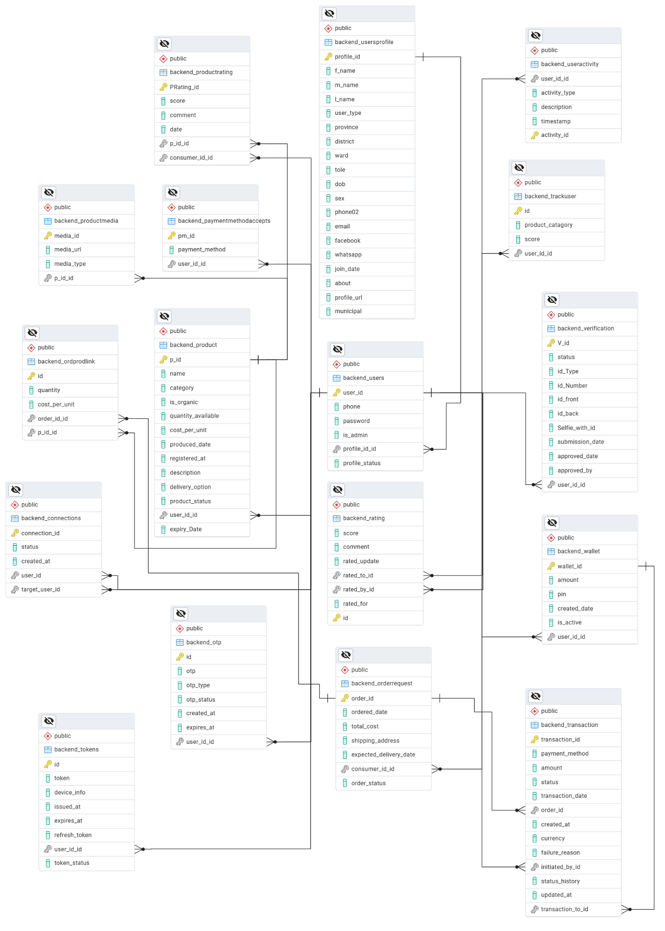
Figure 4.4 Schema Diagram

4.5 Summary
In Chapter 4, we present the foundational design framework for the FARMO. The system design follows a structured architecture that separates the presentation layer (web and mobile apps), business logic, and data layer, ensuring modularity, security, and ease of maintenance. The database design efficiently manages critical agricultural and commercial data, including user information, farmer profiles, product and crop details, orders, transactions, and delivery status, enabling accurate and real-time processing of farm-to-market activities. For interface design, wireframes and UML diagrams such as Use-case diagrams, flowcharts, and components diagram illustrate how different users (Admin, Farmer, and Customer) interact with the system. These interactions include authentication, product listing, order placement, order management, payment processing, and report generation. The system design emphasizes secure access, streamlined workflows, and intuitive navigation for all user roles. Overall, these design components together provide a robust, organized, and user-friendly platform that supports efficient digital agriculture management and allows for future scalability and feature expansion.

CHAPTER 5

IMPLEMENTATION AND TESTING

Implementation Approaches
The implementation stage represents the phase where the designed FARMO system is converted into a working software prototype. The system is currently user active development, with core modules being implemented and integrated incrementally.
Currently, the backend services using Django, the database using PostgreSQL, and the basic frontend interfaces are developed. The Android application for farmers and customers is also in the initial development phase. The primary focus of this stage is to ensure that the basic system structure, database connectivity, and core functionalities work correctly and reliably.
The major outcomes of this stage include:

A working prototype of the system with basic modules such as user authentication, farmer profile management, product listing, and order management.

A configured database with sample data for testing and development purposes.

Source code management using a version control system to track development progress and changes.

Basic integration between frontend, backend, and database to support end-to-end system functionality.

Coding Details and Code Efficiency
While developing the FARMO, special attention is being given to maintaining good code quality and efficiency. The system is being implemented using a modular and layered structure so that each part of the system has a clear responsibility. This makes the code easier to understand, test, and modify.

Code Efficiency
Coding refers to the process of writing instructions using programming languages to develop an application or software system. In the FARMO, the implementation is being carried out using well-known and reliable technologies. The main focus of the coding phase is to ensure that the system is efficient, maintainable, and scalable.
The code efficiency of the system is being ensured through the following practices:
      - Writing clean, modular, and well-documented code so that each module has a clear responsibility and can be easily maintained or modified in the future.
      - Using a layered and structured programming approach to separate user interface, business logic, and database operations.
      - Reducing code duplication by using reusable classes, functions, and services wherever possible.
      - Implementing proper input validation and exception handling to prevent system crashes and reduce logical errors.
      - Organizing the source code properly and adding meaningful comments to make future debugging and enhancements easier.

Testing Approach

Unit Testing
Unit testing was carried out to ensure that each module of the FARMO system functions correctly when tested independently. The modules tested include user login, OTP for password recovery, admin dashboard, farmer profile management, product and crop management, Order placement, and Order status updates. For example, the login module was tested using both valid and invalid credentials to verify authentication and error handling. The OTP generation and verification module was tested to ensure secure and reliable password recovery. Product entry and order-related modules were tested to confirm correct data input, validation, and retrieval from the database.

Integration Testing
Integration testing was performed to ensure that all modules of the FARMO system work together smoothly and consistently. For example, products added or updated by farmers through the product management module were correctly reflected in the product listing and order placement modules. Orders placed by customers were accurately displayed in the farmer order management dashboard, along with correct quantity, pricing, and status details. Changes made in the admin dashboard, such as updates to user roles, product categories, or system settings, were verified to ensure that all related modules were updated consistently across the platform. The interaction between the login module and role-based dashboards (Admin, Farmer, and Customer) was also tested to confirm proper authentication, authorization, and redirection

Modifications and Improvements
As the development and testing phases progress, several areas for improvement have been identified to further enhance the quality, usability and reliability of the FARMO system. These improvements aim to provide better user experience and more efficient system performance.
- Refine User Interface and Workflows: Feedback from users such as farmers, customers, and administrators helps identify areas where the user interface and workflows can be improved. Simplifying product listing steps, improving order tracking views, and making dashboard navigation more intuitive can significantly enhance usability.
- Fix Errors and Logical Issues: During testing minor bugs or logical issues may arise in modules such as order calculation, stock management, pricing validation, or payment status updates. These issues are addressed to ensure accurate order processing and consistent system behavior.
- Improve System Performance: System performance can be improved by optimizing database queries, improving backend logic, and refining data handling mechanisms. This ensures faster product loading, quicker order processing, and smooth operation even with many users and transactions.
- Enhance Security and Data Reliability: Additional input validation, authentication checks, and role-based access control mechanisms can be implemented to prevent unauthorized access and protect sensitive user and transaction data.
- Add New Features if Required: Based on future requirements, features such as advanced sales analytics, demand forecasting, real-time notification, and SMS/mail order alerts can be added to increase the overall usefulness and impact of the FARMO platform.

Test Cases
In the FARMO system, effective testing is essential to ensure accurate product management, secure access, and smooth system operation. Below are some sample test cases across various modules:

Unit Testing (Login Module)

Test Case #1: Enter valid username and password and verify successful login and redirection to the dashboard.

Test Case #2: Enter invalid credentials and confirm that an appropriate error message is displayed.

Test Case #3: Token, Refresh Token, UserID and User Type are received from server when login is successful.

Test Case #4: Login with Refresh Token, Token and UserID.

Unit Testing (OTP / Forget Password Module)

Test Case #5: Request OTP for password reset and verify that it is sent to the registered email.

Test Case #6: Enter the correct OTP and confirm successful password reset.

Unit Testing (Create new User)

Test Case #7: Creating new Admin User .

Test Case #8: Creating new Farmer and Consumer.

Integration Testing (Searching and Viewing Farmer and Consumer details)

Test Case #9: The system successfully displays the correct Farmer and Consumer records based on the entered User ID or Name and accurately filters results according to selected district, verification status, and profile status.

Test Case #10: The system loads and displays all relevant user details on the profile page without errors or missing information.

Integration Testing (Login → Admin Dashboard)

Test Case #11: Log in as an admin and confirm that the admin dashboard loads successfully with access to Total Farmers, Active Products, Total Consumers, and Verification Request.

CHAPTER 6
RESULTS AND DISCUSSION
  - Test Reports
The testing phase of the FARMO System ensures that the software is reliable, accurate, and aligned with the intended functional requirements of the platform. Although formal automated testing tools have not yet been implemented, manual testing has been carried out to validate the core functionalities of the system. This preliminary testing focused on critical modules such as user authentication, product management, order processing, and dashboard operations to ensure correct behavior and data consistency. The outcomes of these tests have been recorded in test reports which provide a clear understanding of the system’s current performance, stability, and reliability.
Key Components of the Test Reports:
- Test Objectives: Each testing activity has specific goals to verify the correctness and efficiency of the system. Manual tests were conducted to ensure that products are added correctly, prices and quantities are processed accurately, orders are handled properly, and reports are generated without errors.
- Test Cases and Scenarios:
Test cases were designed to cover common agricultural and marketplace scenarios, including:
  - Adding and updating farm products
  - Managing product quantity and pricing
  - Placing and processing customer orders
  - Generating individual and summary sales reports
- Defect Logs: Any issues or discrepancies identified during testing were recorded manually, such as incorrect order totals, data validation errors, or display issues in reports. Each defect was documented along with the corrective action taken and its status (resolved or pending).
- Performance Checks: Although formal load or stress testing has not yet been conducted, the system was observed for responsiveness during normal usage. Basic operations such as product listing, order placement, and report generation were verified to function efficiently without noticeable delays.
- Compliance Checks:
The FARMO system is designed to comply with digital marketplace and data handling standards, including secure user authentication, proper handling of farmer and customer data, accurate pricing and order calculations, and consistent report formats. This ensures that the system operates reliably and aligns with expected platform and business practices.
By documenting these observations, the test reports provide a foundation for further improvements and help confirm that the FARMO is functioning as intended.

User Documentation

User documentation is an essential component of the FARMO system, helping administrators, farmers, and customers effectively interact with the platform. The documentation is designed to be simple, clear, and user-friendly, enabling users with varying technical knowledge to use the system confidently.

Contents of the User Documentation:
- System Overview: This section introduces the FARMO system by explaining its purpose, benefits, and key features. It helps users understand how the platform connects farmers directly with customers, simplifies product listing and order management, reduces manual errors, and provides real-time access to farm and order information.
- User Guides: The User Guides section provides step-by-step instructions to help users perform common tasks within the FARMO system. It includes guidance on registering and logging in, creating and updating farmer profiles, adding and managing farm products, placing and tracking orders, managing payments, and generating reports.

FAQs (Frequently Asked Questions): The FAQs section addresses common questions users may face while using the system. This includes queries such as how to update product details, how to cancel or modify an order, how to reset a password, and how to view order history. Clear and simple answers help users resolve issues independently without requiring technical support.

Troubleshooting Tips: This section provides guidance for resolving minor issues such as login errors, missing product listings, incorrect order status, or dashboard loading problems, allowing users to quickly fix common problems on their own.

Contact Information: Clear instructions for reaching support, including email addresses or system administrator contacts, are provided to ensure assistance is available if needed.

CHAPTER 7

CONCLUSION AND RECOMMENDATION

Conclusion

Significance of the System
The FARMO system plays a vital role in modernizing the agricultural and farm-to-market ecosystem by automating and simplifying farm management and product trading processes. Traditionally, farmers rely on manual methods for managing crop details, pricing, and sales, which are time-consuming, inefficient, and prone to errors. The FARMO system significantly reduces these challenges.
One of the major significances of the system is its ability to save time and effort for farmers and administrators. Tasks such as product listing, price calculation, order management, and sales tracking are handled digitally, which speeds up operations and minimizes manual mistakes. Furthermore, the FARMO system improves transparency and consistency in transactions. Since all orders, prices, and payments follow predefined rules and system logic, the chances of pricing errors, disputes, or inconsistencies are reduced.

Recommendations
Although the FARMO system meets its core objectives, there is room for improvement to make it more efficient and user-friendly. Features like automated data backup and recovery, and import/export of product and order data can enhance reliability. Advanced analytics, feedback systems, real-time notifications, and interactive dashboards for farmers and customers can improve usability and engagement. Implementing this enhancement will make the FARMO system more secure, practical and scalable, supporting smooth digital farm management for administrators’ farmers, and customers.

REFERENCES
[1] | Nepalilnfopedia, "Nepali Infopedia," [Online]. Available: https://nepaliinfopedia.com/list-of-food-crops-in-nepal/. [Accessed 19 11 2025].
[2] | Daraz, "Daraz," [Online]. Available: https://www.daraz.com.np/. [Accessed 15 11 2025].
[3] | Wikipedia, "Wikipedia," [Online]. Available: https://en.wikipedia.org/wiki/List_of_most_valuable_crops_and_livestock_products. [Accessed 20 11 2025].
[4] | Microsoft, "Github," [Online]. Available: https://docs.github.com/en. [Accessed 15 11 2025].
[5] | D. S. Foundation, "Django," [Online]. Available: https://docs.djangoproject.com/en/5.2/. [Accessed 20 11 2025].
[6] | Google, "Andriod for Developer," [Online]. Available: https://developer.android.com/develop. [Accessed 20 11 2025]
[7] | React, "Quick Start," [Online]. Available: https://www.react.dev/learn [Accessed 15 11 2025]
[8] | Agribazaar Technology Pvt. Ltd., "Agribazaar," [Online]. Available: https://www.agribazaar.com [Accessed 05 01 2026]s

ANNEX I
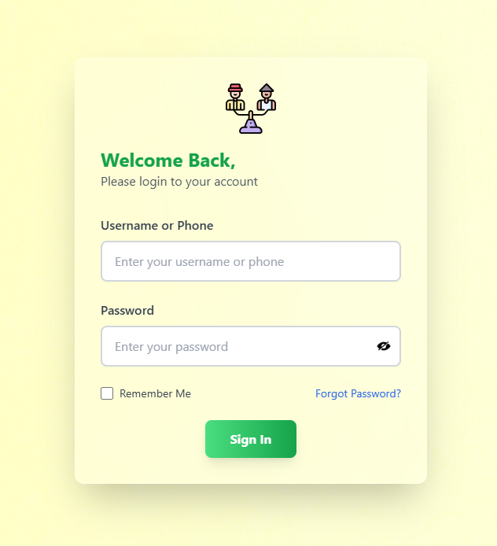
Figure Annex 1.1: Login Module

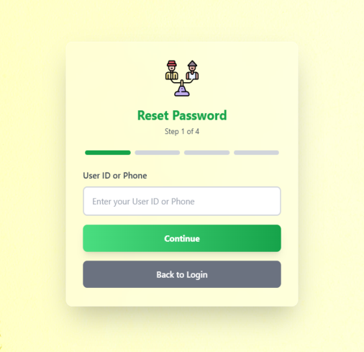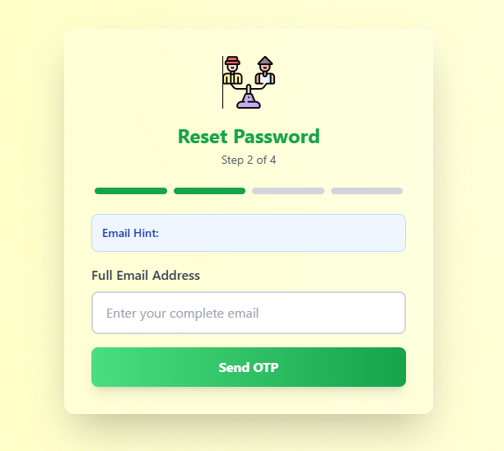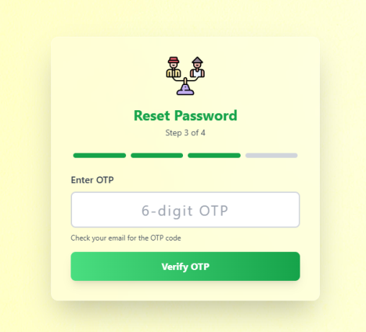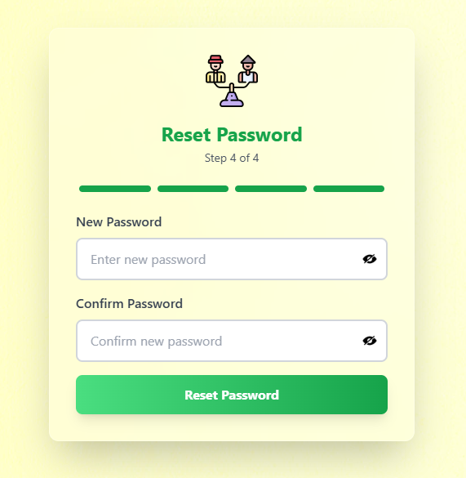

Figure Annex 1.2: Reset Password Module

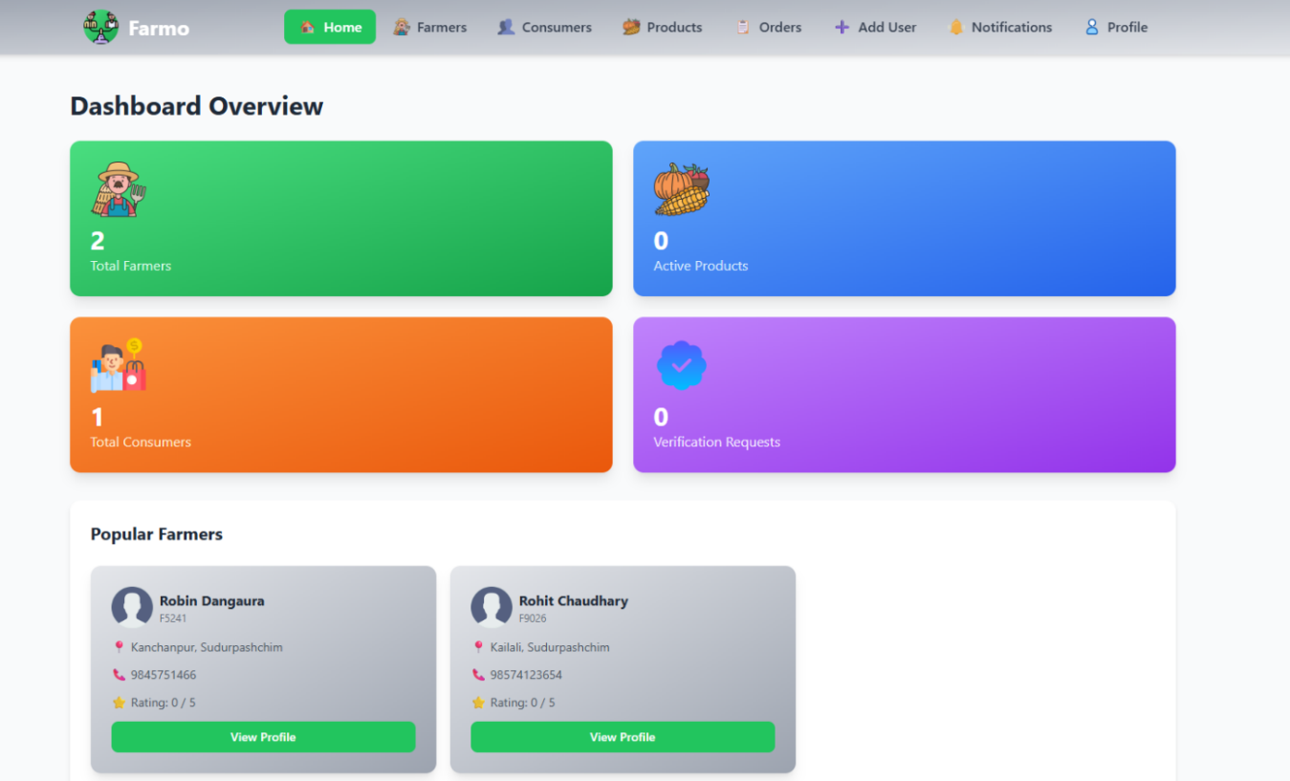
Figure Annex 1.3: Homepage

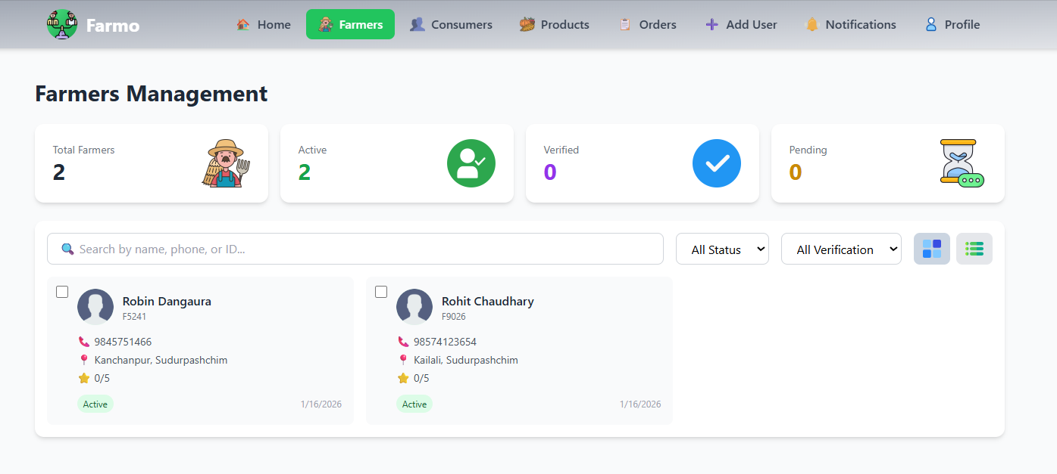
Figure Annex 1.4: Farmer Management Module

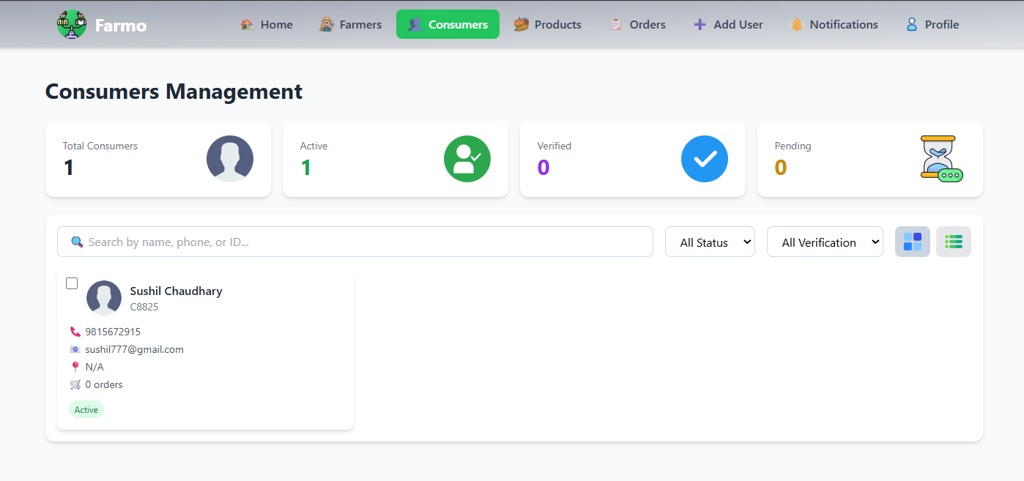
Figure Annex 1.5: Consumer Management Module

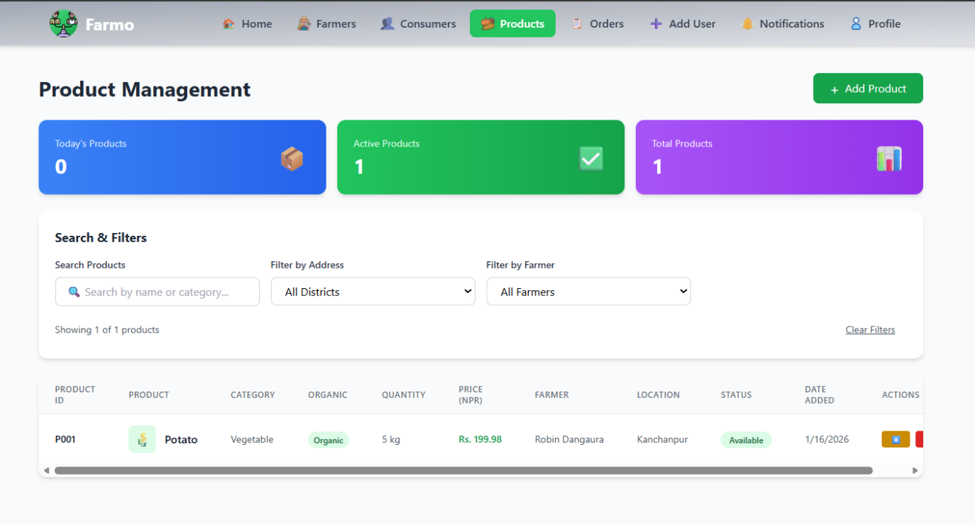
Figure Annex 1.6: Product Management Module

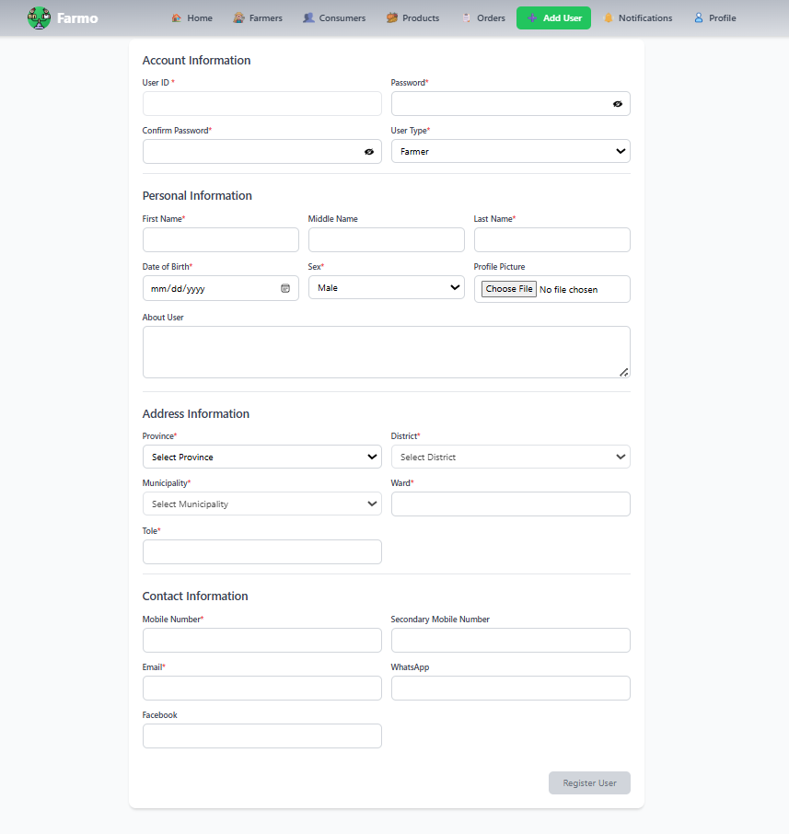
Figure Annex 1.7: Add User Module

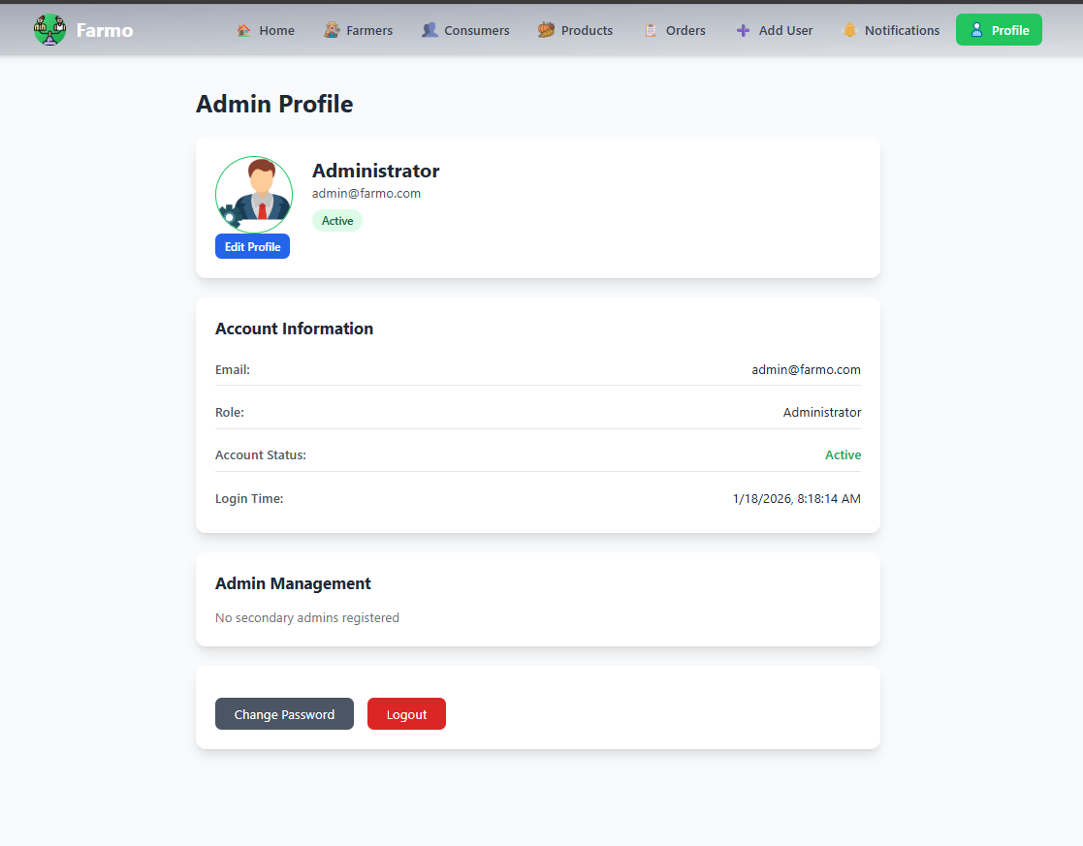
Figure Annex 1.8: Admin Profile Module

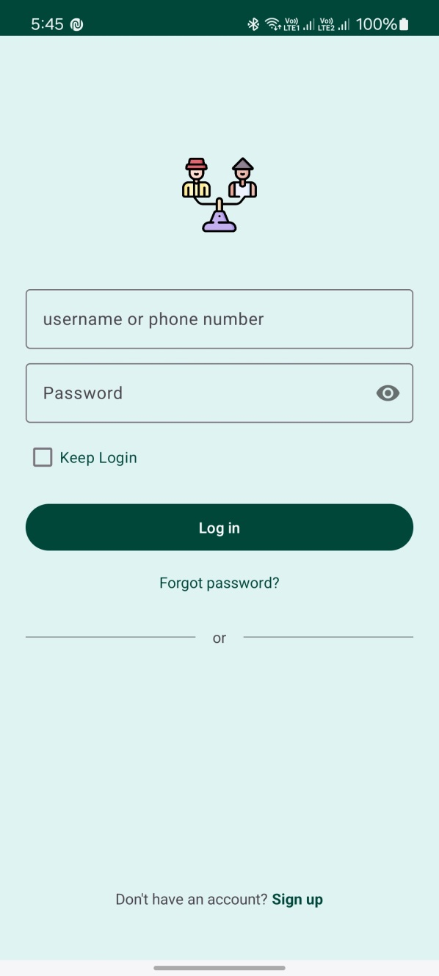
Figure Annex 1.9: Login Module (Mobile Application)
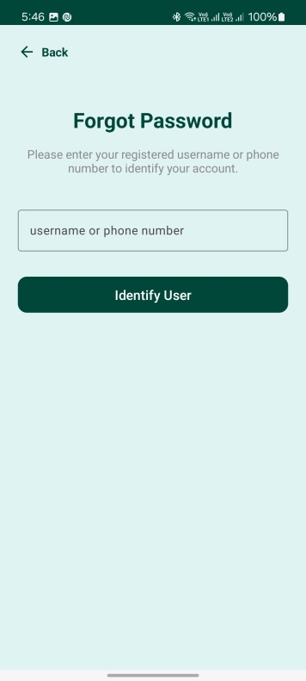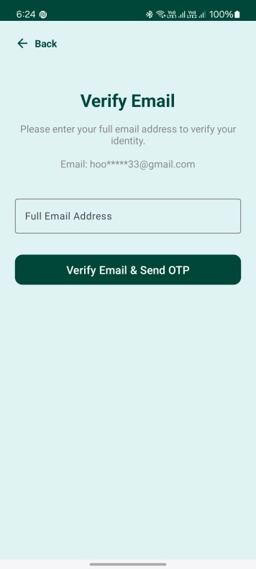
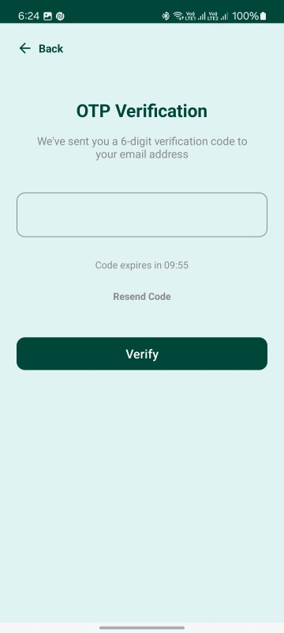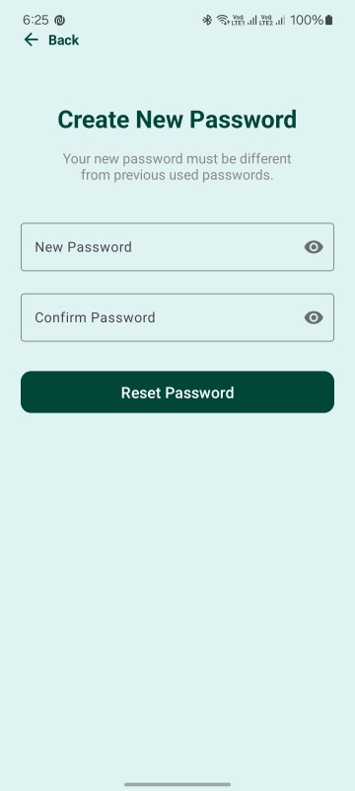
Figure Annex 1.10: Forget Password Module (Mobile Application)

ANNEX II
Python Source Code
models.py
from django.db import models
from django.utils import timezone
from django.contrib.auth.hashers import make_password, check_password
from django.db.models.signals import post_save
from django.dispatch import receiver
import secrets
import random, string
from django.core.validators import MinValueValidator, MaxValueValidator

class UsersProfile(models.Model):
"""User profile storing detailed user information"""
profile_id = models.CharField(primary_key=True)
profile_url = models.CharField(max_length=255, blank=True, null=True)
f_name = models.CharField(max_length=50)
m_name = models.CharField(max_length=50, blank=True, null=True)
l_name = models.CharField(max_length=50)
user_type = models.CharField(max_length=50, default='Consumer')
province = models.CharField(max_length=50, blank=True, null=True)
district = models.CharField(max_length=50, blank=True, null=True)
municipal = models.CharField(max_length=50, blank=True, null=True)
ward = models.CharField(max_length=50, blank=True, null=True)
tole = models.CharField(max_length=100, blank=True, null=True)
dob = models.DateField(blank=True, null=True)
sex = models.CharField(max_length=20, blank=True, null=True)
phone02 = models.CharField(max_length=15, blank=True, null=True)
email = models.CharField(max_length=100, blank=True, null=True)
facebook = models.CharField(max_length=255, blank=True, null=True)
whatsapp = models.CharField(max_length=15, blank=True, null=True)
join_date = models.DateTimeField(default=timezone.now)
about = models.CharField(max_length=50, blank=True, null=True)

@property
def get_Address(self):
province = self.province
district = self.district
municipal = self.municipal
ward = self.ward
tole = self.tole
return f"{municipal}-{ward} {tole}, {district}, {province}"

@property
def get_Full_Name(self):
middle_name = self.m_name
if middle_name != None:
full_name = f"{self.f_name} {middle_name} {self.l_name}"
else:
full_name = f"{self.f_name} {self.l_name}"
return full_name

@classmethod
def create_profile(cls, profile_url,f_name, m_name, l_name, user_type, province, district, municipal, ward, tole, dob, sex, phone02, email, facebook, whatsapp, about):
print(1)
profile_id = f_name[0].upper() + l_name[0].upper() +'-' +''.join(random.choices(string.digits, k=8))
print(id)
print(2)
return cls.objects.create(
profile_id=profile_id,
profile_url=profile_url,
f_name=f_name,
m_name=m_name,
l_name=l_name,
user_type=user_type,
province=province,
district=district,
municipal=municipal,
ward=ward,
tole=tole,
dob=dob,
sex=sex,
phone02=phone02,
email=email,
facebook=facebook,
whatsapp=whatsapp,
about=about,
join_date=timezone.now()
)

def __str__(self):
return f"{self.f_name} {self.l_name}"

class Meta:
constraints = [
models.CheckConstraint(
condition=models.Q(user_type__in=['Consumer', 'Farmer', 'VerifiedConsumer', 'VerifiedFarmer', 'Admin', 'SuperAdmin']),
name='valid_user_type'
)
]

class Users(models.Model):
"""User model storing basic user information"""
user_id = models.CharField(max_length=20, primary_key=True)
phone = models.CharField(max_length=15, blank=True)
password = models.CharField(max_length=128)

profile_status = models.CharField(max_length=20, default='ACTIVATED')
is_admin = models.BooleanField(default=False)
profile_id = models.ForeignKey(UsersProfile, on_delete=models.CASCADE)

def set_password(self, raw_password):
"""Hash and store password securely"""
self.password = make_password(raw_password)

def check_password(self, raw_password):
"""Verify password against stored hash"""
return check_password(raw_password, self.password)

def check_pass(self, raw_pass):
if self.password == raw_pass:
return True

def update_password(self, new_password):
"""Update to a new password"""
self.password = make_password(new_password)
self.save(update_fields=['password'])

def activate_user(self):
"""Activate the user"""
self.profile_status = 'ACTIVATED'
self.save(update_fields=['profile_status'])

def get_full_name_from_userModel(self):
return self.profile_id.get_Full_Name

def get_email_from_userModel(self):
return self.profile_id.email

def get_phone_from_userModel(self):
return self.phone

def get_usertype_from_userModel(self):
return self.profile_id.user_type

def __str__(self):
return f"User {self.user_id}"

class Meta:
constraints = [
models.CheckConstraint(
condition=models.Q(profile_status__in=['PENDING', 'ACTIVATED', 'SUSPENDED', 'DEACTIVATE']),
name='valid_profile_status'
)
]

class Wallet(models.Model):
"""Wallet model for user balance and PIN management"""
wallet_id = models.CharField(max_length=50, primary_key=True)
user_id = models.ForeignKey(Users, on_delete=models.PROTECT)
amount = models.DecimalField(max_digits=10, decimal_places=2, default=0.00)
pin = models.CharField(max_length=128)
created_date = models.DateTimeField(default=timezone.now)
is_active = models.BooleanField(default=False)

def set_pin(self, raw_pin):
"""Hash the 4-digit PIN before saving"""
if len(raw_pin) != 4 or not raw_pin.isdigit():
raise ValueError("PIN must be exactly 4 digits.")
self.pin = make_password(raw_pin)

def check_pin(self, raw_pin):
"""Verify entered PIN against stored hash"""
return check_password(raw_pin, self.pin)

def update_pin(self, new_pin):
"""Update the PIN"""
if len(new_pin) != 4 or not new_pin.isdigit():
raise ValueError("PIN must be exactly 4 digits.")
self.pin = make_password(new_pin)
self.save(update_fields=['pin'])

def __str__(self):
return f"Wallet {self.wallet_id}: {self.amount}"

class Meta:
unique_together = ('wallet_id', 'user_id')

class Product(models.Model):
"""Product model for farmer's agricultural products"""
p_id = models.AutoField( primary_key=True)
user_id = models.ForeignKey(Users, on_delete=models.PROTECT)
name = models.CharField(max_length=255)
category = models.CharField(max_length=100)
is_organic = models.BooleanField(default=False)
quantity_available = models.IntegerField()
cost_per_unit = models.DecimalField(max_digits=10, decimal_places=2)
produced_date = models.DateField()
registered_at = models.DateTimeField(default=timezone.now)
expiry_Date = models.DateField(null=True, blank=True)
description = models.TextField(blank=True, null=True)
delivery_option = models.CharField(max_length=100, default='Not-Available')
product_status = models.CharField(max_length=100, default='Available')

@classmethod
def create_product(cls, user_id, name, category, is_organic, quantity_available, cost_per_unit, produced_date, expiry_Date, description, delivery_option):
"""Create a new product"""
obj = cls.objects.create(
user_id=user_id,
name=name,
category=category,
is_organic=is_organic,
quantity_available=quantity_available,
cost_per_unit=cost_per_unit,
registered_at=timezone.now(),
produced_date=produced_date,
expiry_Date=expiry_Date,
description=description,
delivery_option =delivery_option,
product_status='AVAILABLE'
)
return obj.p_id

def __str__(self):
return f"{self.name} ({self.p_id})"

class Meta:
constraints = [
models.CheckConstraint(
condition=models.Q(delivery_option__in=['Not-Available', 'Available']) & models.Q(product_status__in=['Available', 'Sold', 'Expired']),
name='valid_product_status_delivery_option'
)
]

class ProductMedia(models.Model):
"""ProductMedia model for product images and videos"""
media_id = models.AutoField(primary_key=True)
p_id = models.ForeignKey(Product, on_delete=models.PROTECT, null=True, blank=True)
media_url = models.CharField(max_length=255)
media_type = models.CharField(max_length=10, blank=True, null=True)

@classmethod
def create_media(cls,P_id, media_url, media_type):
"""Create a new media entry"""

obj = cls.objects.create(
p_id=P_id,
media_url=media_url,
media_type=media_type
)
return obj.media_id

@property
def get_media_url(self):
return self.media_url

def __str__(self):
return f"Media {self.media_id}"

class Meta:
constraints = [
models.CheckConstraint(
condition=models.Q(media_type__in=['image', 'video']),
name='valid_media_type'
)
]

class ProductRating(models.Model):
"""ProductRating model for product reviews and ratings"""
ProductRating_id = models.AutoField( primary_key=True)
p_id = models.ForeignKey(Product, on_delete=models.PROTECT)
consumer_id = models.ForeignKey(Users, on_delete=models.PROTECT)
score = models.IntegerField(validators=[MinValueValidator(1),MaxValueValidator(10)])
comment = models.TextField()
date = models.DateTimeField(default=timezone.now)

def __str__(self):
return f"ProductRating {self.ProductRating_id}: {self.score}"

class Rating(models.Model):
"""Rating model for farmer reviews by consumers"""
rated_to = models.ForeignKey(Users, on_delete=models.PROTECT, related_name='rated_to')
rated_by = models.ForeignKey(Users, on_delete=models.PROTECT, related_name='rated_by')
score = models.IntegerField(validators=[
MinValueValidator(1),
MaxValueValidator(10)
])
comment = models.TextField()
rated_for = models.CharField(max_length=50, default='Consumer') #
rated_update = models.DateTimeField(default=timezone.now)

def __str__(self):
return f"Rating {self.Rate_id}: {self.score}"

class Meta:
constraints = [
models.CheckConstraint(
condition=models.Q(rated_for__in=['Farmer', 'Consumer']),
name='valid_rated_for'
)
]

class Verification(models.Model):
"""Verification model for user identity verification"""
V_id = models.AutoField( primary_key=True)
user_id = models.ForeignKey(Users, on_delete=models.PROTECT, db_index=True)
status = models.CharField(max_length=20, default='PENDING')
id_Type = models.CharField(max_length=50, blank=True, null=True)
id_Number = models.CharField(max_length=50, blank=True, null=True)
id_front = models.CharField(max_length=50, blank=True, null=True)
id_back = models.CharField(max_length=50, blank=True, null=True)
Selfie_with_id = models.CharField(max_length=50, blank=True, null=True)
submission_date = models.DateTimeField(default=timezone.now)
approved_date = models.DateTimeField(blank=True, null=True)
approved_by = models.CharField(max_length=50, blank=True, null=True)

def __str__(self):
return f"Verification {self.V_id}: {self.status}"

class Meta:
constraints = [
models.CheckConstraint(
condition=models.Q(status__in=['PENDING', 'VERIFIED', 'REJECTED', 'UNVERIFIED']),
name='valid_status'
)
]

class OrderRequest(models.Model):
"""OrderRequest model for customer orders"""
order_id = models.CharField(max_length=50, primary_key=True)
consumer_id = models.ForeignKey(Users, on_delete=models.PROTECT)
ordered_date = models.DateTimeField(default=timezone.now)
total_cost = models.DecimalField(max_digits=10, decimal_places=2, blank=True, null=True)
order_status = models.CharField(max_length=20, default='PENDING') # Accepted, Rejected
shipping_address = models.TextField(blank=True, null=True)
expected_delivery_date = models.DateField(blank=True, null=True)
ORDER_OTP = models.CharField(max_length=6, blank=True, null=True)

@property
def get_pid_from_orderid(self):
return OrdProdLink.objects.filter(order_id=self.order_id).values_list('p_id')

@classmethod
def create_order(cls, consumer_id, total_cost, shipping_address, expected_delivery_date):
obj = cls.objects.create(
consumer_id=consumer_id,
ordered_date=timezone.now(),
total_cost=total_cost,
order_status='PENDING',
shipping_address=shipping_address,
expected_delivery_date=expected_delivery_date,
ORDER_OTP=secrets.token_hex(6).upper()
)
return obj.order_id

def __str__(self):
return f"Order {self.order_id}: {self.order_status}"

class Meta:
constraints = [
models.CheckConstraint(
condition=models.Q(order_status__in=['PENDING', 'ACCEPTED', 'REJECTED']), name='valid_order_status')]

class OrdProdLink(models.Model):
"""OrdProdLink model linking orders to products with quantities"""
order_id = models.ForeignKey(OrderRequest, on_delete=models.PROTECT, db_index=True)
p_id = models.ForeignKey(Product, on_delete=models.PROTECT,db_index=True)
quantity = models.IntegerField()
cost_per_unit = models.DecimalField(max_digits=10, decimal_places=2, blank=True, null=True)

@classmethod
def create_OrderProdLink(cls, order_id, p_id, quantity, cost_per_unit):
cls.objects.create(
order_id=order_id,
p_id=p_id,
quantity=quantity,
cost_per_unit=cost_per_unit
)
return True if cls.objects.filter(order_id=order_id, p_id=p_id).exists() else False

def __str__(self):
return f"{self.quantity} x Product {self.P_id} in order {self.order_id}"

class Meta:
unique_together = ('order_id', 'p_id')

class Transaction(models.Model):
transaction_id = models.CharField(primary_key=True, editable=False)
order = models.ForeignKey(OrderRequest, on_delete=models.PROTECT, db_index=True)
transaction_to = models.ForeignKey(Wallet, on_delete=models.PROTECT, db_index=True, default=None)
payment_method = models.CharField(max_length=50)
amount = models.DecimalField(max_digits=10, decimal_places=2)
currency = models.CharField(max_length=10, default='NRP')
status = models.CharField(max_length=20, default='PENDING')
failure_reason = models.TextField(blank=True, null=True)
status_history = models.JSONField(blank=True, null=True)
transaction_date = models.DateTimeField(default=timezone.now, db_index=True)
created_at = models.DateTimeField(default=timezone.now)
updated_at = models.DateTimeField(null=True, blank=True)
initiated_by = models.ForeignKey(Users, on_delete=models.PROTECT)

def __str__(self):
return f'Transaction {self.transaction_id}: {self.status}'

class Meta:
constraints = [
models.CheckConstraint(
condition=models.Q(status__in=['PENDING', 'SUCCESSFUL', 'FAILED', 'REFUNDED']), name='valid_status_transaction'),
models.CheckConstraint(
condition=models.Q(payment_method__in=['WALLET', 'COD', 'KHALTI', 'ESewa']), name='valid_payment_method'),
models.CheckConstraint(
condition=models.Q(initiated_by__in=['CUSTOMER', 'ADMIN']),
name='valid_initiated_by'
) ]

class Tokens(models.Model):
"""Tokens model for JWT token management"""
user_id = models.ForeignKey(Users, on_delete=models.PROTECT, db_index=True)
token = models.TextField(db_index=True)
device_info = models.CharField(max_length=255, blank=True, null=True)
issued_at = models.DateTimeField(default=timezone.now)
expires_at = models.DateTimeField()
refresh_token = models.TextField(blank=True, null=True)
token_status = models.CharField(max_length=20, default='ACTIVE')

@classmethod
def create_token(cls, user, days=40):
"""Generate a random token and set expiry days ahead"""

token = secrets.token_urlsafe(32)
refresh_token = secrets.token_urlsafe(32)
return cls.objects.create(
user_id=user,
token=token,
refresh_token=refresh_token,
issued_at=timezone.now(),
expires_at=timezone.now() + timezone.timedelta(days=days),
token_status='ACTIVE'
)

def suspend(self):
"""Suspend this token"""
self.token_status = 'SUSPENDED'
self.save(update_fields=['token_status'])

def deactivate(self):
"""Deactivate this token"""
self.token_status = 'INACTIVE'
self.save(update_fields=['token_status'])

def activate(self):
"""Reactivate this token"""
self.token_status = 'ACTIVE'
self.save(update_fields=['token_status'])

@classmethod
def deactivate_all_user_tokens(cls, user):
"""Deactivate all tokens for a user (logout all devices)"""
cls.objects.filter(user_id=user, token_status='ACTIVE').update(token_status='INACTIVE')

def is_expired(self):
"""Check if the token has expired"""
if timezone.now() > self.expires_at:
self.deactivate()
return True
else:
return False

def is_active(self):
"""Check if the token is still active"""
return self.token_status == 'ACTIVE' and not self.is_expired()

def __str__(self):
return f"Token for {self.user_id}"

class Meta:
constraints = [
models.CheckConstraint(
condition=models.Q(token_status__in=['ACTIVE', 'INACTIVE', 'SUSPENDED']),
name='valid_token_status'
)
]

class UserActivity(models.Model):
"""Track main user activities """
activity_id = models.CharField(max_length=50, primary_key=True)
user_id = models.ForeignKey(Users, on_delete=models.CASCADE)
activity_type = models.CharField(max_length=50, blank=True, null=True) # e.g. LOGIN, LOGOUT, PRODUCT_UPLOAD, ORDER_PLACED
description = models.TextField(blank=True, null=True) # optional details
timestamp = models.DateTimeField(default=timezone.now)

@classmethod
def create_activity(cls, user, activity, discription):
"""Create a new activity record"""
cls.objects.create(
activity_id=secrets.token_urlsafe(32),
user_id=user,
activity_type=activity,
description=discription,
timestamp=timezone.now()
)

def __str__(self):
return f"{self.user_id} - {self.activity_type} at {self.timestamp}"

class Connections(models.Model):
"""Track user-to-user connections (mutual or pending)"""
connection_id = models.AutoField(primary_key=True)
user = models.ForeignKey(Users, on_delete=models.CASCADE, related_name="connections")
target_user = models.ForeignKey(Users, on_delete=models.CASCADE, related_name="connected_to")
status = models.CharField(max_length=20, default="PENDING")
created_at = models.DateTimeField(default=timezone.now)

def __str__(self):
#return f"{self.user.user_id} -> {self.target_user.user_id} ({self.status})"
return f"{self.user} -> {self.target_user} ({self.status})"

class Meta:
constraints = [
models.CheckConstraint(
condition=models.Q(status__in=['PENDING', 'ACCEPTED', 'BLOCKED']),
name='valid_status_connection'
),
models.UniqueConstraint(
fields=['user', 'target_user'],
name='unique_user_connection'
)
]

class PaymentMethodAccepts(models.Model):
"""Track accepted payment methods for each user"""
pm_id = models.AutoField(primary_key=True)
user_id = models.ForeignKey(Users, on_delete=models.CASCADE)
payment_method = models.JSONField(max_length=50, default=list, blank=True) # e.g. WALLET, COD, KHALTI

@property
def get_payment_methods(self):
"""Get the list of accepted payment methods for this user"""
return self.payment_method

def __str__(self):
return f"{self.user_id} - {self.payment_method}"

class OTP(models.Model):
"""Track OTPs for user authentication"""
user_id = models.ForeignKey(Users, on_delete=models.CASCADE)
otp = models.CharField(max_length=6)
otp_type = models.CharField(max_length=20, default='LOGIN')
otp_status = models.CharField(max_length=20, default='ACTIVE')
created_at = models.DateTimeField(default=timezone.now)
expires_at = models.DateTimeField()

def __str__(self):
return f"{self.user_id} - {self.otp_type} ({self.otp_status})"

@property
def get_OTP(self):
return self.otp

def is_expired(self):
"""Check if the OTP has expired"""
return timezone.now() > self.expires_at

def effective_status_OTP(self):
"""Check if the OTP is still active"""
if self.otp_status == 'ACTIVE' and not self.is_expired():
return 'ACTIVE'
elif self.is_expired and self.otp_status == 'ACTIVE':
self.otp_status = 'EXPIRED'
self.save(update_fields=['otp_status'])
return 'EXPIRED'
elif self.otp_status == 'USED':
return 'USED'
elif self.otp_status == 'EXPIRED':
return 'EXPIRED'

@classmethod
def create_otp(cls, user, otp, otp_type, created_at,expires_in=2):
"""Create a new OTP"""
return cls.objects.create(
user_id=user,
otp=otp,
otp_type=otp_type,
otp_status='ACTIVE',
created_at=created_at,
expires_at=timezone.now() + timezone.timedelta(minutes=expires_in)
)

class Meta:
constraints = [
models.CheckConstraint(
condition=models.Q(otp_status__in=['ACTIVE', 'USED', 'EXPIRED']),
name='valid_otp_status'
)
]

class TrackUser(models.Model):
user_id = models.ForeignKey(Users, on_delete=models.CASCADE)
product_catagory = models.CharField(max_length=50, blank=True, null=True)
score = models.BigIntegerField(blank=True, null=True)

class Meta:
indexes = [
models.Index(fields=["user_id", "product_catagory"])
]

def __str__(self):
return f"{self.user_id} - {self.product_catagory}"

settings.py
"""
Django settings for Farmo project.
Generated by 'django-admin startproject' using Django 5.2.9.
For more information on this file, see
https://docs.djangoproject.com/en/5.2/topics/settings/
For the full list of settings and their values, see
https://docs.djangoproject.com/en/5.2/ref/settings/
"""

import os
from dotenv import load_dotenv
from pathlib import Path

# Build paths inside the project like this: BASE_DIR / 'subdir'.
BASE_DIR = Path(__file__).resolve().parent.parent

# Load environment variables
load_dotenv()

# Quick-start development settings - unsuitable for production
# See https://docs.djangoproject.com/en/5.2/howto/deployment/checklist/

# SECURITY WARNING: keep the secret key used in production secret!
SECRET_KEY =
'django-insecure-&q2a_0a=ocu8+0r68eyqpoyjd@_dmhi_=y0aqqr0i#9-vj^=i2'

# SECURITY WARNING: don't run with debug turned on in production!
DEBUG = True

ALLOWED_HOSTS = ['*']

# Application definition
MIDDLEWARE = [
'corsheaders.middleware.CorsMiddleware',
'django.middleware.security.SecurityMiddleware',
'django.contrib.sessions.middleware.SessionMiddleware',
'django.middleware.common.CommonMiddleware',
'django.middleware.csrf.CsrfViewMiddleware',
'django.contrib.auth.middleware.AuthenticationMiddleware',
'django.contrib.messages.middleware.MessageMiddleware',
'django.middleware.clickjacking.XFrameOptionsMiddleware',
]

INSTALLED_APPS = [
'django.contrib.contenttypes',
'django.contrib.auth',
'django.contrib.sessions',
'django.contrib.messages',
'django.contrib.staticfiles',
'rest_framework',
'rest_framework_simplejwt',
'corsheaders',
'backend',
]

ROOT_URLCONF = 'Farmo.urls'

TEMPLATES = [
{
'BACKEND': 'django.template.backends.django.DjangoTemplates',
'DIRS': [],
'APP_DIRS': True,
'OPTIONS': {
'context_processors': [
'django.template.context_processors.request',
'django.contrib.auth.context_processors.auth',
'django.contrib.messages.context_processors.messages',
],
},
},
]

WSGI_APPLICATION = 'Farmo.wsgi.application'

# Database
# https://docs.djangoproject.com/en/5.2/ref/settings/#databases

DATABASES = {
'default': {
'ENGINE': 'django.db.backends.postgresql',
'NAME': os.getenv('DB_NAME'),
'USER': 'postgres',
'PASSWORD': os.getenv('DB_PASSWORD'),
'HOST': 'localhost',
'PORT': '5432',
}
}

# Password validation
# https://docs.djangoproject.com/en/5.2/ref/settings/#auth-password-validators

AUTH_PASSWORD_VALIDATORS = [
{
'NAME': 'django.contrib.auth.password_validation.UserAttributeSimilarityValidator',
},
{
'NAME': 'django.contrib.auth.password_validation.MinimumLengthValidator',
},
{
'NAME': 'django.contrib.auth.password_validation.CommonPasswordValidator',
},
{
'NAME': 'django.contrib.auth.password_validation.NumericPasswordValidator',
},
]

# Internationalization
# https://docs.djangoproject.com/en/5.2/topics/i18n/

LANGUAGE_CODE = 'en-us'

TIME_ZONE = 'UTC'

USE_I18N = True

USE_TZ = True

# Static files (CSS, JavaScript, Images)
# https://docs.djangoproject.com/en/5.2/howto/static-files/

STATIC_URL = 'static/'

# Media files (User uploaded files)
MEDIA_URL = '/media/'
MEDIA_ROOT = BASE_DIR / 'media'

# Default primary key field type
# https://docs.djangoproject.com/en/5.2/ref/settings/#default-auto-field

DEFAULT_AUTO_FIELD = 'django.db.models.BigAutoField'

# Custom User Model
#AUTH_USER_MODEL = 'backend.Users'

REST_FRAMEWORK = {
'DEFAULT_AUTHENTICATION_CLASSES': [],

'DEFAULT_PERMISSION_CLASSES': [
'rest_framework.permissions.AllowAny',
'backend.permissions.HasValidTokenForUser',
'backend.permissions.ConnectionOnly',
'backend.permissions.IsAdmin',
'backend.permissions.IsSuperAdmin',
'backend.permissions.IsFarmer',
'backend.permissions.IsConsumer',
'backend.permissions.IsVerifiedFarmer',
'backend.permissions.IsVerifiedConsumer',
],
'DEFAULT_RENDERER_CLASSES': [
'rest_framework.renderers.JSONRenderer',
],
'DEFAULT_THROTTLE_CLASSES': [
'rest_framework.throttling.AnonRateThrottle',
'rest_framework.throttling.UserRateThrottle'
],
'DEFAULT_THROTTLE_RATES': {
'anon': '100/hour',
'user': '1000/hour'
},
}

# CORS Settings
CORS_ALLOW_ALL_ORIGINS = True
'''CORS_ALLOWED_ORIGINS = [
'http://localhost:3000',
'http://127.0.0.1:3000',
'http://localhost:8000',
'http://127.0.0.1:8000',
'http://192.168.0.115:8000',
'http://192.168.10.145:5173'
]'''
CORS_ALLOW_CREDENTIALS = True

CORS_ALLOW_HEADERS = [
'content-type',
'token',
'user-id',
'ngrok-skip-browser-warning',
]

# Production Security Settings
SECURE_BROWSER_XSS_FILTER = True
X_FRAME_OPTIONS = 'DENY'
SECURE_CONTENT_TYPE_NOSNIFF = True
CSRF_COOKIE_SECURE = not DEBUG
SESSION_COOKIE_SECURE = not DEBUG
CSRF_COOKIE_HTTPONLY = True
SESSION_COOKIE_HTTPONLY = True
SECURE_SSL_REDIRECT = not DEBUG
SECURE_HSTS_SECONDS = 31536000 if not DEBUG else 0
SECURE_HSTS_INCLUDE_SUBDOMAINS = not DEBUG
SECURE_HSTS_PRELOAD = not DEBUG

# Logging for Production
LOGGING = {
'version': 1,
'disable_existing_loggers': False,
'handlers': {
'file': {
'level': 'ERROR',
'class': 'logging.FileHandler',
'filename': BASE_DIR / 'logs/django_errors.log',
},
'security': {
'level': 'WARNING',
'class': 'logging.FileHandler',
'filename': BASE_DIR / 'logs/security.log',
},
},
'loggers': {
'django': {
'handlers': ['file'],
'level': 'ERROR',
'propagate': True,
},
'django.security': {
'handlers': ['security'],
'level': 'WARNING',
'propagate': False,
},
},
}

#email smtp
EMAIL_BACKEND = 'django.core.mail.backends.smtp.EmailBackend'
EMAIL_HOST = 'smtp.gmail.com'
EMAIL_PORT = 587
EMAIL_USE_TLS = True
EMAIL_HOST_USER = os.getenv('EMAIL_HOST_USER')
EMAIL_HOST_PASSWORD = os.getenv('EMAIL_HOST_PASSWORD')
#EMAIL_HOST_USER = 'srrr4286@gmail.com'
#EMAIL_HOST_PASSWORD = 'wvjtvocaploibirn' # Your Gmail App Password
"""

urls.py
"""
URL configuration for Farmo project.
"""

#from django.contrib import admin
from django.urls import path
from django.conf import settings
from django.conf.urls.static import static

from backend.service_frontend.authentication import (
login,
verify_wallet_pin,
login_with_token,
login_change_password,
logout,
logout_all_devices,
forgot_password,
forget_password_change_password,
forget_password_verify_email,
forget_password_verify_otp,
)

from backend.service_frontend.servicesActivity import (
get_online_status,
check_userid_available,
get_address)

from backend.service_frontend.userProfile import (
register,
verification_request,
update_profile_picture,
get_payment_method,
add_payment_method,
change_password)

from backend.service_frontend.servicesForUsers import (
other_user_profile,
search_user,
user_farmer_page,
user_consumer_page)

from backend.service_frontend.orders import (
order_request,
get_order_detail,
all_incomming_orders_for_farmer,
all_consumer_orders)

from backend.service_frontend.servicesRating import (
# Farmer Rating Views (Consumer rates Farmer)
RateFarmer,
EditFarmerRate,
ViewFarmerRate,
DeleteFarmerRate,
ListFarmerRatings,
ListRatingsByFarmer,
farmer_profile_rating,

# Consumer Rating Views (Farmer rates Consumer)
RateConsumer,
EditConsumerRate,
ViewConsumerRate,
DeleteConsumerRate,
ListConsumerRatings,
ListRatingsByConsumer,
consumer_profile_rating,

# Farmer as Consumer Rating Views (Farmer rates another Farmer)
RateFarmerAsConsumer,
EditFarmerAsConsumerRate,
DeleteFarmerAsConsumerRate,

# Product Rating Views
RateProduct,
EditProductRate,
ViewProductRate,
DeleteProductRate,
ListProductRatingsByProduct,
product_profile_rating,

# Top rated user
top_rated_farmers
)
from backend.service_frontend.serviceHome import (
dashboard_fullfillment,
dashboard_fullfillment_test
)

from backend.service_frontend.product import (
add_products
)

urlpatterns = [
#path('admin/', admin.site.urls),
# Authentication
path('api/auth/check-userid/', check_userid_available, name='check_userid_available'),
path('api/auth/login/', login, name='login'), # checked
path('api/auth/login-with-token/', login_with_token, name='login_with_token'), # checked
path('api/auth/login-change-password/', login_change_password, name='login_change_password'),
path('api/auth/logout/', logout, name='logout'),
path('api/auth/logout-all/', logout_all_devices, name='logout_all_devices'),
path('api/auth/register/', register, name='register'), # checked
path('api/auth/forgot-password/', forgot_password, name='forgot_password'), # checked
path('api/auth/forgot-password-verify-email/', forget_password_verify_email, name='forget_password_verify_email'), # checked
path('api/auth/forgot-password-verify-otp/', forget_password_verify_otp, name='forget_password_verify_otp'), # checked
path('api/auth/forgot-password-change-password/', forget_password_change_password, name='forget_password_change_password'), # checked

# User
path('api/user/update-profile-picture/', update_profile_picture, name='update_profile_picture'),
path('api/user/verification-request/', verification_request, name='verification_request'),
path('api/user/online-status/', get_online_status, name='get_online_status'),
path('api/user/wallet/verify-pin/', verify_wallet_pin, name='verify_wallet_pin'),
path('api/user/farmer/order-request/', order_request, name='order_request'),
path('api/user/farmer/all-incomming-orders/', all_incomming_orders_for_farmer, name='all_incomming_orders_for_farmer'),
path('api/user/consumer/all-orders/', all_consumer_orders, name='all_consumer_orders'),
path('api/user/farmer/order-detail/', get_order_detail, name='get_order_detail'),
# Address and others
path('api/user/profile/', other_user_profile, name='other_user_profile'),
path('api/user/search/', search_user, name='search_user'),
path("api/user/farmer/", user_farmer_page, name="user_farmer_page"),
path('api/user/consumer/', user_consumer_page, name='user_consumer_page'),
path('api/user/address/', get_address, name='get_address'),
path('api/user/payment-method/', add_payment_method, name='add_payment_method'),
path('api/user/get-payment-method/', get_payment_method, name='get_payment_method'),
# Rating
path('api/rating/farmer/create/', RateFarmer.as_view(), name='rate_farmer'),
path('api/rating/farmer/edit/<int:pk>/', EditFarmerRate.as_view(), name='edit_farmer_rate'),
path('api/rating/farmer/view/<int:pk>/', ViewFarmerRate.as_view(), name='view_farmer_rate'),
path('api/rating/farmer/delete/<int:pk>/', DeleteFarmerRate.as_view(), name='delete_farmer_rate'),
path('api/rating/farmer/list/', ListFarmerRatings.as_view(), name='list_farmer_ratings'),
path('api/rating/farmer/list/<int:farmer_id>/', ListRatingsByFarmer.as_view(), name='list_ratings_by_farmer'),
path('api/rating/farmer/profile/', farmer_profile_rating, name='farmer_profile_rating'),
path('api/rating/consumer/create/', RateConsumer.as_view(), name='rate_consumer'),
path('api/rating/consumer/edit/<int:pk>/', EditConsumerRate.as_view(), name='edit_consumer_rate'),
path('api/rating/consumer/view/<int:pk>/', ViewConsumerRate.as_view(), name='view_consumer_rate'),
path('api/rating/consumer/delete/<int:pk>/', DeleteConsumerRate.as_view(), name='delete_consumer_rate'),
path('api/rating/consumer/list/', ListConsumerRatings.as_view(), name='list_consumer_ratings'),
path('api/rating/consumer/list/<int:consumer_id>/', ListRatingsByConsumer.as_view(), name='list_ratings_by_consumer'),
path('api/rating/consumer/profile/', consumer_profile_rating, name='consumer_profile_rating'),
path('api/rating/farmer-as-consumer/create/', RateFarmerAsConsumer.as_view(), name='rate_farmer_as_consumer'),
path('api/rating/farmer-as-consumer/edit/<int:pk>/', EditFarmerAsConsumerRate.as_view(), name='edit_farmer_as_consumer_rate'),
path('api/rating/farmer-as-consumer/delete/<int:pk>/', DeleteFarmerAsConsumerRate.as_view(), name='delete_farmer_as_consumer_rate'),
path('api/rating/product/create/', RateProduct.as_view(), name='rate_product'),
path('api/rating/product/edit/<int:pk>/', EditProductRate.as_view(), name='edit_product_rate'),
path('api/rating/product/view/<int:pk>/', ViewProductRate.as_view(), name='view_product_rate'),
path('api/rating/product/delete/<int:pk>/', DeleteProductRate.as_view(), name='delete_product_rate'),
path('api/rating/product/list/<int:product_id>/', ListProductRatingsByProduct.as_view(), name='list_product_ratings_by_product'),
path('api/rating/product/profile/', product_profile_rating, name='product_profile_rating'),
path('api/rating/top-rated-farmers/', top_rated_farmers, name='top_rated_farmers'),
# Home
path('api/home/dashboard/', dashboard_fullfillment, name='dashboard_fullfillment'),
path('api/home/dashboard-test/', dashboard_fullfillment_test, name='dashboard_fullfillment_robin'),
# Profile

path('api/profile/change-password/', change_password, name='change_password'), #checked

# Product
path('api/product/add/', add_products, name='add_products'),
]

# Serve media files during development
if settings.DEBUG:
urlpatterns += static(settings.MEDIA_URL, document_root=settings.MEDIA_ROOT)

