BLG 252E Assignment 2 Report

Ramazan Taş

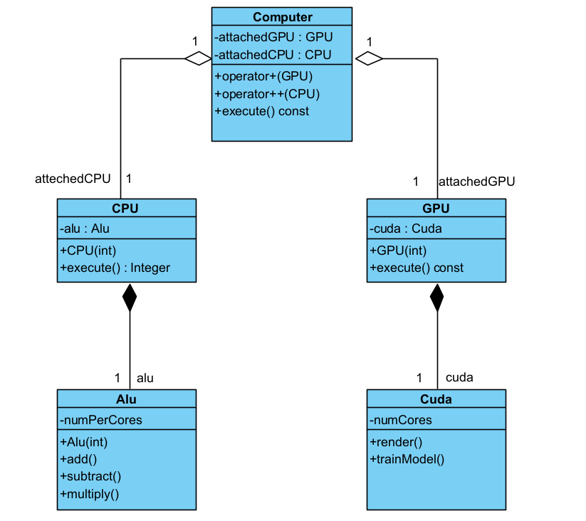

*The Computer class has aggregation relationships with the CPU and GPU classes.
*The CPU class has a composition relationship with the ALU class.
*The GPU class has a composition relationship with the CUDA class.

