TRACK B · CONTRACT REDLINING

Reading a vendor's contract against your own rules
An agent that reads a counterparty contract clause by clause, checks it against the Zycus playbook, drafts replacement language for what fails, and says plainly which findings it cannot stand behind.
FastAPI + React · six-step pipeline · three deterministic tools and three model steps · 132 tests · about six seconds per review · PDF and Word upload · Postgres audit trail

1. The problem
Northwind's draft breaches the playbook in seven places across six clauses. A reviewer has to find every one, decide which are worth escalating, and write the replacement wording. Missing one is not a smaller version of the job done well: the clause ships.
Playbook rule | Threshold | Checked by
Liability cap | at least 12 months of fees | arithmetic
Termination for convenience notice | at least 30 days | arithmetic
Auto-renewal notice | at least 30 days, no penalty | arithmetic
Payment terms | Net 30 or longer | arithmetic
Data ownership | stays with Zycus | reading
Indemnification | mutual, not one-sided | reading
Governing law | neutral jurisdiction | reading

Four rules turn on a number, so they can be settled by arithmetic. Three turn on what the words mean, and only those need a model. The system is built around that split.

2. Architecture
One endpoint runs a fixed pipeline of six steps. Each step is a single module, so the diagram and the directory listing are the same thing. Steps 4 and 5 fan out concurrently, which is what keeps a full review at roughly six seconds rather than a minute.
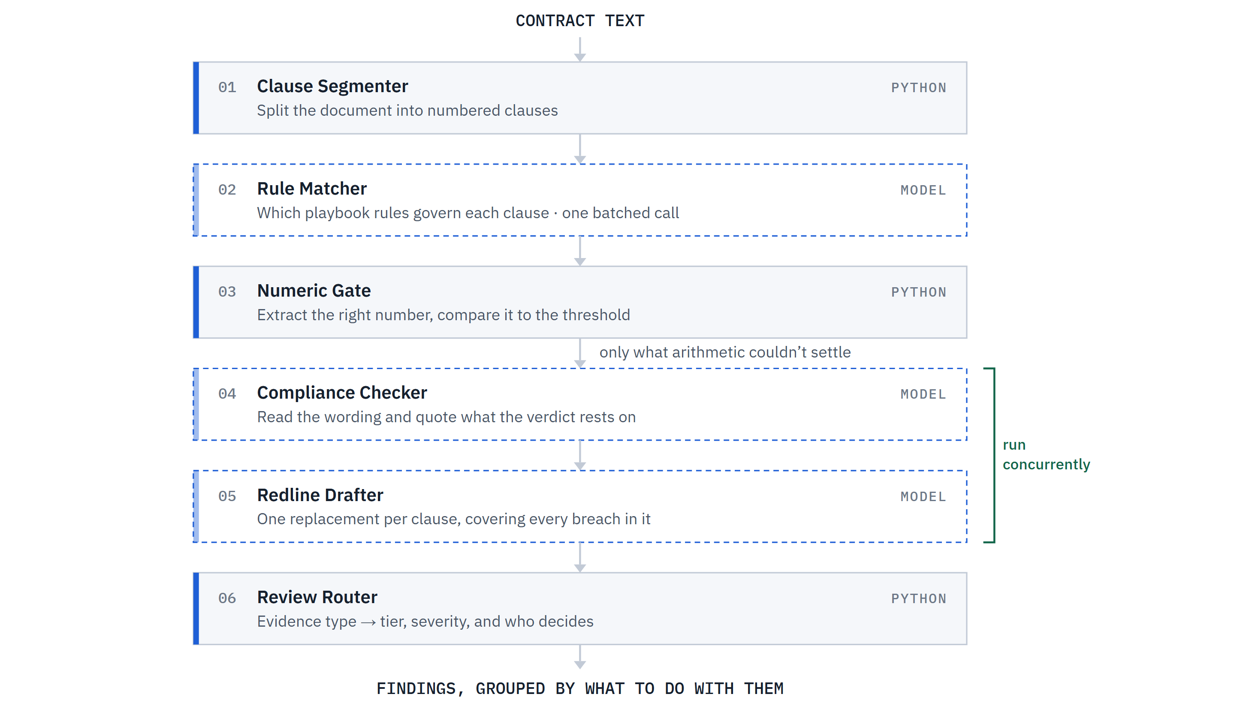
Solid boxes are deterministic Python; dashed boxes are model calls returning structured JSON.
Two decisions are worth calling out. The numeric gate runs before the model rather than as a tool the model chooses to call, so when it produces a verdict that verdict is arithmetic and involves no model judgment at all. And rule matching is model-based rather than a keyword table, because a keyword map would work on the shipped sample and silently match nothing the moment someone pastes a different contract.

3. The product
Findings are grouped by what the reviewer should do with them, not by clause order, so items the agent declined to act on appear first. Each card carries the arithmetic or the quoted wording the verdict rests on, which means a finding can be checked without opening the contract.
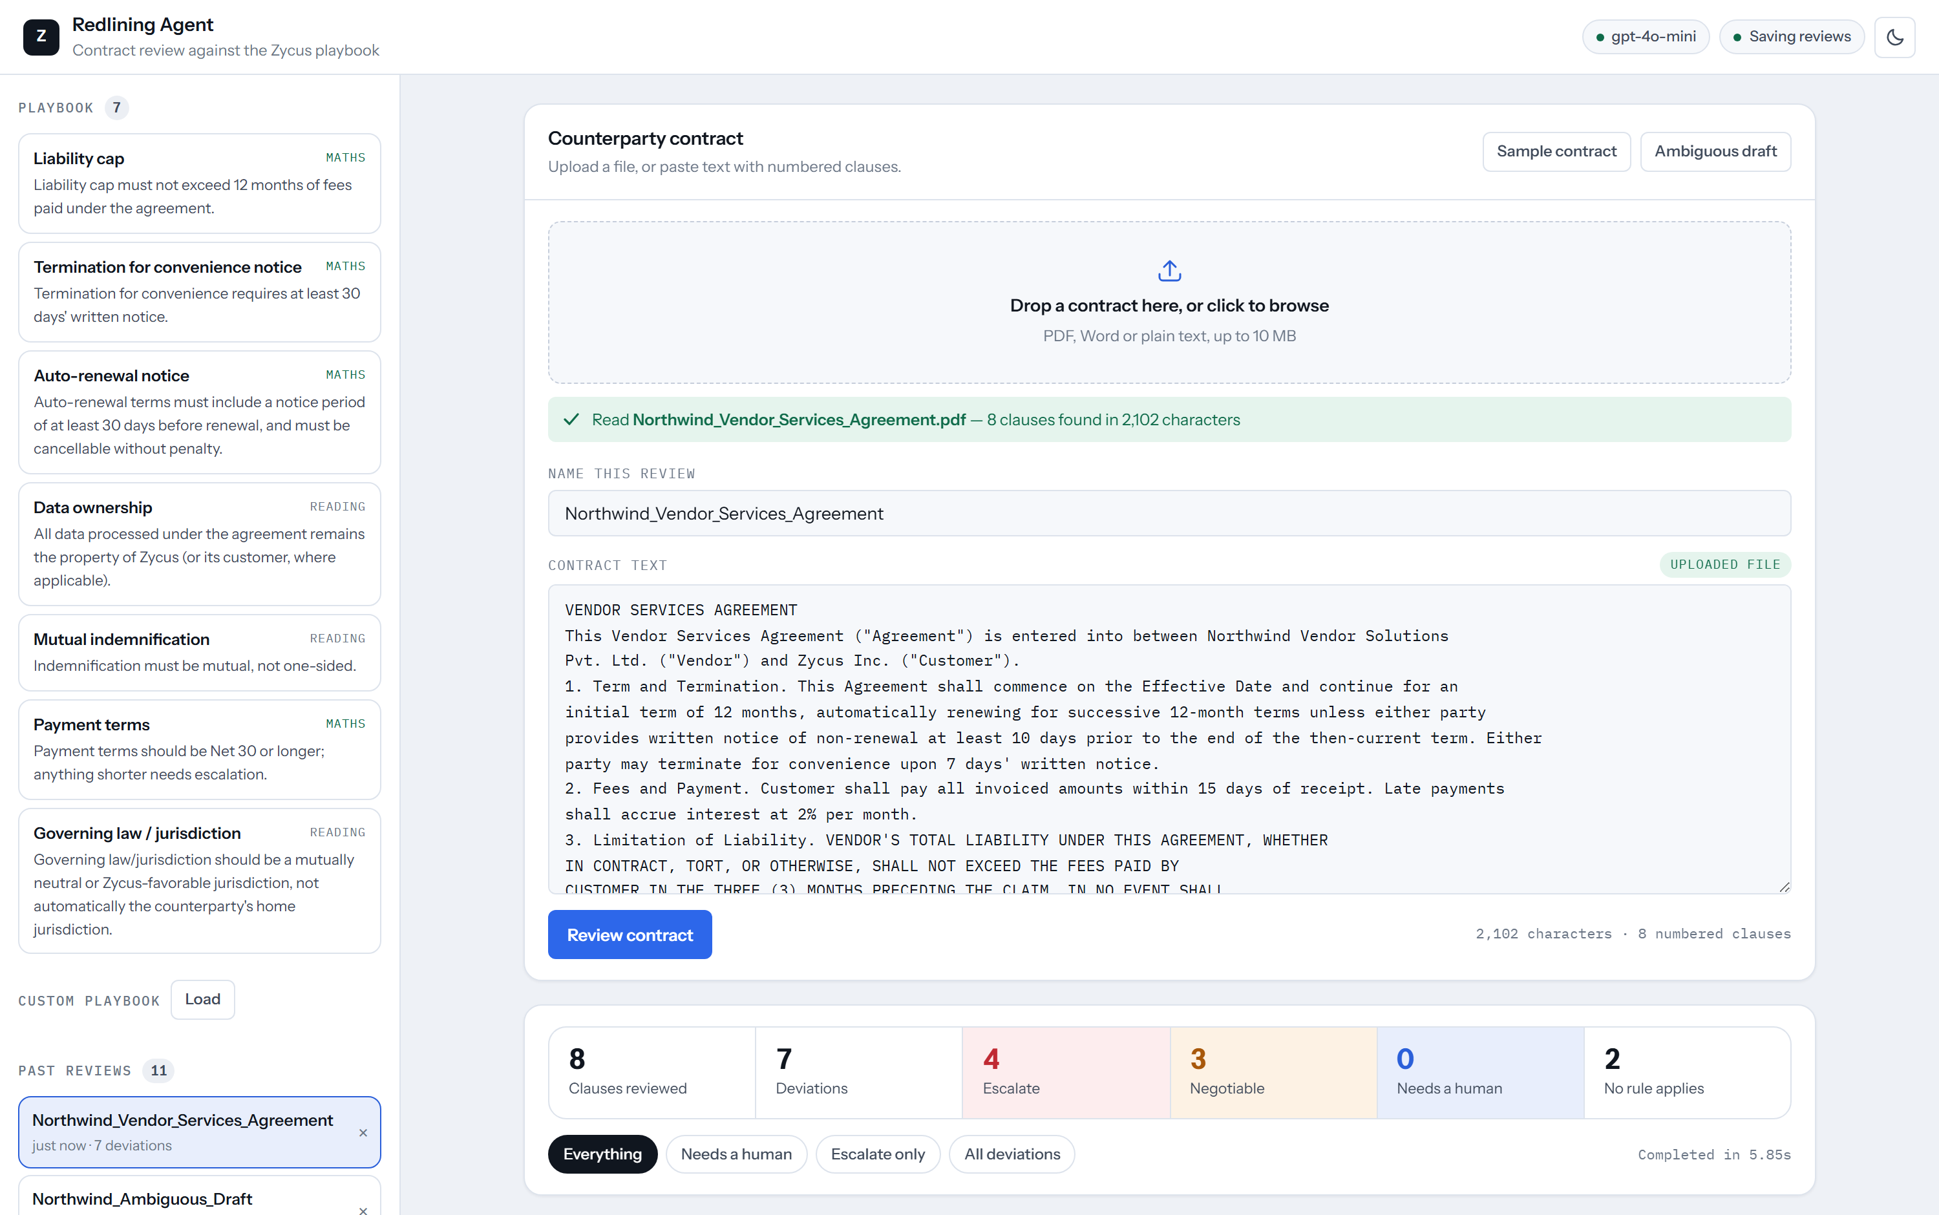
The application: playbook and audit trail in the rail, an uploaded PDF read into the editor, and the review summarised with filters.
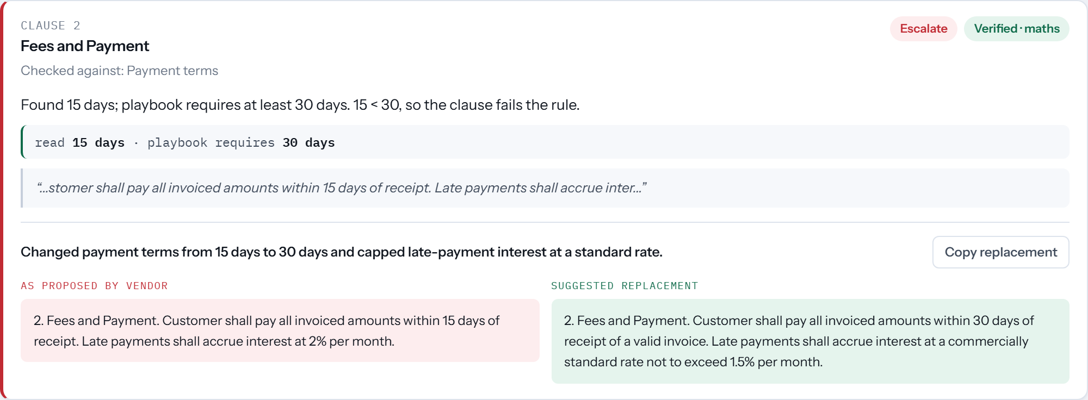
Net 15 against a Net 30 floor, with the vendor's language beside the proposed replacement.

4. What broke
Both bugs were found by running the pipeline against the sample data and reading the output, not by a crash. Neither would have been caught by asking whether the system returns findings.

Bug 1 — two redlines on one clause, each undoing the other
Clause 1 breaches two rules at once: a 10-day non-renewal notice and a 7-day termination notice, both short of the 30-day minimum. Drafting ran per clause-rule pair, so it produced two separate replacements. Because each replacement rewrites the whole clause, they were mutually exclusive:
- The auto-renewal redline fixed 10 to 30 days and kept “terminate for convenience upon 7 days”.
- The termination redline fixed 7 to 30 days and kept “non-renewal at least 10 days”.
A reviewer pasting either one would fix one violation and silently ship the other. Every unit test passed throughout, because each redline was individually correct.
Fix: drafting is now grouped by clause, with every breached rule in one call, so a clause gets a single replacement satisfying all of them. A regression test asserts clause 1 yields one text containing neither of the offending values.

Bug 2 — the model is a poor judge of its own confidence
The low-confidence branch never fired. Run against a deliberately vague draft, the model reported this:
Wording it quoted as evidence | Confidence | Verdict
“a commercially reasonable amount” | 0.80 | violation
“reasonable prior written notice, to be determined” | 0.90 | violation
“such jurisdiction as the parties may mutually determine” | 0.90 | no violation

Self-reported confidence clustered at 0.8 to 0.9 no matter how little the clause committed to. The last row is the dangerous one: a clause naming no jurisdiction at all was confidently cleared. A threshold sitting on top of that number inherits its miscalibration, so the uncertainty feature was decorative.
Fix: the model no longer judges its own certainty in either direction. Arithmetic already overrode confidence upward; a deterministic vagueness check now overrides it downward. When a clause defers its substance to an outside standard, no verdict can be read off the text, so it goes to a human whatever the model claims.
 | Sample contract | Vague draft
Before | 7 auto-suggested, 0 flagged | 4 auto-suggested, 0 flagged
After | 7 auto-suggested, 0 flagged | 0 auto-suggested, 5 flagged

5. The uncertainty decision
The deliberate call: a finding's tier is decided in Python from what kind of evidence exists, never from the model's own estimate. That is what makes the top tier mean something.
Tier | What it rests on | What happens
High | A number extracted and compared to the threshold | Auto-suggest the redline
Medium | Unambiguous wording the model quoted | Auto-suggest, marked for a look
Low | Hedged wording, or a claim with nothing quoted | Flag for a human, no suggestion

Three guardrails follow from that:
- A low-confidence pass is not an approval. “Probably fine” is routed to a human, because silently approving is the failure this tool exists to prevent.
- A deviation asserted without a supporting quote is downgraded, however confident the model claims to be, since a reviewer cannot verify it at a glance.
- A clause no rule covers is reported as uncovered rather than compliant, which also surfaces gaps in the playbook itself.
Confidence and severity are kept as separate axes on purpose. Collapsing them into one risk score would hide the two cases that matter most: certain but minor, and uncertain but serious. Over-flagging is the safe error here, because a false flag costs a reviewer a glance while a false pass is a clause nobody read, signed.
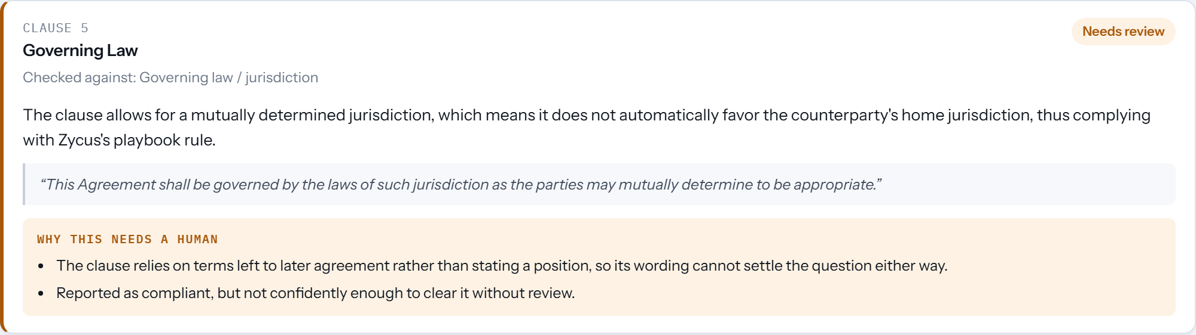
The model called this clause compliant at 0.90. It names no jurisdiction, so it is surfaced rather than cleared.

6. Where it landed
Clause | Finding | Evidence | Call
3 | Liability capped at 3 months, not 12 | arithmetic | Escalate
2 | Net 15 against a Net 30 floor | arithmetic | Escalate
4 | Indemnity runs one way only | quoted wording | Escalate
5 | Vendor owns all data and derivatives | quoted wording | Escalate
1 | 7-day termination and 10-day renewal notice | arithmetic | Negotiable
6 | Vendor's home jurisdiction governs | quoted wording | Negotiable
7, 8 | Confidentiality and boilerplate | — | No rule applies

All seven planted breaches are caught and attributed, the two clean clauses draw no false flags, and the suite runs 132 tests of which 96 need no API key at all.
Severity comes from the playbook's own reasoning rather than the size of the gap. Payment terms are escalated because the rule itself says shorter terms need escalation, even though Net 15 is the smallest numeric miss in the contract. The two notice-period gaps are the largest misses proportionally and stay negotiable, because they are procedural.
The honest limitation: the vagueness check is a phrase list, so a clause that hedges in wording it does not contain still reaches the model unguarded. It is a floor under the failure mode, not a solution to it.

Running it
The repository README covers local setup, the test suite and deployment. The backend serves both the API and the built React bundle from one origin, so it deploys as a single service using the committed render.yaml. The OpenAI key lives in server-side environment variables only and is never exposed to the frontend or committed.

