The following are the steps to be followed for influxdb authentication:

1.Create at least one admin user

create user user with password ‘password’

grant all privileges to user

*Note: Authentication should be disabled in influxdb.conf file while creating first admin user.*

2. Enable authentication in influxdb.conf file under [http] section and uncomment it, if commented.

[http]

enabled = true

bind-address = ":8086"

auth-enabled = true

log-enabled = true

write-tracing = false

pprof-enabled = true

https-enabled = false

https-certificate = "/etc/ssl/influxdb.pem"

3.Restart Influxdb

1. Authenticate with HTTP ALI
2. Authenticate with CLI

Using command auth <username>: <password>:

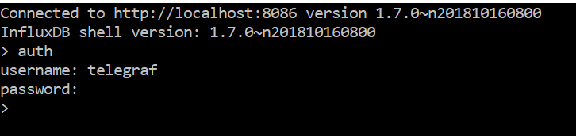

4. Authenticating telegraf requests to influxdb

Uncomment username and password in telegraf.conf file.

Restart telegraf

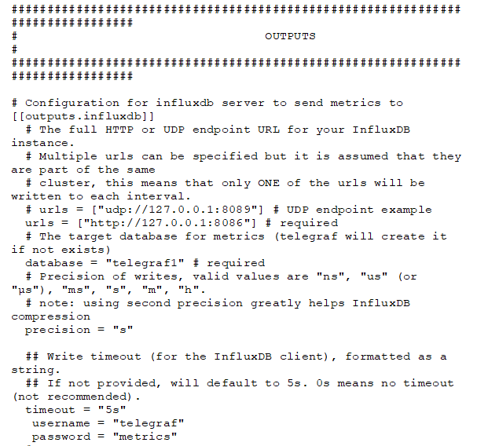

5. Authenticating jmeter requests to influxdb

Provide username and password in jmeter parameters section.

