V5.6 Well Location Update North Slope Gas Hydrate ML Workflow Companion
This companion updates the V5.5 source-backed workflow package with a focused public well-location and API recovery table for the currently mapped North Slope hydrate case-study wells, plus explicit unresolved aliases from screenshots.

Current Public And Runtime Position
The public scaffold tracks 8,084 Arctic Slope public wells, 184 G10015 temperature profiles, 483 temperature-profile matches, 374 rows ready for phase-curve inputs, and 22 methane 5 ppt calculated stability-admissibility intervals. The public side still supports schema/runtime prototyping, source-backed visuals, and guardrail documentation, not public approved-data rows or final model results.
The DOE side now has a public-safe runtime path for the three curated workbooks. Dataset 1 can train prototype saturation regressors, datasets 2 and 3 are treated as external review or alternate training sets depending on target availability, and row-level outputs, predictions, fitted models, and manifests remain in ignored runtime folders.

What V5.5 Adds
- Slide 2 now uses the selected USGS/DOE page-3 hydrate stability source screenshot/crop as the primary stability visual, the project website regional map as North Slope context, and the digitized methane 5 ppt CSV only as a project input inset.
- Slide 5 explains the cleaned DOE three-dataset prototype and model-run card: targets S_h, S_wr, Sh, and Swr are Y-only; cleaned canonical features enter X_allowed; depth/helper/raw-alias columns are excluded; training-fit metrics are runtime proof only.
- Slide 8 makes the stability overlay explicit: context, mask, confidence, and caveat are allowed uses; occurrence proof, saturation, hydrate-present labels, and negative labels for blocked rows are not allowed.
- Slide 9 closes with what has been done, what is not claimed, and what must happen next before final ML or stability claims.
Slide 2 structure language is intentionally narrow: Structure I methane-dominant hydrate is the project baseline. Structure II and Structure H can occur with larger hydrocarbons such as ethane, propane, butane, or heavier components, but they are not the current North Slope baseline claim. Variable gas composition stays a mentor-approved sensitivity path.

Guardrail Language
- Use 'training-fit/runtime proof only' for current DOE prototype metrics, not final model performance.
- Use 'stability-admissibility context' for the public screen, not hydrate proof, occurrence, or saturation.
- Keep S_h, S_wr, Sh, Swr, Sgh, NMR_SAT, hydrate saturation, occurrence labels, and phase labels out of X_allowed.
- Bring back only public-safe summaries after mentor, data-owner, and release review.

Slide-By-Slide Companion

Slide 1 - Personal/about-me opener
Preserved from V5.4 to keep the agreed mentor-facing opener style.
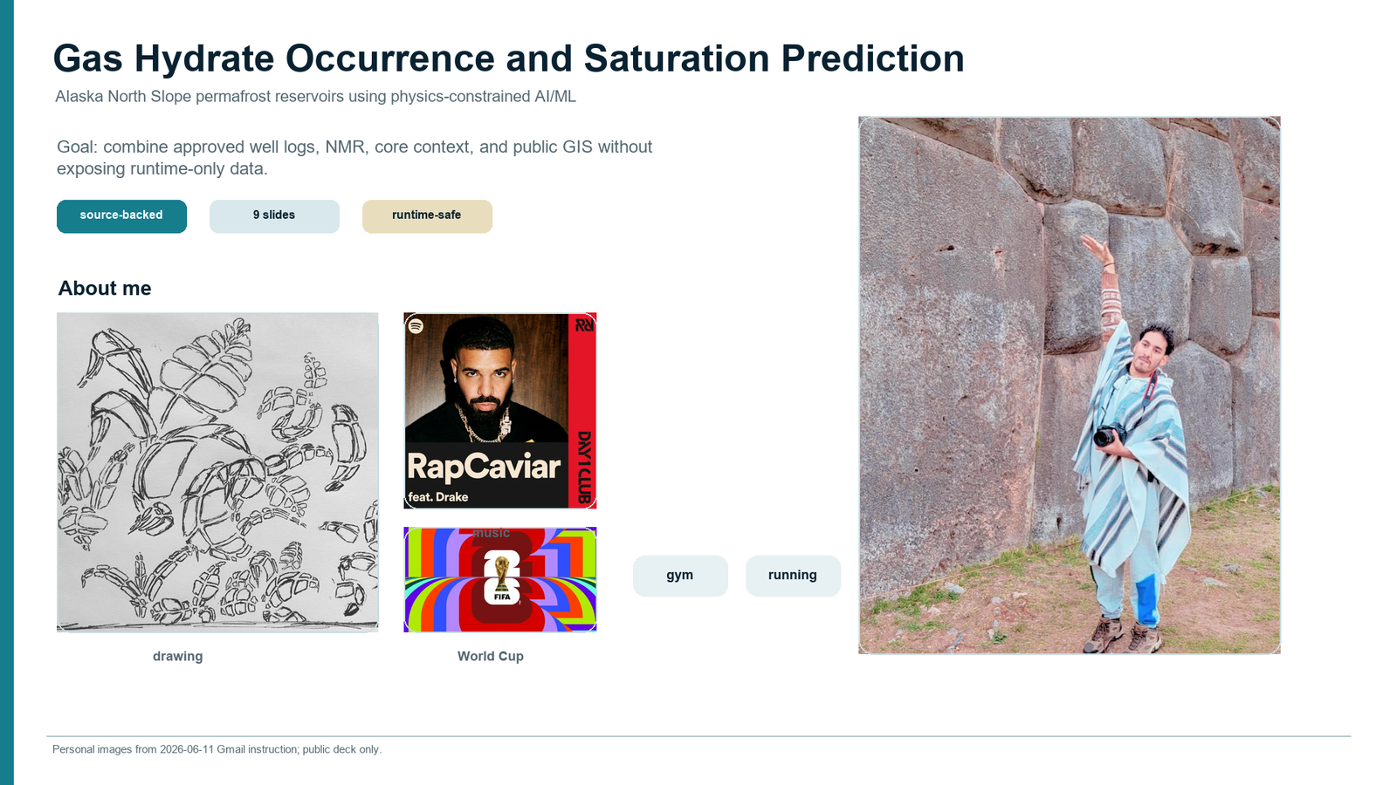

Slide 2 - Source-backed hydrate and North Slope context
Rebuilt around the original context spine: what gas hydrates are and why the Alaska North Slope matters. This accepted Slide 2 direction uses a fuller World Atlas hydrate-structure figure crop with Structure I highlighted as the methane-dominant baseline assumption, a public DGGS RI 2018-6 Umiat-Gubik North Slope geology-layer preview showing map units, contacts/faults, and fold axes, a USGS Arctic Alaska generalized cross section, and the selected USGS/DOE pressure-temperature stability figure. Stability remains a pressure-temperature admissibility screen only; occurrence and saturation evidence must come from approved logs, core, NMR, and mentor-reviewed labels. The hydrate-structure figure remains marked for rights/caption review before public release.
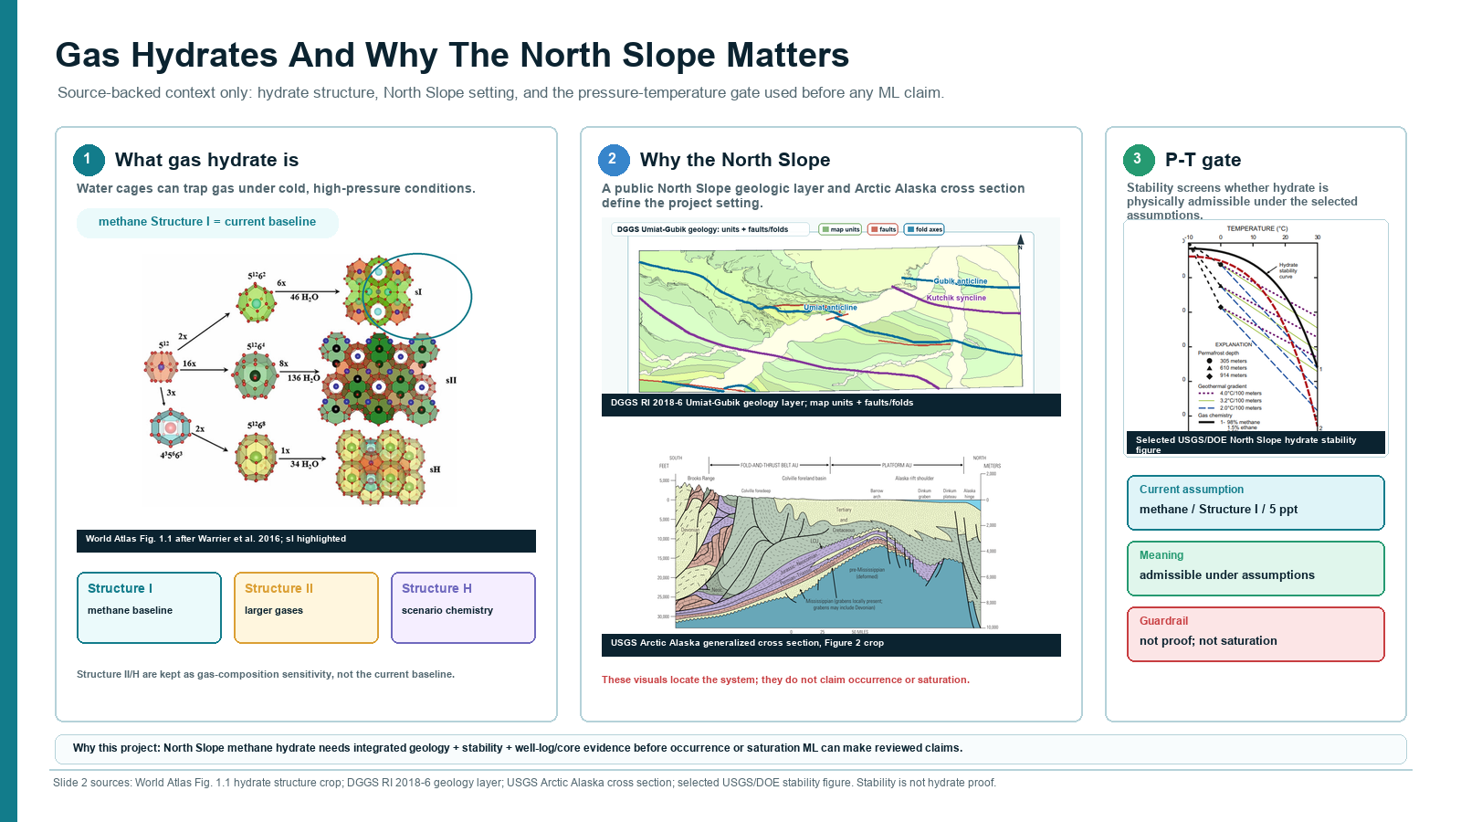

Slide 3 - Parameters and expected hydrate ranges
Preserved the registry-backed range board: working envelopes, mimics, roles, and Y-only labels.
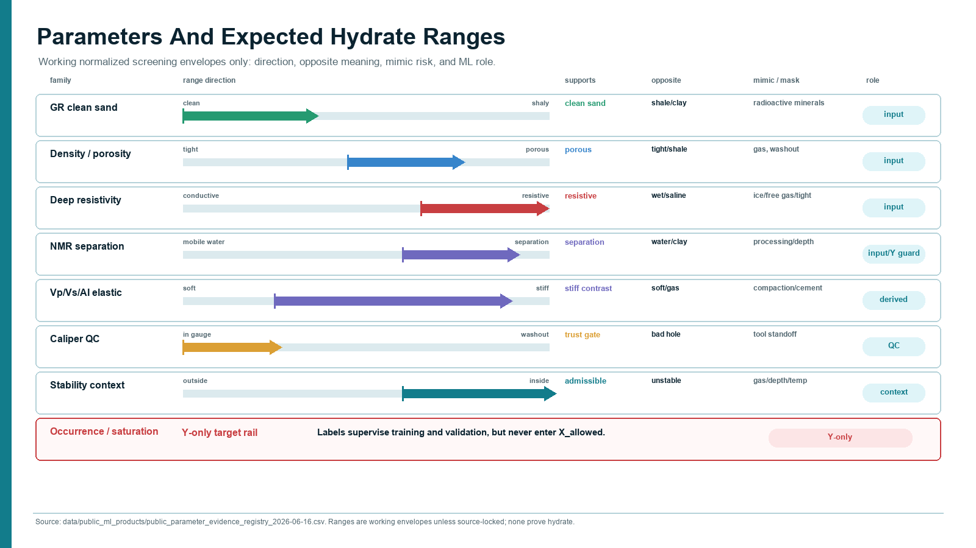

Slide 4 - Full complex project workflow
Kept the whole complex architecture as a main-sequence plate, not an appendix-only reference.
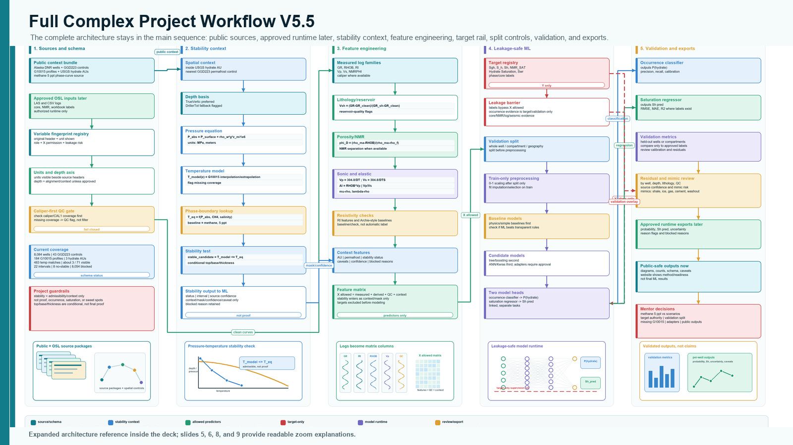

Slide 5 - DOE three-dataset prototype
Adds the cleaned prototype story, feature exclusions, target-only saturation variants, and training-fit disclaimer.
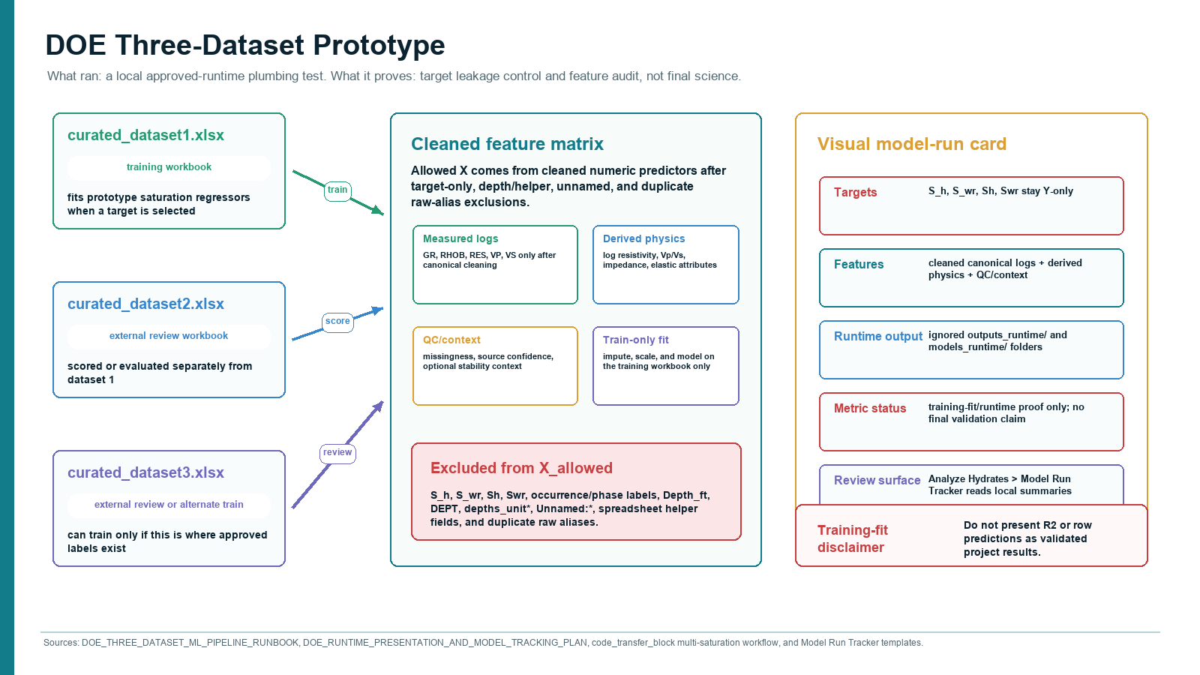

Slide 6 - Equations, feature engineering, and unit gate
Preserves the unit/QC/leakage gate for equation features.
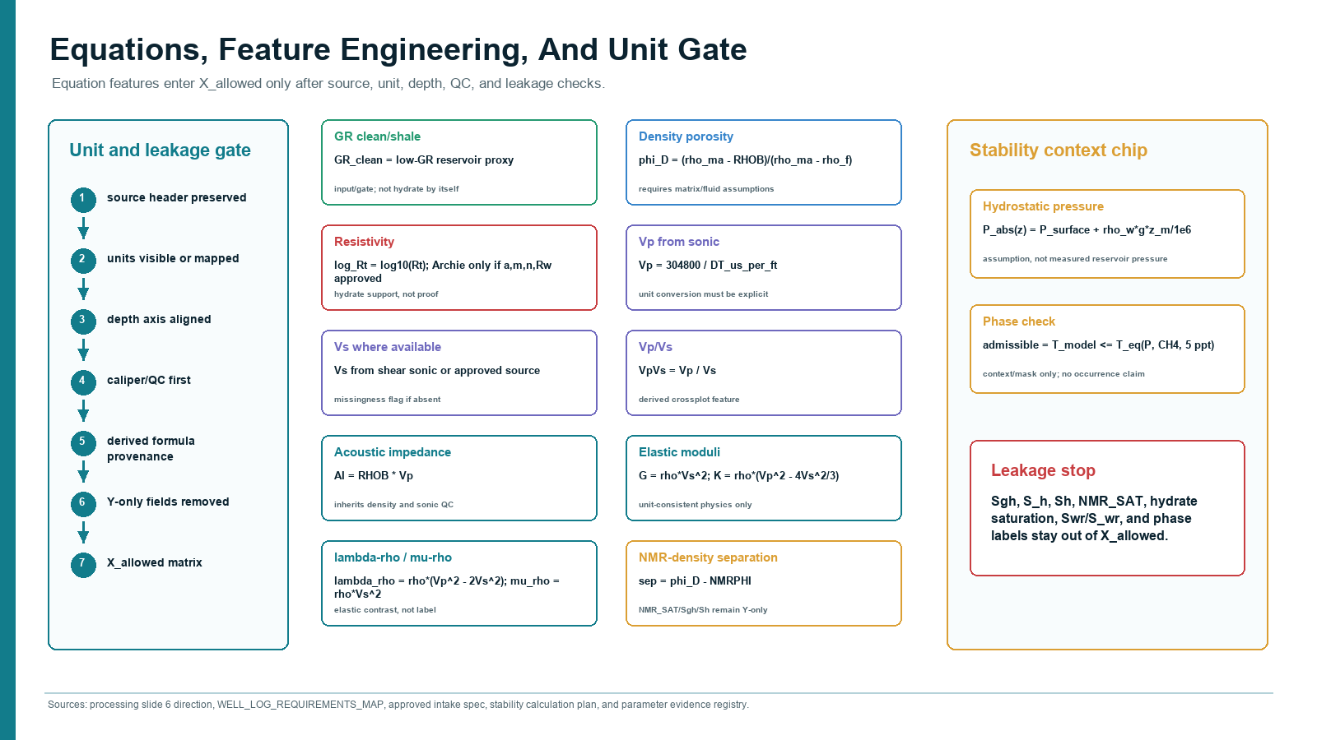

Slide 7 - Complex ML runtime architecture
Keeps the complete ML runtime plate in the main sequence.
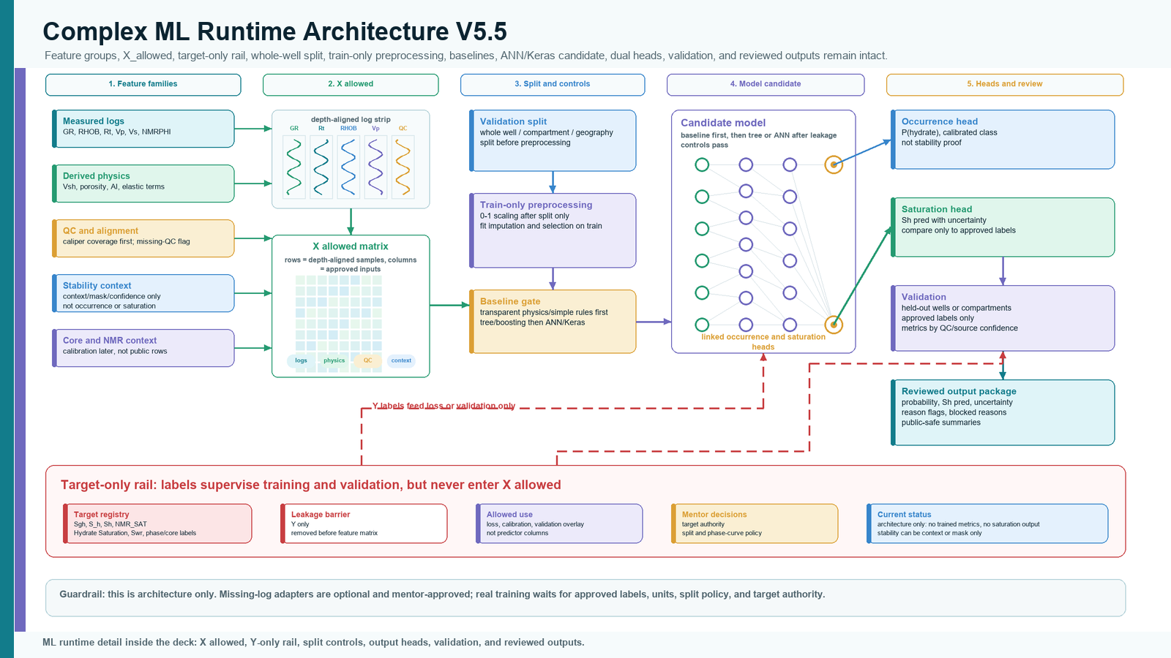

Slide 8 - Stability-to-ML overlay
Shows stability as context, mask, confidence, and caveat only.
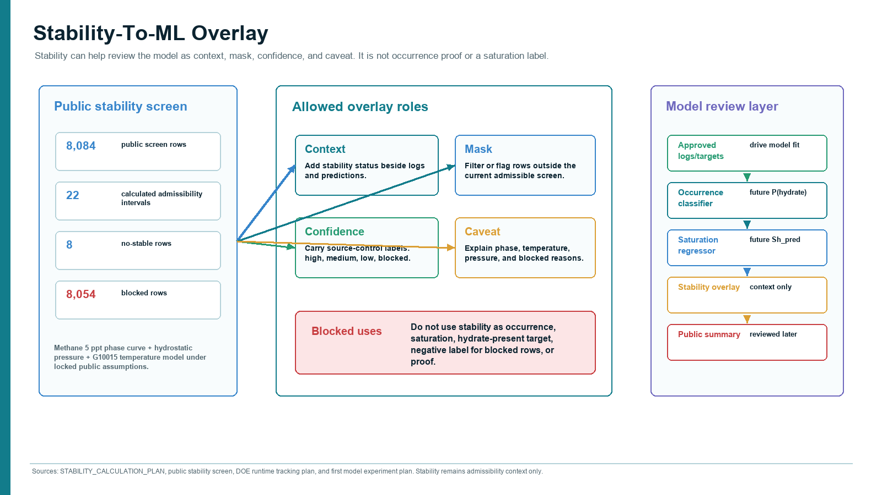

Slide 9 - Done / not claimed / next
Closes with current accomplishments, explicit non-claims, and next approved-runtime steps.
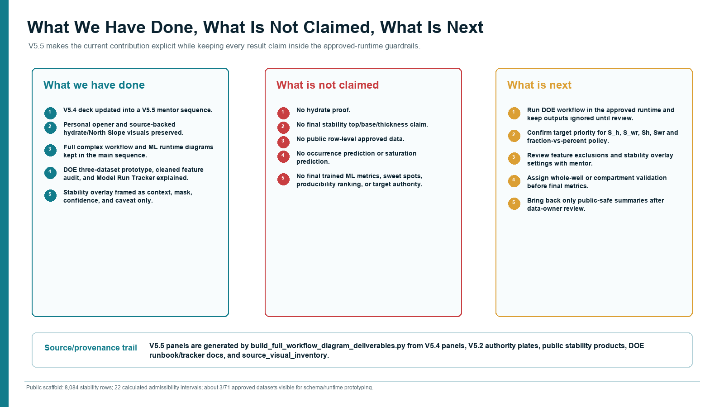

Contact Sheet
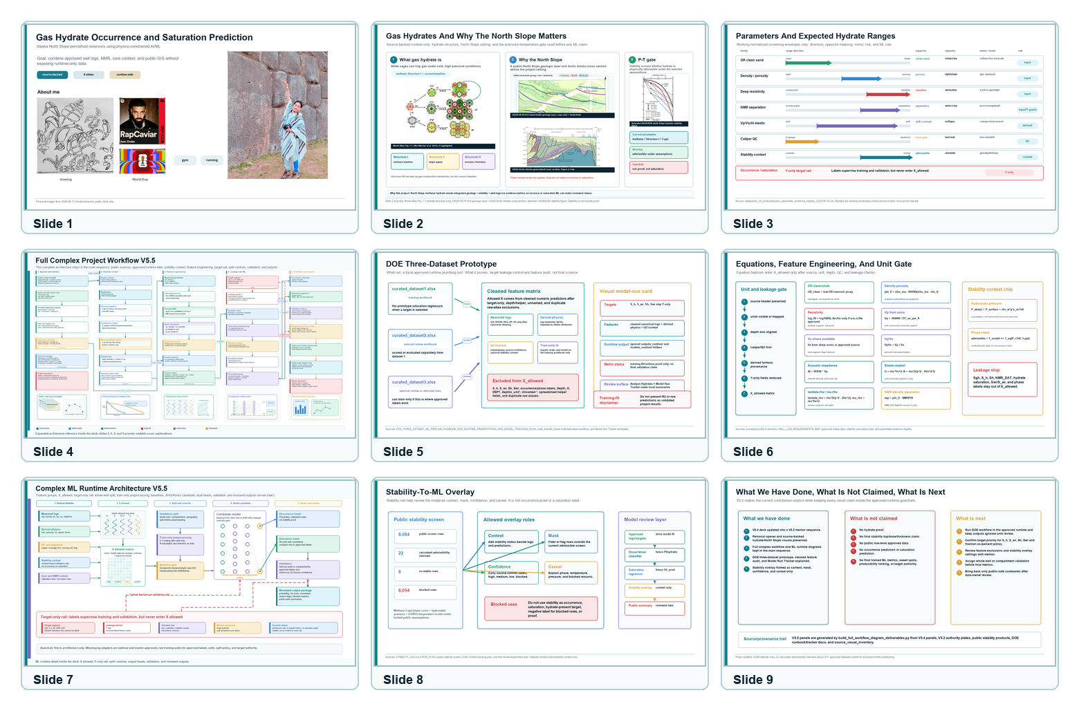

Source And Visual Provenance
- docs/evidence/slide02_source_bundle_2026_06_17/ for the rebuilt Slide 2 source bundle.
- Original selected USGS/PDF page screenshot: https://drive.google.com/file/d/17T48zhoJKvxB21dJUovXhN-6V8DEgzf7/view?usp=drivesdk
- Cropped hydrate stability curve: https://drive.google.com/file/d/1_edIg2LrifTnCL2GP23fcWfnpvIGulYn/view?usp=drivesdk
- Digitized methane 5 ppt CSV inset: https://drive.google.com/file/d/1O7hFSgt3eEjaYt3FocJUlFhAZuswwlm3/view?usp=drivesdk
- DGGS RI 2018-6 geology-layer preview: docs/evidence/slide02_source_bundle_2026_06_17/slide02_selected_11_dggs_umiat_gubik_geology_layer_slide_map.png
- Prior Structure Explorer 2D wells/seismic export retained as provenance: docs/evidence/slide02_source_bundle_2026_06_17/slide02_selected_05_structure_explorer_2d_wells_seismic.png
- USGS Arctic Alaska generalized cross section crop: docs/evidence/slide02_source_bundle_2026_06_17/slide02_selected_06_usgs_arctic_alaska_cross_section_fig2_crop.png
- World Atlas Fig. 1.1 hydrate structure crop with Structure I highlighted: docs/evidence/slide02_source_bundle_2026_06_17/slide02_selected_09_world_atlas_fig1_1_full_structure_types_si_highlighted.png. Use only after rights/caption review in public deliverables.
- docs/project_blueprints/presentation_assets/v5_4_corrected_2026_06_16/ for the V5.4 reference panels.
- docs/project_blueprints/presentation_assets/full_workflow_diagram_2026_06_15/ for the V5.2 complex workflow and ML runtime authority plates.
- data/public_ml_products/source_visual_inventory_2026-06-16.csv for slide and website visual provenance.
- docs/DOE_THREE_DATASET_ML_PIPELINE_RUNBOOK_2026-06-16.md and docs/DOE_RUNTIME_PRESENTATION_AND_MODEL_TRACKING_PLAN_2026-06-16.md for the DOE prototype language.
- docs/STABILITY_CALCULATION_PLAN.md and public stability products for the stability overlay.

V5.6 Well Location And API Recovery
Scope. The table below is public-source context only. It records official Alaska DNR / Division of Oil and Gas surface-hole and bottom-hole points where API numbers are confirmed. The path field is a straight surface-to-bottomhole endpoint segment, not a measured directional survey or approved runtime wellbore path.
Alias | Official well name | API | Field | Wellhead lat/lon | Bottomhole lat/lon | Depth m / path m
MTE | MT ELBERT 1 | 50029233020000 | MILNE POINT | 70.45563616, -149.41079781 | 70.45564162, -149.41072442 | 914.4 / 2.8
IGS | PRUDHOE BAY UN IGNIK SIKUMI 1 | 50029234430000 | PRUDHOE BAY | 70.34871222, -149.31709625 | 70.34868492, -149.31707172 | 791.6 / 3.2
HYDRATE-01 | HYDRATE 01 | 50029236130000 | *EXPLORATORY | 70.31693632, -149.20010365 | 70.31783739, -149.19263623 | 1033.0 / 297.1
HYDRATE-02 | HYDRATE 02 | 50029237280000 | *EXPLORATORY | 70.31717387, -149.20028453 | 70.31808587, -149.19693678 | 1064.4 / 161.3
Official source services checked. Alaska DNR Open Data / Alaska Division of Oil and Gas Well Surface Hole Location and Well Bottom Hole Location FeatureServer layers. AOGCC Data Miner remains the public daily-updated well-info/data reference and source documents remain the official record.
Unresolved screenshot aliases. MLK and an EIT/E1T/ETG-like alias are preserved as separate candidate wells from the user-reported screenshots. They are not mapped to official names, API numbers, or coordinates yet; do not merge them into Hydrate-01 or Hydrate-02 until the original workbook or sharper screenshot source proves the mapping.
Repo files updated. See data/public_stability_products/focused_well_location_recovery_2026-06-19.csv and docs/FOUR_WELL_CORING_PAPER_AND_LOCATION_NEEDS_2026-06-19.md.

