North Slope Gas Hydrate Full ML Workflow Diagram
This companion page explains the one-map workflow requested for the slide refresh. The figure connects public source inputs, OpenScienceLab and approved-runtime inputs, the guarded pressure-temperature stability branch, feature engineering, the leakage barrier, occurrence classification, saturation regression, validation, and public-safe exports.
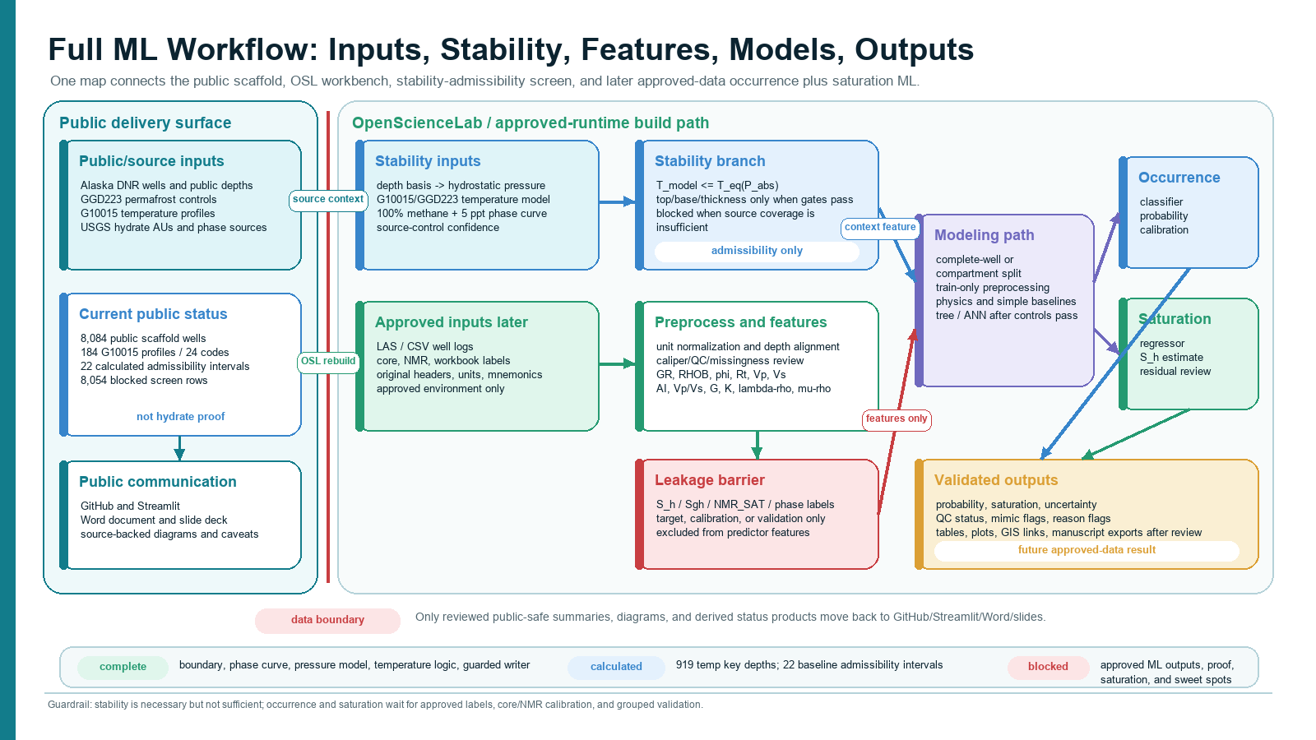

How To Read The Diagram
- The left lane is the public delivery surface: public sources, public stability products, GitHub, Streamlit, Word, and slides.
- The center and right lanes are the OSL and approved-runtime path: raw source rebuilds, approved logs/core/NMR later, preprocessing, feature engineering, modeling, and validation.
- The stability branch feeds context, masks, confidence labels, and caveats into the ML workflow. It does not become hydrate proof or a saturation label.
- The leakage barrier keeps S_h, Sgh, NMR_SAT, phase labels, and final ranks out of predictor features unless a field is proven to be an independent measured input.
- The final ML design keeps occurrence classification and saturation regression linked but separate.

Current Status Shown In The Figure
Complete | Calculated | Blocked / Future
Public/OSL boundary; phase curve; pressure model; temperature-model logic; source-control labels; guarded writer. | 919 temperature key depths, 387 extrapolated key depths, and 22 baseline stability-admissibility intervals. | 15,249 temperature key-depth rows, 8,054 screen rows, approved logs/core/NMR, trained ML metrics, saturation outputs, hydrate proof, and sweet-spot ranking.

Required Guardrail Language
This is a workflow and admissibility-screen diagram. It does not claim final hydrate stability, hydrate proof, hydrate saturation, validated ML performance, producibility, or sweet spots.

