V5.3 North Slope Gas Hydrate ML Workflow Companion
This companion explains the refreshed mentor-facing deck. It describes the public-safe workflow, the gas-hydrate science context, the parameter evidence logic, the guarded stability branch, and the future leakage-safe machine-learning architecture for occurrence classification and saturation regression. It does not report trained project metrics or final hydrate predictions.

1. Project Purpose
The project is building a source-backed North Slope workflow that can later use approved well logs, core, NMR, and mentor-approved labels to predict gas hydrate occurrence and saturation. The current public work is readiness and method architecture: it documents what will enter the feature matrix, what stays target-only, how physics context is used, and how validation should be performed.

2. Public vs OSL Boundary
The GitHub and Streamlit side can show public-source context, public scaffold counts, diagrams, source-ledger logic, schema coverage, and caveats. Approved runtime or OSL space is reserved for raw/approved well-log rows, core/NMR values, sensitive source files, model fitting, trained artifacts, and reviewed outputs.
The public scaffold currently shows 8,084 public wells, 43 GGD223 permafrost controls, 184 G10015 temperature profiles, 483 temperature-profile matches, and 22 baseline methane 5 ppt admissibility intervals.

3. Gas Hydrate Science And North Slope Context
Gas hydrate is an ice-like crystalline solid in which water cages trap guest gas molecules, most commonly methane. North Slope hydrate work is permafrost-associated and tied to public context such as hydrate assessment units, permafrost depth, public wells, and case-study areas including Mt. Elbert and Ignik Sikumi where supported by source documentation.

4. Why Gas Chemistry And Structure Type Matter
Structure I is the methane-dominant baseline used for the current public stability screen. Structure II can be stabilized by larger molecules such as propane or isobutane, and Structure H involves larger hydrocarbons plus methane. Because gas composition shifts the pressure-temperature boundary, the current deck labels methane 5 ppt as the baseline and keeps variable chemistry as a later scenario capability.

5. Parameter Evidence Table
Parameter family | Hydrate-compatible direction | Opposite / mimic | Caveat
GR | Lower GR, cleaner sand/reservoir quality. | Higher GR can mean shale/clay and can confuse response. | Directional only unless thresholds are source-supported.
Rt / resistivity | Higher resistivity can support resistive pore fill. | Lower resistivity trends saline water or wet sand. | Resistivity alone is not proof.
RHOB / density porosity | Porosity/storage context and density-derived porosity. | Tight or low-quality intervals are less favorable. | Density is an input or derived feature, not a target.
NMRPHI / NMR separation | Density-vs-NMR separation can be meaningful because hydrate may reduce mobile-water signal. | High mobile water tends water-bearing. | NMR saturation-like fields stay target-only.
Vp, Vs, Vp/Vs, AI | Hydrate-bearing or cemented sand can be stiffer with higher velocity/impedance. | Free gas, cement, or poor consolidation can mimic or reverse signals. | Use only when units and logs support the calculation.
Caliper / QC | In-gauge hole supports trust in logs. | Washout or bad hole means caution. | QC only; not a hydrate signal.
Pressure-temperature stability | Inside methane 5 ppt phase boundary is admissible under assumptions. | Outside is not stable under that assumption. | Not occurrence and not saturation.

6. Stability Method
The public stability branch combines a depth basis, hydrostatic absolute pressure, a public temperature model, and a methane 5 ppt phase-boundary lookup. The pressure equation shown in the deck is P_abs(z) = P_surface + rho_w * g * z_m / 1e6. The calculation identifies intervals where the modeled temperature is at or below the equilibrium temperature for the chosen phase curve.
The methane 5 ppt baseline is retained as the official public baseline. Scenario chemistry can be added later only with labeled sources and mentor approval. Stability means physically admissible under assumptions; it is not hydrate proof, occurrence, saturation, producibility, or final top/base/thickness.

7. ML Workflow
- X inputs: measured logs, derived features, QC/context flags, and optional stability/context fields if approved.
- Y-only targets: occurrence labels, Sgh, S_h, Sh, NMR_SAT, hydrate saturation, Swr/S_wr, and interpreted phase labels.
- Two outputs: future occurrence classification as P(hydrate) and future saturation regression as Sh_pred.
- Model order: simple physics/rules baseline, tree or gradient boosting baseline, then ANN/Keras candidate.
- Validation: split by whole well, compartment, or geography before preprocessing; avoid final random depth-row splits.
- Leakage guardrail: target labels supervise training and validation but never enter the feature matrix.

8. What The Website Currently Shows
- 2D public regional map / North Slope layer overview.
- Structural explorer preview with public horizons and wells.
- Public scaffold counts and stability-admissibility readiness.
- Schema coverage and target-leakage architecture views.
- Public-safe diagrams without approved/private data rows.

9. Complete vs Future Work
Complete | Calculated | Future / blocked
Public/OSL boundary; website surface; public well map; structural explorer; first ML intake and leakage architecture. | 8,084 public wells; 43 controls; 184 profiles; 483 temp-profile matches; 22 methane 5 ppt admissibility intervals. | Approved log/core/NMR rows; target authority; final blind validation wells; trained occurrence/saturation models; reviewed public prediction release.

10. Mentor Decision List
- Methane 5 ppt baseline only, or add clearly labeled variable gas-chemistry scenarios?
- Which saturation label is authoritative when Sgh, S_h, Sh, NMR_SAT, or hydrate saturation differ?
- Should occurrence labels come from phase labels, saturation threshold, or mentor-reviewed intervals?
- MTE is Mt. Elbert and IGS is Ignik Sikumi; confirm whether *_refined tabs are processing stages by workbook metadata.
- Which wells become blind validation once the full well inventory is available?
- Are missing-log adapters allowed, or should the first models use only observed log combinations?

Research / Source Anchors
- USGS Gas Hydrate Crystals image: https://www.usgs.gov/media/images/gas-hydrate-crystals
- USGS SIR 2008-5175 North Slope stability/prospect method: https://pubs.usgs.gov/sir/2008/5175/
- Chong et al. 2024 / USGS ANN occurrence and saturation architecture anchor: https://pubs.usgs.gov/publication/70250169
- OSTI / NETL MTE and IGS context: https://www.osti.gov/servlets/purl/1893637
- MDPI missing-log adapter background: https://www.mdpi.com/1996-1073/16/23/7709

Deck Figures
Audience workflow slide:
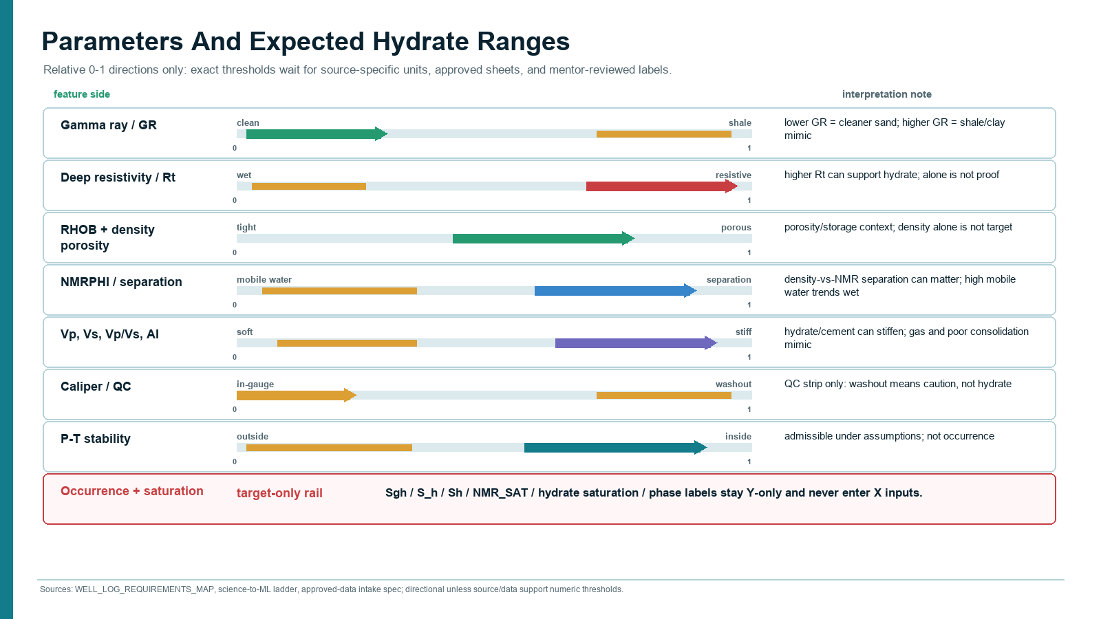
Expanded technical workflow:
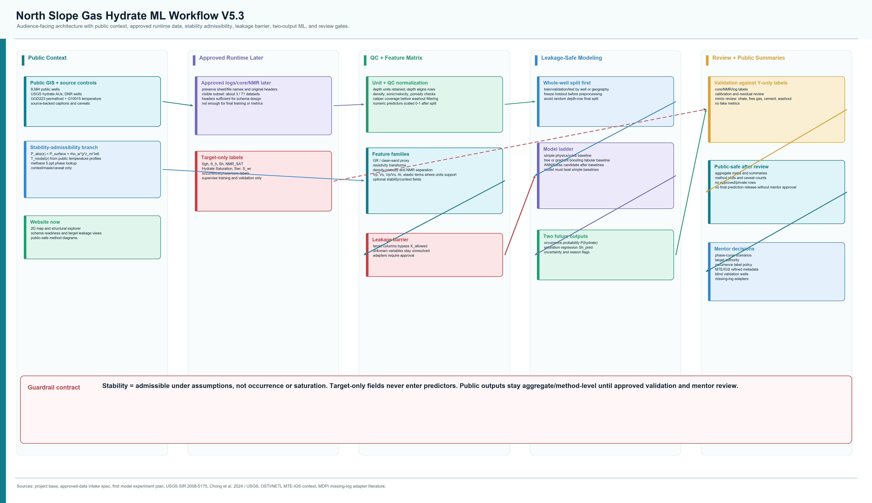
ML runtime detail:
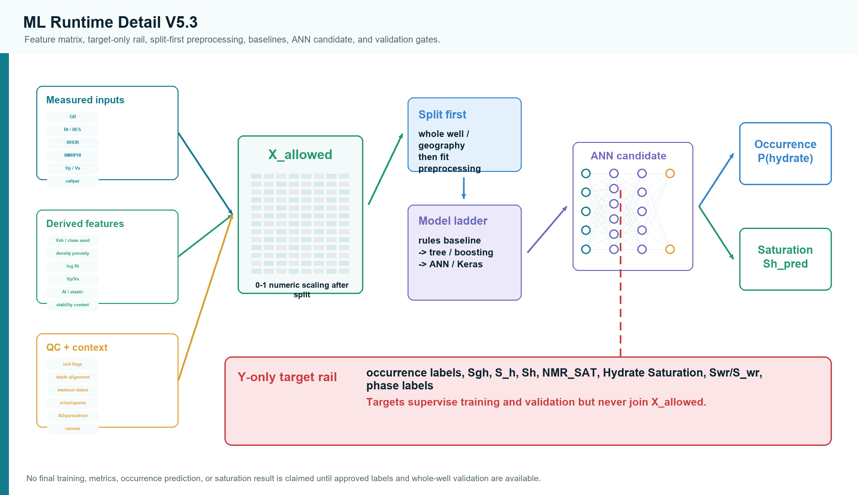

Guardrail Language
Use 'admissible under assumptions,' 'candidate context,' 'confidence/caveat,' and 'validation required.' Do not call the stability scaffold hydrate proof, final stability, occurrence, saturation, or trained ML performance.

